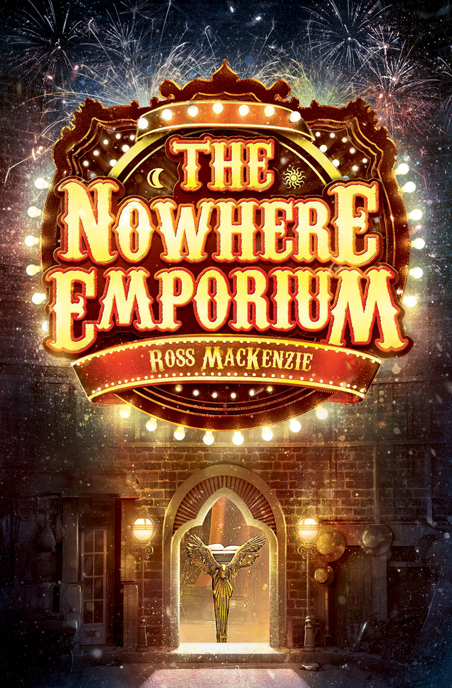
Resource created by Scottish Book Trust

The Nowhere Emporium
learning resource
Age 8-12

CFE Second Level

Activities inspired by The Nowhere Emporium by Ross Mackenzie

scottishbooktrust.com

/scottishbktrust

@scottishbktrust

How to use this resource
This resource gives cross-curricular activity suggestions to accompany Ross MacKenzie’s The Nowhere Emporium. These activities can be used independently, or built upon to create a class project.
The Nowhere Emporium by Ross MacKenzie
Create your own book of wonders
EXA 2-02a, EXA 2-03a, ENG 2-27a
“When I have a new wonder, and I’ve thought it through carefully and decided that it is suitable, I begin to write it down. The pages are enchanted and entwined with the shop. When I have finished writing, a Wonder will appear somewhere in the corridors.’’
- Have a day at the library. Research book jackets and identify the many styles of book covers; images, calligraphy, typography. Discuss what makes a book alluring or special. Have your pupils issue one book, ask them to read this and at a later time discuss with their peers whether they thought that the book jacket effectively reflected the story. They can upload your findings on Padlet.
- Now, ask your pupils to decorate a note book of their own to make their own personal Book of Wonders. Using arts and crafts they can make it look mysterious and ancient like the magic book in the story or they can put a modern twist on it.
- Once your pupils have finished decorating their Book of Wonders ask them to imagine a room and write a description in their book. What style would it be? What characters would live there? What does this room mean to them?
Bring the room to life
TCH 2-12a, TCH 2-14a, EXA 2-02a, SCN 2-09a
When your pupils have finished their entry in their Book of Wonders, ask them to create their imagined room by using a shoe box, arts and crafts and recycled goods.
- Ask them to measure the dimensions of their room. What size will the furniture be? What size will the characters be? What tools will you need to measure these things?

- Will it have lights? Can they make a circuit? It’s easy and all they need is 1-2 D batteries, aluminium foil, electrical tape, a small light bulb from a flashlight and enthusiastic scientists! This blog offers guidelines for quick experiments.
- What fabrics and textiles can they use? Where are these sourced? You can find some helpful examples online.
Research a city
LIT 2-14a
“We’re lucky. We can see New York, Cairo, and Paris…watch Kings and queen and governments come and go. We get to see everything Ellie, the whole of history---’’
Have your pupils’ research one of the cities mentioned in the book:
- What century will they research?
- Has the city landscape changed over the years?
- What’s the population?
- Are there any famous locations?
- What is the city culture?
- How does it look different during seasons?
Make a city snow globe
EXA 2-02a
The first entry that Daniel creates in the Book of Wonders is a room filled with empty snow globes, waiting for secrets to be added. People often collect snow globes on their travels as they usually depict a city scene and make great souvenirs.
When your children have finished researching their chosen city, have them make a snow globe. It’s simple and fun and you can use a jam jar. This site has some helpful ideas.

