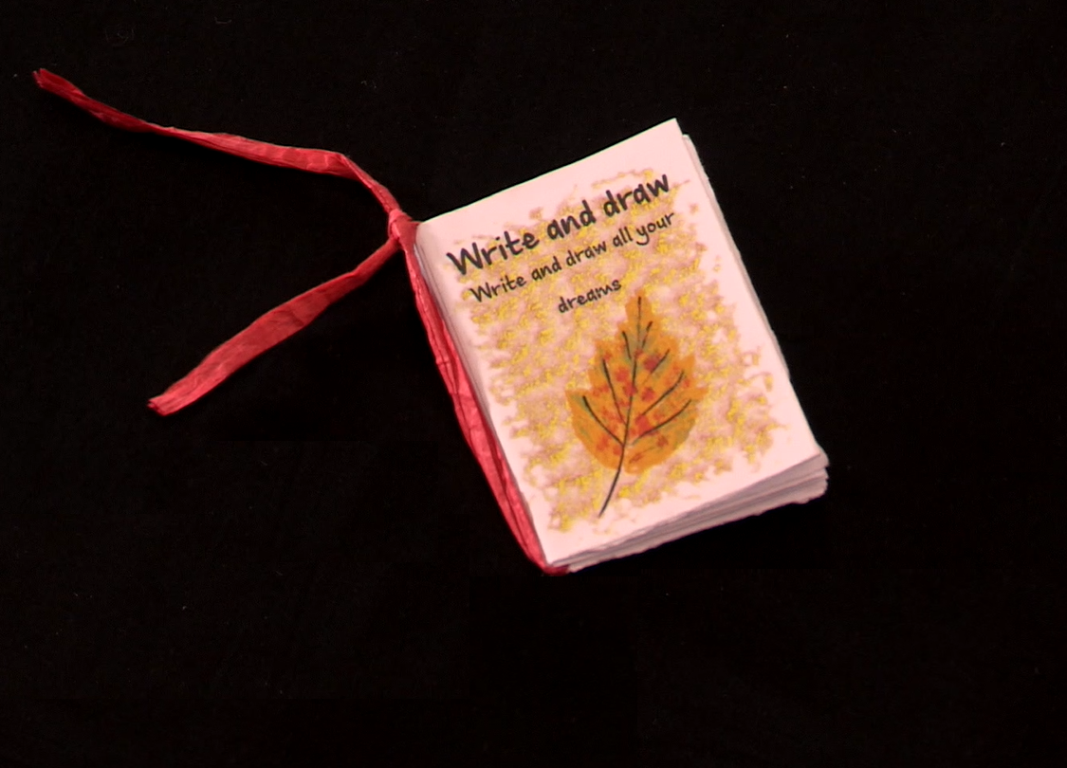

How to Make a Book
Age 6-11

CFE Levels First and Second

Resource created by Scottish Book Trust

Create your own mini book to fill with stories, poems and drawings
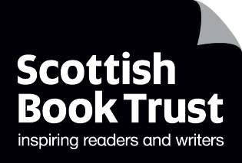

scottishbooktrust.com

Contents
About this resource 1
How to make a book 2
Fill the book with your creations 2

About this resource
This resource will show you how to create a mini book from one sheet of A4 paper. This quick and easy activity is a fantastic way to encourage children to write and illustrate their own stories or poetry. The resource also contains links to other activities to help children come up with ideas on what they can write or draw in their book.
How to make a book
EXA 1-02a, LIT 1-20a, LIT 2-20a
We have created a template which is available to download and print out from the Scottish Book Trust website. Children can also make their own template based on the one provided and design their own cover if they like.
Once you have your template, children can follow these instructions or watch the video instructions:
- Fold the paper into 16 rectangles along the lines of the template
- Be sure to make the folds very crisp – fold forward, and back
- Rip along all of the dotted lines – you will need to fold the paper in half with the dotted lines facing outwards to do this
- With the images facing down, fold open the flaps so that you have a window shape
- Fold down the top row of four rectangles
- Fold the bottom row of four rectangles under
- You should now have two rows of four rectangles, with the back cover in the bottom left corner, and the front cover to the right of the back cover
- Fold the bottom row of four rectangles under again and hold up so that the two covers are facing you
- Pinch into the middle, so the whole book comes together and the images form the front and back cover
- To finish, you could tie your book with a ribbon or string

Fill the book with your creations
Now that you have your book, it’s time to fill it with stories, poems, drawings – whatever you like! Here are some of our other resources which will give children some inspiration on what to fill their book with.
- Joseph Coelho suggests some brilliant activities to help children write their own poems in his Authors Live event which you can watch on our website
- Story sticks and poetry stones are fantastic ways to generate ideas and inspiration for stories and poetry.
- Our creative writing activities for upper primary resource contains lots of ideas to encourage children to create and share stories
- Our Authors Live on Demand Library has over 70 events to inspire children and young people, including lots of events with illustrators who show you how they create their characters.

