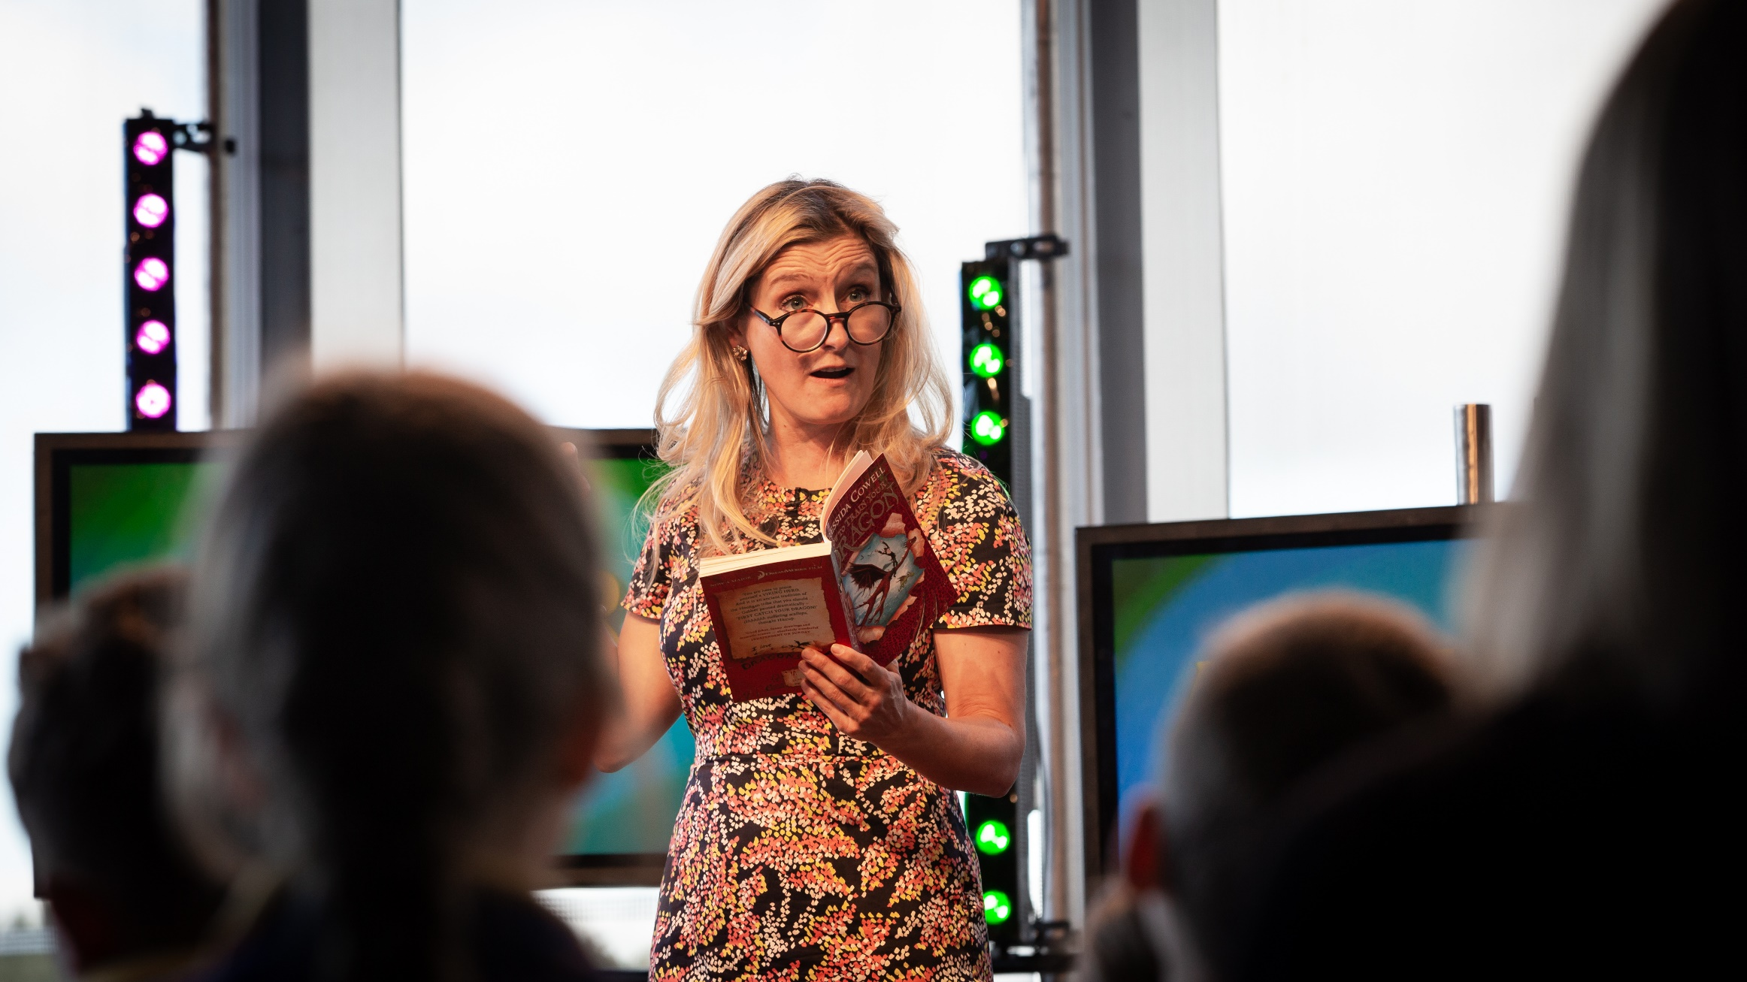

How to Train Your Dragon film activities
Age 8-11

CFE Second Level

Resource created by Linda Murray

Activities to help you explore the film adaption of Cressida Cowell’s How to Train Your Dragon

scottishbooktrust.com

Contents
About this resource 1
Use of a narrator and character development 2
Film themes 2
Use of accent and vocabulary/slang 2
The music score ​ 3
Dragon animation ​ 3
Use of animation with little or no dialogue 3
A ‘beautiful oops’ 4
Prosthetics ​ 5
The Northern Lights 5

About this resource
This resource contains cross-curricular activity suggestions to help you explore the film adaption of How to Train Your Dragon by Cressida Cowell. The resource has been produced to help you get the most out of our online Authors Live event with Cressida, but you can use them at any point to engage pupils with How to Train Your Dragon.
You may also be interested in our How to Train Your Dragon book resource, for activities based on the original novels.
The Screening Shorts website and Into Film website have further resources to help pupils to analyse films.

Use of a narrator and character development LIT 2-02a, LIT 2-04a, LIT 2-07a, LIT 2-20a, LIT 2-24a, ENG 2-27a
The film’s opening sequence is narrated by Hiccup. You are instantly on his side and immediately relate to him. Discuss how this ‘sets up’ the rest of the film for you and what the director is achieving here. The other characters are introduced through Hiccup which gives you his perspective on them. Do your perceptions change over the course of the film or does this device speed up the development of a character? Does this view of a character remain fixed for the rest of the film? In a novel, descriptive language is used to aid the reader to create their own mental picture, but in the film, we are given an immediate visual. How then do we build empathy with these characters?
Print off stills of the main characters and have your pupils select one to focus on. Ask them to jot down notes as they watch to be able to produce a written character description later. How does this compare to the book’s descriptions? Is their character even in the book? If not, why has the character been introduced into the film? The most obvious character to discuss here is Astrid who is Hiccup’s ‘love interest’ in the film although officially she is there to give the film a strong female role model. Why would this be considered necessary? Does she fulfil this role?
Write your own narration for the opening of the film, or another film of your choice. Have a go at voice overs and see what it brings to the films you have chosen. The Voiceover Gurus Blog has lots of tips to perfect your narration technique.

Film themes LIT 2-02a, LIT 2-04a, Lit 2-29a, HWB 2-44b
One of the main themes of the film is strained father/son relationships. Another is the forbidden friendship between Hiccup and Toothless. Watch the film with the recurring themes as a focus. What other themes can we see emerging? Discuss how successful the filmmakers have been. Have they missed any that could have been pursued with more intent or is a children’s film the place for big themes to be discussed? If you are also reading the novel, how do these themes differ in both storylines? Why might this be?
Have a general class discussion using cooperative learning techniques such as carousel or placemat group chat and if you have time planning, write a piece of persuasive writing based on your findings.

Use of accent and vocabulary/slang ​LIT 2-02a, ENG 2-03a
There is an interesting discussion to be had about the use of accent or dialect, in this case, in the film, but this could be extended to consider television and the evolution of regional accent over received pronunciation. All the adults in the film have Scottish accents but the youngsters, Hiccup included, speak with American accents. Ask your class what they think about the following questions:

- What is the director trying to achieve here? How does this affect how we feel about the characters, does it make a difference?
- Why are Vikings speaking with Scottish accents anyway?
- The directors have said that the use of the accent change was to show the older generation making way for the next generation of Vikings. What does your class think about this?
Use this to prompt a discussion about accent, spoken grammar and general speaking skills. What importance should we place on how we speak and the words we use? Try to tease out an understanding of where text speak is acceptable. There is considerable debate out there just now about whether we should desist from using words children don’t know, or if this is one of our roles as educators.

The music score ​EXA 2-19a
Music always plays a big part in films. This film won an Oscar nomination for its score by John Powell. He used the work of the Finnish composer Sibelius to inspire him. Listen to some of Sibelius’ work and compare. There are hints of pipes and drums there too (the theme tune was used in the Edinburgh Military Tattoo 2011).
Discuss what purpose the music in this film fulfils. Look at recurring themes within the music- can you identify them and any slight variations? When are they used? Do different characters have their own compositions?
Put groups of children together to either recreate the music, or to develop their own film scores. Pupils can listen to the movie score through the internet, rather than replaying the film. Listen to ‘Romantic Flight’ and ‘Test Drive’ to get you started.

Dragon animation ​TCH 2-09a, TCH 2-11a, TCH 2-15a
Each of the younger characters is matched to a specific dragon. This is something we don’t fully appreciate until the grand finale. Have your class identify the features of each dragon which matches their riders. Have them design their own dragon for themselves – what would it feature?
Following on from this, you could ask pupils to create mini scenes using models to develop animation skills, or create an online game based on ​How to Train Your Dragon. You could use Scratch, or other animation software for children.

Use of animation with little or no dialogue LIT 2-20a, LIT 2-26a, ENG 2-27/31a
Toothless communicates through sound and facial expressions. The production team chose a puma on which to base his image, which has some elements of horses and dogs as well as a little bit of Stitch from Lilo and Stitch. Watch the scenes where Hiccup and Toothless interact with only short phrases of dialogue from Hiccup – for example, the scene around 28 minutes into the film where Hiccup feeds Toothless a fish, they play a game and start to become friends. If you could, what dialogue would you write for Toothless? You may find you need to ‘tweak’ Hiccup’s dialogue too. What words would you use? Have your learners write the screenplay for a scene of their choice.
Extend this to other films. Pixar shorts work well for this sort of exercise to. Use ​one of the clips below ​for a whole-class example before dividing your class up to look at different shorts. Have the groups write their screen plays and perform them to the rest of the class.
Pixar’s shorts are available on DVD but some clips can also be found on Pixar’s YouTube channel. Some good options for this task are:
- Dante’s Lunch – A Short Tail
- The Blue Umbrella
- La Luna

A ‘beautiful oops’ HWB 2-11a
Early in the film, Hiccup persists in trying to befriend his Night Fury dragon through various actions e.g. bringing him fish. There is a defining moment when Toothless allows Hiccup to raise his hand and touch the dragon on his muzzle (32 minutes into the film). There is a slight pause as he does this, which was originally a technical glitch within the animation. It was agreed that the slight pause gave more poignancy to the moment, and hence the glitch was left in.
There is a big emphasis in education to help children to understand that it is perfectly ‘safe’ to make mistakes; that mistakes should be regarded as a positive aspect of our learning and that we can make something from them. This technical hitch is a lovely example to share with them – a ‘beautiful oops’.
You could share Beautiful Oops ​by Barney Saltzberg with pupils. Beautiful Oops is a great picture book which celebrates the creative potential in making mistakes. The Mindset Kit resource on celebrating mistakes may also be helpful for this discussion.
Discuss the following questions with pupils:
- Everyone makes mistakes. What are all the different reasons why someone might make a mistake?
- Is making a mistake always a bad thing? In what ways could making a mistake be a good thing?
You might like to try a carousel task asking your class in their groups to respond to each of the words written on large sheets of paper- one word per sheet e.g. mistakes, risk, courage, perseverance, effort, success and creativity. Discuss their responses and why you wanted them to complete this to develop a receptive attitude to mistakes.
Invite your learners to share their mistakes during plenary sessions to reduce the ‘taboo’ around them. This can be linked into the idea that it’s okay to ask for help - it’s a strength, not a weakness.

Prosthetics ​HWB 2-09a, HWB 2-10a,​​ HWB 2-21a, Soc 2-16a
Gobber the Viking has a prosthetic arm. Over the course of the film he is shown with 14 different attachments. Hiccup ends up losing his foot and has a prosthetic too. Lots of joking goes along with cartoon characters who wear a prosthetic and this film uses a very light touch to let us know about Hiccup’s injury. It is not shown to be a hindrance or a disability for him and he goes on to do great things in the next film.
How does this affect children in real life? There are many reasons why children might lose a limb. How do they cope, what support is available to them and how might we make their lives easier in school and out? How can we adapt activities and events to ensure they are able to take part and be included? Perhaps there is someone within your school community who has experience of this and can be asked to come in and discuss how they manage and what others can do to be of help.
Pupils could research charities who provide services for people who have amputated or absent limbs, like Finding Your Feet and Team Unlimbited, to learn more about this. They could also research role models such as famous Paralympians.
Can your class plan an awareness/fundraising day? They might include activities for others to try which highlight difficulties, sporting action adjusted to meet their needs.
Checking into the backgrounds of your families before contemplating this activity would be advisable.

The Northern Lights ​SOC 2-09a, SOC 2-10a
The Northern Lights feature in the background of the flying scenes with Hiccup and Astrid. Investigate this phenomenon as a class and present your findings to another class – The Conversation website and the Northern Lights Centre website will help.
There are lots of places in Scotland where the Northern Lights are visible. Ask pupils to research places in Scotland where you can see the Northern Lights, and create a map to show these different locations. Pupils could find out facts about the different places, what time of year the Northern Lights are visible in each location, and include photos or illustrations. They could also come up with a key or colour coding system to show how strong the Lights are in each place.
Depending on where you live, you may be able to see the Northern Lights from your home - you can check whether the Aurora is likely to be seen in Scotland by following Aurora Watch.

