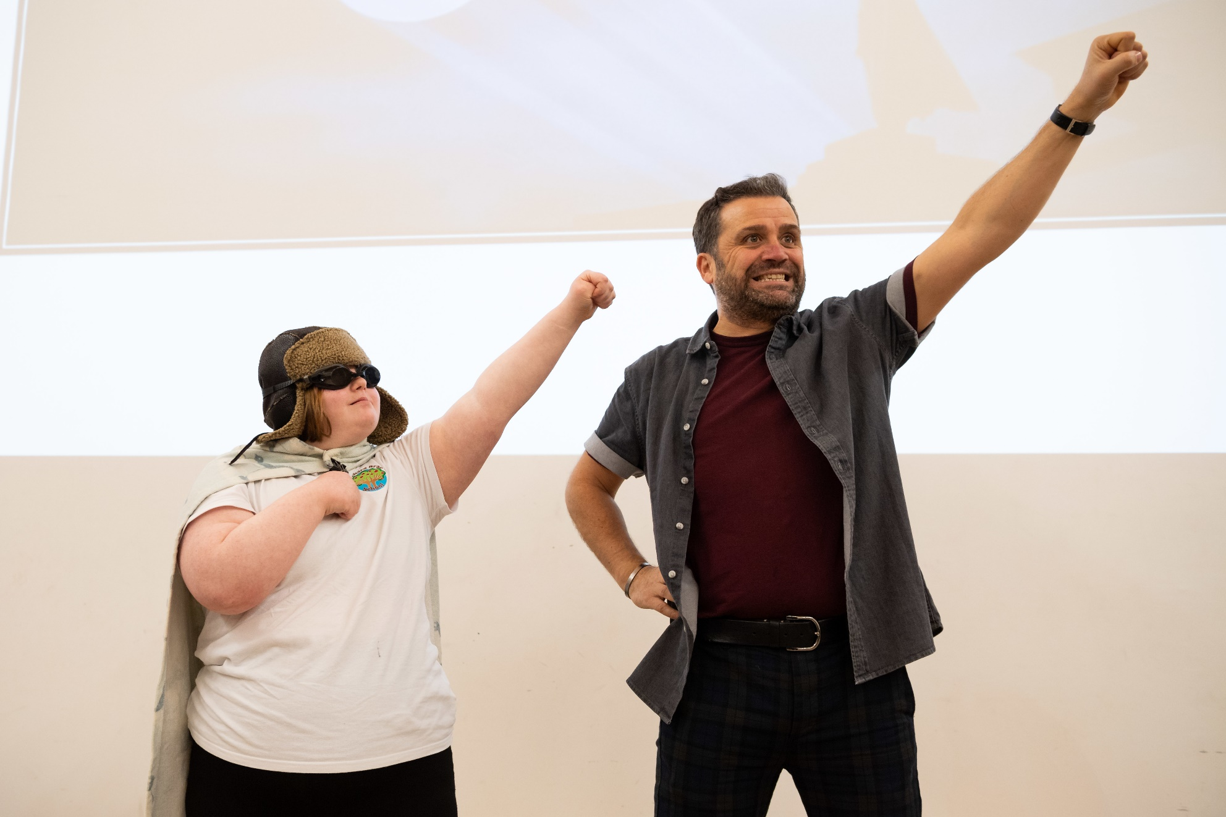

Step by Step: Stick Man by Julia Donaldson
Age 3-18

CFE Levels First to Fourth

Resource created by
Ailie Finlay

A guide to turning picture books into sensory story

scottishbooktrust.com

Step by step, picture book to sensory story: Stick Man by Julia Donaldson
The first thing I do when I am turning a picture book into a sensory story is to read through the story and decide what I want to emphasise in my version. For some very simple stories there may not be many choices, but with a rich story like Stick Man there are lots of different directions I could go with the sensory story. I could choose to emphasise the different characters that Stick Man meets (dog, girl, swan etc.) or the different environments that he passes through (park, river, ocean etc.), or the different emotions he feels (scared, angry, tired, happy etc.). In this example I am going to concentrate on the actions that Stick Man does or has done to him.
Now I write a summary of the story using the emphasis that I have chosen:
Stick Man lives with his family in a tree.
Dog uses him to play ‘fetch’.
Stick Man is thrown in the river.
Swan sits on Stick Man in nest.
Stick Man is found by a man and turned into a flag.
Time passes.
Stick Man is covered in snow.
He is collected for firewood and put on someone’s fire.
Santa rescues him in his sleigh.
Stick Man is back with his family, dancing
Next, I begin to think about the props for the story. An obvious choice for Stick Man himself would be a stick, but because I want to emphasise the actions in my version, I choose to make a simple Stick Man out of brown felt. By making him soft and strong I will be able to throw him in the air, drop him etc without worrying about damaging him (or anyone else).
I work my way through the story choosing props as I go; in each instance I am thinking what it is I am trying to convey and how I can make the sensory experiences interesting:
The dog and Stick Man: The actions here are fetching and dropping. In my experience children enjoy objects being dropped…I could drop my Stick Man on to the floor or on to a child’s wheelchair tray. Repetition makes things funnier so I could do this a few times (whilst barking and saying ‘ow’ for Stick Man!)
Stick Man in the River: Here I would choose either floating or covering as the main action. I might wrap Stick Man up in a blue silky scarf and let the child feel him ‘covered with water’. I would encourage the child to bump the silk-and-Stick-Man bundle around on their desk or wheelchair tray to give the feeling of him being swept away and bumped around. (Note that in this story I would say that the wetness of the water is less important than the fact that it covers him and sweeps him away.)
Stick Man and the Swan: The action I would choose here is Stick Man being sat on by the swan! I might put Stick Man on the child’s wheelchair tray and invite the child to cover him with a cuddly toy swan or large pillow and voice his words ‘I’m not a twig! Why can’t they see!’ Again, repetition makes this funnier!
Stick Man becomes a flag: Flags are a fun sensory item! I would probably have a flag double of my felt Stick Man to avoid having to fiddle around with tying the flag together in the middle of the story. Then I would do lots of flag waving.
Stick Man is covered in snow: I would use confetti (or white paper cut up into tiny pieces) and sprinkle this on Stick Man.
Stick Man is collected for firewood: The action here is sleeping…I would add in some snores. I steal my ‘snores’ out of shaking baby toys (the kind that vibrate when you pull them). If you snip the toy open you can take out the ‘shaking’ mechanism. This makes a lovely snore if you put it in a tiny drawstring bag with the pull string hanging out. Children will enjoy putting their hand on the bag to ‘feel’ the snore.
Santa rescues Stick Man: This is the climax of the book so I would want to make it the most interesting part of the story from a sensory point of view. I would include Christmas bells (bells on jingle sticks) and smells (spices such as cinnamon sticks and star anise in small fabric bags) for atmosphere.
The action would be flying! If I was reading the story to a group I would use a large piece of preferably bouncy fabric (such as Lycra). I would make Santa and the sleigh by cutting simple shapes out of felt. Then we could hold the fabric spread out between us and bounce Santa, the sleigh and Stick Man all around. For a one-to-one story I would do this on smaller scale or use a soft toy Santa and simply throw him and the Stick Man into the air with a loud ‘Wheeeeee!’ (And repeat!) Then a long downward blow on a slide whistle could be the Stick Man landing back in his tree home.
Stick Man dancing with his family: A calm ending is nice. I might use a music box at the end for the dancing. If I was telling the story to a group I might give everyone a simple little stick person at the end so that they could join in with the dancing. (These could be made out of big lollipop sticks or wooden spoons with eyes drawn or stuck on.) If the group found noises more engaging I might give them all some gentle bells to ring for the dance.
If I had been focusing on the characters in the story rather than the actions I would have chosen differently; a dog noise-maker toy, feathers for the swan (or maybe a puppet that could give some playful ‘bites’ with its beak) and so on. Or I could have created an atmospheric version, with the noise of children playing, an ocean drum for lapping waves, ice cubes for winter time… Any of these stories could be lovely, but if we tried to include all these versions at once we would tie ourselves in knots and confuse our children. Less is always more when it comes to sensory storytelling.

