Exploring translation

Age 9-11

CFE Levels Second

Resource created by
Lawrence Schimel

A resource to encourage introducing translation in the Modern Languages classroom

scottishbooktrust.com

Contents
Words and palabras 2
One word, many meanings 3
Idioms 4
Rhyme time 5
A rose by another name… 6

About this resource
The aim of this resource is to support exploring translation in the classroom. This resource is adaptable, and can be used with any of the Modern Languages included in the Curriculum for Excellence and as part of the 1+2 Languages approach. The examples are in Spanish, but knowledge of this language is not required. The resource is written for pupils.
The resource explores the principles of translation, and challenges pupils to think about how to translate the essence or meaning of a phrase. The resource has been written by Lawrence Schimel, a bilingual Spanish/English author and translator. He has written and translated a number of children’s books and poetry including:
- Will you Read a Book with Me? By Lawrence Schimel, illustrated by Thiago Lopes
- Poems the Wind Blew In by Karmelo C. Iribarren, translated by Lawrence Schimel
- The Wild Book by Juan Villoro, translated by Lawrence Schimel
About translation
Translation is the act (and the art) of taking a text in one language and recreating it in another. Sometimes this can be very straightforward, when both languages share the same words that mean the same things. But when the original text involves idioms or expressions, or rhymes or puns, things can get much more complicated.
Some people say translation is like making a cover of a song; the translator makes their own version, in the new language, like playing the song on a different instrument, but it's still recognizably the same song.
For me, translation is like playing word games.
Shall we play with translation together?
Words and palabras

Let's look at this poem by the Mexican writer Gabriela Cantú Westendarp.

I've replaced some words in the English translation with emojis. If the emoji appears twice in a row, that means the word is plural.

Can you identify what Spanish word each emoji represents?
El idioma de los fantasmas
de Gabriela Cantú Westendarp

Mamá hoy descubrí el idioma de los fantasmas.

¿De qué estás hablando, Claudio?

Sí, mamá. En serio, descubrí
el idioma de los fantasmas.

Para decir hola dicen: Hu hú.
Para decir sí dicen: Hú.

¿Y para decir adiós cómo dicen?

No sé, todavía no se han ido.

The Language of []
by Gabriela Cantú Westendarp
translated into English by Lawrence Schimel

Mama, today I discovered the language of [].

What are you talking about, Claudio?

Yes, mama. Seriously, I discovered
the language of [].

To [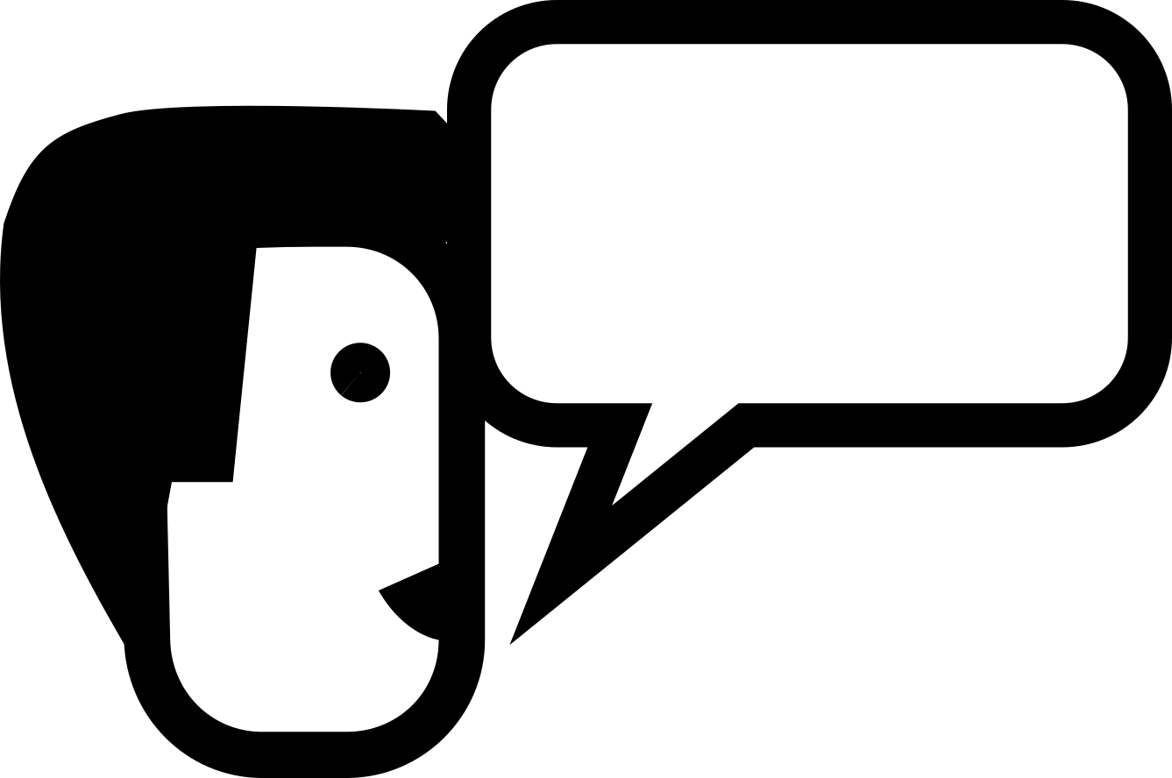] hello they []: Hoo hoo.
To [] yes they []: Hoo.

And how do they [] goodbye?

I don't know, they haven't left yet.

Did you notice that the word Mama is the same in both Spanish and English?

Vocabulary:

Fantasma: ____________________

Decir: _________________

See page 8 for answers.

The Language of Ghosts
First published in Spanish in Poemas del árbol by Gabriela Cantú Westendarp, Mexico: UANL, 2009. First published in English in Modern Poetry in Translation, No 2, 2015.

One word, many meanings

Sometimes a word like "decir" in Spanish can have many different possible translations in English:

to speak
to say
to talk

The translator's job is to figure out which meaning to use.

When two or more words mean the same thing they are called synonyms.

Words that mean the opposite thing are called antonyms.

But sometimes it's possible to create a synonym by using a negative antonym!

If you say brave or without fear, they both mean the same thing, but the emphasis is different.

If you want to hear a little more about antonyms and synonyms before moving on, visit BBC Bitesize to watch a short video.

Can you think of other synonyms for the following words or phrases, using a negative antonym?

Word/Phrase | Antonym | Synonym
Happy | Sad | Untroubled
Vast

Measureless

Jumbled

Enormous

Relentless

Pairing synonyms game
Can you pair the jumbled synonyms below? Print, cut out and pair.

Happy | Without number | Without Stopping
Relentless | Vast | Enormous
Jumbled | Untroubled | Incalculable
Measureless | Without order | Without end

Idioms

Sometimes words mean something else when they're used together than when they're on their own. These expressions are called idioms, and they can be the trickiest things to learn–or to translate. You can watch a video explaining idioms on BBC learning.

In these cases, it's important not to translate the words literally, but instead to translate the meaning of the words together.

Take the expression "don't sweat it". Now, you wouldn't just translate this literally into Spanish, "no lo sudes," because not sweating doesn't mean anything in Spanish. You need to use a Spanish expression for "don't worry" like "no te preocupes" o "no pasa nada" instead.

There are lots of expressions that mean something when those two words are together that mean something else if you look at the individual words by themselves.

Like "head start". You could translate this literally into Spanish:
head=cabeza
start=comienzo

But "cabeza comienzo" doesn't mean anything, it's gibberish. In Spanish, one usually just says you gave someone a "ventaja" or an "advantage."

Another example is "looking glass". If you didn't know that a looking glass is an expression for a mirror, you might wind up translating it literally as "vidrio que mira" or "glass that looks" since that's what those two words mean if you consider them as individual words, and not as a single expression or idiom.

So a translator needs to recognize when words used together mean something different than when they're used on their own.

Let's practice trying to recognize these instances.

Can you think of expressions or idioms that you use, that would make no sense if you translated them literally?

Make a list of expressions or idioms for feelings, like "tickled pink" or "under the weather".

Now imagine if someone who is learning English heard those expressions.
Wouldn't they be confused if you translated them literally?

Rhyme time

One of the trickiest things for translators can be trying to recreate rhyme.

Because sometimes words that rhyme in one language don't rhyme at all in the other.

Take the word "bat" in English: it's a short, easy word, which has lots of rhymes in English.

But in Spanish, bat is "murcielago": not at all a short or easy word! Instead of just ONE vowel like in English, in Spanish it contains all the vowels!

Let's look at this rhyming couplet in Spanish from a poem by Luna Baldallo:

Me estoy mudando a La Luna con mi gata.
Lo primero: comprarle comida en lata.

Extract first published in Spanish and English in the bilingual collection Thirteen Trece, by Luna Baldallo, translated by Lawrence Schimel, Spain: Ediciones en Huida, 2015.

Now the words that rhyme in Spanish (gata/lata) don't rhyme in English (female cat/tin can)!

So what is a translator supposed to do?

Do you rhyme with the first line or the second line?

Try doing BOTH as exercises!

Here are literal translations of these two lines. Try and write a second line, based on the poem, that rhymes with it.

1) I'm moving to the Moon with my cat.

_______________________________

2) _____________________________

First thing to do: buy her food in a can.

Sometimes as a translator you can decide not to use either end rhyme, but instead take an element from inside one of the lines and rhyme with that.

In English, it would sound more natural for the second line to read: "buy her cans of food" so you could try and find a rhyme to match with "food" instead of with "can."

My version of these two lines that was published in the book was:

I'd better go the store soon
to buy cat food to take to the Moon.

Sometimes a translator needs to take liberties in order to recreate the reading experience in the new language. If the original text is lively and fun, or has a sing-song quality, the translation should also have those same aspects.

A rose by any other name...

Translation usually happens between one language and another. But did you know it's also possible to translate from English to English?

Take a look at these sentences and see if you can say the same thing in a different way:

"Is something wrong?"

"Can I help you?"

"I'd rather not."

"We'll have a jolly good time."

There isn't only one right answer. Write down all the different ways you can come up with to rephrase each of the sentences or questions. Thinking of lots of variations is good practice for translating!

And with translation there isn't only one right answer. Every translator will make their own decisions, and as a result, each translation will be different--sometimes only slightly, but other times, hardly alike at all!

Even though the original text is written by the author, your translation of it is something created by YOU!

Answers to words and palabras

The Language of [Ghosts]
by Gabriela Cantú Westendarp
translated into English by Lawrence Schimel

Mama, today I discovered the language of [ghosts].

What are you talking about, Claudio?

Yes, mama. Seriously, I discovered
the language of [ghosts].

To [say] hello they [say]: Hoo hoo.
To [say] yes they [say]: Hoo.

And how do they [say] goodbye?

I don't know, they haven't left yet.

