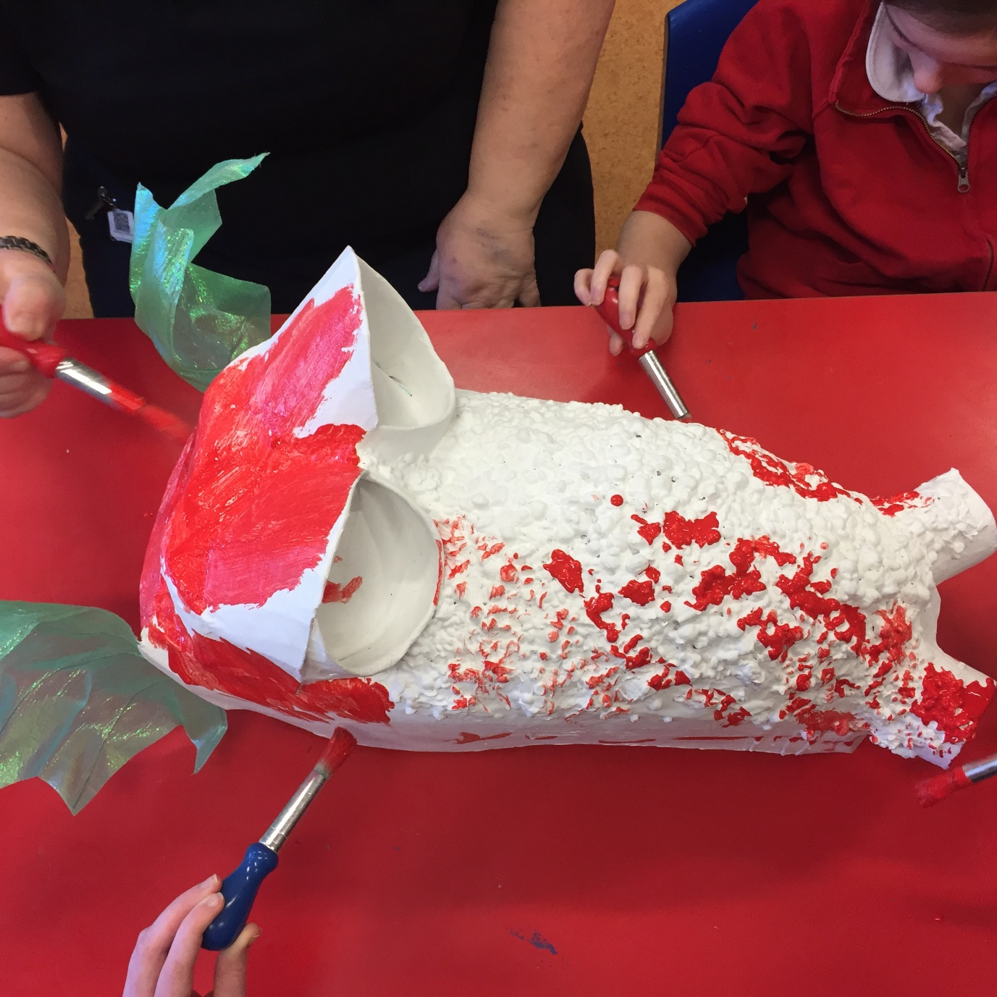

Let there be dragons

CFE Levels Early, First and Second

Resource created by Kate Leiper

A tactile and sensory art project

scottishbooktrust.com

/scottishbktrust

@scottishbktrust

Contents
How to use this resource 1
Sensory storytelling: once upon a dragon 2
Idea generation: hatching a dragon 3
Creating a dragon: let there be dragons 5
A celebration: hear the dragon’s roar! 6
Project resonance and longevity: long live the dragon! 7
Book list: the dragon’s library 8
How to use this resource
Dragons exist in many cultures all over the world and are a wonderful means for exploring our imaginations and expressing our creativity, making them a rich topic for the additional support needs (ASN) classroom.
This resource aims to provide ideas on how a dragon can be brought to life through sensory exploration, simple storytelling and classroom art activities. The project can be as small or as ambitious as you like, with a focus on encouraging the children to make their own choices and decisions as to how they perceive their dragon to be.

Sensory storytelling: once upon a dragon
Build up a very simple narrative for your dragon, encouraging the children to contribute their ideas wherever possible. This narrative can be repeated and embellished as often as you like. It a wonderful group activity which encourages the children to take turns in sharing the sensory props and is a great way to discover individual preferences and dislikes.
- What is the dragon’s name? - Can one of the children choose? Perhaps give them a couple of choices? Remember to use this name whenever you’re retelling the story.
- Where does it live? - Perhaps somewhere local, thereby creating familiarity for the audience.
- When does it live? - Living in the distant past, e.g. ‘Once upon a time, a long, long, long time ago…’, is great for creating mystery and ambiguity, thereby including lots of different ideas. For example, ‘some people said the dragon had rough, scaly skin; other people said it had soft, fluffy feathers’
Describe the dragon using lots of sensory props and allow the children to take turns in handling them too.
- How does your dragon move? Hitting a drum could be the ‘Stomp!, Stomp!’ as the dragon walks. Small jangling bells could describe a small dragon that likes to run around. A big piece of fabric wafted above a child’s head could suggest wings, as could a big feather stroking cheeks and necks.
- What does your dragon feel like? Explore a selection of textured fabrics. Introduce the idea of scales (maybe with sequined fabrics), fur, feathers and also the concept of rough and smooth. Does your dragon have claws - if so, are they sharp or blunt? What do they sound like? - maybe tap or scratch something on the desk. Castanets are great for simulating the ‘clackety-clack’ sound of teeth, maybe even trapping the odd finger or two!
- How does your dragon smell? Perhaps make smelling jars scented with essential oils to represent the dragon’s breath. Use an old salt or pepper shaker, or a plastic jar with holes drilled in the top, and pop in a bit of toy stuffing so that the oil has something to soak into. An icy and fresh breath could be peppermint, a hot and spicy breath could be cinnamon, etc.
- What does your dragon say? An opportunity for everyone to join in a class roar or pre-record a roar on a Switch or Go Talk 9 device.

Wee Tip: Remember that dragons aren’t always male!

Idea generation: hatching a dragon
Through sensory storytelling the children have been introduced to the concept of what a dragon is and that it comes from our imagination. They are hopefully fully primed to begin exploring different aspects of a dragon in more detail through a series of small sensory activities and art projects. Adapt these to the capabilities of the children, again observing which activities the children are particularly drawn to. Perhaps consider beginning to draw out the character of the dragon that the children are imagining through offering the children choices, e.g. Is it friendly or scary, is it happy or sad, and how can this be represented, e.g. What colour is a scary dragon?, does a friendly dragon have smooth or rough scales?, etc., etc.
Textures
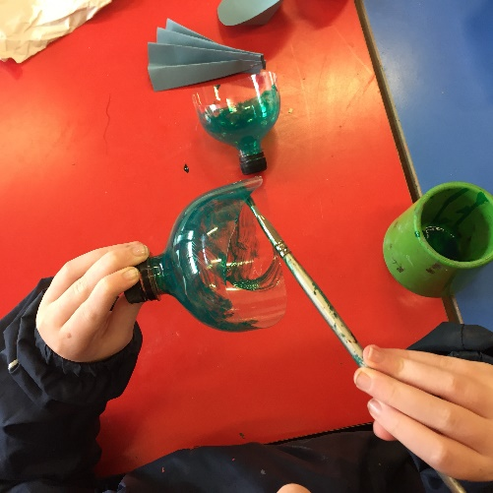
- Textures can be explored more deeply through simply playing with a range of fabrics, maybe encouraging the children to arrange them into ‘rough’ and ‘smooth’ piles and if possible, include fur fabrics and feathers.
- Encourage a discussion as to what their favourite pile is; would a dragon with rough skin be scary or friendly? Big or small? Noisy or quiet? Would it have wings and if so, what would they feel like? etc., etc.
Scales
- The selected fabric could be cut into rough circles and laid out in slightly overlapping rows to create tactile scales.
- If children are able to use scissors, fabric can be difficult to cut. They could do the same exercise as above using different coloured and textured papers, maybe even ripping the paper instead of cutting it.
- Scales could be made from air-drying clay or a salt dough. Roll it out and then either provide or encourage the children to find as many objects as they can to press into the clay or dough to make interesting textures and patterns. With a cookie cutter, or jar, cut the clay or dough into circles. Once dry these can be painted. If you want to be really fancy they can be finished off with a light sponging of paint in a contrasting coloured. It will enhance the texture and if the paint is gold, it will add a bit of bling too! (Wee Tip: Crayola’s ‘Model Magic’ is a good self-dying clay as it’s very lightweight. There are many salt dough recipes online, though be aware that you’ll need access to an oven to bake these)

Colour
- A selection of fabrics and/or papers can be used to explore colour. Sort into piles of hot or cold colour, dark or light colours or maybe arrange the colours into a rainbow!
- Paint is also obviously another great way to explore colour. Perhaps get the children to mix their own colours, such as blue and yellow to make green, or red and yellow to make orange, or blue and red to make purple. How many different greens, oranges or purples can they make? What happens if they add white to their paint? Which colour do they think their dragon should be?
Mark making
- Children could explore mark making by painting on a variety of fabrics with different textures. (Wee Tip: It’s a lot easier if the fabric can be taped down to the desk). How many different kinds of marks can they make? Perhaps use different sizes and kinds of brushes (toothbrush, nail brush, etc)? Encourage the children to cover the whole piece of their fabric as some may have a tendency to just work, and maybe overwork, the centre.
- Maybe explore printing using lots of different objects and textures, eg. bubble wrap, forks, the end of cotton thread reels, potatoes, scrunched up paper, etc, etc.
- Their painted fabrics could also be cut into rough circles and turned into scales. Maybe use them to make a collaged dragon for the classroom wall. If a whole dragon is too ambitious, or too big, you could always depict a flicking tail, or just the dragon’s head.
Playing with paint
- Paint could be mixed with different materials so that when it dries, it has a variety of textures. Try sawdust, sand, lentils, different grains and pulses, rice, flour, sugar, etc, etc. Enhancing paint by adding textural material will work best with acrylic paint or poster paint with some PVA added. (Wee Tip: It’s probably obvious, but make sure that the children also wear overalls or aprons!)
- Again, experiment with mark making using this paint on different textured fabrics and papers.
- Maybe scent your paint by adding a few drops of essential oils, giving each colour a different smell, which could work well for children who are visually impaired.

Creating a dragon: let there be dragons
If you are feeling ambitious, you could now go onto make a class or school dragon, incorporating as much as possible the ideas, suggestions and preferences that the children have already come up with. The great thing about dragons is that as they come from the imagination, there are no rules as to how they should look or be.
The dragon’s head
- A dragon headdress can be made using cardboard, old newspapers and glue. It could be built up around an inflated balloon or even an old cycling helmet, which should be light to wear and would have a chin strap which will make it more secure for the wearer.
- Think about the eyes and how you might make them - maybe the ends of plastic bottles or yoghurt pots. What about the ears? Will they be droopy and floppy, pointy, or like fish fins? And the nose and nostrils? Will they breath fire, or ice?
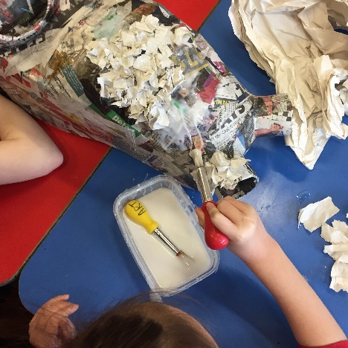
- You could add textured skin by glueing on dried lentils, chickpeas, pasta, etc.
- Then the head needs to be painted. What colours will you use? Try experimenting with using brushes, sponges, spatulas, etc. Mix your paint with PVA and water it down a wee bit so that you can build up layers of glazes, giving the finished colour more depth and richness.
- Could you build the head using as much recycled materials as possible?
The dragon’s body
- You could commit to making just the dragon’s head, which could only be worn by a single person at any given time. Or you could go on to make a body, so that multiple people are needed to make this dragon come to life! The body could simply be a long strip of fabric which could be carried by a few pupils and attached to the headdress wearer in the same way as a cape.
- Think about what fabric may be used for the body. The children may have already given some direction to this as a result of previous sensory activities exploring different fabrics.
- Will your dragon have wings? These may involve being operated by yet more pupils, making bringing this creature to life a real group effort. What should these wings be made of? Feathers? Transparent fabric? Recycled plastic bags?

The dragon’s tail
- Then finally there is the tail at the very end. This could be made very sensory with bells, ribbons and braids attached. It could be stuffed, maybe with dried pulses so that it has a bit of weight to it. It could also have something crinkly in it so that it has a sound when it’s touched.
- If this is too elaborate, it could simply be a dragon-tail-shaped piece of fabric attached to the end of the body, maybe left to drag along behind the dragon, over the laps or feet of an audience.
Uses for the dragon
- The dragon could be decorative, maybe designed to be hung in a hall or library.
- It could be a great big multi-sensory prop or toy which could be used for storytelling and stimulating the imagination.
- It could be a costume to be worn by multiple pupils, to act out stories and adventures in far off lands.
- It could be all of the above!
Dragonettes- little dragons
- If you don’t have the space for a big dragon, or you feel that making one this size is too much of a commitment, or maybe the children are bursting with lots of different ideas, then they could always make individual sock puppet dragons. Dragonettes!
- In this way they could play with their own individual ideas, decorating their sock with scraps of fabric, paper, wool, threads, pasta, chickpeas, mini pompoms, buttons, the list is endless!!! A latex based glue (such as Copydex) is good for this activity because it dries quicker and doesn’t soak through materials as much as a PVA glue does. Be careful though, as it does not wash out of clothes!

A celebration: hear the dragon’s roar!
Once you have created your big dragon or lots of little sock-dragons, you could use it/them to have some fun and encourage the children to make up their own dragon stories. Activities can be adapted to the capabilities and interests of the children.
- Sensory play: Travel from the head of the dragon down to the tail and gradually discover all the dragon’s textures and sounds and smells.
- Storytelling: Use the dragon to explore character development and create a narrative. How would you describe the dragon, eg happy, sad, lonely, bored, angry, shy, etc., Why is the dragon like this? Where does it live? Does it have friends? Might it go on an adventure or a journey? Why? Is it a dangerous journey? Etc. etc.
- Drama activity: Perhaps act out your story in the classroom. Maybe make simple masks for other characters from paper plates, or use toys as other actors.
- Discussion: Do other cultures and countries have their own dragon stories and traditions? Do their dragons look like your school dragon or are they different?

Project resonance and longevity: long live the dragon!
By creating a sensory box of dragon-themed props, children can repeatedly return to, play with and explore this topic and it is also a resource that can then be shared amongst teachers and parents/carers. It is a great way for children to familiarise themselves with the idea of dragons and imaginary creatures, build up confidence within those who may at first be wary of trying or touching new things and encourage sharing within the group as props are passed around individuals.
Your box may contain -
- A very loose outline of a story as a means of introduction, perhaps a laminated printout. For example, ‘Once upon a time a long time ago there live a dragon called (blank). (Blank) the Dragon lived in a cave/burrow/underground just outside of (name of the town/city/place you’re in). (Blank) the Dragon liked to…..etc., etc.
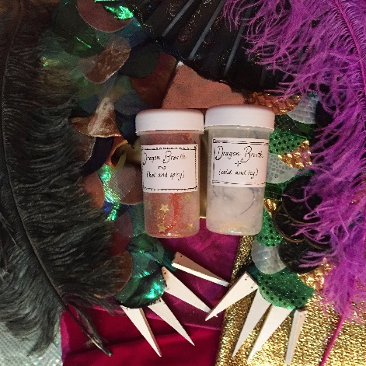
- A selection of textured fabrics, fur fabrics, feathers - use to explore concept of scales and how the dragon’s skin, fur or feathers might feel like
- Big ostrich feathers - great for tickling hands and cheeks and also moves beautifully
- Smelling jars for the dragon’s breath
- A big papier-mâché egg - where do baby dragons come from?
- A selection of small musical instruments, eg. bells, castanets, drum. - the sounds of stomping dragon feet, clacking claws and teeth, fluttering wings.
- A piece of gauze fabric, or another transparent material - can be wafted above heads to simulate wings beating.
- Sleeves cut from an old jersey, with fabric scales stuck to them. One could have smooth scales and the other rough? Or one could have cold colours and the other hot. You could attach cardboard claws to the end?

Book list: the dragon’s library
An Illustrated Treasury of Scottish Folk and Fairy Tales written by Theresa Breslin and published by Floris Books
An Illustrated Treasury of Scottish Mythical Creatures written by Theresa Breslin and published by Floris Books
An Illustrated Treasury of Scottish Castle Legends written by Theresa Breslin and published by Floris Books
The Worst Princess by Anna Kemp and Sara Ogilvie
Sylvia and Bird by Catherine Rayner
The Trouble with Dragons by Debi Gliori
There is no Dragon in this Story by Lou Carter and Deborah Allwright
Jill and Dragon by Lesley Barnes
The Knight who said No by Lucy Rowland and Kate Hindley

