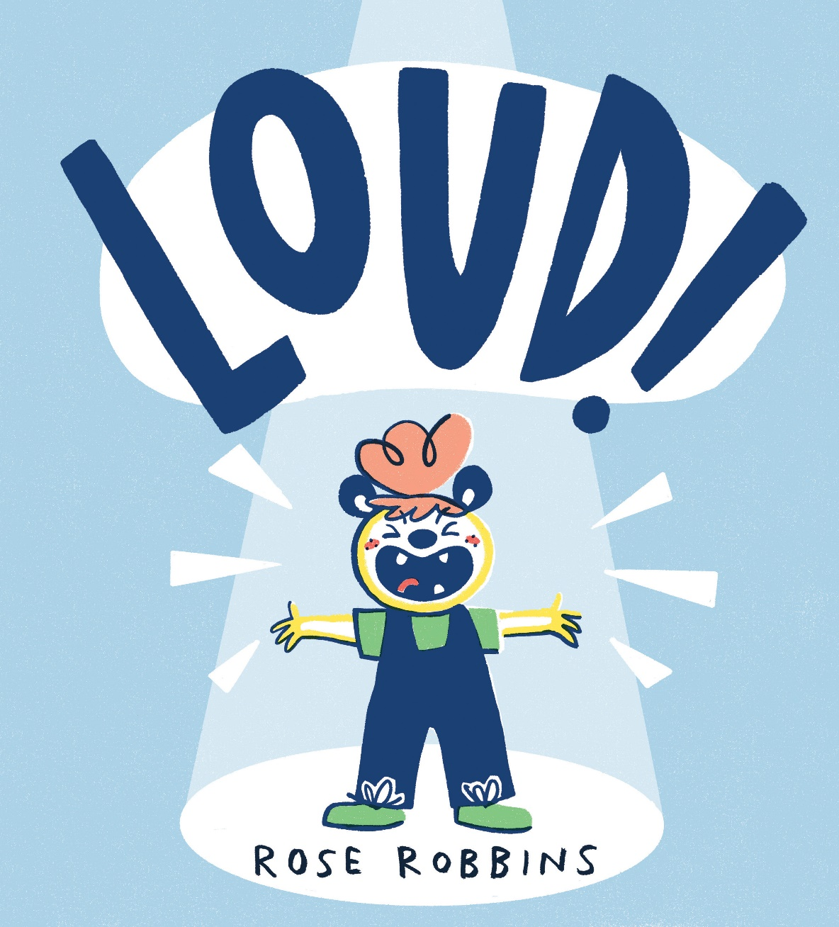

LOUD! sensory storytelling

Age 3-18 (all ages)

CFE Levels First to Fourth

A resource to support sharing the picture book LOUD! as a sensory story
Resource created by
Rose Robbins

scottishbooktrust.com

Contents
How to use this resource 1
Story and actions (by page number) 2

How to use this resource
LOUD! is a picture-book full of sounds and textures, making it perfect for sensory-storytelling. Use the recommended props and actions described in this resource to bring the book to life for all ages and abilities. Feel free to adapt this guide to suit the individual needs of the children that you are working with (e.g. swapping relaxing music sound effects for a hand massage).
Props and stimuli:
- A copy of the book LOUD! by Rose Robbins.
- Pens/pencils/crayons
- Paper stationary
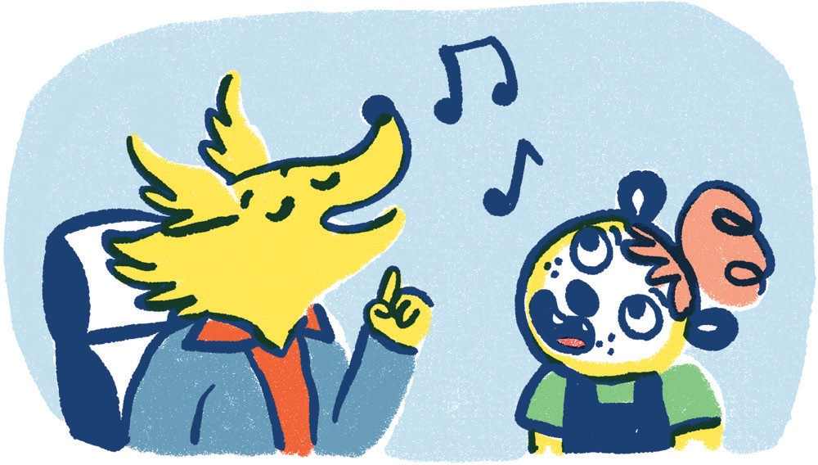
- A wig or hair extensions
- Percussion instruments or noisy objects
- Cardboard box
- Sound effects (can be found on YouTube, search: children’s orchestras and noisy classrooms)

Pages one and two

It wasn’t a good day. Abigail was restless. She didn’t want to do writing.

Actions: Play sound effect of noisy classroom, give pupils pencils/pens/crayons/paper to handle.

Pages three and four

She wanted to do scribbling… and fiddling with her hair… and fiddling with Lottie’s hair! Lottie didn’t like it but Abigail thought it was funny.

Actions: Let the child feel the texture of the wig/hair extensions to mimic Abigail.

Pages five and six

Teacher wasn’t pleased. Abigail was taken to the calming down room.

Actions: Play sound effect of calm music.

Pages seven and eight

The lady in the calming down room was kind but Abigail did not feel like talking.

The next class was music. She had never been to a music class before…

Pages nine and ten

She was LATE. “There you are Abigail! Come and join us,” said Miss Butler. She didn’t seem cross at all.
“Choose any instrument you like.”

Actions: Give the child the cardboard box with a selection of percussion instruments/noise making objects to feel and explore.

Pages eleven and twelve

Lina was playing the recorder. She was Brilliant! “I’ll never be as good…” thought Abigail.

Actions: If you have a recorder or whistle to hand, use this to mimic the playing of Lina and Abigail, alternatively you could whistle or use sound effects.

Ruby was drumming a beat all of her own. She had terrific rhythm. Abigail just couldn’t keep up.

Actions: Using either a drum or a solid surface, mimic the drumming in the story. Encourage the children to join in.
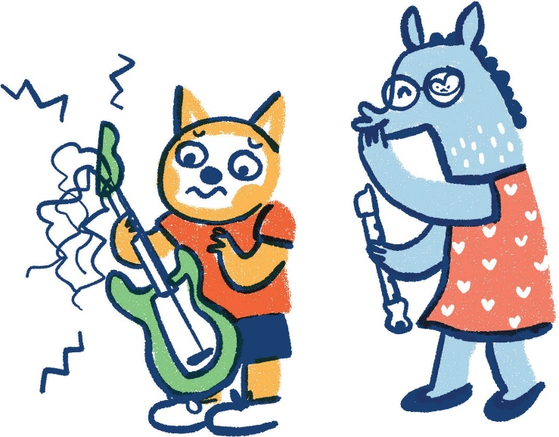

Pages thirteen and fourteen

The guitar looked fun but the strings hurt Abigail’s fingers. Rex didn’t care! He played it like a pro.

Actions: If you have a guitar or string instrument you can use these to mimic Rex and Abigail, if not, use sound effects or carefully use elastic bands/ hair ties as strings.

Abigail wanted to join in… but she didn’t know how to.

Pages fifteen and sixteen

So she opened her mouth and SCREAMED!

Actions: Switch off any sound effects at this point, and make screaming noises (being mindful of students who may be sensitive to such sounds).

Pages seventeen and eighteen

UH-OH Miss Butler was coming over. “Back to the calming down room,” thought Abigail.

Actions: As Miss Butler is a wheelchair user, you could use a small wheeled toy (you can get miniature toy wheelchairs, which would be ideal) to roll over children’s arms or across the floor/desk.

Pages nineteen and twenty

But instead, Miss Butler smiled. “Wow, Abi!” she said. “you have such a strong voice! You’re a natural born singer.”

“Ooh! We need a singer for our band,” said Ruby. “Will you join us?” Abigail could have BURST with pride!
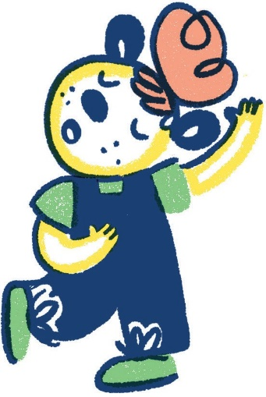

Pages twenty-one and twenty-two

And suddenly, Abigail DID want to write. She wanted to write what she wanted to sing. Miss Butler helped her to choose the words.

Actions: Allow children to explore paper and pens/pencils. (This could also be the prompt for a separate song writing activity).

Pages twenty-three and twenty-four

So they started jamming and singing and this was their song…

Actions: Play Abigail’s song from the Scallywag website, either sound only or the animated music video. The children can sing along, or make up their own tune/words.

Pages twenty-five and twenty-six

They practiced and they practiced and they practised.

Actions: Encourage children to play with the percussion instruments, or play to them.

Pages twenty-seven and twenty eight

So when it was time for the school talent show they shone like STARS

Actions: Everyone applauds.

Pages twenty-nine and thirty
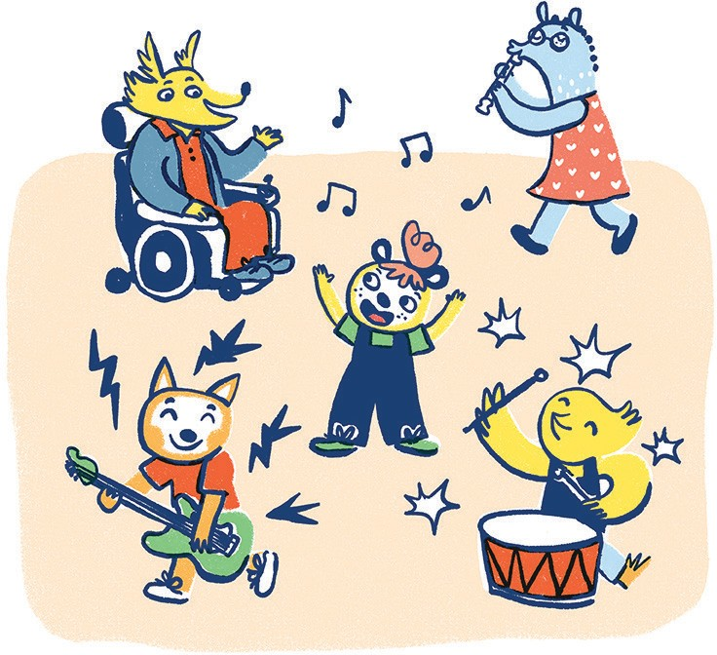
How COOL is that?!

Actions: End.

