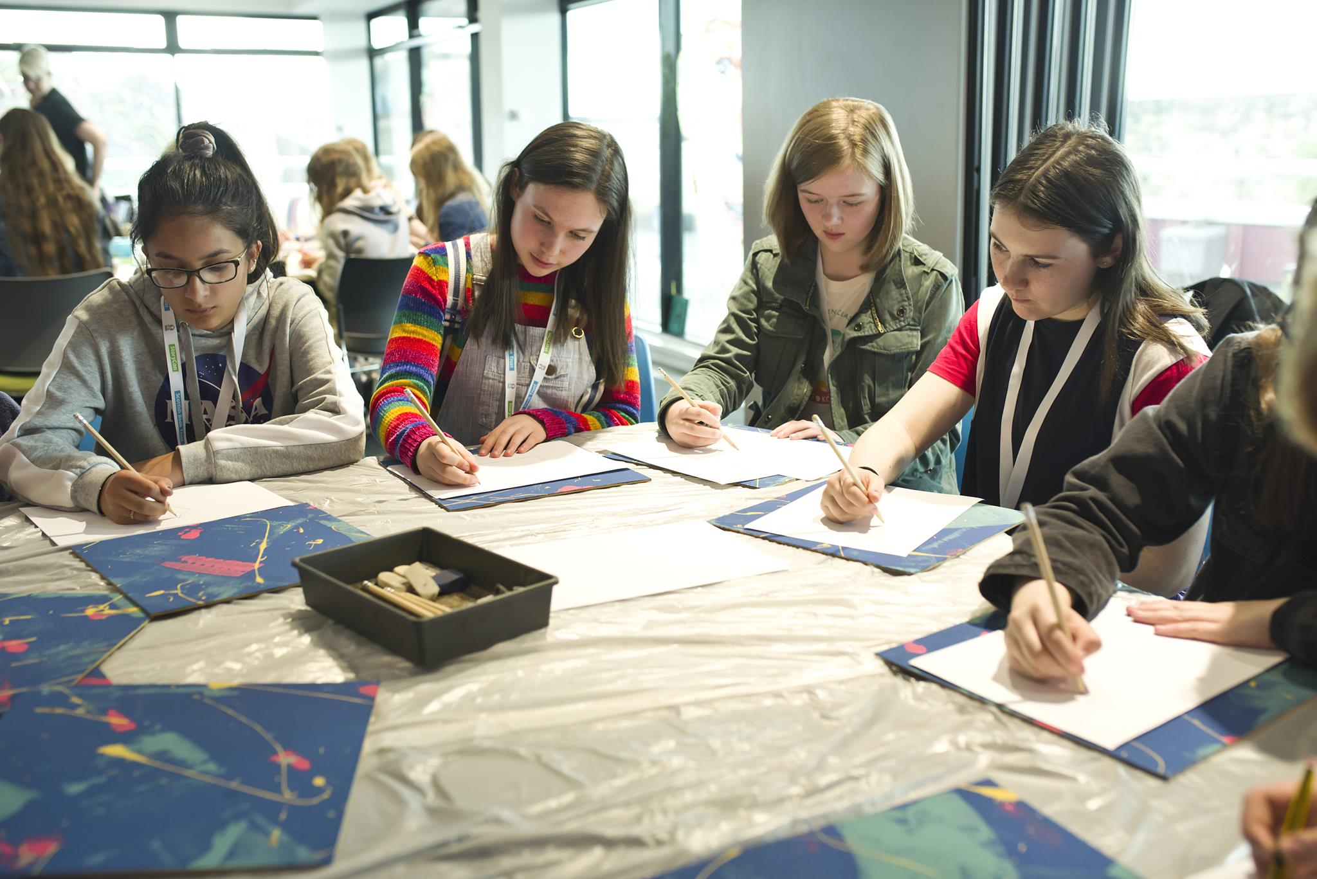

Creative Writing in Scots
Age 12-18

CFE Levels Third, Fourth and Senior Phrase

Resource created by Liz Niven

Resource to support introducing and writing in Scots in the secondary classroom
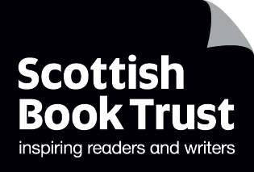

scottishbooktrust.com

Contents
About this resource 1
Section 1: Talking, Listening, Reading 2
Activity 1: Learning about Scots language 2
Activity 2: The History of Scots 2
Activity 3: Listening to Scots 4
Section 2: Writing 5
Activity 4: It’s aw aboot me 5
Activity 5: ‘Naw it wisnae’. ‘That’s no whit happent’. ‘it wisnae me’ 5
Activity 6: Writin a review 6
Activity 7: Dialogue and narrative choices 7
Activity 8: hold a Scots class or school event 7
Further reading and website 8
Further reference: teachers and upper secondary 8

About this resource
This resource will primarily be relevant to English departments but may also support other secondary departments who are engaging with the Scottish Studies Award, as well as Teachers and staff wishing to increase their knowledge about Scots.
A brief background to the language is included, with references to sources for wider reading. Unlike the English language, there are various dialects of Scots. These activities can be tailored to the dialect variation of the school community. Additionally, activities can increase knowledge of Scottish speech beyond the local area and provide greater familiarity with the literature of a wider range of Scots.
The activities are not sequential and can be approached as standalone work. However, it may be useful to begin with a discussion about what contemporary Scots language is and how it has developed.
Activities include reading, writing and speaking in Scots and cover a variety of outcomes for Talking and Listening, Reading and Writing for the Curriculum for Excellence. All activities aim towards:
‘Enhancing skills in literacy, developing successful learners and confident individuals’.

Section 1: Talking and Listening, Reading
Activity 1: Learning about Scots language
- At home and school, you can hear Scots voices. Listen to the voices carefully.
- Are they all the same?
- What are the differences? Different words or different accents?
- In groups, note down any words you think might be Scots. Include words you think are not Scots but are not English either. Sometimes people use the word ‘slang’. Even if you’re not sure what that means, or what the words are, include them in your list.
- With the whole class, compare your lists and discuss the vocabulary you have chosen. Write them on the whiteboard so that everyone can see them. You might choose to list them in columns with headings. Scots or slang. Or Don’t know.
- Using Scots dictionaries or online dictionaries (see sources below) search for the words you have gathered. How many of them appeared in the dictionary as Scots words? Did any of your ‘slang’ words actually appear in the dictionary? Slang words are continually changing but most Scots words have been around for hundreds of years. Sometimes Scots words are called slang words by people who don’t know they are actually Scots.
- Rewrite your words into the columns now.
- You might have noticed that some words have different spellings. One might be yin, ane or wan. Scots, unlike English doesn’t have a standardised form. Years ago, English didn’t either until one form was agreed on.
- Discuss how you feel about your own language. Do you speak the same all the time or do you change the way you speak? If so, why?

Activity 2: The History of Scots
- Divide into two groups
- One group read about the history of Scots (see Information One below)
- Another group read about the different dialects of Scots with examples (see Information Two below)
- Next, link up a pupil who has read about the origins of Scots, to a pupil who has looked at the dialect variations. Explain to your partner what you have learned.
- Make a large version of the dialect map for the classroom wall. Find words from different dialects and parts of the country and pin them next to the location on the map. Poems from various dialects are available on websites including Scots Language Centre and Education Scotland. You may also have books in your English Department such as The Kist/A Chiste which has a range of poems from all over the country.

Information One: Learning about the history of the Scots language
Scots is a European language like French or German. It has official status as a European language.
Around 450AD the language of the Angles and Saxons arrived in Britain from Germany and made its way across England and into Scotland. By the 11th century Anglian was spoken in the north of England, southern and central Scotland. It began to be called Inglis. Visitors to Scotland over the centuries brought words from Latin, Dutch, French and Scandinavian. Words like, Janitor, pinkie, braw, lass, lug. While Gaelic was brought from Ireland and became the main language in the Highlands and Galloway, some Gaelic words became part of Scots. Whisky, bens and glens.
By the early 16th century, the language was called Scots and was used among the people, the parliament and the royal court. It was the national spoken and written language of Scotland. Many plays, poems and documents were written in Scots.
Three main things happened that made more people want to learn English as well as or instead of Scots.
- The Geneva Bible was translated from Latin into English instead of Scots in the 16th century.
- King James 6th of Scotland became King James 1st of England when the Union of Crowns happened in 1603. He went to live in London and began to speak more English.
- In 1707 the Union of Parliaments meant official documents started to come out in English instead of Scots.
The ordinary people of Scotland continued to speak Scots as they still do.
Scots is a language with many dialects.
‘The special characteristics of Scots – its linguistic distinctiveness, its occupation of its own ‘dialect-island’ bounded by the border, its individual history, its own dialect variation, its varied use in a remarkable literature, the ancient loyalty of many Scottish people to the notion of the Scots language, as well as the fact that since the sixteenth century Scots has adopted the nation’s name – all of these are attributes of a language rather than a dialect. Manifestly Scots is to be seen as much more than simply another dialect of English’. (from Dictionaries of the Scots language)
Scots is a modern language and, like other languages, continues to add new words. E.g. sitooterie/patio, high-heid-yin/the boss.
More detailed histories of the Scots language can be found at the Scots Language Centre.
Information 2: Dialects of Scots language
You might look at some poetry in different dialects on the Scots Education website.
A good dialect map can be found online by the dictionary of the Scots language at Dictionaries of the Scots Language or via the Scots Language Centre.
There are lots of names for the different dialects such as Doric, Lallans, Buchan, Glaswegian, Shetlandic, Dundonian, Gallovidian. Can you think of others?
The main dialects of Scots
Since the 1870s, the 4 main dialects are called Insular, Northern, Central and Southern. The Scots Dictionary divides them further into 7 main dialect areas. North East, Central, South, North, East Central, West Central and South West.
Which part of Scotland is your school in? Which dialect area is this?
Like all languages, Scots isn’t only made up of different words from English. It has its own grammar, prepositions like ‘but’ at the end of a sentence, and pronunciation (stane not stone), as well as vocabulary (wean not child).

Activity 3: Listening to Scots
After researching Scots dialect and history, and talking about familiar Scots words, now is a great time to encourage pupils to listen to Scots language. You could listen to different dialects and discuss the similarities and differences, and what sounds familiar to their lives.
- The Scots Language Centre recommends a range of prose and poetry to read and hear in Scots.
- You can explore each region of Scotland to hear poems and people talking in dialects on the Main Dialects section of Scots Language Centre.
- The Scots Language Centre learning section has a range of videos that features a variety of dialects.
- Listen to Bletherin Scots BBC progamme. In this episode, you can hear people talk about the weather in Scots, and hear different voices in Scots.
- Watch Ross Sayers read an extract from his teen novel in Scots Daisy on the Outer Line. The event was filmed in partnership with Scottish Book Trust and BBC Scotland Digital Learning. You can watch the full event on our On Demand Library.

Section 2: Writing
Activity 4: It’s aw aboot me
In 1785, Robert Burns, Scotland’s most famous poet, wrote:
O wad some Power the giftie gie us
To see oursels as ithers see us!
You’ve probably seen or heard this quote before. Although it was written in the 18th century, some of the Scots hasnae changed intae the 21st century.
If only we could see ourselves the way other people see us. It’s a bit like Facetime or Zoom or What’s App. Sometimes in yer ain heid ye feel different fae how ye look.
- Think aboot yerself. Think aboot yer physical looks – yer heid, yer herr colour, are ye big or wee?
- Think aboot yer personality. Are ye shy an timorous, or a wee bit o a bully, or jist a genius at makin pals?
- Think aboot yer character. Ur ye honest? Dae ye tell lies? Ur ye a safty or a strang character when things gan wrang? Dae ye get fed up a lot?
- Think aboot yer hobbies, whit ye’re guid at or whit ye’re rubbish at. Whit dae ye like daein?
Write a description o yersel. It micht be how you see yersel as weel as how ithers see ye. The twa might no be the same.
Use as much or as little Scots as ye like.

Activity 5: ‘Naw it wisnae’. ‘That’s no whit happent’. ‘it wisnae me’
Imagine a situation where three folk are involved. Two of them are brother and sister and they’re talkin tae thir mum or dad.
It might be an accident, a stooshie in the hoose, somethin’s got broken, the dug’s got lost on a walk etc. You decide. Yer parents are scunnert wi ye aboot somethin and cannae thole it onie langer sae they’ve got youse in tae talk. ‘Ye’re nippin ma heid’.
The brither an sister are each explainin whit happent bit they’ve got different explanations an cannae agree oan the truth.
- Write a conversation where each o them explains tae the parent whit they think really happent. ‘Naw it wisnae like that. This is whit happent.’.

Ye might include whit the ma or da says at the end. An instruction tae go an dae somethin?
While ye’re writing, dinnae worry ower much aboot aw yer words bein in Scots. Even jist a few words that ye ken, like mankie, mingin, scunnert, dreich, wee, argie-bargie will mak yer dialogue sound mair Scottish.
In Activity 1 there’s a note to say that Scots doesn’t have a standardised form of spelling, so you might have a few choices in the way you spell words.
An thir’s lots o grammar Scots uses that we dinnae really think aboot as different fae English. We say pinkie instead of little finger, we say ‘A’ve got the flu’ and not ‘I’ve got flu’. Has the bell went? Awa an ask the jannie whit he thinks aboot it.
Think aboot yer ain and ithers roon aboot ye. Hiv a guid listen when ye’re oot an aboot, oan buses, in shops at hame.

Activity 6: Writin a review
Work with a partner.
Ask yer partner aboot a television programme they watcht last nicht. Listen carefully tae whit they say and write it doon jist they wey they say it.
Show yer notes tae yer partner. Read them oot tae her/him. Discuss they wey ye’ve chosen tae spell words. Dae ye baith agree? Or wid ye huv picked a different wey tae write it doon?

Activity 7: Dialogue and narrative choices
Read the following examples of Scots prose.
‘Jill comes intae the livin room, shruggin her backpack on tae her shooders.
‘Why urr ye up so early?’ she says.’If ah didnae huv work ah’d be sleepin til twelve at least.’
‘Ah’ve got a plan,’ ah say, slurpin a mouthful ae Frosties. ‘Aw, Frosties urr so underrated, man. Ah’ve no hud them in ages.’
‘Really?’
‘Aye, ah usually huv Cheerios.’
‘Naw, ah meant, ye’ve really got a plan? Whit is it?’
Ah tap ma nose, then continue rubbin the skin. Rose hasnae gor her nose pierced, and ah miss the wee indent ae the hole under ma fing’r.
‘It’s a secret,’ ah say.
(from Daisy on the Outer Line by Ross Sayers (Cranachan, 2020))

Because Ross Sayers has his central character, Daisy, tell the story, his narrative language is also in Scots.
Look at the dialogue and the narrative. Are they both in Scots? Is only one of them in Scots?
The following narrative:
‘Ah tap ma nose, then continue rubbin the skin. Rose hasnae gor her nose pierced, and ah miss the wee indent ae the hole under ma fing’r’.
Could have been written like this:
‘I tap my nose, then continue rubbing the skin. Rose hasn’t got her nose pierced, and I miss the wee indent of the hole under my finger’.
What difference does it make, if any, by having one or both in Scots?
- Write a short paragraph, using Scots in the dialogue, or narrative, or both. Write it as you might speak or hear it around you. You might imagine a breakfast scenario like the one above where two people are speaking to each other in Scots. Write it just as you might speak or hear it spoken around you. The main task here is to try writing in Scots, not to worry too much about creating a terrific piece of creative writing!
- If you just want to practice your Scots, without creating a new piece of writing, choose a book in the classroom with dialogue and narrative and translate a few paragraphs.

Activity 8: hold a Scots class or school event
Wall display: gathering together written work, poetry, translations and illustrated work, create a collage of new work in Scots. Pupils struggling to produce new work might include favourite Scots poems to display.
Performance event: showcasing the new work can take the form of an event to the class, to other classes or to a whole school concert. Burns Night and St. Andrew’s night are frequently occasions for celebration of Scots although any time of the school term can provide a suitable occasion.
Publication: put together a pamphlet of new Scots work to distribute to parents or raise funds for future class activities or buying new Scots books.

Further reading and websites
- Video of an animated history of Scots language
- Education Scotland Keen tae Ken yir kin resource and activities
  - It is designed to 'twin' classes from different areas of Scotland for learners to share their experiences of and in Scots language.
- Education Scotland resources and video on the history of Scots
- SQA Scots language blog
- The Scots Language Centre (based in Perth)
- Dictionaries of Scots language
- Scots language app for schools
- Scots Language Pack. Dumfries & Galloway Education Dept.
- Scots in Schools
- Scots book recommendations for 9-14 year olds

Further reference: teachers and upper secondary
- Creative Scotland Scots Language Policy (June 2015)
- Scottish Education: Fifth Edition: VII The Scots Language in Education by Anne Donovan and Liz Niven
- Creative Scotland Introduction to Scots languages and resources
- SQA Scots Language Award
  - This award is available at SCQF levels 3,4,5 and 6
- SQA Scots language blog
- The Scots language in education in Scotland: Mercator European Research Centre on Multilingualism and Language Learning
- Education Scotland Scots language in the Curriculum for Excellence: Enhancing skill in literacy, developing successful learners and confident individuals (August 2017)
- Education Scotland Briefing Curriculum for Excellence: Scots language
- Open University and Education Scotland courses in Scots and Scottish Culture
- Scots book recommendations for 15-18 year olds and adults

