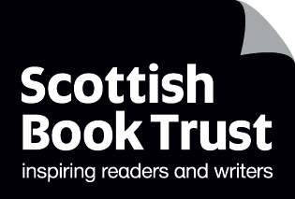
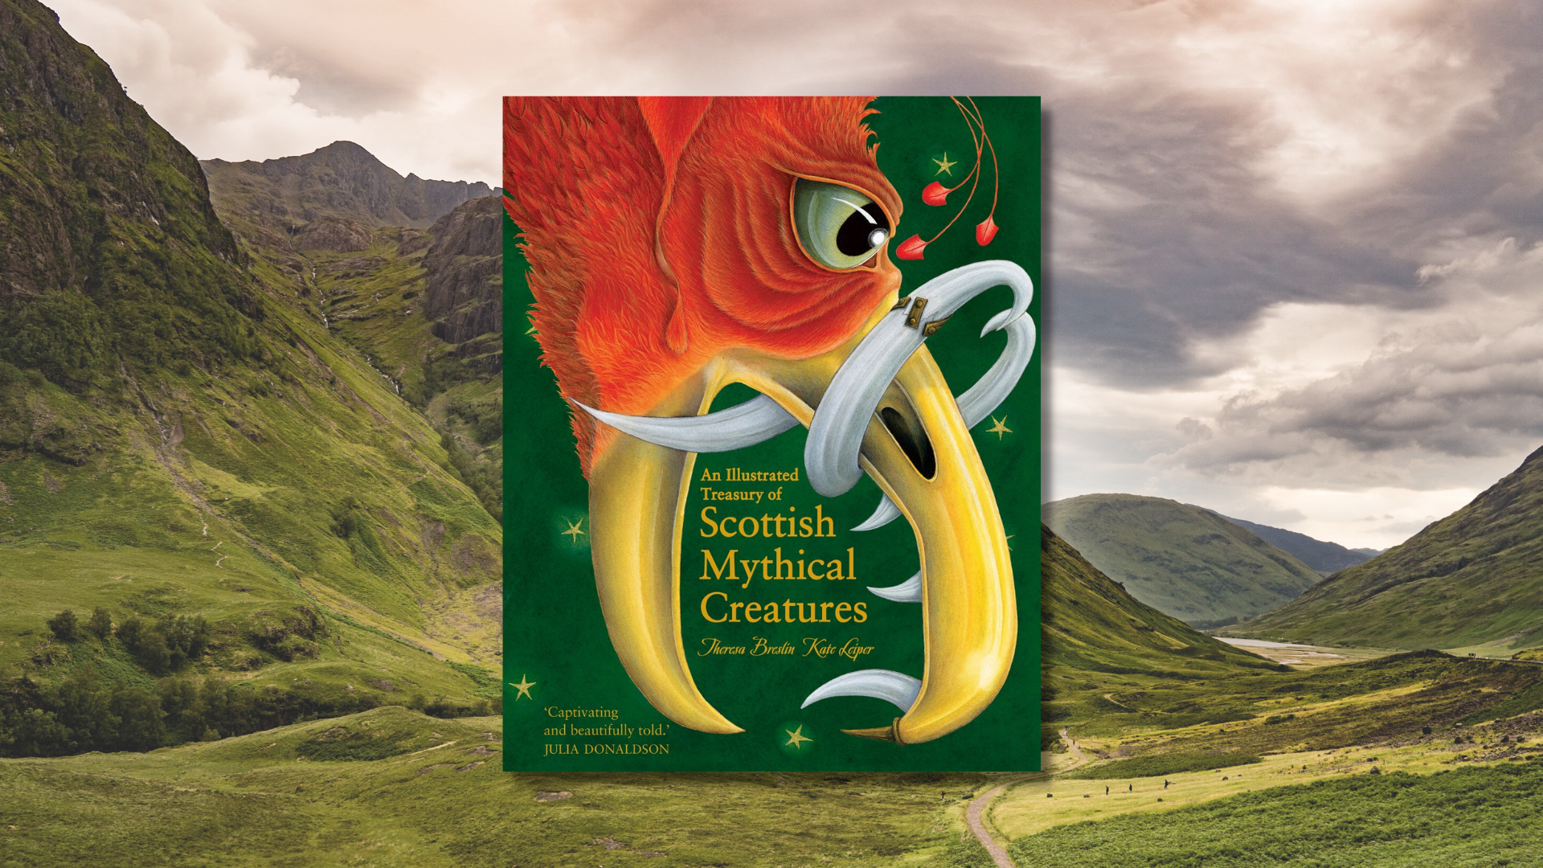

Scottish myths and legends learning activities
Cross curricular learning activities for An Illustrated Treasury of Scottish Mythical Creatures by Theresa Breslin, illustrated by Kate Leiper

Age: 6-12
CFE Second Level
Resource created by Scottish Book Trust

scottishbooktrust.com
Scottish Book Trust is a registered company (SC184248)
and a Scottish charity (SC027669).

Contents
About this resource 2
Learning activities 2
Quick activities 9
Further resources 10

About this resource
This resource contains learning activities across the curriculum for An Illustrated Treasury of Scottish Mythical Creatures by Theresa Breslin, illustrated by Kate Leiper. This resource should be used alongside our downloadable PowerPoint on the website.
The main focus of the learning resource is to develop learner’s understanding of myths and legends, as well as cross-curricular activities that tie into history, science, social studies and religious, moral and philosophical studies as outlined in Curriculum for Excellence.

Learning activities

Pre-reading activity
LIT 2-08a
Explain to the pupils that you’re going to read some Scottish myths and legends. Ask if anyone knows what a myth or a legend is, and if they have any they can share.
Download the accompanying lesson PowerPoint to explore the difference between a myth and a legend. Read through the definitions together and complete the sorting activity (up to and including slide 18).

Activity 1: Legends and lighthouses
LIT 2-04a, SOC 2-04a
This activity involves learning about the difference between myths and legends, as well as learning about the real history behind the Bell Rock Lighthouse.
Read the story “The Mermen of the Bell Rock” together and ask the pupils to use the definitions from the PowerPoint to identify what they think in the story is a myth (mermen) and what is a legend (the Stevensons, Bell Rock Lighthouse). You can revisit slide 7 to give them some help.
Explain that we can also research history to try and think about what is a story or what is historical fact. Visit the National Library of Scotland website to look at images of the Bell Rock Lighthouse. You can also read the story of the pirate Ralph the Rover which tells the legend of the Abbott who gave Bell Rock its name, and the pirate who stole the bell.
Ask the pupils to draw a line down the middle of a piece of paper to create two columns and label them “history” and “story”. Ask them to go through the story again and write a list of what happened in history and what was created for the story.
Some examples are:
History | Story
The lighthouse was difficult to build because it was only uncovered for a few hours a day | Mermen removed the bell from the rock
The rock is called Bell Rock because of a legend about an Abbott tying a bell to the rock to warn sailors | Mermen are harmed by light, including lighthouses
Robert Stevenson did build lighthouses | Robert Stevenson was told to build the lighthouse by a woman called Catriona
Robert Stevenson did have a boat called The Smeaton | Thomas, Robert’s son, loved telling stories
Robert Stevenson was Robert Louis Stevenson’s grandfather | Catriona and her grandmother saved the engineers with a fishing net

If you want to extend this idea, you could research how lighthouses are used today and what it’s like living alone in one for long stretches of time.

Activity 2: Selkies and ships
SOC 2-09a, SOC 2-12a, SCN 2-02a, MTH 2-17d
This activity looks at how myths can spread across different countries and cultures, as well as linking selkies to real grey seals and how people travel both now and in the past.
Use slides 19 to 23 from the PowerPoint to explore how myths can travel between different areas or countries. Read the story “Gillon and the Selkie” together and then show the map on slide 24.
Explain how the word “selkie” comes from the Scots “selch” which means “grey seal”. Visit the Wildlife Trust’s webpage on grey seals to look at pictures of them. There is also a short video you can watch (1 minute, 35 seconds) that shows footage and facts about grey seals.
Now look at the IUCN’s map of grey seal habitats and compare it with the countries and islands that have a selkie myth. Ask the children why they think there’s an overlap? Although there are various origins of the selkie myth, it makes sense that all of these countries and islands would have their version of the story, as people living there would be familiar with seals.
Research the different seal habitats with the Wildlife Trust website, and compare the different countries coastlines. What do they all need to support the seal population living there? What do they eat? What are seals main threats?
Use a map to measure the distances between two of the locations (e.g. Orkney and Shetland, or Iceland and the Faroe islands) and research how people can travel between these countries or islands. Ask the pupils to write a pro and con list of the different forms of transport considering:
- How long they take
- How much they cost
- Their impact on the environment
You can use the following websites for more information:
- NorthLink ferries (Orkney, Shetland)
- How to travel to Shetland (Orkney, Shetland)
- How to travel to the Faroe Islands (Faroe Islands, Iceland, Orkney, Shetland)
- How to travel to Iceland (Iceland, Faroe Islands)

If you want to extend this, you could also look at how the Vikings travelled to all of these countries and islands, the routes they took and learn about their longships.

Activity 3: Meanings and morals
RME 2-02b, RME 2-04c, HWB 2-05a
This activity looks at the meanings behind stories, linking the myth of the Wee Folk into the idea of The Golden Rule across religions and philosophies.
Explain that because myths were often used to explain things that people couldn’t always explain, they often have a moral – a lesson that the listener can take away and apply to other situations. Read “The Wee Folk of Merlin Craig” together and ask the children for their initial thoughts.
- What is the lesson of this story?
- Who acted kindly? Who acted unkindly?
- Who has a happy ending and who has an unhappy ending?
Go through slides 25-34 of the PowerPoint together looking at the moral of the story. Explain that the moral of this story is one that is also found in a lot of religions and is sometimes called The Golden Rule. This rule says we should treat others how we would like to be treated. It can be found in religions including Christianity, Islam, Judaism and Hinduism as well as a lots of forms of philosophy.
Split the classroom into groups and ask them to discuss how someone who followed The Golden Rule might behave in each of the following situations:
- Example 1: You’re eating a packet of crisps at the park with your friends. You finish the bag, but can’t see a bin nearby.
- Example 2: You see someone being bullied at break time. You’ve never met them before, but they seem upset.
- Example 3: You really want to borrow something from your sibling, but they aren’t home at the moment so you can’t ask them.
- Example 4: You promised a friend you’d go to their house with them after school, but you’ve just remembered you’re going to visit your grandparents.
- Example 5: You realise you’ve accidentally broken something your Dad let you borrow.
Allow everyone to share their answers. Then have a class discussion to tie it back into the story:
- Who in the story, if anyone, obeyed The Golden Rule?
- How would The Master have acted if he was obeying The Golden Rule?
- Does The Master owning the land mean he has the right to do what he wants with it, including destroying someone else’s home?
- Is it right for The Master to force Dougal, his employee, to do something he thinks is wrong?
- The Master’s punishment for destroying someone else’s home is to lose his in turn. Do you think that punishment is fair?

Activity 4: Lochs and landscapes
SOC 2-07a, SOC 2-14a, SCN 2-05a, MTH 2-17d
This activity looks at the formation of Loch Ness during Scotland’s Ice Age, and how Loch Ness’s size has led to the myth of a Loch Ness Monster, as well as looking at misinformation and fake news.
Read “The Monster of Loch Ness” together. Explain that Loch Ness is a real place (if you don’t live nearby!) and ask if anyone has visited. Use the Visit Inverness website to look at Loch Ness through their various live cameras – see if you can spot Nessie!
Learn about how Loch Ness was formed together as a class. Loch Ness was formed by glaciers during the Ice Age roughly 22,000 years ago. Use the National Geographic website to look at images of glaciers and learn key vocabulary.
You can use the BBC Geography video (3 minutes, 55 seconds) on YouTube to look at how glaciers shape the landscape through erosion and abrasion. You can also use the University of Sheffield’s interactive map to look at the effects of the Ice Age on the landscape on Scotland.
Read through the Nature Scotland Ice Age webpage together and ask the children to create a timeline of the Ice Age in Scotland using a ruler to create a scale of the dates from 20,000 years ago until today.
Loch Ness’s depths show the extent of this glaciation in Scotland. In fact, Loch Ness contains more water than all of the lakes in England and Wales combined! Because of this, people think it is deep enough to hide a monster. Look at the famous “surgeon’s photograph” of the Loch Ness Monster from 1934 and discuss it with the class.
- Who thinks the image is real?
- What can we look for in a photograph to tell if it’s real or not?
- Does anyone know of any ways that photographs can be changed or edited?
- The photograph is from 1934 – before the invention and use of things like Photoshop or Deep Fakes. Does anyone know other ways that images can be changed?
Use our Misinformation and fake news resource to explore as a class what counts as a useful source of information, how sources can be edited or falsified and how misinformation spreads.
After your discussion you can look at the Britannica guide which shows how the surgeon’s photo was faked using a toy submarine.
Activity 5: Words and wulvers
ENG 2-03a, EXA 2-04a, LIT 2-06a, MLAN 2-07a
This activity looks at the different languages used in the myths, and asks pupils to compare myths from Scotland with other cultures.
Read “The Wulver” together. Ask the children if they’ve heard of a wulver before.
- Have they heard of any other half human/half animal creatures?
- Have they heard of any other mythical wolf creatures?
- What do wulvers and werewolves have in common?
- How are they different from werewolves?

Use slides 35 to 37 together. Ask the children to draw three columns. In one they write everything unique to wulvers, another everything unique to werewolves, and in the middle write down what they have in common. This could be elements from the story, as well as adjectives they could use to describe wulvers. You can also use the Kids Britannica webpage on Werewolves for some quick facts about them!
Ask the children to create their own half-human, half-animal mythical creature. They can base it on themselves and their favourite animal, or take inspiration from one of the other creatures in the book (selkies, mermen etc.)
Use slides 38 to 42 to learn about the story behind the word “wulver”. You can also look at the version on the Shetland Museum Archive website together and read the story.
Follow the activity on slides 43-45 to look at words in Scots and English and where they came from. Ask the children to guess where the words come from. Look up the different languages to look at them together on a map. Some of the words have travelled much further than others! On the notes of slide 46 you can also find a list of how these words changed over time.
For example:
- Penguin comes from Welsh pen gwyn meaning “white head”
- Sock comes from Latin soccus meaning “low-heeled slipper”
- Gloaming partially comes from gloom meaning “darkness”

Follow the activity on slides 47 and 48. Ask the children to pick a word and explain it to someone who doesn’t understand the word. They can do this in partners, or write it down.
Then look at the questing beast on slide 49 – can anyone guess what this animal is? Slide 50 will reveal that many historians think a questing beast was a giraffe – which shows how hard it can be to explain something to someone else!
Pick some words from the book’s glossary (page 191 to 193 of the Illustrated Treasury) and look them up together using Scots Language Dictionary to explore the meanings and history behind them. If you’re studying Gaelic, or another modern language, research if these words also exist in that language.
Have a discussion about which Scots words they recognise or use. For more activities using Scots, look at our resource Using Scots in your classroom. You can also watch our Authors Live of The Gruffalo being read in Scots and Gaelic.

Quick activities

Create your own mythical creature
ENG 2-31a
Write a story starring one of the mythical creatures in the book – or create your own!

Get storytelling
LGL 2-07a, EXA 2-01a
Use our Storytelling in schools resource to practice storytelling aloud.

Find your myth on the map
SOC 2-01a
Look up your own local myth on Folklore Scotland’s map by clicking on your local authority.

Further resources
- For more on using Scots in your classroom, explore our Using Scots in your classroom and Creative Writing in Scots resources
- For book recommendations we have book lists on Scots books for 6-8 year olds and 9-14 year olds, as well as Scottish books for 9 to 11 year olds
- Explore the fantasy genre of our Authors Live on Demand catalogue
- Use our How to Train Your Dragon resources including learning activities using the book and the film, as well as our Let there be dragons resource for children with additional support needs
- Use our resource to explore Ross Mackenzie’s fantasy novel The Nowhere Emporium with our The Nowhere Emporium learning activities and his Authors Live

