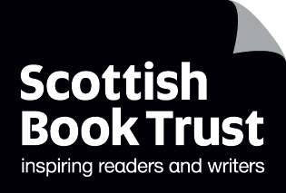
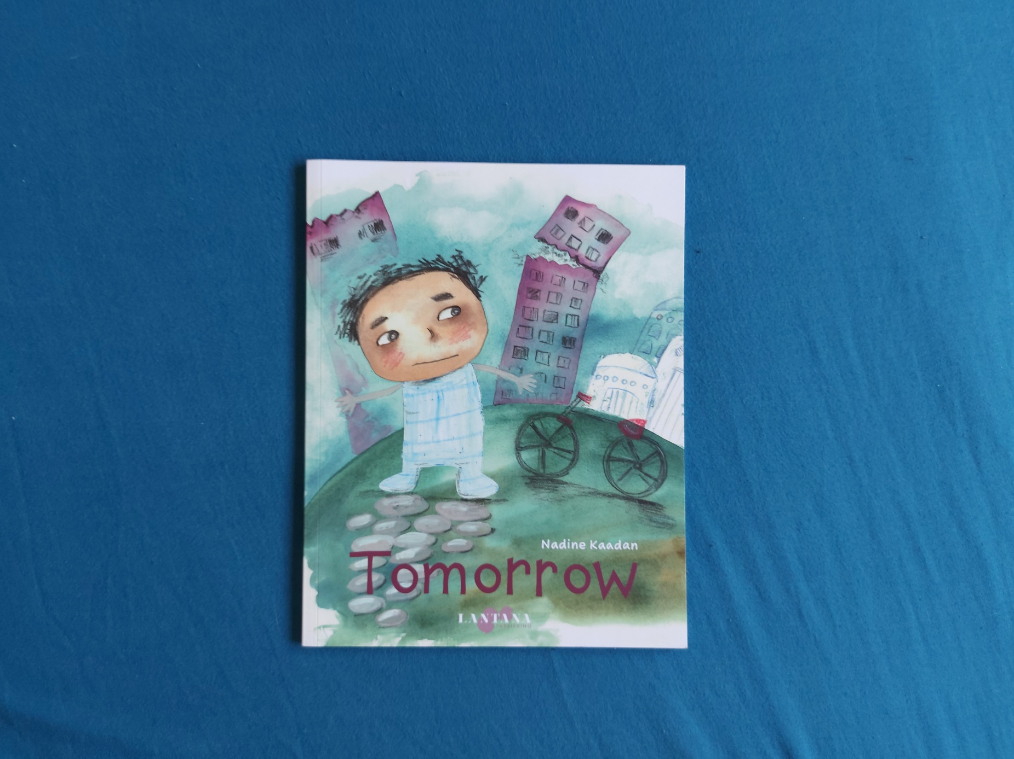

Read Woke: Tomorrow
Activity ideas to support classroom use of the book Tomorrow by Nadine Kaadan.

First and second level
Resource created by Scottish Book Trust

scottishbooktrust.com
Scottish Book Trust is a registered company (SC184248)
and a Scottish charity (SC027669).

Contents
Scottish Book Trust 2
Read Woke 2
Read Woke South Ayrshire 3
Learning activities 4
Further resources 9

Scottish Book Trust
Scottish Book Trust is a national charity that believes everyone living in Scotland should have equal access to books. Our work provides opportunities to improve life chances through books and the fundamental skills of reading and writing. Access to books and a love of books bring many important benefits from family bonding and advancing children’s learning, to unlocking creativity, helping employability and improving mental health & well-being. Scottish Book Trust aims to support all communities across Scotland, with particular focus on those who are vulnerable and under-represented.

Read Woke
‘Read Woke is a movement. It is a feeling. It is a style. It is a form of education. It is a call to action; it is our right as lifelong learners. It means arming yourself with knowledge in order to better protect your rights.’
- Cicely Lewis, Founder of Read Woke.
The Read Woke challenge was developed by Cicely Lewis in Georgia, USA in 2017. Motivated by the political climate and seeing students grapple with issues of social injustice daily, Cicely realised the need to empower them with knowledge. Knowledge about the issues they (and others) face and knowledge about their own rights. The aim is to educate children and young people through reading. Find out more on the Read Woke website.

Read Woke South Ayrshire
The Read Woke challenge was brought to Scotland in 2020 via the School Library Improvement Fund. A collaboration of South Ayrshire secondary schools created a book list and incentivised reading programme for S1–6 students with the aim of improving representation within library collections, celebrating diversity and encouraging students to be socially aware. Further backing from the Scottish Library and Information Council has allowed this work to be expanded into a primary school setting with Read Woke South Ayrshire Primaries launched in February 2022.
Providing carefully chosen books to schools – along with tailor-made resources and activities through the year – is allowing us to educate and empower students to engage with social justice issues and stand up for the rights of themselves and others. The resources produced will help schools embed themes of equality, diversity, social justice, and human rights throughout their curriculum from P1–7. Learn more on the Read Woke South Ayrshire website.

How to use this resource
Tomorrow is a picture book for 3-5 year olds by Nadine Kaadan, based on her own experience of living in Damascus and seeing local children who were unable to have the same freedom in their life due to conflict. The book follows a young boy called Yazan who can no longer go out to the park, and finds way to play inside.
This book is specifically about Syria and the experience of Syrians living through war, but children you work with may ask about conflict in other countries, including the current ongoing war in Ukraine. This resource will focus specifically on Syria and what you can do to help Syrian refugees, but the resources linked at the bottom on how to talk to children about war can be applied to other conflicts if they do come up in your conversations.
We also recognise you may have children in your classroom or communities who are refugees or from migrant families. With all Read Woke resources, we highly recommend that you read the book before using it with your class and use your best judgement about whether teaching about this topic is appropriate for the children in your class. If you think it’s appropriate, you can also speak to their parents or guardian to see what they think.
If you do have a child or children in your class who are migrant or refugees, it’s important not to put them on the spot. You can ask them before the lesson if there’s anything they would like to do or add. Part of this resource includes exploring Syrian culture, so you could ask them if there’s something from home they’d like to bring in. If they say no that’s okay, it’s still important to make the offer and give them a sense of ownership.

Learning activities

Activity 1: Read Tomorrow together
LIT 2-04a, LIT 2-09a, SOC 2-15a
The first time you read Tomorrow together, ask questions that link to the story. Some examples could include:
- Do you remember when we had to stay and play inside too?
- Did you miss going somewhere like school or the park?
- What was your favourite thing to play inside? Did you have something that made you feel relaxed or happy?
These can help them understand Yazan’s feelings and put themselves in his shoes.
Once you’ve finished it’s a good idea to start from how much the children know. Children are incredibly observant, so they may have absorbed a lot more than you’ve anticipated – this could be from their parents, or overhearing the news. Ask them what they know about the war in Syria, and how they feel. Remind them that none of their feeling are wrong – it’s okay to be confused, scared, worried, sad or angry.
When you talk about war or conflict, remember to focus on compassion. Instead of talking about people who are “bad” or “evil” doing something wrong, focus on those who are in difficult positions – like Yazan’s parents who want to take him to the park, or Yazan himself, who misses seeing his friends at school.
They might have questions – always use age appropriate language when asked and remember you can link it back to the story. Books, as objects, give us a safe separate space to talk about big things – whether war and conflict, or big emotions – that mean we don’t have to talk directly about our own lives. For example, if they ask why they have to stay at home, you can use the example of how Yazan’s mum is very anxious about going outside because of what she sees on the TV, and going outside their house is dangerous.
It’s okay to not have all the answers. If a child asks a question you don’t feel like you can answer it’s okay to say “I don’t know” or “I’ll have to go and look that up, is that okay?”

Activity 2: Community action
SOC 1-20a
Focussing on what you can do is a great way to help children feel less helpless or anxious about a situation. It’s also helping them build their sense of empathy and understand how we can help other people. Here are some things you can do together to help:

Write a letter to a refugee
Refuweegee, based in Glasgow, has an address you can send letters to for refugees arriving in Scotland as a welcome to their new home – you can send them postcards, drawings and letters!

Raise money to donate
Hold an event in your school, or classroom, to raise money for charities that support refugees. You could hold a bring-and-buy book sale or run a book café with donations for drinks and baking.

Look at local charities and organisations
At the end of this resource you’ll find some charities or organisations which you can support. It’s also worth looking at if there are any local organisations which support refugees in your community. Some things you can look for are:
- Petitions you can sign online
- Writing to your local MP
- Any local protests or demonstrations

Activity 3: Make a pledge for peace
SOC 2-19a
As part of your conversation about conflict and refugees, it’s also worth talking about bullying. If you do have any refugee or migrant children in your class, they are often affected by bullying. It’s worth talking with children, as a class and individually, about what bullying can look or feel like, and who to talk to if they, or someone they know, is being bullied.
Have a conversation together about what peace means to them. Peace is used in lots of different ways – for example, for Yazan, he finds a peace outside in the park. This could open up conversations about looking after each other, anti-bullying, as well as looking after your local area so it’s a place everyone can enjoy. You could make a classroom display about what peace means and revisit it throughout the year.
You can also explore UNICEF’s Poetry for Peace – these are poems created by children and young people exploring the meaning of peace to them. You could create your own peace poems, either individually or in groups, reflecting on why an end to conflict is important.

Activity 4: Learn about Syrian culture
It’s important not to conflate Syria, as a country, just with war. Syria has its own culture which children can explore and celebrate. Here are some examples:

Art
EXA 2-04a
Explore Islamic art and geometric patterns. You can create your own whilst also using maths to explore symmetry. You can also look at examples of Islamic stained-glass windows and compare them with Yazan’s window in the book. Ask the pupils to create their own version of the window with what they love on it.

Food and cooking
TCH 1-04a
Try making Syrian food such as manakish, falafel or pitta. You can also use a computer or iPad to research recipes online and use maths to look at pricing and measurements. If you’re making anything that requires specific ingredients or utensils, you could also research the nearest shop where you could buy these.

Geography
SOC 2-12a, SOC 2-13a
Learn about Syria as a country. Identify it on a map and measure how far it is from your school. Look at facts together, for example, how many people live there, what temperature it is in summer and winter, and the different languages.
You could create a fact sheet comparing different facts with Syria and Scotland. You can also learn about Damascus, the city lives in and look at photographs of the different styles of art and architecture in the city.

Religion
RERC 2-25a
Roughly 87% of the population in Syria is Muslim. The BBC has a suite of resources, including videos which can be used with first and second level to learn about the mosque, prayer, Ramadan, the Qur’an and more.
Start by learning about the Five Pillars of Islam by watching the BBC video “My Life, My Religion: Islam”. In it Sara, an eleven-year-old Muslim, introduces the key beliefs of her religion (3 minutes, 41 seconds). Ask your pupils to draw five pillars and make note of the five key beliefs.
You can also watch “Being a young Muslim” in which Sara talks about her life and being Muslim (1 minute, 37 seconds). Ask your pupils to make a mind-map about Sara, with five facts about her (e.g. she has a pet guinea pig, she’s getting ready to wear the hijab, she loves bouncy castles, her Dad is Algerian etc.) After that, they can create a mind-map with their name and five facts about them.
You can also explore our Read Woke resource on The Proudest Blue by Ibtihaj Muhammad, S.K. Ali and Hatem Aly, which explores a young girl wearing the hijab to school.

Music
EXA 1-19a, EXA 2-16a
Damascus, where Nadine Kaadan is from, is known as a centre of classical Arab music. Find some examples to listen to online. You could also explore muwashshah, which combines poetry with music. Listen to some examples and experiment with writing your own peace poems that can be set to music.

Activity 5: Health and Wellbeing
HWB 1-01a, HWB 1-07a
Exploring topics like war, conflict and refugees, can bring up a lot of emotions. You can also use this as a way to explore health, wellbeing and emotional regulation. Keep checking in. As with most other chats with children, this isn’t just a one-time conversation. Remind them you’re always here to answer questions or if they have any worries. You can also start the conversation by asking questions like – “would you like to read Tomorrow again?” or “Do you have any other questions about Syria?”
Draw happy hands to remind yourself of what makes you feel happy. Draw around your hand and find one thing for each finger (and the thumb!) that makes you feel happy. This is a good way to explore grounding, which is a good technique for calming anxious feelings. You can also tie this into their peace pledges when exploring what brings them peace.
Explore breathing techniques like using different ways to count breaths in and out – you can use favourite animals, for example, breathing in for “one elephant, two elephants…”
Remember – talking about war and conflict is hard for adults as well as children, but children are surprisingly resilient. It’s not about scaring them, but giving them a place to talk about their feelings and explore ways to help others. Make sure you take care of yourself too – if you’re also feeling anxious, talk to your friends or family about how you feel.

Further resources

Read Woke
- Read Work South Ayrshire website
- Read Woke resources on the Scottish Book Trust website
- Scottish Book Trust book lists on books to understand the migrant experience and books for Black History Month.

War and conflict
- Watch Nadine Kadaan talk about Tomorrow on Milkshake’s YouTube channel
- Education Scotland: Teaching about conflict and war
- Oxfam: Teaching controversial issues
- UNICEF: How to talk to your children about conflict and war
- Letters of love: Write letters to children experiencing conflict in Syria

Refugees
- Scottish Book Trust: Using art and drama to explore refugee stories
- Gov.uk: What you can do to help Syrian refugees
- Refuweegee: Glasgow-based charity for refugees
- UNCHR’s Emergency Appeal
- Refugee Action’s Emergency Appeal

