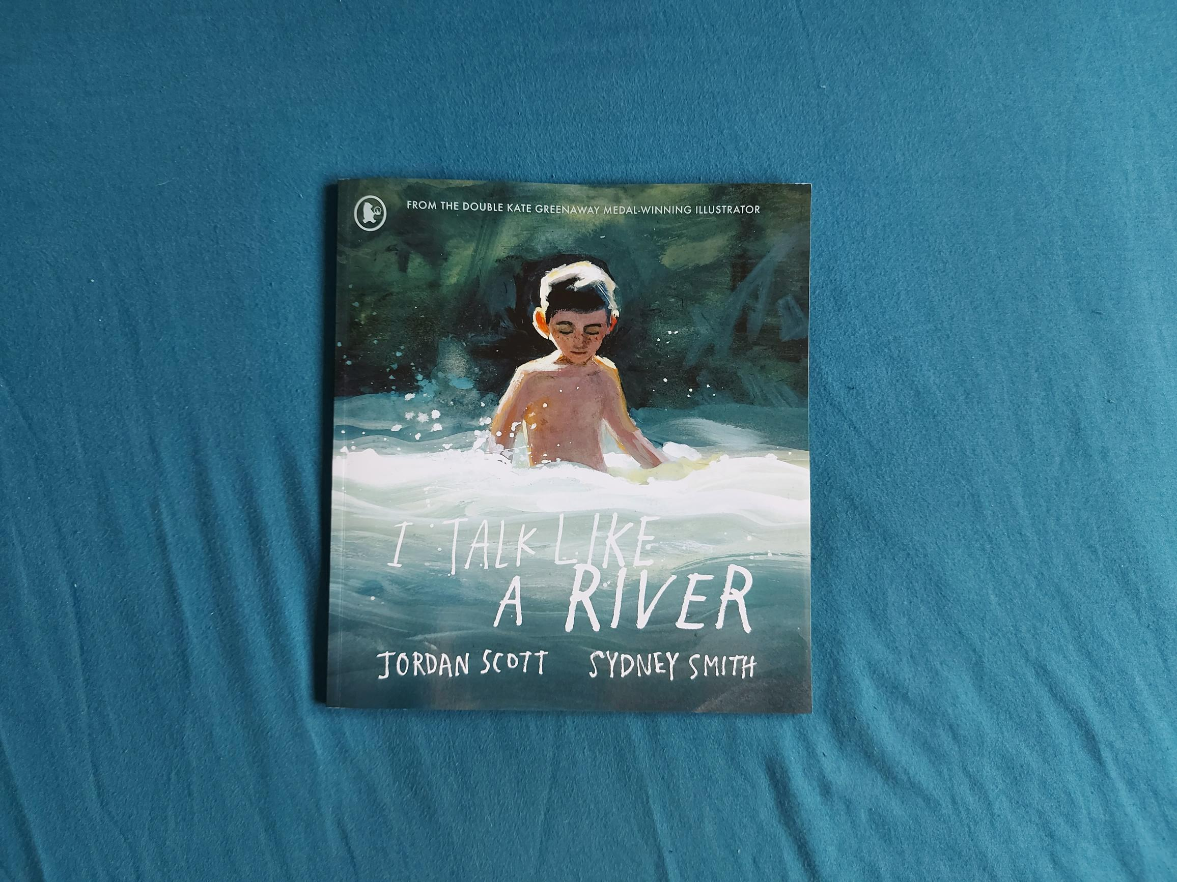

Read Woke: I Talk Like a River
Activity ideas to support classroom use of the book I Talk Like a River by Jordan Scott and Sydney Smith.

First and second level
Resource created by Scottish Book Trust

scottishbooktrust.com
Scottish Book Trust is a registered company (SC184248)
and a Scottish charity (SC027669).

Contents
Scottish Book Trust 2
Read Woke 2
Read Woke South Ayrshire 3
How to use this resource 3
Learning activities 4
Further resources 8

Scottish Book Trust
Scottish Book Trust is a national charity that believes everyone living in Scotland should have equal access to books. Our work provides opportunities to improve life chances through books and the fundamental skills of reading and writing. Access to books and a love of books bring many important benefits from family bonding and advancing children’s learning, to unlocking creativity, helping employability and improving mental health & well-being. Scottish Book Trust aims to support all communities across Scotland, with particular focus on those who are vulnerable and under-represented.

Read Woke
‘Read Woke is a movement. It is a feeling. It is a style. It is a form of education. It is a call to action; it is our right as lifelong learners. It means arming yourself with knowledge in order to better protect your rights.’
- Cicely Lewis, Founder of Read Woke.
The Read Woke challenge was developed by Cicely Lewis in Georgia, USA in 2017. Motivated by the political climate and seeing students grapple with issues of social injustice daily, Cicely realised the need to empower them with knowledge. Knowledge about the issues they (and others) face and knowledge about their own rights. The aim is to educate children and young people through reading. Find out more on the Read Woke website.

Read Woke South Ayrshire
The Read Woke challenge was brought to Scotland in 2020 via the School Library Improvement Fund. A collaboration of South Ayrshire secondary schools created a book list and incentivised reading programme for S1–6 students with the aim of improving representation within library collections, celebrating diversity and encouraging students to be socially aware. Further backing from the Scottish Library and Information Council has allowed this work to be expanded into a primary school setting with Read Woke South Ayrshire Primaries launched in February 2022.
Providing carefully chosen books to schools – along with tailor-made resources and activities through the year – is allowing us to educate and empower students to engage with social justice issues and stand up for the rights of themselves and others. The resources produced will help schools embed themes of equality, diversity, social justice, and human rights throughout their curriculum from P1–7. Learn more on the Read Woke South Ayrshire website.
How to use this resource
I Talk Like a River is a picture book written by Jordan Scott and illustrated by Sydney Smith. It follows the day of a young boy with a stutter who struggles to speak, especially when put under pressure in the classroom. The boy’s father takes him to a safe space, a local river, where he tells his son that he speaks like the river. The book is ideal for considering empathy, especially understanding differences in speech and confidence in the classroom.
With all Read Woke resources, we highly recommend that you read the book before using it with your class and use your best judgement about whether teaching about this topic is appropriate for the children in your class. It is important teachers are mindful of discrimination and inclusivity when approaching the book. It’s also worth spending some time looking at resources which support learners with stammers, for example from Stamma: The British Stammering Association.
Despite the barriers the young boy faces, his main realisation is that the way he speaks deserves respect. It’s a positive story about finding your voice, family and finding peace in nature.

Learning activities

Activity 1: Pre-reading activity
LIT 1-02a, ENG 1-03a
Gather pupils together and let them look at the books cover but keep the title covered. Ask them to consider:
- What do they think of first when they see the cover?
- What do they think the book might be about?
- What do they think this book is called?
Write down their suggestions on a mind-map, then uncover the title and ask the questions again. What has changed?

Activity 2: Morning words
LIT 1-20a, LIT 2-20a, MNU 0-10a
“P is for the pine tree outside my bedroom window. C is for the crow in its branches. M for the moon fading in the morning sky.”
The narrator of the book talks about the words he wakes up to in the morning. Get the pupils to list five words they wake up to every morning thinking about:
- What they can see
- What they can hear
- What they can smell
Ask learners to write out their name horizontally down the side of their paper and come up with a morning word for each letter of their name to create an acrostic poem.

Activity 3: Similes
LIT 1-28a, LIT 1-29a
Split them into groups and give them each a piece of paper. Ask pupils to write one of the following example sentences in the centre of their paper and then come up with some example words they could use to complete the sentence.
- As quiet as a…
- Blue like a…
- As fast as a…
- Tall like a…
- As small as a…
Alternatively, learners can revisit the central simile in the book – “I talk like a river” – and come up with their own versions:
- I talk like a...
- I move like a…
- I play like a…
- I am tall/short like a…
- My eyes are… like a…
You can display these in the classroom and revisit them throughout term, updating them as they change and find new ways to describe themselves.

Activity 4: Listening charter
LIT 1-02a, LIT 2-02a, HWB 1-09a, RME 2-02b
In the book, the narrator describes how being in a classroom can be stressful for him. Use these questions about the character to develop a listening charter that you and the learners can follow.
- Why do you think the main character feels anxious when speaking in class?
- How could the other children and his teacher make him feel more comfortable?
- How does his dad speak with him compared to his teacher and the other children?
- Why do you think he finds it easier to speak with his dad?
Look at the UNCRC Article 12: “I have the right to be listened to and taken seriously”. Ask the pupils to suggest some ways that make them feel listened to and take a note of them on your whiteboard.
If everyone has a right to be listened to, what is everyone else’s responsibility to make sure they listen to everyone else? Ask them to suggest how they can listen to others in the same way they would like to be listened to.
- How do you know someone else is listening to you?
- What helps you feel comfortable talking at home or in class?
- What makes you feel nervous?
Create a class charter by coming up with a list of promises the learners will make to be good listeners and support each other, and a list of promises you’ll make to make sure they feel comfortable talking in class.

Activity 5: Illustrations
EXA 1-05a
The illustrator has used different styles of art to show the main character’s emotions during certain scenes. Put the pupils into different groups, assigning each group a different page.
Look at the illustrations when the main character is at school. Ask them to discuss:
- What do you feel when you look at the pages?
- Why does the art get more blurry?
- Why does the young boy become covered by the crow and branches?
- What do these illustrations this tell us about how the main character is feeling?
Look at the pages where the boy is at the river. Ask pupils to discuss:
- What do you feel when you look at these pages?
- What is different about these pages compared to the ones about the classroom?
- How does the illustrator draw the father and his son?
- What do these illustrations tell us about how the main character is feeling?
After each page, ask the different groups to feed back to the class about what they thought of each page. As they share their thoughts, hold up each page so the rest of the class can see and add any thoughts they had.

Activity 6: River Soundtrack
EXA 0-19a, EXA 2-17a, TCH 0-06a
Explore sounds of rivers and water. You could do this through looking up recordings online or, if you’re able, explore different forms of water. This could be in your classroom or school – taps, sinks or water trays – or you could go on a trip to a local pond, river or sea. Record sounds so you can play them later in your classroom.
Try and match your recordings with the different adjectives used to describe the river in the book – bubbling, whirling, churning, crashing, smooth, and glistening.
You can add to this using music or musical instruments to explore different rhythms and volumes.

Activity 7: Speech and rhythm
EXA 2-17a
Explore rhythm by listening to recordings of water and asking pupils to mirror the sounds by tapping drums or their desks with different parts of their hands. Explore how drumming their fingertips can create different sounds, volumes and speeds to using their fingers or palms.
Split the pupils into pairs and have them talk to each other for a couple of minutes, trying to tap their desks in time with their speech. Ask them to think about:
- How does it feel focussing on both the rhythm and speaking at the same time?
- What words would they use to describe their rhythm?
- Was their rhythm the same or different to their partners?

Activity 8: Rain garden
SCN 2-05a, SOC 1-12a
Create a rain garden to explore the different sounds and rhythms water can create by taking different objects into an outdoor space. These could include:
- Waterproof fabric like a rain jacket or tarpaulin
- Plastics – such as bottles or containers from a recycling bin
- Tins or cans – making sure they don’t have any sharp edges
- Pots, pans, colanders
- Metal mixing bowls
- Plastic cups or bowls
- A plastic paddling pool or tuff tray
Take your objects outside when it’s raining and explore some of the different sounds they make. A top tip – metal bowls in a full paddling pool create an excellent set of drums you can play with a wooden spoon or stick!
If you want your rain garden to be more permanent, you can use string or cable ties to secure your objects in place. You can also revisit this idea with different objects, following some of the children’s suggestions.
This could also be part of a take-home activity, asking children to bring in an item from their recycling at home. Once items are dry, they can be recycled again.

Further resources

Read Woke
- Read Work South Ayrshire website
- Read Woke resources on the Scottish Book Trust website
- Scottish Book Trust book lists on books that feature disability and neurodiversity, books to encourage empathy and books that help children explore emotions.

Stammering and Speech
- Watch Jordan Scott talk about I Talk Like a River and growing up with a stammer via The San Diego Union-Tribune’s YouTube video (11 minutes, 22 seconds)
- Stamma: What is a stammer?
- Stamma: Resources for Teachers
- Stamma: Talking with someone who stammers
- Action for Stammering Children: Support for Schools

