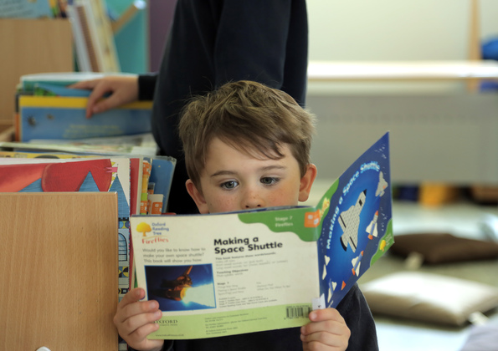

Establishing a reading routine with children with additional support needs
Ideas for using books to support children with ASN, including building a reading routine, developing independence, and bonding together

Resource created by Lucy Noguera

scottishbooktrust.com
Scottish Book Trust is a registered company (SC184248)
and a Scottish charity (SC027669).

Contents
About this resource 2
What to look for in a book 3
Finding regular time to read 3
Ideas for exploring books together 6
Further resources 8

About this resource
Books are incredibly powerful. As an adult if I come across anything new in life, whether it be a problem or an interest, I look for a book to help me understand more.
They are powerful tools whether you are a baby or an adult. The feeling that someone else has been there before you and wants to share that knowledge and experience with you is both helpful and validating. This is why using books creatively with all children and in a more focused way with children with additional needs can be so rewarding.
Reading isn’t limited to a child’s age or stage, you can also use wordless picture books, comics or graphic novels, or even catalogues and brochures.
This resource will share some ideas for building a routine of reading with children who have additional support needs.

What to look for in a book

Interest and connection
The most important thing to look for is something you think will connect with the child you’re reading with. All reading is good reading, whether it’s fiction or non-fiction, magazines or newspapers, audiobooks, eBooks, graphic novels or comics – start with them and what they like. Look for something that ties into their interests, whether it’s a favourite animal, activity, place, toy or vehicle. Starting with something you know they already like puts you in the best position to capture their interest!

Engaging and clear images
Starting with something abstract can be confusing, so look for illustrations that represent the subject in an easily recognisable way. If possible, try and find some books where the backgrounds aren’t too distracting or busy. This doesn’t have to apply to every book you have, but making sure it’s part of your offer can really help children who may have access barriers to reading books.

White or cream backgrounds and clear text
As with looking for engaging and clear images, this doesn’t have to apply to every book you have – but making sure some of the books you offer have plain fonts which stand out against their background can really help children follow the text. Look for sans serif fonts – you can look at Google’s guide on fonts for examples of what this looks like. Whilst reading, point to the words on the page. This helps children connect the words with the pictures.

Finding regular time to read
Using books at the same time each day can help build a sense of routine. You might already read before bed to help with sleep, but you can also read to help with any other transitions, and split the day into separate sections. You could consider reading:
- Before they get up
- Whilst in the car on the way to school
- Before mealtimes
- After their bath
- Before bed

Bath time
Look for waterproof bath books. You can link them to toys you might have in the bath already by looking for stories featuring sea creatures, water, the sea or fish. This is a great way to connect books to play and introduce new vocabulary.

When you’re out and about
Keep books in the buggy or car so they’re easy to reach for. You’re modelling that books are a choice, can bring pleasure and are a nice, easy way to spend time.

Difficult routines or transitions
You can also look at any transitions that are particularly difficult for your child, or the children you work with. For example, if they find getting ready to go outside overwhelming, a book can be a good way to move from one space to the other.
You can also look for books which share routines – e.g. eating breakfast, putting on shoes/jackets to go outside, brushing their teeth, going to bed etc. You can use these to chat with children about their own routines without putting them on spot or making them feel like they’re being quizzed. For example:
- This character is brushing his teeth. Do you remember when we brush our teeth? What do we do after that?
- That character looks like she’s getting ready for school. Shall we pretend to pack our school bag? What should we put in first? It looks cold out, do we need a jacket?
Starting from a place of familiarity can help children connect what takes place in the book to their own life. Look for things you have in common with the characters, family or setting. Then you can use this as a way to start conversations on routines or independence skills that you are trying to support.
Act out the routine together using props and toys. For example, if a child struggles with brushing their teeth have a cuddly toy and ‘clean’ their teeth too! Bringing elements out of the story and into play will help develop their understanding.

Creating a positive reading environment

Keep it quiet and comfy
Finding somewhere quiet is a great way to help children focus. Make sure you turn off any background noise (TV, radio) and limit distractions for both yourself and the child. Sit somewhere comfortable with chairs/sofas, or cushions and blankets. Make it feel nice and cozy. If you have a pet that likes cuddling up or sitting in a lap, that can help it feel like a nicer, warmer space too.
If you’re working in a school or setting, creating a cozy and quiet space for reading can be really useful for children who can get overwhelmed by noise or just need some space to relax.

Using toys
Involve toys – especially their favourites. Can they act out some elements of the stories? Keeping books wherever you have toys in your home or class is a great way for children to have easy access to books and help them associate them with play and fun.

Model reading
If you’re not reading the same book together, you can still model reading. Read when they’re reading – even if they’re just flicking through the pages and looking at pictures.

Ideas for exploring books together

Can you find?
Look to see what you can find in the book, for example:
- Biggest or smallest animal/object
- How many things you can find of one colour
- Counting the amount of a specific animal/object

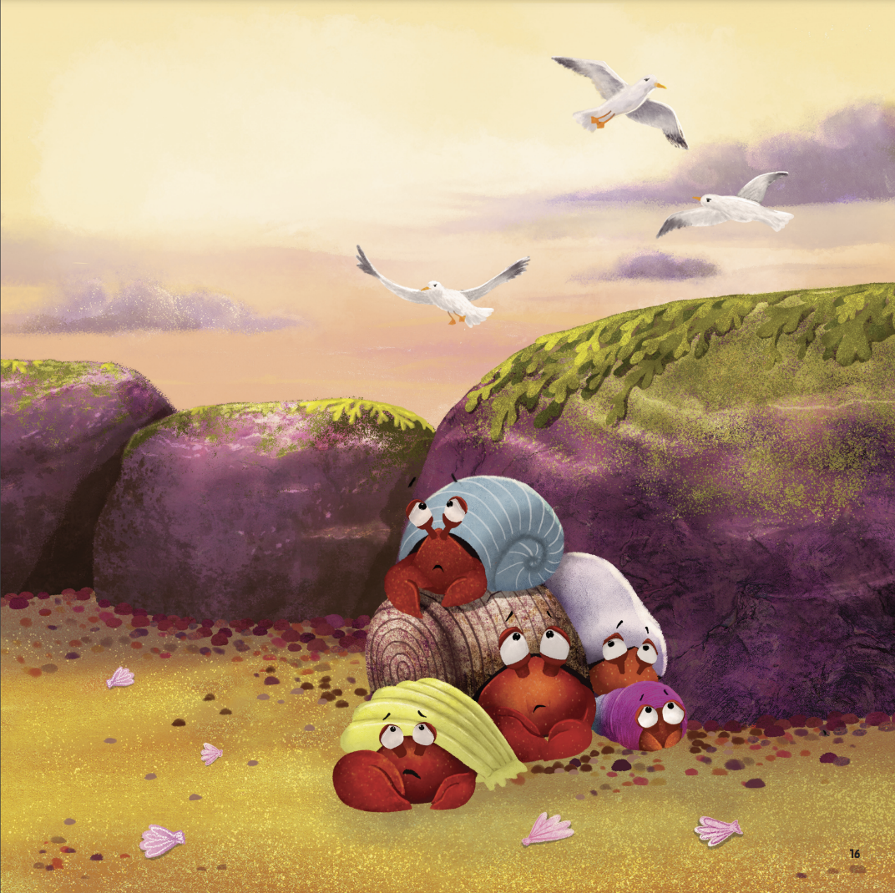
Illustration reproduced with the kind permission of Brilliant Monsters Books.
For example, on this page of Herman Needs a Home by Lucy Noguera, illustrated by Emma Latham, you could look for the following:
- Who is the biggest/smallest crab?
- How many purple/blue/green (etc.) things are there?
- How many crabs/birds/rocks/shells are there?
This is a great way to develop vocabulary and make books more interactive. It can also bring new life to a book you’ve read a few times!
If you’re looking for some recommendations, our book list on science contains books which are really visually engaging and great for these kinds of “scavenger hunts” on the page.

Finding feelings
Look at the emotions of the characters in the illustrations. How are they feeling? Happy, sad or upset? Why? Relate this to your and the child’s life – you could share a time you felt that feeling, or ask them if there’s something that makes them feel happy, angry or proud. On the above page from Herman Needs a Home the crabs look nervous. Why? Do you feel nervous sometimes too? It’s okay if they don’t instantly open up, you’re still showing them that books can offer a safe space to talk about how they feel.

Talking about change
Look for examples in books where there are different caregivers, including teachers, nursery practitioners or childminders, or transitioning between different caregivers (e.g. going to school, coming home, staying with other family members). Talk about how a character might feel. You could also use this to talk about other forms of change, for example, a new baby coming into the family, moving house or starting nursery or school for the first time.
If you’re struggling to find a book on this topic, The Koala Who Could by Rachel Bright is a great place to start! You can watch Rachel Bright and Jim Field on our Authors Live on Demand library.

Making your own books
Making a book together is a great way to help a child feel more confident about books more generally. Here are some ideas for creating a book together:

My Day
Create a typical day’s routine with one page for each element. You can use photographs, drawings or images from catalogues/magazines to represent different parts of their day. Always label even if just one clear word underneath so when you ‘read’ it you can put your finger underneath the word as you say it. You could also do a My Week version if there are any regular activities (e.g. swimming, school, clubs etc.)

My Family
Have the child’s name, and photo of them on the cover and fill the book with photos of their family members, their names and relationship to the child. Let the child take ownership of writing – including any nicknames or family names.

My Favourite Foods
Include photographs or actual wrappers/labels that you’ve washed and dried. This can be a great tool for children with dietary needs who can use the book for communicating the foods they eat.

Further resources

Scottish Book Trust
You can find further resources for children with additional support needs on the disability and neurodiversity section of our website. You can also find the following resources:
- Getting started with sensory stories
- Make your own sensory story
- Sharing books with children with additional support needs
You can also find out more about our Sensory Storytelling programme on the Scottish Book Trust website.

Lucy Noguera
Follow Lucy Noguera on Twitter and Instagram.

