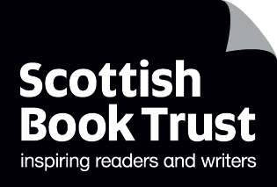
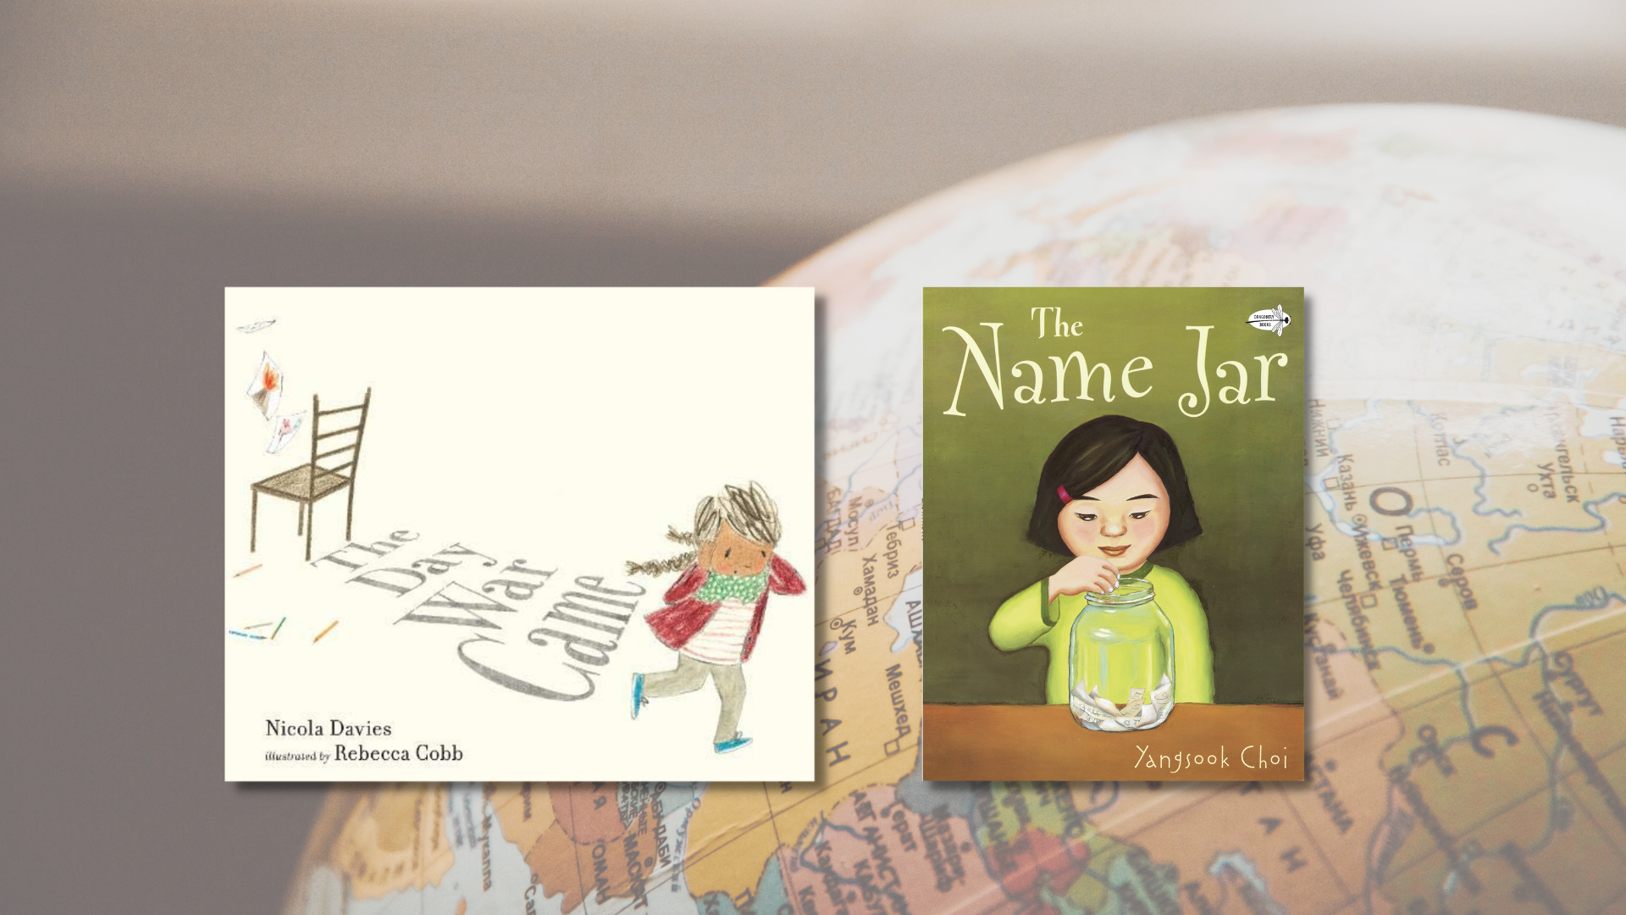

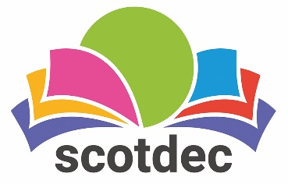

Taking a rights-based approach to fiction in primary schools: Second Level
A guide to using picture books to teach about, through and for children’s rights and UNCRC. This resource contains all Second Level activities.

CFE Second Level
Resource created by Scottish Book Trust and Scotdec
scottishbooktrust.com
scotdec.org
Scottish Book Trust is a registered company (SC184248)
and a Scottish charity (SC027669).

Contents
About this resource Error! Bookmark not defined.
Second level learning activities 4
The Day the War Came, Nicola Davies and Rebecca Cobb 4
The Name Jar, Yangsook Choi 7
Other texts 12
Further resources 12

About this resource
This resource aims to support teachers of second level to explore children’s rights through fiction in the classroom. The first section of the resource explores questions and discussion points which could be used and adapted in relation to any primary text. The resource then examines two picture books in detail, with suggested activities and questions for each. The aim is to provide teachers with confidence, motivation and understanding of how to take a rights-based approach when reading fiction with children.

Taking a rights-based approach
Taking a rights-based approach means that the articles of the convention in the UNCRC underpin the ethos and life of the classroom. For a simplified child-friendly version of the UNCRC to use with children, visit the UNICEF website. This approach involves teaching about, through and for rights which are explained in more depth in this resource.

Texts as mirrors, windows and doors
The metaphor of texts as mirrors, windows and doors is often used when exploring children’s literature. As a mirror, texts and images can give opportunities for children to see their own realities, cultures and identities. As windows, literature can enable children to view someone else’s world, exploring ideas and cultures that are new and realising that multiple perspectives exist. As a door, texts help children to develop as critical thinkers who can respond actively, making links between the texts and taking social action.

About rights
Learning about the different rights in the UNCRC includes looking at characters’ needs and wants, relating their needs to the rights in the articles of the UNCRC and asking pupils to reflect on the rights in their own life. Example questions include:
- What is the difference between what a character wants and needs?
- Which rights are, or are not, being upheld in the story?
- How are these rights upheld in your life? Are there individuals or groups who do not have these rights? Why not?

Through rights
For children to understand their rights, they also need to experience a rights-based approach in the classroom, where teachers:
- Demonstrate a commitment to human rights through relationships based on equality and mutual respect
- Put dignity at the heart of classroom principles and promoting and demonstrating cooperation, kindness, empathy and trust
- Use creative and active learning to encourage all children to engage in learning opportunities
- Equally recognise all children’s achievements
- Ensure children are supported to understand the consequences of their behaviour through nurturing relationships with each other and adults
- Recognise that behaviour is a form of communication
- Create a democratic culture where all children have a voice and believe adults will take them seriously
- Enable all children to directly influence their learning
- Teach children their rights in relation to their own daily lived experiences

For rights
This focuses on equipping children to advocate and take action for their own, and others’ rights. Texts offer chances for children to learn about systems of support, how their choices matter, the impact of their voice and participation and practical ways to take action. Example questions include:
- Can you engage in action or campaigns relating to the text?
- What can you do when you want to raise an issue? Who can you go to? Are there groups or people who will listen? Are there ways to improve the system?
- What choices does the character have/make in the text? What choices do you have? When should you be able to make your own choices?
With all the texts mentioned in this resource, we highly recommend that you read the book before using it with your class and use your best judgement about whether that specific text, or topic, is appropriate for the children in your class. There may be children in the class with a range of backgrounds and lived experiences: children should only talk about or share these if they wish to. Teachers may wish to send a copy of the book home to share with parents in advance or to talk about it with the child before reading it with the class.

Second level learning activities

The Day the War Came, Nicola Davies and Rebecca Cobb (Article 22 and 28)
‘Refugee children have the right to special protection and help.’ – Article 22: The right to special protection and assistance to enjoy all the UNCRC rights from governments, if they are a child seeking refuge or have refugee status.
‘Children have the right to an education.’ – Article 28: The right to an education no matter who they are, regardless of race, gender or disability, if they’re in detention or a refugee.
This picture book follows a little girl whose life is upended by war. When her school is bombed, she’s forced to flee to a new country, but is rejected from joining a new school because the teacher says there is no chair for her to sit in.

Teaching about rights
Ask the children about what they know about refugees. Watch the “Who is a refugee?” video on YouTube from UNCHR Teaching About Refugees (3 minutes, 7 seconds). Discuss:
- What makes someone a refugee?
- Can accompanied children be refugees?
- Do refugees bring all their belongings to a new country?
- Can refugees go home?
- How do refugees get to a new country?

Explain that refugee children, whether alone or with parents/carers, have the right to special protection and help, and have the right to extra support to make sure all of their other rights are fulfilled.
Read the story The Day War Came. While reading, draw children’s attention to the images which give additional information to what is going on that isn’t written in the written text e.g. the military helicopters approaching in the sky.
After reading, ask the pupils:
- At no point in the text does it say that the child is a refugee. How do we know she is one?
- How did she become an unaccompanied child refugee?
- What belongings did she bring to the new country?
- Is she able to go home? Why?
- How did she get to the new country?

Teaching through rights
SOC 2-16b
Read through the story and then focus on the pages that show the main character in the U.K. (when she is walking around and her visit to the school). Ask children to talk about the ways she is treated unfairly by different people.
Explain that when people treat others in a negative way because they are perceived as being different due to their racial affinity, age, ability or refugee status then this is called discrimination. Ask learners what they know about this. Watch the BBC Bitesize video on discrimination (2 minutes, 17 seconds).
Throughout the story, the girl says that war is everywhere: in her heart, in the way people closed doors to her, in the way people looked away and didn’t smile, in the way she was turned away from school. These are all examples of ways that the girl was discriminated against because of her refugee status. Ask learners:
- What effect did the discrimination have on the girl?
- What is it that the girl feels, at the end of the story, will help to start driving war out of her heart?
- What does the chair represent?
Relate learning about discrimination from the story to other types of discrimination that exist. Make a list of other types on the board. Ask learners what the consequences of all types of discrimination may be.

Teaching for rights
Explain to children that only 63% of primary school-aged refugees are in education. To improve this, it requires work by lots of different organisations and groups including the public, government and schools. One of the ways the UN Refugee Agency say schools can help is by ensuring refugee children feel welcome. Invite children to consider ways they might do this. This could include things that cost nothing e.g. welcoming smiles instead of stares (like in The Day War Came) or creating classroom/school welcome signs.
An organisation which supports refugees arriving in Scotland is called Refuweegee. They provide welcome packs to refugees which include a letter written by a Scot to welcome the refugee to our country. Children can write letters or postcards of welcome to children who are refugees arriving in Scotland. Find out how to write a letter and send them on the Refuweegee website.

The Name Jar, Yangsook Choi (Article 8 and 30)
‘Every child has the right to an identity. Governments must respect and protest that right, and prevent the child’s name, nationality or family relationships from being changed unlawfully.’ – Article 8: Protection and Preservation of Identity
‘Every child has the right to learn and use the language, customs and religion of their family, whether or not these are shared by the majority of the people in the country where they live.’ – Article 30: Children from Minority or Indigenous Groups
When Unhei, a young Korean girl, moves to America, she is anxious about introducing herself on the first day at her new school. She tells the class that she will choose a new name by the following week. Intrigued, her classmates fill a jar with names she could choose from. On the day of her name-choosing, the jar mysteriously disappears and, encouraged by her friends, Unhei chooses her own Korean name and helps everyone learn what it means and how to pronounce it.
After reading the text, ask children if anyone has had experience of someone not being able to pronounce their name. Ask:
- How did they feel?
- Did they do or say anything?
- Did anyone try to change or shorten their name to make it easier to say?

Ask children what they understand by the term “identity”. Why is identity important? Explain that identity gives us a sense of belonging, and to feeling included, accepted and secure in the everyday environments in which we spend time. Our names are an important part of our personal identity.
Ask children what other things form our personal identity. These are things that we would attribute to ourselves and may not be visible to others (beliefs, values, individual characteristics, abilities, interests, personality etc.). All of these go together to contribute to our personal identity.
We can also have a social identity. This is to do with the groups we are part of and the way we act and behave in different social situations (these may include religion, racial affinity group, gender, age, immigration status). Article 30 tells us that if we move country or continent, our personal and social identities should be upheld.
Find examples in the text of Unhei and her family maintaining their Korean identity when they move to America. There may be children in the class who have moved city or country and who are willing to talk about their experiences of relocating. Have they managed to find ways to continue with their customs, religion, food or language in their new home country, as outlined in the Article?
Ask students to draw the outline of a suitcase or backpack, filling a piece of paper. Explain that inside, they should write in one colour aspects of their personal identity. In another colour, they should write aspects of their social identity. Ask the class why they have written about their identity inside a suitcase. Explain that the UNCRC states that our right to our identity can never be taken away, regardless of where we are in the world.

Teaching through rights
EXA 2-05a
In this text, the importance of our name as part of our identity is explored. The children are intrigued that Unhei’s name has meaning and they discover that many of their names have meaning, too. Children should write their own full name in bubble writing, spacing letters and filling a page. Inside the letters, they should write words and phrases to demonstrate what they know about their name as an integral part of their identity. This might include:
- Who gave you your name
- What your name means
- If anyone else in your family has that name
- If there is any interesting historical background to your name
- If you have any nicknames
- What is your preferred name

This could be a research or homework task for children. Once the bubble letters are full of information about the significance, meaning and background to their name, ask learners what they have learnt from this. It may be that names carry much more importance than they had previously considered, or that our names are special and carry different meanings for all of us. This helps us to think about the character Unhei in the text and why she chose not to change her name in the end.

Teaching for rights
HWB 2-09a
The UNCRC states that the right to an identity means that children have the right:
- To a name, a nationality and a birth certificate
- To have their birth and name registered as soon as possible
- To have their birth recognized by government
There are, however, millions of children around the world whose births and names are not recognised by their government and this can have very serious consequences. What might these be?
Ask children when they will be required in the U.K. to provide a certificate to show their identity. Examples include to get a passport, to register for school, to register with a doctor, to get married, to own or rent a house, to receive support from the government or to get a driving license, amongst others.
Explain that one of the most devastating violations of human rights is taking place just now in Myanmar. Find this country on a world map and explain that almost a million people have been forced to leave Myanmar and many now live in a refugee camp called Cox’s Bazar, in Bangladesh. Locate Bangladesh on the map. Explain that the Rohingya people are a Muslim ethnic minority group and one of the most persecuted in the world. Their own government in Myanmar does not recognise their identity and without recognition as citizens or permanent residents of the country, the Rohingya have limited access to education, jobs, and health services, resulting in poverty and exclusion from society.

Case Study: Tosmin’s Story
Together, read the case study of Tosmin (adapted from “Tosmin’s story” on the UNICEF website):
The last time Tosmin saw her father, she was 16 years old. Soldiers from the Myanmar army were making their way through the Rakhine State, and when they arrived in Buthidaung, Tosmin’s village, everything was torn apart. Tosmin lost everything, including her father. Tosmin watched her home, village and everything she once knew burn. Shouldering the loss, she began walking: it took nine days for her, her brothers and group of relatives to arrive in Bangladesh. They walked by foot, with no food, for the trip’s entirety. Eventually they would make their way to the world’s biggest refugee camp, a crowded sprawling settlement that is now home to over 910,000 Rohingya refugees like Tosmin.
Though the Rohingya community can trace their roots in Myanmar back centuries, in that country, they are considered illegal immigrants in their own country. The Rohingya have no access to citizenship or a legal identity, although they – and their families – were born in Myanmar.
In Tosmin’s hometown, Buthidaung, Rohingya are barred from even the most basic human rights. Couples are only allowed to have two children, must bribe government officials to let them marry, and need official approval to move to a new home or village. Though Tosmin loved her village and her life at home, being part of the Rohingya community was always difficult. Her teachers often ignored Muslim students like Tosmin and placed barriers between Rohingya children and educational success.
Two years after her father’s death, Tosmin still lives in Bangladesh. She and her brothers have tried to rebuild their lives in Cox’s Bazaar, but living among hundreds of thousands of the world’s most vulnerable people has not been easy. Though Tosmin hopes to claim her status as a Myanmar citizen, such an ambition is currently impossible for Rohingya refugees. Half a million Rohingya children, including Tosmin, are now countered as “stateless refugees” in Cox’s Bazaar. They have lacked a legal identity well before becoming refugees, and with no birth certificate or formal citizenship, they hold no legal claim to the country of their birth.
“We do not have rights here or in Myanmar,” Tosmin said. “We are just in the middle of these two countries. None of us have a personal identity – and we are not recognised as individual human beings.”
This situation goes against Article 8 of The Convention on the Rights of the Child, a worldwide treaty signed by almost every country in the world – including Myanmar – in 1989. Thirty years later, we are seeing the effects of this opposition in Bangladeshi refugee camps, where children are stranded, stateless, with nowhere to go. The Convention on the Rights of the Child states that if a child is deprived of an identity, state parties need to immediately intervene in providing assistance, protection and establishment of an identity. But in Myanmar and throughout the world, governments are blatantly doing the opposite. As a result, children like Tosmin are paying the price for a conflict beyond the bounds of anything they can control.
“I don’t want to be a refugee anymore,” Tosmin said. “I want my home back.”
Discuss the case study and identify examples of the impact that the lack of a legally-recognised identity has on Tosmin’s personal sense of identity and on her ability to thrive and survive. Work together as a class to create an issue tree which explores the root causes, effects and possible solutions to the issue of Tosmin’s right to an identity not being respected. Ideas may include:
- Causes – discrimination, persecution, rights not respected by government, no official identity
- Effects – basic human rights not being respected, lack of education, lack of access to health services, isolation, lack of job opportunities, marginalisation, inequality, poor life chances
- Solutions – campaigning, awareness-raising, organisations helping to respect basic human rights to food, shelter, healthcare

Other texts
- Escape: One Day We Had to Run, Ming and Wah (Article 22 and 38)
- The Kites are Flying, Michael Morpurgo (Article 15)
- Maya and Her Friends, Larysa Denysenko (Article 7 and 18)

Further resources

UNCRC and children’s rights
- UNICEF: UNCRC summary and full versions
- Amnesty International: Human rights education
- Children’s Parliament: resources
- Article 8: “Why Getting Someone’s Name Right Matters” from Ascend
- Article 30: “Why we have the right to an identity” from Amnesty International

Scottish Book Trust
- For more resources exploring reading and social justice, see our Read Woke resources and our Understanding and challenging racism resource.
- Our Read Woke resource on The Proudest Blue can be used to explore Article 14: freedom of thought, belief and religion.
- Use our book lists to find more picture books or children’s books exploring migrant and refugee experiences

Scotdec
- For a curated list of high quality teaching and learning resources about rights see Scotdec’s Signpost Series
- For a range of educational resources exploring children’s rights in different contexts, see Scotdec’s Signpost for Global Citizenship
- For steps designed to support young people to create their own campaigns and lead the learning on issues including children’s rights see Scotdec’s Active Global Citizens resource

