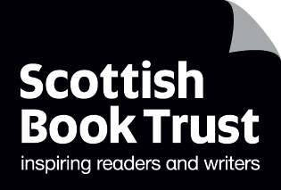
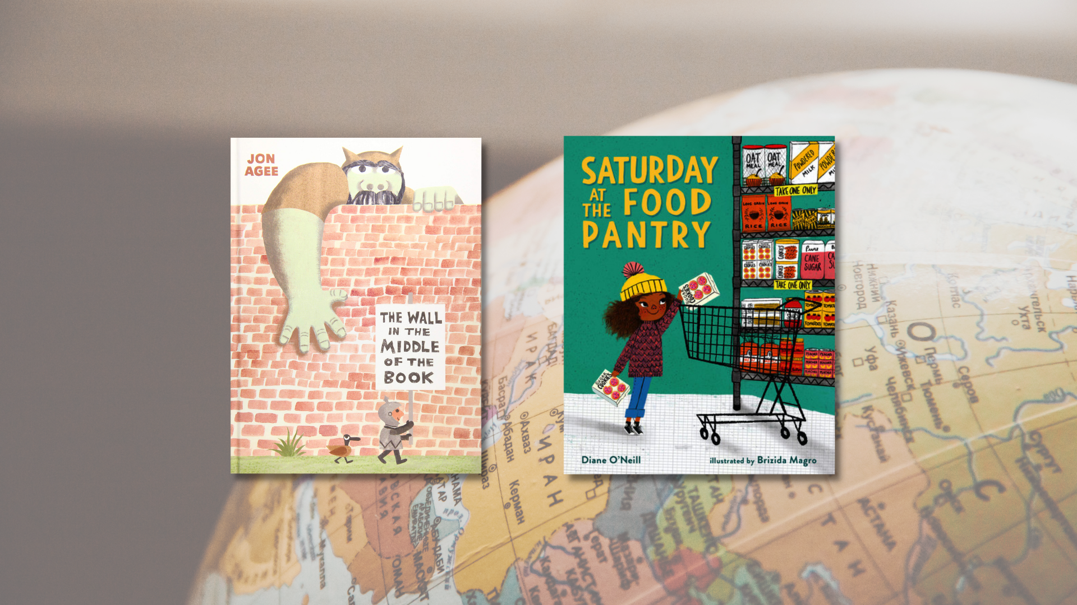

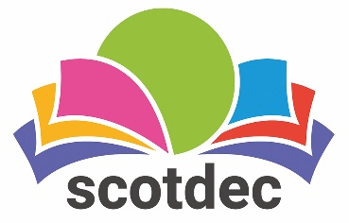

Taking a rights-based approach to fiction in primary schools: First Level
A guide to using picture books to teach about, through and for children’s rights and UNCRC. This resource contains all First Level activities.

CFE First Level
Resource created by Scottish Book Trust and Scotdec

scottishbooktrust.com
scotdec.org
Scottish Book Trust is a registered company (SC184248)
and a Scottish charity (SC027669).

Contents
About this resource 2
First level learning activities 4
The Wall in the Middle of the Book, John Agee (Article 2) 4
Saturday at the Food Pantry, Dianne O’Neill and Brizida Margo (Article 24 and 27) 8
Other texts 11
Further resources 11

About this resource
This resource aims to support teachers of first level to explore children’s rights through fiction in the classroom. The first section of the resource explores questions and discussion points which could be used and adapted in relation to any primary text. The resource then examines two picture books in detail, with suggested activities and questions for each. The aim is to provide teachers with confidence, motivation and understanding of how to take a rights-based approach when reading fiction with children.

Taking a rights-based approach
Taking a rights-based approach means that the articles of the convention in the UNCRC underpin the ethos and life of the classroom. For a simplified child-friendly version of the UNCRC to use with children, visit the UNICEF website. This approach involves teaching about, through and for rights which are explained in more depth in this resource.

Texts as mirrors, windows and doors
The metaphor of texts as mirrors, windows and doors is often used when exploring children’s literature. As a mirror, texts and images can give opportunities for children to see their own realities, cultures and identities. As windows, literature can enable children to view someone else’s world, exploring ideas and cultures that are new and realising that multiple perspectives exist. As a door, texts help children to develop as critical thinkers who can respond actively, making links between the texts and taking social action.

About rights
Learning about the different rights in the UNCRC includes looking at characters’ needs and wants, relating their needs to the rights in the articles of the UNCRC and asking pupils to reflect on the rights in their own life. Example questions include:
- What is the difference between what a character wants and needs?
- Which rights are, or are not, being upheld in the story?
- How are these rights upheld in your life? Are there individuals or groups who do not have these rights? Why not?

Through rights
For children to understand their rights, they also need to experience a rights-based approach in the classroom, where teachers:
- Demonstrate a commitment to human rights through relationships based on equality and mutual respect
- Put dignity at the heart of classroom principles and promoting and demonstrating cooperation, kindness, empathy and trust
- Use creative and active learning to encourage all children to engage in learning opportunities
- Equally recognise all children’s achievements
- Ensure children are supported to understand the consequences of their behaviour through nurturing relationships with each other and adults
- Recognise that behaviour is a form of communication
- Create a democratic culture where all children have a voice and believe adults will take them seriously
- Enable all children to directly influence their learning
- Teach children their rights in relation to their own daily lived experiences

For rights
This focuses on equipping children to advocate and take action for their own, and others’ rights. Texts offer chances for children to learn about systems of support, how their choices matter, the impact of their voice and participation and practical ways to take action. Example questions include:
- Can you engage in action or campaigns relating to the text?
- What can you do when you want to raise an issue? Who can you go to? Are there groups or people who will listen? Are there ways to improve the system?
- What choices does the character have/make in the text? What choices do you have? When should you be able to make your own choices?
With all the texts mentioned in this resource, we highly recommend that you read the book before using it with your class and use your best judgement about whether that specific text, or topic, is appropriate for the children in your class. There may be children in the class with a range of backgrounds and lived experiences: children should only talk about or share these if they wish to. Teachers may wish to send a copy of the book home to share with parents in advance or to talk about it with the child before reading it with the class.

First level learning activities

The Wall in the Middle of the Book, John Agee (Article 2)
‘This Convention applies to every child without discrimination, whatever their ethnicity, sex, religion, language, abilities or any other status, whatever they think or say, whatever their family background.’ – Article 2: Non-discrimination
A wall runs down the middle of this book, supposedly protecting a knight from dangers on the other side of the wall: angry animals and evil ogres. However, water rises dangerously and a perilous crocodile looms on the knight’s side of the wall, and he finds himself in need of help. Who will come to his rescue? This picture book highlights the dangers in holding preconceived ideas and ways in which these can be wrong and harmful.
This book looks at stereotypes, prejudice and discrimination. For clarity here’s the difference between the three terms:
Term | Description
Stereotypes | An oversimplified idea or opinion about a person, group or thing
Prejudice | Judging someone unfavourably and incorrectly without knowing them on the basis of their appearance or if they belong to a particular group or community
Discrimination | Treating an individual or group unfairly as the result of a prejudicial attitude

Teaching about rights
Create an artificial division using a display board or curtain. If using cardboard, children can paint, print or draw on bricks to create a wall. Ask for four volunteers and tell them to form a group on one side of the wall. Give each a piece of paper with one of the following written on: a grandmother, a footballer, a nurse and a farmer. Ask the remaining children to sit on the other side of the wall and give them four pieces of scrap paper and a pencil, working as individuals or in pairs. Explain that on the other side of the wall, one of their peers will read out a person that they are pretending to be. The individuals or pairs should draw a quick sketch of what they think the person might look and behave like, and/or write words that they would associate with that person.
Once the activity is complete, lay the four pieces of paper with the different people written on in different areas of the room and ask children to put their drawings and words next to the correct person. Visit each person as a class and discuss the images and words:
- Were there commonalities?
- Were all of the footballers and farmers men?
- Were the nurses women?
Explain that when we have fixed, simplified ideas about what a person looks, acts, behaves and feels like, this is called a stereotype. Show images of female footballers and farmers, a male nurse or a grandmother from another country.
Sometimes, parts of stereotypes can apply to someone. For example, a stereotype of Scottish people could be wearing kilts and haggis – sometimes this is true, but not all the time, and it doesn’t give a complete picture about a person or group and doesn’t apply to every Scottish person. Sometimes, stereotypes can be harmful and hurtful.
Discuss:
- What does the knight in the story expect the ogre to be like?
- In what way does the ogre break down this stereotype? Can children think of other picture books where the character breaks down a stereotype?
- Where do we get stereotypes from?
- Stereotypes can lead to prejudice. Prejudice is when we have bad thoughts about others based on stereotypes. What sorts of things do people sometimes form prejudiced ideas about?
- Why can stereotypes be hurtful and harmful?

Teaching through rights
ENG 1-19a, EXA 1-13a
After reading the story, discuss:
- Why do people build walls?
- Have you ever built a wall? Why?
- Can you name some famous walls? (Great Wall of China, The Berlin Wall, Hadrian’s Wall). What was the purpose of them? (To keep people out/separate people)
- From what does the character in the book think the wall protects him? Is his side safe?
- Why do you think there is a mouse on the ogre’s side? What does this tell us about the ogre?

Jon Agee has designed this book so that it is both about a wall and shows a wall running down the centre of each double page. Discuss:
- The wall symbolises other things, too. What could it stand for?
- There are very few words in the book. Why do you think this might be?
- The ogre says very little in the book. Why do you think the author has chosen to do this?
- Look at the illustrations of the ogre’s expressions and body language throughout the text. How do they show the reader what he might be feeling and thinking?
Create thought bubbles which could go beside the ogre on different pages, giving his perspective on the knight and showing his feelings. Write these thought bubbles onto the board for the class to see.
Divide the class into groups of six and allocate each a character from the story. Explain that they are going to act out the story, but from the point of view of the ogre’s side of the wall. Using the ideas shared on the board, encourage groups to act out the story from the other perspective. Encourage them to think about what the duck, mouse, gorilla and rhino might also think and say. Ask willing groups to show their dramatizations to the class.
Ask children what they have learnt about the importance of seeing issues from other people’s point of view.

Teaching for rights
Often, as in this story, fears and prejudices are based on lack of understanding. As a class, create a display, entitled, If You Don’t Know, Don’t Be Afraid to Find Out! It could contain a ‘Dos’ and ‘Don’ts’ list. For example:
- Do: ask questions, research, talk to others, learn, question ideas (etc.)
- Don’t: be afraid of the unknown, be scared of new, use stereotypes to decide, believe everything you hear and read (etc.)
This could be displayed to teach and encourage others to stop and think, too.

Saturday at the Food Pantry, Dianne O’Neill and Brizida Margo (Article 24 and 27)
‘Every child has the right to nutritious food.’ – Article 24: The right to good health
‘Every child has the right to have their physical needs met and Governments must help families who cannot afford to provide this.’ – Article 27: The right to a life that meets their physical, social and mental needs
“Everybody needs help sometimes”. This important reminder is woven throughout this picture book about a young girl and her mum making their first visit to the local food bank. An affirming message to those children who see themselves reflected in the text and a simple non-judgemental introduction to the process of using food banks for those for whom the book will act as a window.
Read Saturday at the Food Pantry. After reading, ask children if they noticed something that Molly really wanted at the Food Pantry (the sugar cookies). Ask children if they think Molly needs this food to keep her body healthy. Explain that our bodies need nutritious food, although we also might want biscuits, our bodies don’t need them.
Use the Eatwell plate to show children what foods we need to stay healthy. Explain that the food on the plate is nutritious and we need a mixture of all these foods to stay healthy. Make sure children understand that it is okay to eat crisps, biscuits etc. just less often and not as much of these.
Bring out a shopping bag full of different kinds of food. Ask children to sort it into ‘needs’ (nutritious food our bodies need) and ‘wants’ (food we don’t need but like to enjoy now and then).
Explain to the children that the things we need are our rights. All children have the right to nutritious food and to learn about what foods we need to stay healthy. Explain that all children have the right to have their physical needs met and this means food to help their bodies to grow. Explain that the governments must help families who do not have enough money to provide this.
Explain that Molly’s family weren’t able to buy food, and that they needed some help with this. Discuss:
- Did Molly’s family get help?
- Who provided the food?
- Is the government doing anything to help Molly get nutritious food?
- Are the children in our school getting nutritious food?
- Who provides this?

It’s important the children understand that governments do not provide foodbanks, and the food is donated by people and run by trusts or charities. Children may not realise that all children in P1-5 are entitled to free school meals which are provided by the government.

Teaching through rights
In this story, the different characters feel differently about using the food pantry. As a class, discuss:
- How do Molly, Caitlin and Molly’s mum feel about using the pantry?
- Do their attitudes change throughout the story?
- When have you ever needed help?
- What kind of help did you need?
- How did you feel about asking for or receiving help?
- How did you feel after you had been given help?
Explain that both adults and children need help sometimes.

Teaching for rights
HWB 1-03a
In the book, Molly and her mum know that they can go to the food pantry so that they have their right to nutritious food respected. It’s important that we all know where to go and whom to ask for help, and not to be embarrassed.
Ask learners what they can do at school, both indoors and outdoors, when they need help. Create a list of things that children can do to help themselves, to help each other or ask. Put the ideas into a table, for example:
I can help myself by… | I can help others by … | An adult I can ask for help when…
Trying again | Showing them or explaining in a new way | I’m hurt
Taking deep breaths and staying calm | Working together to do something | I don’t feel well
Taking a break and doing something else for a while | Telling them not to worry | I’m lost

Another way of teaching for the right to good health can be to take part in UNICEF’s OutRight Campaign 2022/23: Speak out on Children’s Right to Health. This campaign is created by young people for young people. Any school, youth organisation, home-schooler or youth club can take part.

Other texts
- Nen and the Lonely Fisherman, Ian Eagleton and James Mayhew (Article 8 and 15)
- Four Feet, Two Sandals, Karen Lynn Williams (Article 22)
- It’s a No Money Day, Kate Milner (Article 24)

Further resources

UNCRC and children’s rights
- UNICEF: UNCRC summary and full versions
- Amnesty International: Human rights education
- Children’s Parliament: resources
- Article 8: “Why Getting Someone’s Name Right Matters” from Ascend
- Article 30: “Why we have the right to an identity” from Amnesty International

Scottish Book Trust
- For more resources exploring reading and social justice, see our Read Woke resources and our Understanding and challenging racism resource.
- Our Read Woke resource on The Proudest Blue can be used to explore Article 14: freedom of thought, belief and religion.
- Use our book lists to find more picture books or children’s books exploring migrant and refugee experiences.

Scotdec
- For a curated list of high-quality teaching and learning resources about rights see Scotdec’s Signpost Series
- For a range of educational resources exploring children’s rights in different contexts, see Scotdec’s Signpost for Global Citizenship
- For steps designed to support young people to create their own campaigns and lead the learning on issues including children’s rights see Scotdec’s Active Global Citizens resource

