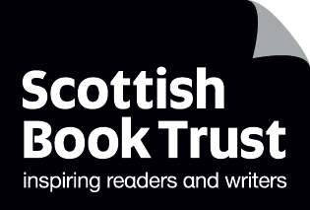
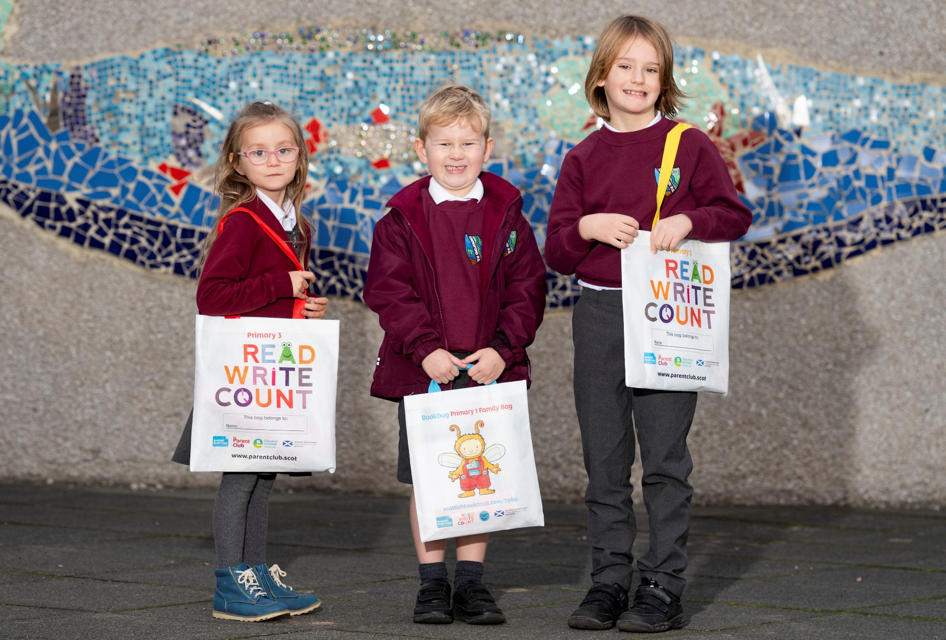

Read, Write, Count evaluation 2021–22
An evaluation of the reading and numeracy resources gifted to every P2–3 child in Scotland, along with the supporting CLPL and resources.

April 2022

Report created by Scottish Book Trust

scottishbooktrust.com
Scottish Book Trust is a registered company (SC184248)
and a Scottish charity (SC027669).

Contents
Executive summary 3
Introduction 5
Background 5
Programme outcomes 5
Methodology 5
Parents and carers 7
P2 bag 7
P3 bag 9
Gaelic bags 11
Suggestions and improvements 11
Using the bags 12
Impact on families 13
Learning professionals 15
Gifting the bags 15
Gaelic bags 16
Support and resources 16
P2 bag 17
P3 bag 19
Impact on pupil enthusiasm 21
Suggestions and improvements 24
Impact on families 25

Executive summary
The Read, Write, Count bags continue to be popular with both parents/carers and learning professionals.
Parents and carers reported that both they and their children enjoyed using the items in the bags. 90% of respondents liked all the items in the bags. The books were very popular, with 94% reporting they had read them together, and many parents/carers reporting that the gifted titles had become favourites:
'My daughter loves hearing/reading Octopus Shocktopus, it’s a family favourite now!'
In the P2 bag, the Shape Shuffle and Act/Talk it Out card games were also popular with families using them for entertainment, bonding, and learning social and emotional skills:
'We have been using the act/talk it out cards most days and it’s been such a lovely way of enabling my son to speak about how he is feeling as well as how he treats others.'
In the P3 bag the tape measure was very popular, as in previous years:
'My P3 and P1 child loved the measuring tape and they spent hours filling out the activities and writing in the notebook.'
71% said they used the bags with their child either a lot or a fair bit. Respondents notes a variety of impacts on their home learning:
- 87% agreed that the bag made them more confident about engaging with their child’s learning
- 82% agreed that receiving the bags gave them new ideas or ways of doing things with their child
- 81% agreed that the information in the bag had made them realise how important it is for them to be involved with their child's learning
'The bag always gives me a confidence as a parent that I will be supported at home with resources to support education but always gives me new ideas about how to use them.'
Learning professionals were also very positive about the contents of the bags. Many noted that the continued Covid restrictions meant that they could not undertake some of their usual gifting activities with families. However, some did describe gifting activities they undertook in class with pupils, and the excitement these produced:
'It was a lovely 'special' day which allowed the children to really engage with their book bags and parents reported that there was a lot of enthusiasm for sharing them at home as well as a result of our launch.'
Some learning professionals noted that less contact with parents and carers due to Covid restrictions had made it more difficult to assess the impact of the bags. However, there were a number of comments suggesting that there had been an impact on pupil enthusiasm and parental engagement:
'The Read, Write, Count bags always engage the children. They love the books and activities and the bright bag that holds the contents. It is a truly beneficial gift as many of our children come from families who are unable to buy new books for their children. It is always an exciting learning experience when we are giving out the Read, Write, Count bags.'
It was particularly noted that the bags were valuable to those families who might not otherwise be able to afford books and learning resources, and an important home–school link in the context of Covid restrictions:
'It’s a lovely event that they really enjoy. Pupils love receiving their own books. They love the fact they can keep them. Makes a real difference to those that maybe don’t get to purchase books very often.'
'Our parental partnerships have taken a big knock with the pandemic restrictions and it was just great to be able to give a high quality educational gift to the parents to enjoy with their children.'

Introduction

Background
Read, Write, Count (RWC) is a national campaign to improve the literacy and numeracy skills of Scotland's children. The campaign is delivered by Scottish Government, Scottish Book Trust (SBT) and Education Scotland. It is a key part of the Scottish Government's commitment to raise attainment for all.
As part of the campaign, every child in primary 2 and 3 receives a free bag with books and activities to support their learning. In addition, the campaign provides advice and support for learning professionals and families from SBT and Parent Club through training events, online resources and targeted programmes of activity in areas of high deprivation.

Programme outcomes
The gifting of the P2 and P3 bags is intended to support the overarching RWC programme aims:
- Contribute to the joint aims of raising attainment for all and closing the attainment gap, with the focus on the latter
- Provide resources and advice to parents and children to support fun and accessible home-based learning (incorporating growth mind-set principles, particularly in relation to numeracy)
- Ensure good integration between the bags and the wider social marketing campaign (in line with the strategic approach of belief, competency and behaviours)
- Secure buy-in and support from teachers and other practitioners, such as library staff and family/community learning

Methodology
The evaluation of the 2021–22 Read, Write, Count bag gifting programme was undertaken in-house by Scottish Book Trust and comprised two feedback surveys of parents/carers and learning professionals. Respondents to the surveys submitted responses voluntarily and the surveys were circulated through Scottish Book Trust channels in December 2021. The surveys were incentivised, with parents/carers given the option to enter a prize draw to win a bag of games, books and activities for home learning, and learning professionals a book token for their school. The parent/carer survey received 337 responses, and the learning professional survey received 462 responses. The findings should not be considered entirely representative as many respondents were already engaged with Scottish Book Trust, though the feedback gathered still provides a valuable insight into the reception and impact of the programme.

Parents and carers

P2 bag
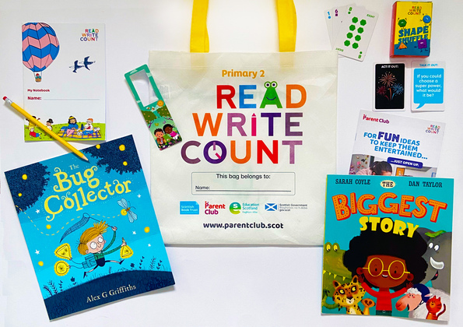

59.5% of respondents received a P2 bag. The overall feedback was positive with the books (and The Bug Collector in particular) proving popular for reading, playing, and learning:
'Read my daughter the story every night she absolutely loves it.'
'My child was able to use the ideas from the biggest story to develop his own imagination.'
'My son loved the book and magnifying glass, he didn’t just use it for the book but items around our house too, including the dogs nose.'
'My granddaughter loved reading the story book to me and then looking around for bugs, in the house, with the magnifying glass. None to be found, 😂'
The Shape Shuffle and Act/Talk it Out card games were also popular with families using them for entertainment, bonding, and learning social and emotional skills:
'Yes the Act/ talk it out my daughter loved it she made the family to play with it and honestly we had great fun playing it.'
'We have been using the act/talk it out cards most days and it’s been such a lovely way of enabling my son to speak about how he is feeling as well as how he treats others.'
'We played with the act it out cards every evening for a week – my boys loved them!'
'My daughter started using the shape shuffle card game as an alternative to a bedtime story. This has introduced the idea that games can be a fun time rather than being about winning and losing. This has helped improve her flexible thinking.'
'My daughter got this in P2 and played with it with her sister (preschool age). They had such fun acting out the different words on the cards. It was great for their imagination skills and some of their actions were hilarious.'
Additional items in the bag (including the notebook, pencil and parent guide) were prominently featured in some responses:
'She enjoyed the stories and I enjoyed the parents book fantastic for all the family!'
'The notebook and pencil my son enjoyed he drew pictures and starting writing without any prompt he wanted to show me what he had been doing in class.'
'I remember my child writing and drawing with the pencil in the notebook, she still loves doing this now.'

P3 bag
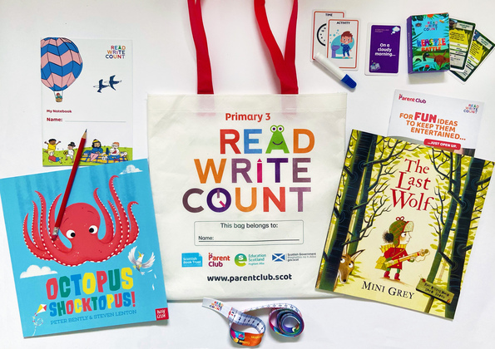
35.5% of respondents received a P3 bag. The books (especially Octopus Shocktopus) were particularly popular with children and families, a number of whom reported that it had become a favourite:
'My child being excited by the illustrations at the start and end of Octopus Shocktopus and spotting the squid.'
'I loved watching my son read me octopus shocktopus, he loves this book and reads it himself or to me regularly.'
'My daughter loves hearing/reading Octopus Shocktopus, it’s a family favourite now!'

As discovered in last year’s evaluation, the measuring tape was also extremely well used and appears to have struck a chord with some children:
'My child loves the measure tape and brings it with him everywhere. It came in very handy in a clothes shop when trying to figure out the height of his big sister and out pops the measuring tape. "This will do it," he proudly announced. Brilliant!'
'My P3 and P1 child loved the measuring tape and they spent hours filling out the activities and writing in the notebook.'
'She was very excited with all the items in her bag and uses the bag to store some of her books. She loves writing just now especially little notes so she also uses the notebook and pencil.'

Gaelic bags
Only 3% of respondents had a child in Gaelic Medium Education. However, those who did receive a Gaelic bag as well as an English version felt that receiving a Gaelic bag was important:
'We got the Gaelic version of this bag and my daughter loves it. She read both books the same day she got the bag and got to work with her notebook writing and drawing pictures. Thank you so much!'

Suggestions and improvements

90% of respondents liked all the items in the bags; the minority who did not like a particular item would have preferred an additional book. Respondents were given the opportunity to suggest additional items for inclusion in the bag. The most common request was for additional books, though puzzles, crafts, games, toys and resources for ASN children were also suggested.
'You do a fantastic job of getting it just right at every age and stage.'
'Book suggestions by genre and age would be great, especially for new or local authors.'
'Some basic BSL. Even for hearing children it's a valuable skill to have.'
While most of the feedback given on the bags was positive, a minority of respondents were unsure of their value to parents/carers who either do not want or do not need support:
'I think the bags as a general resource for people who perhaps don’t have a learning culture at home are really good. I do wonder at their value for those parents who are aware of child development needs and who are already doing all of this stuff anyway.'

Using the bags

Respondents did not report significantly altering their behaviour due to receiving the bags, though 45% said they tried out new ideas or activities since receiving the bags.
'Used them as a family and that in itself was so valuable. Parents are medics and work long hours so time with the children is precious.'
'We used the act it out card game with the whole family which was nice.'
'Keep up the great work the bags are lovely for our Children.'
'My daughter love writing and drawing so used all the accessories. We read her story every night and she uses the books for her library bag.'
71% noted that they used the bags with their child either a lot or a fair bit. Those who did not use the bags extensively sometimes said that they were already very active in their child’s learning:
'The bags are useful but for a parent already heavily involved with their children's learning they are not revolutionary.'
Others said that they found the resources extremely useful:
'Great way to learn how to engage and learn with my son.'
'I think it’s an absolutely essential kit to provide families with the opportunity to engage with each other and the school environment. It provides the tools and clear guidance to enable a positive learning experience for all involved.'
Most (79%) planned to use the items in the bag for a few months or more, with some noting that the books would be in use for longer:
'The books in the bag are excellent and, in our home, are read time and again for a number of years.'

Impact on families
87% of respondents to the survey agreed that the bag made them more confident about engaging with their child’s learning. While fewer respondents pinpointed an increase in confidence specifically with reading, writing or numeracy, this general increase in confidence is notable. In addition to this, 81% agreed that the information in the bag made them realise how important it is for a parent to be involved with their child's learning:
'The bag always gives me a confidence as a parent that I will be supported at home with resources to support education but always gives me new ideas about how to use them.'
Would you agree that the bag has made you more confident with: | Option selected by respondents
Reading | 50%
Writing | 32%
Mathematics / numeracy | 35%
Engaging with your child's learning | 87%

82% of respondents agreed that receiving the bags gave them new ideas or ways of doing things with their child, suggesting that the programme provides a useful starting point for some parents and an additional source of information for others:
'My granddaughter absolutely loved the cards and she organised myself and her sisters in the 'game' making up her own rules. We had such fun and all stories were enjoyed and not judged. Great idea.'
'We have had so much fun playing with the cards. The talking points have given us some interesting chats at meal times and the Act it out cards have given us a new game that everyone in the family can play. Thank you.'

Learning professionals

Gifting the bags
There were 462 responses to the learning professional survey. 69% gifted the P2 bag and 65% gifted the P3 bag. 67% gifted the bags in November. Many found their gifting plans impacted by Covid or uncertainties surrounding Covid:
'The bags were gifted to them during class time in which we had a whole-class lesson. Parents weren't allowed in due to COVID-19.'
Some found innovative ways to gift the bags in a socially distanced way, including finding ways to include parents and carers from a distance:
'We held a socially distanced Teddy Bears Picnic with the children and gifted the bags at that.'
'Worked with the packs in class, read book aloud, activities in class then gifting. Recordings of children interacting with pack to send to parents.'
'We wrapped the book bags up as a giant present with ribbon and a label and sat it in the class for a week before the children could open it – children were very excited! Info and links relating to the bags were posted on Google Classroom for parents and pupils to enjoy at home together.'

Gaelic bags
4% reported gifting Gaelic bags. These respondents had strong opinions on the positive impact the Gaelic versions of the bags on their classes:
'With so few colourful texts available in Gaelic, children really love receiving books to keep that they haven't seen before in school. It is also so rewarding when older pupils in the Gaelic composite class recall stories from packs they received while in P1-3.'
'They can read in Gaelic and develop vocabulary and then read in English at home, developing understanding of the text.'
'It's fantastic that the books are available in Gaelic and can be used for their learning in class. The pupils love the bags and the suspense that is created in the class during the week of Book Week Scotland.'
'It is so beneficial to the class and children to receive books in Gaelic.'

Support and resources

Most (79%) had used the Read, Write, Count teacher guide. Those who had accessed Scottish Book Trust resources reported finding them useful:
'I really enjoy using the Scottish Book Trust website and find the resources very useful. I have noticed an improvement in reading for enjoyment since the Bookbug and Read, Write, Count books have been introduced. They are a great idea, particularly for pupils who may not have access to many reading materials at home.'
'The learning resources are fun and I am curious if you have any more modified resources as we have a Learning Centre for children with complex needs.'
While only 11% of respondents had attended a CLPL session, 62% would be interested in attending one in the future. 70% of those who had attended a CLPL event found it useful:
'Great ideas and I enjoyed seeing what other schools had done. I wanted to make the experience special as we couldn’t have parents in to share the bags like in previous years.'
'It gave me a real focus for my planning and got me excited about the book bags.'
'I felt more knowledgeable about the Read, Write, Count bags as I attended the CLPL course which was full of useful information, however I feel if there was more guidance from the council of how to make best use of the gifting of the bags during the pandemic this would have benefitted other staff too.'

P2 bag
Learning professionals who gifted the P2 bags detailed the range of creative activities they used to engage their classes with the books and resources. Feedback on the books and activities was positive:
'The bags were given at a very appropriate time as the children had just been learning about COP26 and the environment. We focused on The Bug Collector in class, following the children making bug hotels. They were able to make amazing connections and the magnifying glass to find and explore different bugs.'
'The children enjoyed the gifting experience and exploring the contents of their bags. The book activities available online were most engaging.'
'We had a pj day at school and read the books in our school library with hot chocolate. It was very cosy and the children loved hearing the stories. We then discussed the stories and choose our favourite part of each book.'
'It was a lovely 'special' day which allowed the children to really engage with their book bags and parents reported that there was a lot of enthusiasm for sharing them at home as well as a result of our launch.'
'The pupils were excited when each resource was revealed from the bag. They thoroughly enjoyed the interactive story about Errol and The Biggest Story. The pupils all listened carefully as the contents of the bags were shown, they answered questions and asked questions about the pack, they sat well for the story, and they all took part in the activity about their Perfect Day. They spoke about their perfect day and drew pictures of it.'

P3 bag
Feedback from respondents who gifted the P3 bag was also positive. Learning professionals described a range of ways they had used the bags to spark enthusiasm and excitement:
'Reading the stories, using the measuring tape as we had been learning about length, and looking through the bags in class, they were very excited.'
'The children thoroughly enjoyed the storytelling cards, each child was given a selection of cards they could create a story with that they verbally shared with one another. The stories were shared in class and when reading a second time, children chose a character from the story they wanted to play and acted out the scenes.'
'The children loved playing the Beastie Battle and one to create their own at our class writing area. The also loved Octopus Shocktopus and enjoyed making a 3D paper octopus and designing a house for it to sit on. We also looked at climate change through The Last Wolf and I have had a couple of pupils continue to create climate change posters.'
'My class just loves the whole bag and being able to explore all the lovely resources.'
'The children responded really well to the storytelling cards and a few children sent stories that they had created from using them on Seesaw. They also enjoyed the books which we recorded and posted on Seesaw.'
'Actually, the best thing was the children unpacking the bags in class, sharing what was in their bag with friends to read/play/discuss etc. Then we fed back to each other about which things we enjoyed the most and what we would do next with the resources at home or in class.'
'The children loved using the measuring tape as they were up on their feet and working together as a group, they also loved the books being read to them especially when I did the voices of different characters.'
'The children loved the Octopus Shocktopus book. We spoke about what children would do if an octopus landed on their house. The children decided the Octopus should have super powers! We then designed our own octopus's with superpowers and show cased them to the rest of the class.'
'Kids loved the Octopus book therefore were extremely excited to do activities in the notebook related to it!'
'The children really enjoyed listening to the story books and then reading them with a friend. They were very excited about taking them home and also taking their own bag home too.'

Impact on pupil enthusiasm

80% of the respondents to the learning professional survey felt the pupils were more enthusiastic about books and reading since receiving the bags:
'The children are so enthusiastic to look in their bag to see their new books and this enthusiasm can be encouraged and built on to develop positive reading habits and a love of books.'
'They do get very enthusiastic when they make a connection with a book. Children look forward to taking their books home to share their learning with their family.'
'I love reading to the children and a few parents have passed comment that their child is talking more about books.'
'The children were excited to have read the books in class and then have their own to take home to share the excitement with their families.'
Some felt that the programme had a direct impact on pupil attitudes to reading in particular:
'The children always ask for books home so it is brilliant for them to have physical copies they can keep. Some of the children bring books in to share with the class and they all love listening to a story. I have quite a few children still in Group A-C and ditties in RWI and I feel the gifting helped them to see reading more positively.'
Others noted that their pupils still had positive reactions to the books in their bags years after gifting:
'I recently brought out one of the P1 books from last year to support our bird hyde role play area, much to the excitement of our P2 pupils who recognised it.'
'Also have some of the books from current and previous book bags in class library. Pupils are enthusiastic about these books and can retell the stories.'
'The class still find the class copy of the books from the book bag in our classroom library and say how much they enjoyed them.'
Some respondents did not think the bags had an impact on pupil enthusiasm, or were cautious about attributing enthusiasm solely to the Read, Write, Count programme:
'I don't feel that they are more enthusiastic. However, I think they are a good tool to maintain their enthusiasm with reading, writing and maths. They enjoy books and reading and are always excited to receive their bags and explore what is inside. My P4s always talk about their memories of receiving their bags when they are handed out and are a little disappointed that they no longer receive one.'
'Reading for enjoyment forms an important part of my classroom teaching already. The children look forward to story time on a daily basis and at the end of the week they choose their favourite books and we collate the information as a pictograph wall display. They are already very enthusiastic about reading but they did enjoy the books provided in the RWC bags.'
'They enjoyed the events around the book gifting, and I feel it is hugely positive to be giving children books, but I don't feel it changed their general attitude to books.'
'It is difficult to generalise as some children have access to lots of books at home and others don't. All the children enjoyed listening to the stories and were enthusiastic about taking the books home.'
'They were enthused at the time, but I have not noticed a discernible difference since.'
Learning professionals were less certain that the programme had a direct impact on pupil enthusiasm for writing and numeracy. Many noted that this was difficult to evaluate or to pinpoint to one intervention, though they were generally positive about the resources:
'The Bug Collector encouraged data handling and measurement using the ruler.'
'They really enjoyed the measuring tape because it was tactile as well. They measured each other's body parts and we did a project about giants where the measuring tapes were used.'
'The children love the notebooks and pen. We encourage the children to try the writing activities with some children participating in these experiences at home.'
'The storytelling cards have been a great resource to motivate learners who may find it more challenging to come up a story line.'

Suggestions and improvements
Issues experienced by respondents included timing, Covid-related issues, the difficulties of gifting to select year groups in a composite class environment, and the reading levels of their pupils being higher or lower than the gifted resources. Suggestions for improvements included gifting at a different time of the year to allow for more outdoors activities, expanding the programme to include more year groups, being gifted spare bags, and making the bag contents and resources available earlier in the year for planning purposes.
'They get better each year and more innovative. We will be holding more in person events in the future. It is limited because of the impact of COVID.'
The inclusion of non-fiction books is popular with teachers and children. Suggestions for additional items and resources included additional books, whiteboards, a teacher copy of the bag, resources in additional languages and resources for ASN pupils and families.
'My school is an MLD ASN school and we have pupils & parents with VI and parents who were former pupils and struggle themselves with literacy. For those parents I recorded the story on my phone and sent it to them in a video that way they could share it with their child.'
'A suggestion would be some books in braille, sensory books, also some story links with recordings that way if parents have literacy issues they have support also English as additional language books is there scope for books in various languages / I have Spanish, French and Arabic parents.'
'I feel that the bags are literacy heavy. During this pandemic numeracy has taken a big hit. A few extra numeracy items such as dice (many young children are not recognising dice patterns) and things to count with would be fantastic.'
'The suggested activities were helpful. I think more age and weather appropriate outdoor learning experiences would be beneficial, particularly due to the current COVID climate.'
They also suggested extending the programme to other year groups, receiving the resources earlier, and getting a teacher copy of the bag:
'They enjoy books and reading and are always excited to receive their bags and explore what is inside. My P4s always talk about their memories of receiving their bags when they are handed out and are a little disappointed that they no longer receive one.'
'It would be useful to have a bag for the class teacher so that there is spare and they can teach from their own bag rather than sharing.'
'If we had more time I would include the books in my planning. I do like to link the books to what we are learning or structure a numeracy/literacy lesson around the book.'

Impact on families
A key impact of the programme for many learning professionals was ensuring that their pupils had learning resources at home. This was particularly important to teachers with pupils from economically disadvantaged backgrounds:
'I think they are a great leveller, providing all the materials needed for the activities and great choices of books.'
'Encouraging continued reading at home. Some parents have limited resources to buy books, so this is a wonderful resource for engaging parents and for involving children reading with their families.'
'I certainly think that it provides books and resources to some parents who do not have these things within their home. Having these resources within the home environment is essential and I think it would enable more parents to become more involved when the resources are gifted to them.'
'The Read Write Count Bags always engage the children. They love the books and activities and the bright bag that holds the contents. It is a truly beneficial gift as many of our children come from families who are unable to buy new books for their children. It is always an exciting learning experience when we are giving out the Read Write Count Bags.'
'It’s a lovely event that they really enjoy. Pupils love receiving their own books. They love the fact they can keep them. Makes a real difference to those that maybe don’t get to purchase books very often.'
'I feel that the children are generally very enthusiastic but the bag gives them the opportunity to read their own books at home if they do not have any of their own.'
'I think it is a fantastic resource for the pupils to receive, the pupils are always so excited and happy when they get their Read, Write and Count bags. There are probably so many children who benefit from these books who would normally not be able to afford them.'
Parental engagement was also highlighted as an important impact of the gifting programme:
'Yes, I feel that it is an essential engagement tool which is paramount in involving parents. Anything with is fun is attractive for families to take part in.'
'Yes, in that for the parents who time and time again say they don't know anything about their child and his/her learning, this is a perfect opportunity to find out. Having said that, some parents still believe it is the school's job rather than theirs to teach children - not recognising the fact it is a two way process with both parties' involvement. "Oh you played this at school, so we don't need to" is a common statement.'
'Our parental partnerships have taken a big knock with the pandemic restrictions and it was just great to be able to give a high quality educational gift to the parents to enjoy with their children.'
'I think the Read Write Count bags and Campaign are so important in providing a firm foundation in Literacy and Numeracy, superb links to families, especially families who cannot afford to buy books or resources.'
A number noted that Covid restricted their ability to engage with parents or that, in previous years, an in-person gifting event encouraged parental involvement:
'Again, usually a confident yes but due to being unable to speak with parents at the open event it is hard to gauge.'
'Covid restrictions have made this difficult this year. In previous years I think there has been a more positive impact with parents.'
'In the past, I have invited parents in for a special gifting event and, when covid restrictions allow this would do so again. Very positive to have such lovely resources to pass out to parents and help them to see how it links to our curriculum in school. Thank you.'
'Previously we have parents in for the gifting and activities, this did build better links with parents and carers.'
However, some felt the bag gifting was particularly meaningful during the pandemic as it could be used for home learning activities:
'This year we were unable to have parents in school for the family learning event we usually host as part of the book bags however they are definitely a helpful tool for homework or sharing learning experiences.'

