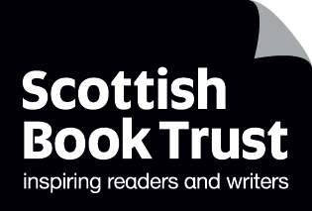
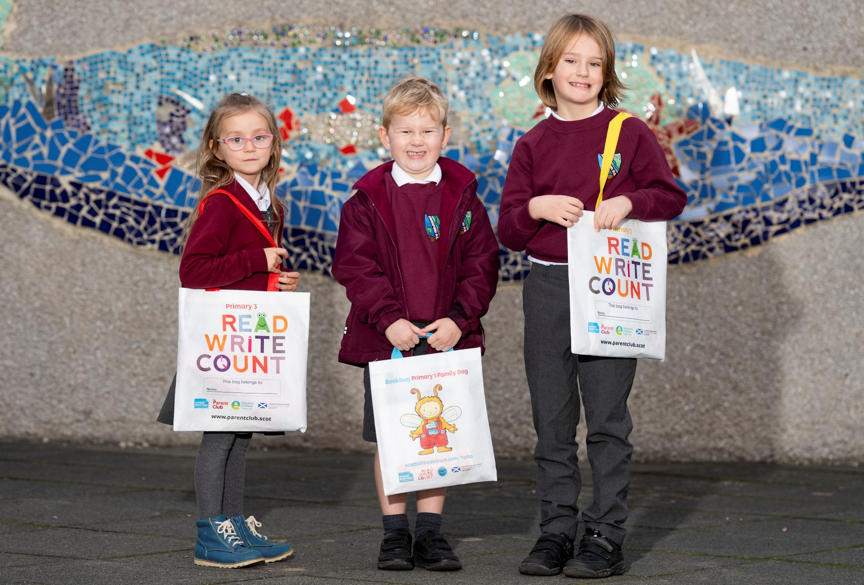

Read, Write, Count evaluation 2021–22
An evaluation of the reading and numeracy resources gifted to every P2–3 child in Scotland, along with the supporting CLPL and resources.

Executive Summary created by Scottish Book Trust

scottishbooktrust.com
Scottish Book Trust is a registered company (SC184248)
and a Scottish charity (SC027669).

Contents

Background 3
Programme outcomes 3
Methodology 4
Key findings 5
Conclusions 11

Background
Read, Write, Count (RWC) is a national campaign to improve the literacy and numeracy skills of Scotland's children. The campaign is delivered by Scottish Government, Scottish Book Trust (SBT) and Education Scotland. It is a key part of the Scottish Government's commitment to raise attainment for all.
As part of the campaign, every child in primary 2 and 3 receives a free bag with books and activities to support their learning. In addition, the campaign provides advice and support for learning professionals and families from SBT and Parent Club through training events, online resources and targeted programmes of activity in areas of high deprivation.

Programme outcomes
The gifting of the P2 and P3 bags is intended to support the overarching RWC programme aims:
- Contribute to the joint aims of raising attainment for all and closing the attainment gap, with the focus on the latter
- Provide resources and advice to parents and children to support fun and accessible home-based learning (incorporating growth mind-set principles, particularly in relation to numeracy)
- Ensure good integration between the bags and the wider social marketing campaign (in line with the strategic approach of belief, competency and behaviours)
- Secure buy-in and support from teachers and other practitioners, such as library staff and family/community learning

Methodology
The evaluation of the 2021–22 Read, Write, Count bag gifting programme was undertaken in-house by Scottish Book Trust and comprised two feedback surveys of parents/carers and learning professionals. Respondents to the surveys submitted responses voluntarily and the surveys were circulated through Scottish Book Trust channels in December 2021. The surveys were incentivised, with parents/carers given the option to enter a prize draw to win a bag of games, books and activities for home learning, and learning professionals a book token for their school. The parent/carer survey received 337 responses, and the learning professional survey received 462 responses. The findings should not be considered entirely representative as many respondents were already engaged with Scottish Book Trust, though the feedback gathered still provides a valuable insight into the reception and impact of the programme.

Key findings
The Read, Write, Count bags continue to be popular with both parents/carers and learning professionals.
Parents and carers reported that both they and their children enjoyed using the items in the bags. 90% of respondents liked all the items in the bags. The books were very popular, with 94% reporting they had read them together, and many parents/carers reporting that the gifted titles had become favourites:
'My daughter loves hearing/reading Octopus Shocktopus, it’s a family favourite now!'
In the P2 bag, the Shape Shuffle and Act/Talk it Out card games were also popular with families using them for entertainment, bonding, and learning social and emotional skills:
'We have been using the act/talk it out cards most days and it’s been such a lovely way of enabling my son to speak about how he is feeling as well as how he treats others.'
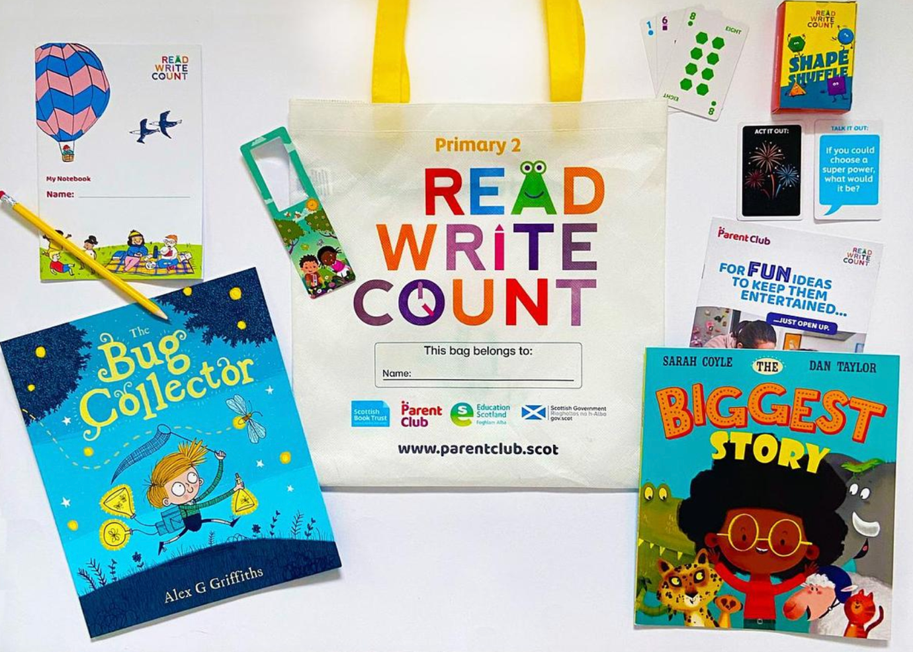
In the P3 bag the tape measure was very popular, as in previous years:
'My P3 and P1 child loved the measuring tape and they spent hours filling out the activities and writing in the notebook.'
71% said they used the bags with their child either a lot or a fair bit. Respondents notes a variety of impacts on their home learning:
- 87% agreed that the bag made them more confident about engaging with their child’s learning
- 82% agreed that receiving the bags gave them new ideas or ways of doing things with their child
- 81% agreed that the information in the bag had made them realise how important it is for them to be involved with their child's learning
'The bag always gives me a confidence as a parent that I will be supported at home with resources to support education but always gives me new ideas about how to use them.'
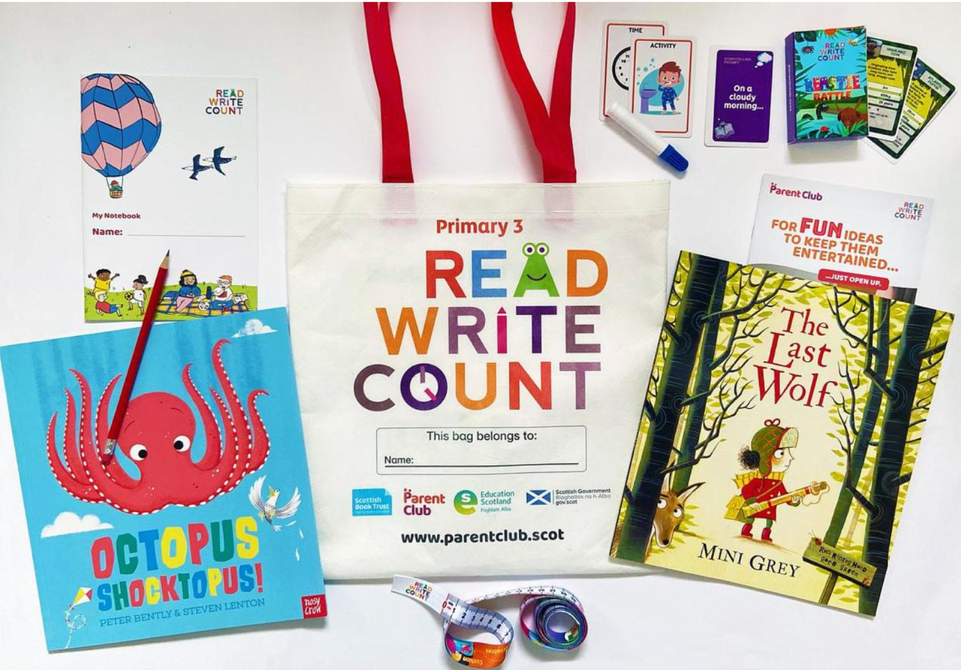

Learning professionals were also very positive about the contents of the bags. Many noted that the continued Covid restrictions meant that they could not undertake some of their usual gifting activities with families. However, some did describe gifting activities they undertook in class with pupils, and the excitement these produced:
'It was a lovely 'special' day which allowed the children to really engage with their book bags and parents reported that there was a lot of enthusiasm for sharing them at home as well as a result of our launch.'
Some learning professionals noted that less contact with parents and carers due to Covid restrictions had made it more difficult to assess the impact of the bags. However, there were a number of comments suggesting that there had been an impact on pupil enthusiasm and parental engagement:
'The Read, Write, Count bags always engage the children. They love the books and activities and the bright bag that holds the contents. It is a truly beneficial gift as many of our children come from families who are unable to buy new books for their children. It is always an exciting learning experience when we are giving out the Read, Write, Count bags.'
It was particularly noted that the bags were valuable to those families who might not otherwise be able to afford books and learning resources, and an important home–school link in the context of Covid restrictions:
'It’s a lovely event that they really enjoy. Pupils love receiving their own books. They love the fact they can keep them. Makes a real difference to those that maybe don’t get to purchase books very often.'
'Our parental partnerships have taken a big knock with the pandemic restrictions and it was just great to be able to give a high quality educational gift to the parents to enjoy with their children.'
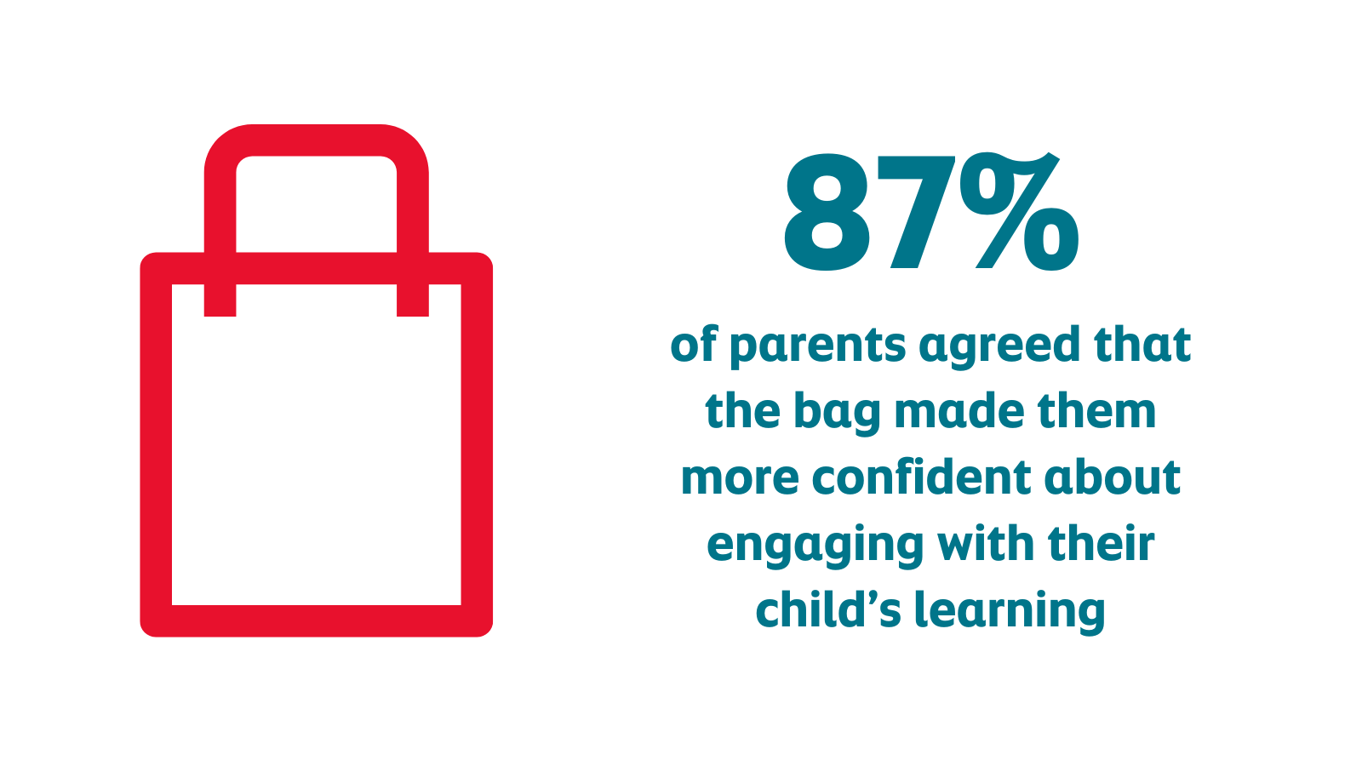
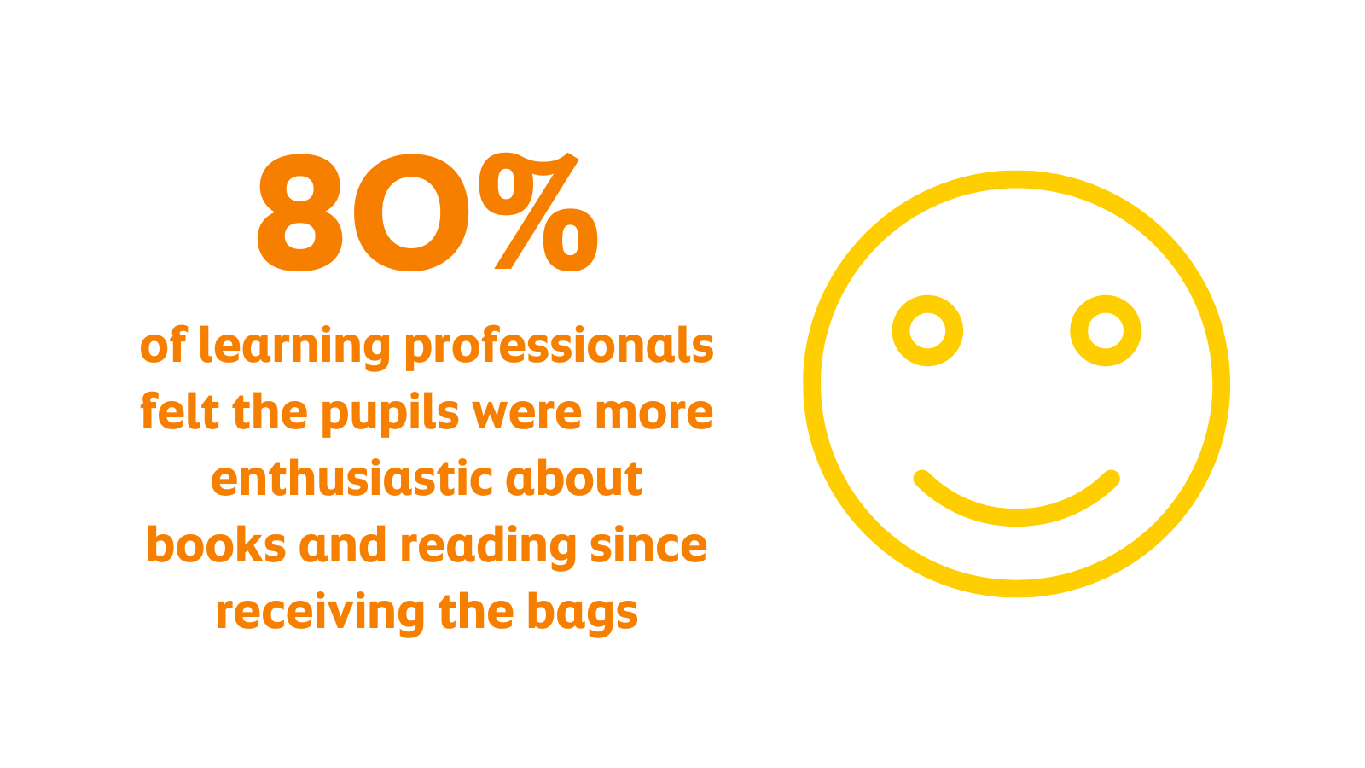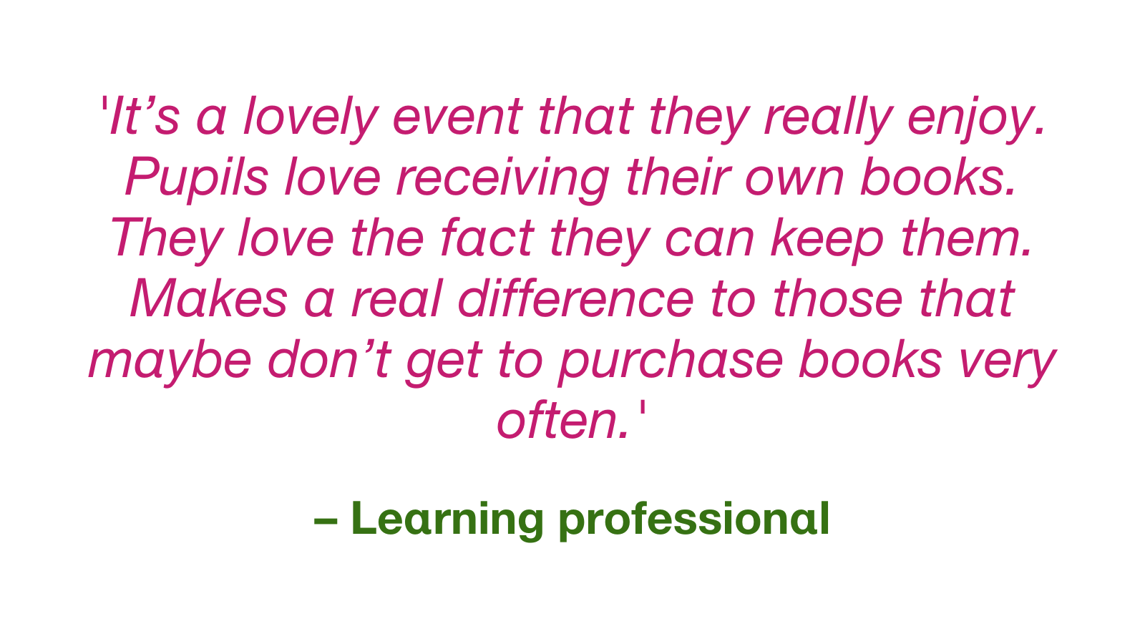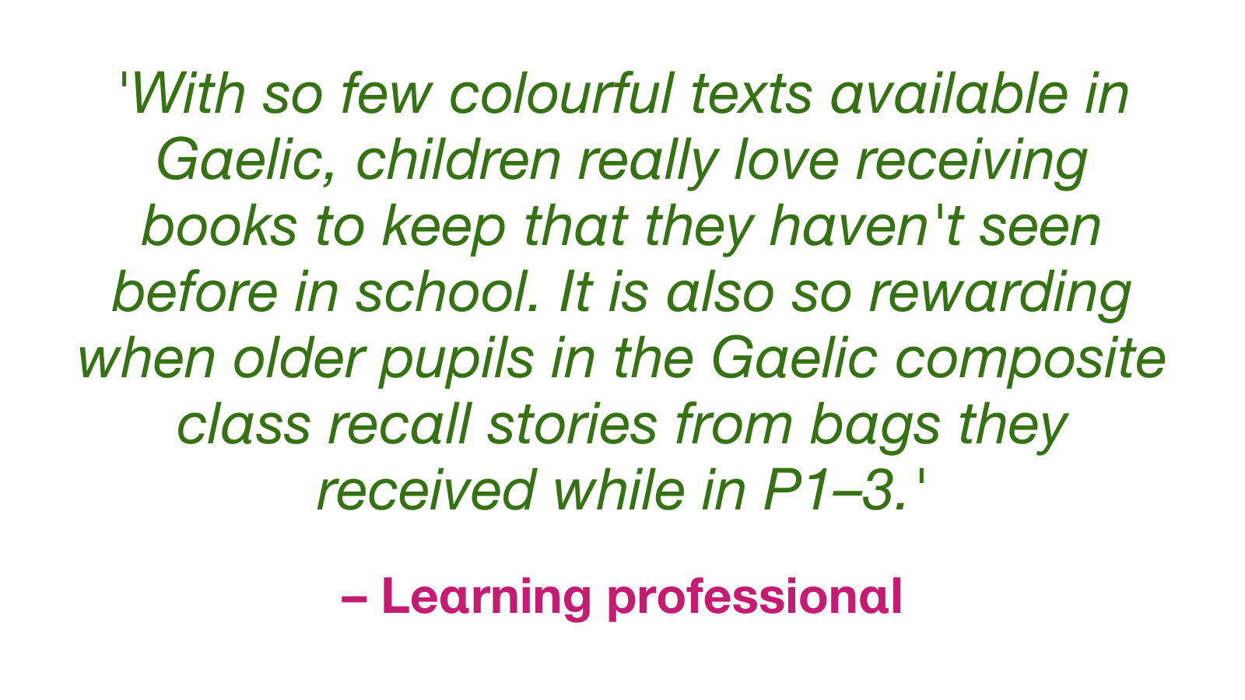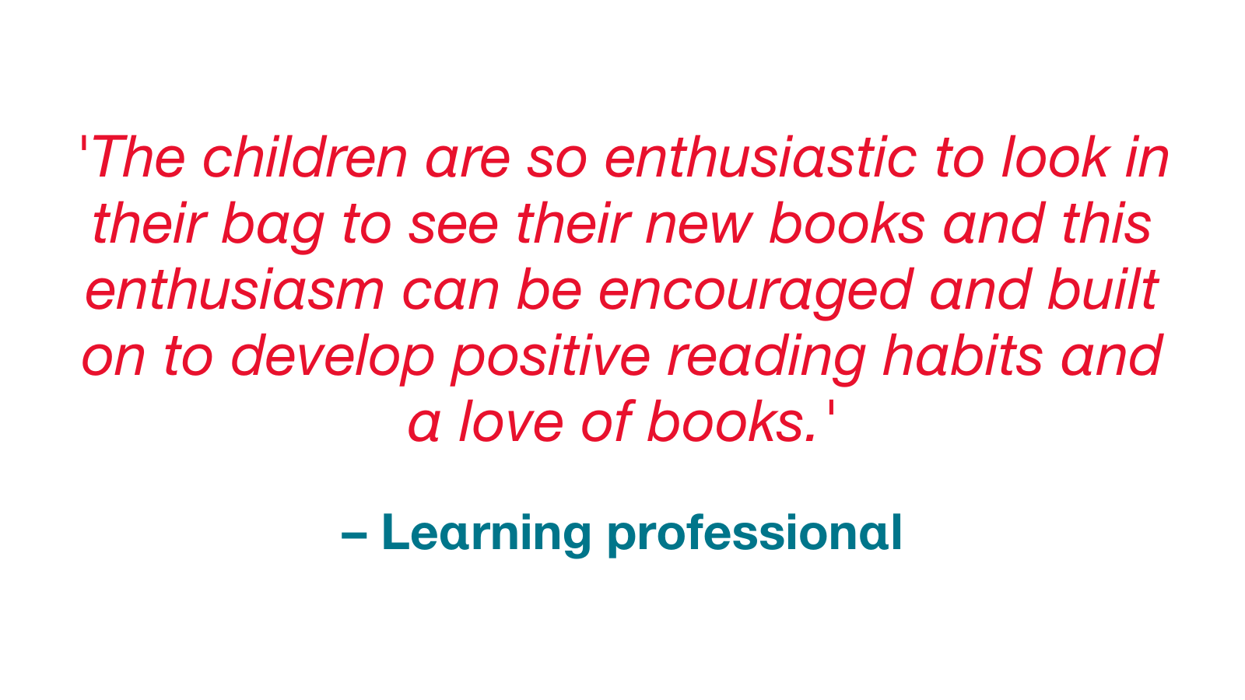

Conclusions

The gifting of P2 and P3 bags is intended to support Read, Write, Count, which aims to:
- Contribute to the joint aims of raising attainment for all and closing the attainment gap, with the focus on the latter
- Provide resources and advice to parents and children to support fun and accessible home-based learning (incorporating growth mindset principles, particularly in relation to numeracy)
- Ensure good integration between the bags and the wider social marketing campaign (in line with the strategic approach of belief, competency and behaviours)
- Secure buy-in and support from teachers and other practitioners, such as library staff and family/community learning

This evaluation backs up existing research that shows if books and materials are explored in school first to allow children to become familiar with and excited by the materials, families are far more likely to use them together at home.
The gifting bags continue to spark interest and excitement for reading and learning.
82% of parents and carers agreed that receiving the bags gave them new ideas or ways of doing things with their child, suggesting that the programme provides a useful starting point for some parents and an additional source of information for others.
There is an overwhelming positive response to the quality of the books and other materials gifted in the Read, Write, Count bags. 90% of respondents liked all the items in the bags; the minority who did not like a particular item would have preferred an additional book.
80% of learning professionals felt the pupils were more enthusiastic about books and reading since receiving the bags.
A key impact of the programme for many learning professionals was ensuring that their pupils had learning resources at home. This was particularly important to teachers with pupils from economically disadvantaged backgrounds.

