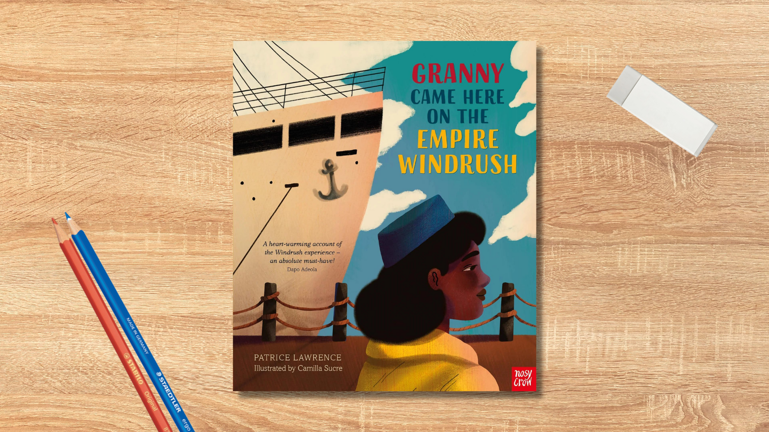

Read Woke: Granny Came Here On The Empire Windrush
Activity ideas to support classroom use of the book Granny Came Here On The Empire Windrush by Patrice Lawrence, illustrated by Camilla Sucre.

First level

Resource created by Scottish Book Trust

scottishbooktrust.com
Scottish Book Trust is a registered company (SC184248)
and a Scottish charity (SC027669).

Contents
Scottish Book Trust 2
Read Woke 2
Read Woke South Ayrshire 3
How to use this resource 3
Learning activities 4
Further resources 7

Scottish Book Trust
Scottish Book Trust is a national charity that believes everyone living in Scotland should have equal access to books. Our work provides opportunities to improve life chances through books and the fundamental skills of reading and writing. Access to books and a love of books bring many important benefits from family bonding and advancing children’s learning, to unlocking creativity, helping employability and improving mental health and well-being. Scottish Book Trust aims to support all communities across Scotland, with particular focus on those who are vulnerable and under-represented.

Read Woke
‘Read Woke is a movement. It is a feeling. It is a style. It is a form of education. It is a call to action; it is our right as lifelong learners. It means arming yourself with knowledge in order to better protect your rights.’
– Cicely Lewis, Founder of Read Woke
The Read Woke challenge was developed by Cicely Lewis in Georgia, USA in 2017. Motivated by the political climate and seeing students grapple with issues of social injustice daily, Cicely realised the need to empower them with knowledge. Knowledge about the issues they (and others) face and knowledge about their own rights. The aim is to educate children and young people through reading. Find out more on the Read Woke website.

Read Woke South Ayrshire
The Read Woke challenge was brought to Scotland in 2020 via the School Library Improvement Fund. A collaboration of South Ayrshire secondary schools created a booklist and incentivised reading programme for S1–6 students with the aim of improving representation within library collections, celebrating diversity and encouraging students to be socially aware. Further backing from the Scottish Library and Information Council has allowed this work to be expanded into a primary school setting with Read Woke South Ayrshire Primaries launched in February 2022. Providing carefully chosen books to schools – along with tailor-made resources and activities through the year – is allowing us to educate and empower students to engage with social justice issues and stand up for the rights of themselves and others. The resources produced will help schools embed themes of equality, diversity, social justice, and human rights throughout their curriculum from P1–7. Learn more on the Read Woke South Ayrshire website.
How to use this resource
The aim of this resource is to support the use of Granny Came Here on the Empire Windrush by Patrice Lawrence and illustrated by Camilla Sucre in a classroom setting. Activities reflect some of the central book themes and scenes and cover a range of curriculum areas at first level.
Granny Came Here on the Empire Windrush features themes of love, resilience, loneliness, missing home, family and courage. Activities within this resource primarily reflect this positive representative theme.
With all Read Woke resources, we highly recommend that you read the book before using it with your class and use your best judgement about whether teaching this topic is appropriate for the children in your class. It is important teachers are mindful of discrimination and inclusivity when approaching the book. For more information on learning about Windrush and racism, see the end of this resource.

Learning activities

Activity 1: Make a Collaborative Display
HWB 1-01a, HWB 1-05a, HWB 1-14a, RME 1-09b
Ava really loves and admires her Granny. What are all the things she loves about this special person in her life? Think of someone you really love and admire. What are the things you love and admire about them? Discuss in small groups.
List all of the things that you can do to be a good friend to others. Draw a picture of one thing you can do to show someone that you care about them. Create a classroom display of pictures and photographs showing friendship, caring, sharing, fairness, equality and love.

Activity 2: Create a Storyboard
SOC 1-03a, EXA 1-03a, EXA 1-05a
Ava’s Granny mentions the famous musician Winifred Atwell, the nurse Mary Seacole and the activist Rosa Parks. In groups create a storyboard strip of each of these women using evidence from the past. Find out where they were born, when they were born and what made them famous.
Play the game Who Am I with different people acting as Winifred, Mary or Rosa and see how quickly you can identify them. Remember the actors can only answer YES or NO.

Activity 3: Listen and Talk It Out
LIT 1-04a, LIT 1-16a, LIT 1-07a, LIT 1-09a
Listen to the audio recording of the book and consider what you think the main ideas of the story are. Discuss them with your partner then share your ideas with the class. Other people may have different ideas. Can you think about the story the way they see it too? Are there any questions you’d like to ask about what they have said?

Activity 4: Dance to the Music
EXA 1-08a, EXA 1-18a
Play a piece of music by Winifred Atwell. How does it make you feel? Work with a partner to create a short dance sequence to the music using travel, turn, jump, gesture, pause and fall – staying safe at all times and being as creative as you wish. You can add in vocal percussion as you dance. You can use this YouTube video from Les Mills Born to Move for inspiration (3 minutes, 23 seconds).

Activity 5: Leaving Home
MNU 1-11a, TCH 1-02a, 1-12a, TCH 1-14a, TCH 1-14b, SCN 1-15a,
Ava’s Granny brought an empty jar, a smooth grey pebble, a hat and a pair of gloves in her grip. What would you want to take with you if you were going to move to another country. You need to be able to fit it all into a small case. Weigh the individual items and your filled case. Would you be able to carry it for a long time?
Ava’s Granny’s case was made of cardboard which she didn’t think was a good idea for travelling in rainy England. What kind of material would you choose? Design a case which would be suitable for all weathers and easy to carry. Think about the best shape for a case and consider what the handle and locks should be like too. Choose design colours and patterns you like. Ask a friend to try it out and tell you what they think. Is there anything you could do to improve it? Consider which materials would be best to use to protect the environment.

Activity 6: Our Tree of Gold
RME 2-02b, RME 2-05b
Make a class tree – it can be a picture of a tree or a 3D tree. Ask each child to draw on a luggage label a picture of someone who is more precious than gold to them and write the name of that person on the back of the label. Look at your tree and all of the more precious than gold people in our lives and talk about what makes them so special.

Activity 7: Make Tasty Caribbean Food
TCH 2-02b
Ava’s Granny really missed the food from her home. Choose a Caribbean recipe you can cook and taste together. You’ll need to purchase the ingredients and weigh them out carefully. Talk about where the ingredients have come from. Can they be grown locally? Here are some recipes on the Tesco website:
- Griddled pineapple rings with coconut caramel
- Jamaican ginger cake
- Reggae drumsticks with pineapple chutney

Activity 8: Plants and produce
SCN 1-03a
Look at the plants, vegetables and fruits grown in Scotland and compare them with some of those grown in Jamaica. Explore the weather and climate conditions needed by each of these plants. Grow a variety of plants in school – indoors and outdoors. Create a table or chart showing what each plant needs to help it grow successfully and how it has been used to benefit society.

Further resources

Read Woke
- Read Work South Ayrshire website
- Read Woke resources on the Scottish Book Trust website
- Scottish Book Trust book lists on books to understand the migrant experience and books for Black History Month.

Windrush
- BBC News: What was life like on-board the Empire Windrush? (2 minutes)
- Footage of the Empire Windrush’s arrival in the U.K. (2 minutes, 49 seconds)
- The British Library’s Windrush teaching resources
- Royal Museums Greenwich teaching resources
- Reading Museums resources for Windrush Day
- Scottish Book Trust: Read Woke resource on The Good Turn by Sharna Jackson and Windrush Child by Benjamin Zephaniah

Anti-Racism
- Education Scotland: Promoting race equality and anti-racist education
- Time for Inclusive Education: Resources
- Show Racism the Red Card
- Scottish Book Trust: Understanding and challenging racism
- Scottish Book Trust: Anti-racist learning resources

