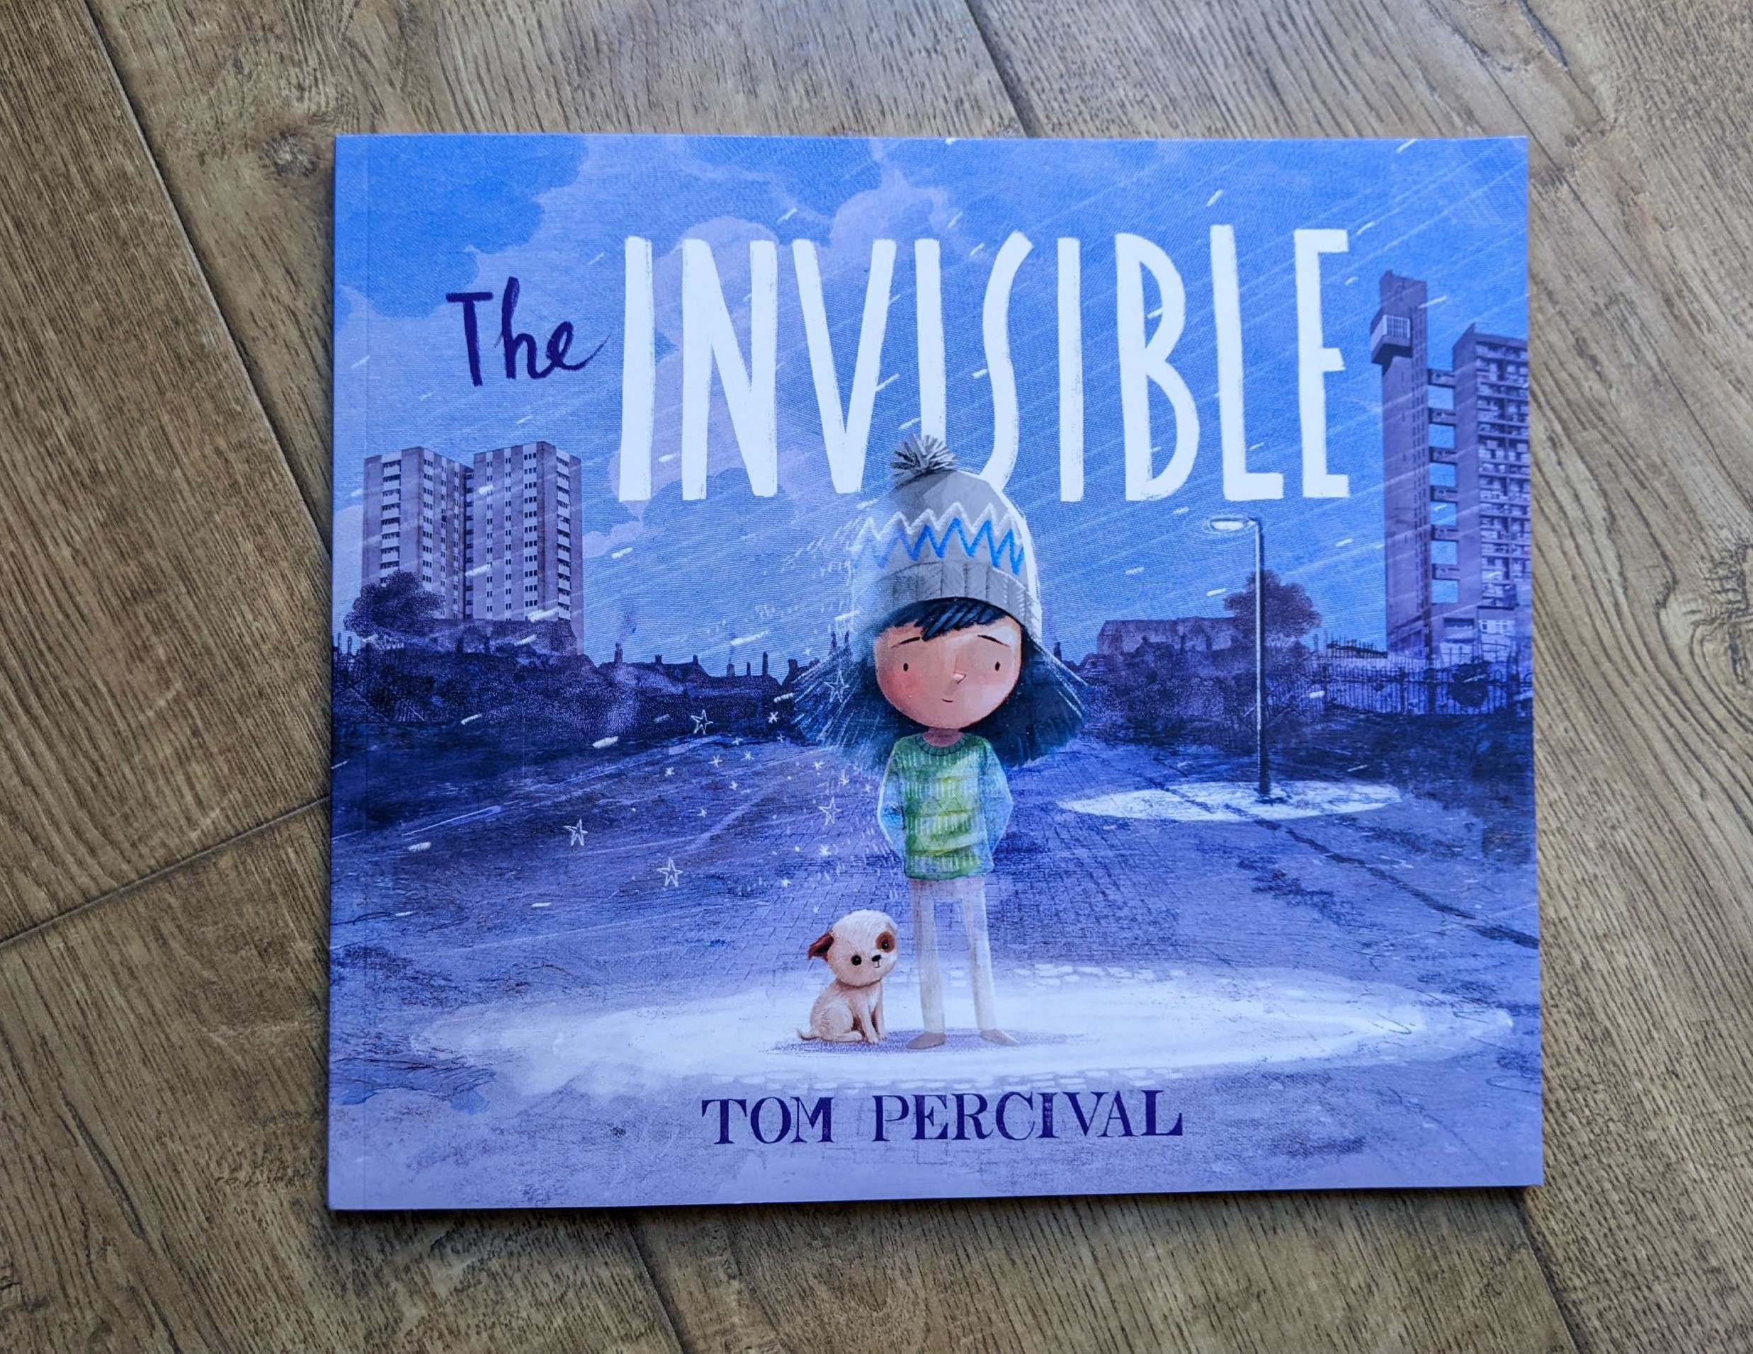

Read Woke: The Invisible
Activity ideas to support classroom use of the book The Invisible by Tom Percival

CFE First and Second Level

Resource created by Scottish Book Trust

scottishbooktrust.com
Scottish Book Trust is a registered company (SC184248)
and a Scottish charity (SC027669).

Contents
Scottish Book Trust 3
Read Woke 3
Read Woke South Ayrshire 3
How to use this resource 4
Lower primary learning activities 4
Upper primary learning activities 8

Scottish Book Trust
Scottish Book Trust is a national charity that believes everyone living in Scotland should have equal access to books. Our work provides opportunities to improve life chances through books and the fundamental skills of reading and writing. Access to books and a love of books bring many important benefits from family bonding and advancing children’s learning, to unlocking creativity, helping employability and improving mental health & well-being. Scottish Book Trust aims to support all communities across Scotland, with particular focus on those who are vulnerable and under-represented.

Read Woke
‘Read Woke is a movement. It is a feeling. It is a style. It is a form of education. It is a call to action; it is our right as lifelong learners. It means arming yourself with knowledge in order to better protect your rights.’
– Cicely Lewis, Founder of Read Woke
The Read Woke challenge was developed by Cicely Lewis in Georgia, USA in 2017. Motivated by the political climate and seeing students grapple with issues of social injustice daily, Cicely realised the need to empower them with knowledge. Knowledge about the issues they (and others) face and knowledge about their own rights. The aim is to educate children and young people through reading. Find out more on the Read Woke website.

Read Woke South Ayrshire
The Read Woke challenge was brought to Scotland in 2020 via the School Library Improvement Fund. A collaboration of South Ayrshire secondary schools created a booklist and incentivised reading programme for S1–6 students with the aim of improving representation within library collections, celebrating diversity and encouraging students to be socially aware. Further backing from the Scottish Library and Information Council has allowed this work to be expanded into a primary school setting with Read Woke South Ayrshire Primaries launched in February 2022. Providing carefully chosen books to schools - along with tailor-made resources and activities through the year – is allowing us to educate and empower students to engage with social justice issues and stand up for the rights of themselves and others. The resources produced will help schools embed themes of equality, diversity, social justice, and human rights throughout their curriculum from P1–7. Learn more on the Read Woke South Ayrshire website.

How to use this resource
The aim of this resource is support the use of The Invisible, written and illustrated by Tom Percival, in a classroom setting. Activities reflect some of the central book themes and scenes, and cover a range of curriculum areas for first and second level.
In The Invisible, themes of homelessness and poverty are central to the story. Isabel becomes invisible to others in society because of her changed family circumstances. As Tom outlines on the final page of the book, ‘poverty isn’t the only way in which people get overlooked in society; there are many ways that the world has of saying “you don’t belong here”’, and other characters in the book also become invisible for a range of different reasons.
It is important that teachers are mindful of inclusivity when sharing this book. According to the Child Poverty Action Group, there are 4.3 million children living in poverty in the UK. That’s nine children in a classroom of 30. Be aware that some pupils will have similar experiences to Isabel. The Poverty Alliance have lesson plans to support discussion of poverty and children’s rights in class, and Amnesty International have great resources to support discussions of children’s rights and how these are not being met.

Lower primary learning activities

Literacy and English

Activity 1: Reading aloud (LIT 0-01a)
Read the story aloud to pupils. Ask pupils: What do you think it is about? Why do you think Isabel became invisible?

Activity 2: Happy senses (ENG 1-30a)
Ask pupils to think of a really happy time at home or school. Write down the things that made then happy, what they saw, what they smelt, what they heard and how they felt.

Activity 3: Acrostic poems (LIT 1-26a)
Write an acrostic poem using the letters of the word HOME. Start by writing down all the words which come to mind when the class think of ‘home’ and then organise the ideas to create a poem.

Activity 4: Write your own story (ENG 1-31a)
Choose one of the other characters who is invisible and write a story together about them. Where do they live? What is their home like? What matters to them? Consider why they might not be seen. Why do pupils think they are invisible and disappearing?

Health and wellbeing

Activity 1: What makes you happy? (HWB 1-01a)
Read the story individually or in pairs. Make a list of things that made Isabel feel happy/unhappy, and then ask pupils to make a list of things that make them happy/unhappy. Compare lists. Do the same things makes us feel happy/unhappy? Do pupils think there is anything they could do to help Isabel feel happier?

Activity 2: Pack a suitcase (HWB 1-07a)
Ask pupils: if you had to leave home and had to take only a few things with you, what would they be? Talk about the difference between what we want and what we need and discuss what we need to prioritise in our lives to help us when we need support.

Social studies

Activity 1: Make a difference (SOC 1-08a)
At the end of the story we are reminded that Isabel has made a difference in her local community. Discuss as a class what pupils could do to make a difference: At home? At school? In the community?

Activity 2: Weather charts (SOC 1-12a)
Look at the symbolism of the weather in the book. Talk to pupils about how it mirrors Isabel’s feelings. What is the weather like when she is sad/happy/struggling? Make a weather chart for a week or a month so that the class can record the weather. Collect rainwater in a jar outside and measure the rainfall. You may wish to record how pupils feel on different days too.

Activity 3: Community facilities (SOC 1-14a)
What are the community facilities that pupils are aware of in their local area? Make a map of them to show what’s available (park, library, shops, bus stops, recycling areas).

Mathematics and numeracy

Activity 1: Counting characters (MNU 0-02a)
Ask pupils to count all of the people who are invisible in the book. Who is the first person to seem to be invisible? Who is the last person to seem to be invisible? What do pupils notice about the number of people in the groups on the pages starting ‘And the more people came together. . .’?

Sciences

Activity 1: Rainy days (SCN 1-15a)
Explore different materials. Choose one which would be best for dressing the class teddy or mascot on a rainy day. Discuss why that is a good choice of material. Do the same for dressing the teddy on a windy day, a sunny day or a snowy day. What will be required to keep teddy comfortable?

Activity 2: Find the light (SCN 1-15a)
Using batteries and bulbs or torches or flameless tea-lights, can pupils create some form of lighting for school or home? How can pupils attach the lights to make sure teddy has lighting where he needs it?

Technology

Activity 1: Create a home (TCH 1-02a)
Create a home for class teddy bear using a cardboard box. Decorate the interior and exterior and make furniture using recycled modelling materials and found materials such as twigs, pebbles and pine cones.

Expressive arts

Activity 1: Draw along with Tom Percival (EXA 1-07a)
Watch this video of Tom Percival talking about The Invisible (24 minutes, 38 seconds). Why do pupils think he wanted to write this book? How does the story make them feel? Draw along with Tom to illustrate Isabel. Ask pupils in what way is their picture like Tom’s and in what way is it different from Tom’s?

Activity 2: How do they feel? (EXA 1-13a)
While the teacher reads the story each child can role-play one of the characters showing with their body language and facial expressions what each character is feeling.

Activity 3: Create a song (EXA 1-17a)
Choose a simple melody such as “Twinkle Twinkle Little Star” and work in groups to put words to the melody to create a song about helping others. Use the illustrations to help pupils and create a musical accompaniment with percussion instruments.

Modern languages

Activity 1: Language labels (MLAN 1-13a)
Photocopy and label the “And more people came together…” pages and label the page with as many modern language words as you can for the colours, people, objects and animals.

Upper primary learning activities

Shelter activities
HWB 2-08a
Read The Invisible to pupils. Talk about the key themes of the book. What did they think of the story? How does Isabel feel during the book? How might some of the other characters be feeling? Look especially at the early pages where Isabel and her family have money worries and realise they have to leave their home.
Shelter have some great resources to support discussing homelessness and housing difficulties in class. Use their primary support materials to take part in the Shelter 50p challenge to raise awareness of homelessness and housing difficulties.

Paired reading
LIT 2-10a
Pupils can use The Invisible to practise reading for an audience, by taking part in paired reading with P1/2 pupils or to younger children in an Early Years setting. They can also prepare questions and activities to help engage the younger children. Explore Scottish Book Trust’s Paired Reading Toolkit for ideas and activities to support running a paired reading project, including special mission cards to engage reluctant readers and drama activities to improve their confidence in reading aloud.

Story soundtrack
EXA 2-17a
Pupils can create a soundtrack to the reading of the story to enhance the experience for younger pupils by exploring sounds of voice and musical instruments and using music technology to record the soundtrack.

Leaving home
TCH 2-04b
Read The Invisible together as a class, then use the Oxfam resource materials to help your pupils understand some of the reasons why people might move between and within countries, to develop critical thinking skills and build empathy for those forced to leave their homes. Create an assembly PowerPoint to share with the whole school.

What support in your local area?
SOC 2-16a
Pupils can explore what provision is made in the local community for homeless people and give a presentation to peers to share what they have learnt. This can be done by creating a model, a mapping of services, a collage of photographs, a poster or a PowerPoint presentation.

