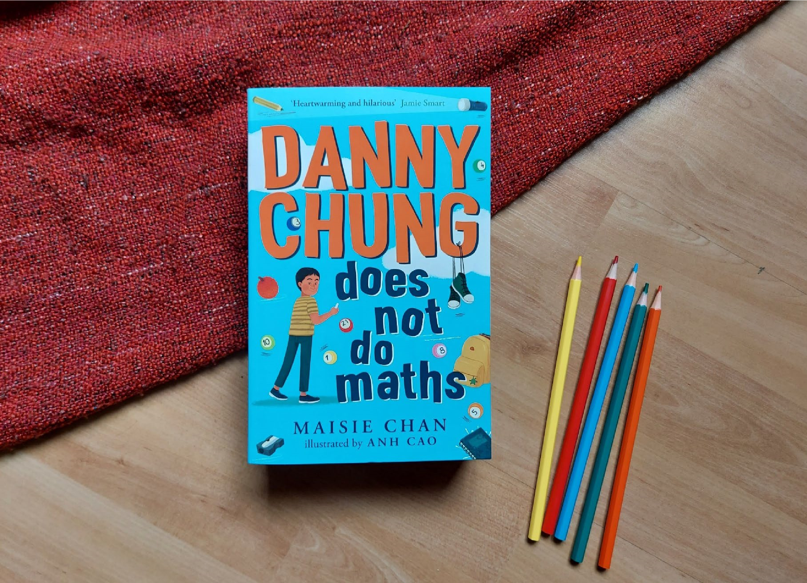

Read Woke: Danny Chung Does Not Do Maths
Activity ideas to support classroom use of Danny Chung Does Not Do Maths by Maisie Chan

CFE Second Level

Resource created by Scottish Book Trust

scottishbooktrust.com
Scottish Book Trust is a registered company (SC184248)
and a Scottish charity (SC027669).

Contents
Scottish Book Trust 2
Read Woke 2
Read Woke South Ayrshire 3
Learning activities 4
Q&A with Maisie Chan 7

Scottish Book Trust
Scottish Book Trust is a national charity that believes everyone living in Scotland should have equal access to books. Our work provides opportunities to improve life chances through books and the fundamental skills of reading and writing. Access to books and a love of books bring many important benefits from family bonding and advancing children’s learning, to unlocking creativity, helping employability and improving mental health & well-being. Scottish Book Trust aims to support all communities across Scotland, with particular focus on those who are vulnerable and under-represented.

Read Woke
‘Read Woke is a movement. It is a feeling. It is a style. It is a form of education. It is a call to action; it is our right as lifelong learners. It means arming yourself with knowledge in order to better protect your rights.’
– Cicely Lewis, Founder of Read Woke
The Read Woke challenge was developed by Cicely Lewis in Georgia, USA in 2017. Motivated by the political climate and seeing students grapple with issues of social injustice daily, Cicely realised the need to empower them with knowledge. Knowledge about the issues they (and others) face and knowledge about their own rights. The aim is to educate children and young people through reading. Find out more on the Read Woke website.

Read Woke South Ayrshire
The Read Woke challenge was brought to Scotland in 2020 via the School Library Improvement Fund. A collaboration of South Ayrshire secondary schools created a booklist and incentivised reading programme for S1–6 students with the aim of improving representation within library collections, celebrating diversity and encouraging students to be socially aware. Further backing from the Scottish Library and Information Council has allowed this work to be expanded into a primary school setting with Read Woke South Ayrshire Primaries launched in February 2022. Providing carefully chosen books to schools - along with tailor-made resources and activities through the year – is allowing us to educate and empower students to engage with social justice issues and stand up for the rights of themselves and others. The resources produced will help schools embed themes of equality, diversity, social justice, and human rights throughout their curriculum from P1–7. Learn more on the Read Woke South Ayrshire website.
How to use this resource
The aim of this resource is to support the use of Danny Chung Does Not Do Maths by Maisie Chan and illustrated by Anh Cao in a classroom setting. Activities reflect some of the central book themes and scenes, and cover a range of curriculum areas at second level.
In Danny Chung Does Not Do Maths, issues of racism and discrimination are central to the narrative. Danny is the subject of negative stereotyping based on his race, and Danny and his friend Ravi experience bullying by a peer. Nai Nai is also subject to discrimination from her peers at bowls and bingo.
It is important that teachers are mindful of discrimination and inclusivity when approaching this book. There are some fantastic resources and support materials available from Show Racism the Red Card. Scottish Book Trust has also worked with Show Racism the Red Card to create a resource on Understanding and Challenging Racism.
However, Danny Chung Does Not Do Maths is an overwhelming positive and heartwarming story. Joining Danny as his relationship with his grandma changes and develops is a wonderful reading experience and at its heart, this book is a humorous tale of friendship, family and identity. Pupils are sure to enjoy sharing this book in class.
Learning activities

Literacy and English

Activity 1: What are stereotypes? (LIT 2-08a)
In the story, there are some examples of characters being stereotyped. Discuss and explain what a stereotype is. Ask pupils to list places where stereotypes most often appear, such as in film or advertising. Discuss why these stereotypes are harmful.

Activity 2: “A Me-Shaped Box” (ENG 2-31a)
If you have a copy of Woke: A Young Poet’s Call to Justice, read the poem “A Me-Shaped Box” before or after the stereotype discussion above. Ask pupils how the poem makes them feel. Next ask pupils to imagine how Danny would respond to the poem. Let pupils write a creative response to the poem from Danny’s perspective. It could be a piece of personal writing, a poem, or a drawing.

Activity 3: Newspapers and social media (LIT 2-18a)
Leading on from the stereotype discussion, look at the differences between newspaper reports and social media stories. Discuss the difference between fact and opinion and how you can tell which is which. Give pupils some examples to look at. Can pupils pick out the facts?

Health and wellbeing

Activity 1: Relationships and family (HWB 2-44a)
After reading the book, talk about the different relationships in the story. Discuss and identify different kinds of friendships and relationships. Ask pupils to make charts of two of the characters and their relationships. Next, work together to map the transition in the relationship between Danny and his gran. Identify key points that changed the relationship and helped Danny change his attitude towards his gran.

Activity 2: What makes a good friend? (HWB 2-45a)
Look at parts of the story that highlight difficulties in the relationship Danny has with his friends. Discuss the skills required to manage changing relationships. Work with pupils to create a recipe for being a good friend. Look at: pages 30, 112, 115 and 215. Next, ask pupils to draw around their hands and cut them out to create a hand. Write key words from the discussion on friendship onto the hands. Display the hands together in a circle to signify friendship.

Activity 3: Bullying word bank (HWB 2-29a)
Identify and discuss the abusive and bullying behaviour in the book. Use circle time to talk about experiences of similar behaviour. Some of the adults at the bingo are not welcoming to Nai Nai, and Carter bullies Danny and Ravi. Ask pupils what they think of Danny’s reaction and solution? Create a word bank and class guide for dealing with instances of bullying and abuse. Look at pages 30, 144, 145, 172 and 224.

Activity 4: Create together (HWB 2-23a)
Danny and Ravi work together on the comic strips, each using their own talents to create them together. Ask pupils to identify their own special skill and find a partner who has a different skill. Work together to create something together. It could be art, music, poetry, dance, or storytelling.

Religious and moral education

Activity 1: Lucky colours (RME 2-07a)
Danny mentions lucky colours and numbers in the story. Look at the beliefs in one of the religions you are studying relating to luck and life. Look at traditional Chinese beliefs and sayings relating to luck and life. Compare these with Chinese beliefs. What are the similarities?

Social studies

Activity 1: Exploring your local area (SOC 2-10a)
Danny takes Nai Nai around the local area to find activities to keep her entertained. Ask pupils to explore their local area and identify places of interest. Create a map for Nai Nai of the local area including fun activities and attractions that would make her feel welcome.

Expressive arts

Activity 1: The Golden Ratio (EXA 2-03a)
Collect and display examples of the golden ratio in nature and art. Use these as inspiration for pupils to create their own work following the golden ratio. Once they are finished, put pupils in pairs to discuss what works well and what could be improved in their work.

Activity 2: Takeaway role play (EXA 2-13a)
Danny is worried about the calculations he has to do in the takeaway. Role play working at the takeaway. Make class menus to help pupils practise counting and improve their speed of calculation. Use drama skills and techniques to help pupils with their maths.

Mathematics and numeracy

Activity 1: Nature, arts and maths (MTH 2-12a)
Danny presents on maths in nature and art. Work with a partner to create a presentation on the impact of maths in life, school and work. Run a class discussion on the role of mathematics in the creation of important inventions, now and in the past.

Activity 2: The Fibonacci Sequence (MTH 2-13a)
Like Danny, learn about the Fibonacci sequence. Explain and use a rule to extend well known number sequences including square numbers, triangular numbers and Fibonacci sequence.

Technology

Activity 1: Create a computer game (TCH 2-13a)
One of Danny’s classmates uses a computer game to make his maths presentation. Look at simple computer processes and coding together. Compares activities consisting of a single sequence of steps, such as dancing, with those consisting of multiple parallel steps, like making dinner.

Q&A with Maisie Chan

Question 1: Why do you think it’s important to see characters like the Chung family represented in children’s books?
This is such a good question. We've heard a lot about mirrors and having diverse and inclusive books for children, yet in 2021 we still have very few books with British Chinese or British East and Southeast Asian characters. Occasionally, you will find a book has one British Chinese character but rarely do you see full-formed, well thought out characters that represent the diaspora. Often British Chinese people are seen as 'other' or 'foreign' even though we've been born here. I wanted to show a loving, hard-working family who have struggles just like anyone else. There are three generations of Danny's family, and also another British Chinese family that are used in the book as a contrast. It's imperative to see humanised British East Asian and Southeast Asian (BESEA) characters in books, especially now as there is a lot of blame and racism abuse being directed towards the BESEA community because of COVID-19 and the fact that it originated in China. Children like Danny are being singled out all over the country and made to feel small. I hope this book can make them feel better about themselves and seen.

Question 2: Which character do you relate to most in the book?
I probably relate to Danny the most. I used to love drawing when I was younger. More than writing actually! I won my first art competition when I was 5! My picture of Little Red Riding Hood was put on display in my local library and I won £5 which was a lot of money in those days. Often British Chinese people are seen as the model minority who become doctors and lawyers and that's not always true because there are a lot of creatives in the BESEA community but we need more and we need more people like Danny who want to create. Also I met my Chinese grandmother in my late 20s and we have a similar relationship to the one in the book as I couldn't speak Cantonese and my grandmother couldn't speak English that well. I also would see 'cool' people and want to be part of those gangs, but never really was.

Question 3: What was the most fun thing about writing this book?
Writing the book made me laugh quite a bit! The bowling scene made me laugh out loud (you'll have to see what happens by reading the book!) and also Mrs Cruickshanks and her dialogue made me chuckle. The whole book was a pleasure to write to be honest. That doesn't always happen, but with this book it did and I think you can sense that when you read it. I also enjoyed putting in little snippets of British Chinese culture that readers from that background might understand more than non-Chinese people. And I also liked putting in relevant references for today's primary-aged children such as Pokémon and Blasters which are similar to other toys that kids play with today.

Question 4: And what was the most difficult or challenging thing about writing the book?
The most difficult thing was writing Nai Nai and her interaction with Danny as she doesn't speak English in the book and she appeared in most of it! So I had to make sure I got her physicality right and created humour through her movements and Danny's reactions to them instead of with dialogue. And I was very conscious of not mocking her for being 'different' to Danny, she's as much a central character as he is. So it was a fine balance to create humour without it being disparaging humour. I didn't want to show anything Chinese to be disgusting or have internalised racism in the book which you might see in other books with similar characters. It was important for me to get it just right and I had other British Chinese writers check the Chinese language, the representation and authenticity.

