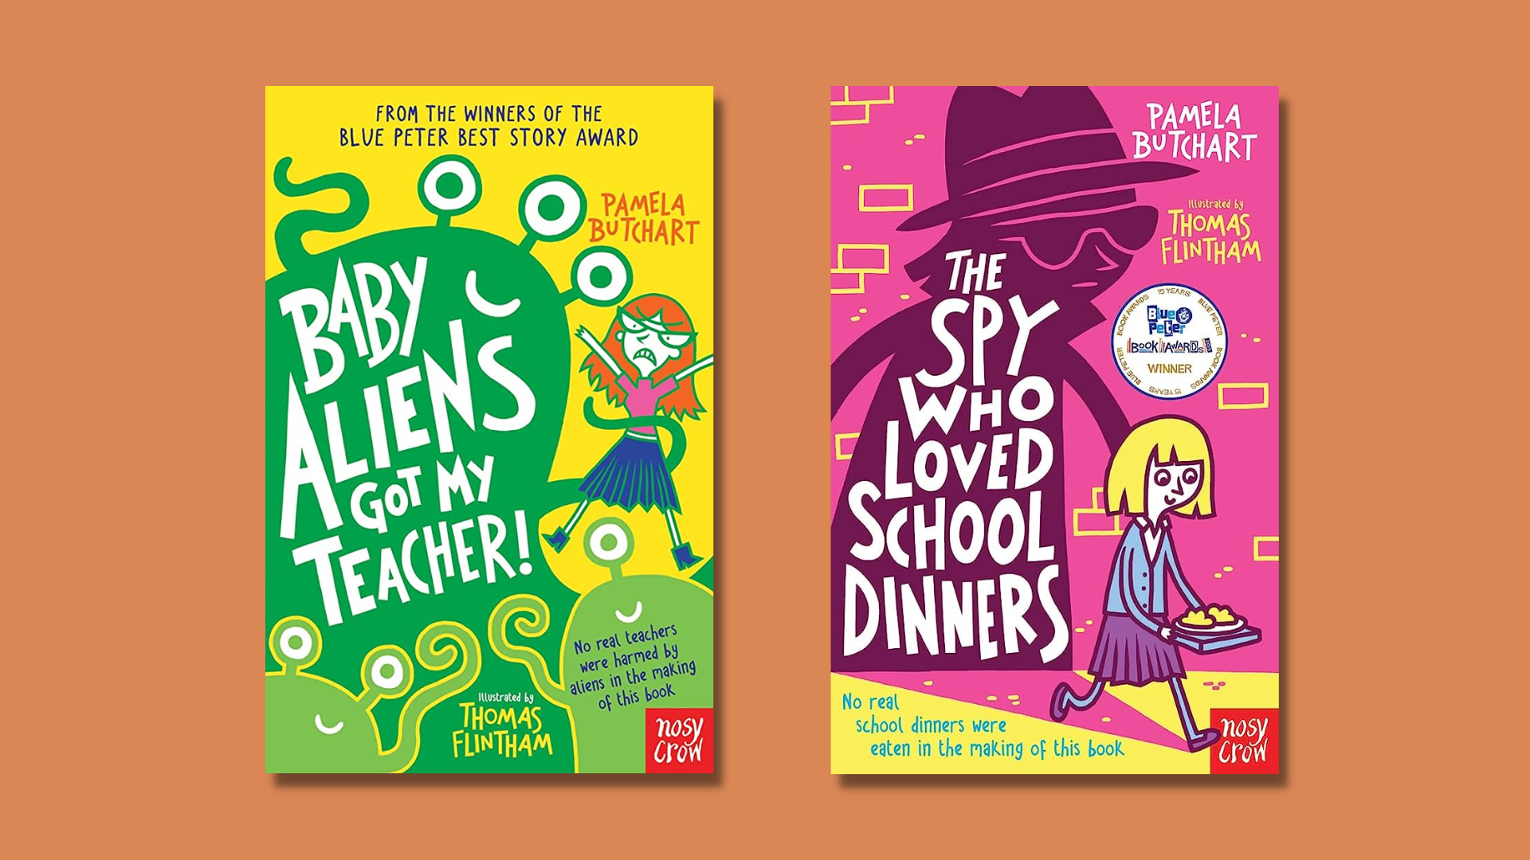

Baby Aliens Got My Teacher! learning activities
Creative activities to tie into Pamela Butchart’s Baby Aliens series.

CFE First Level

Resource created by Scottish Book Trust

scottishbooktrust.com
Scottish Book Trust is a registered company (SC184248)
and a Scottish charity (SC027669).

Contents
About this resource 2
Baby Aliens Got My Teacher learning activities 2
The Spy Who Loved School Dinners learning activities 4
Further resources 6

About this resource
This resource contains activities to support the use of the Baby Aliens Got My Teacher! or The Spy Who Love School Dinners by Pamela Butchart in the classroom. These are the first two books in the popular Baby Alien series. You could complete some of these activities alongside reading either book together as a class, or you could use these activities after finishing the book/s as a class novel.

Baby Aliens Got My Teacher learning activities

Activity 1: Produce a TV news broadcast
LIT 1-28a, TCH 1-01a
Izzy’s school will be buzzing with rumours after the numerous chaotic scenes involving Izzy and her friends! Ask your pupils to set the record straight by imagining they are reporters for the local TV news. Their job is to write a news script explaining what has actually happened (and you could even record the ‘broadcast’).
Pupils will need to start off by writing about the classroom incidents, then interviewing Izzy and her friends about why they behaved in the way they did. Pupils could focus on what really happened, with details about Miss Jones’ engagement and the teddy bears, and how Izzy and her friends got it wrong.
Split pupils into small groups and ask them to consider what makes up a news report, e.g:
- An anchor’s introduction from the newsroom
- An on the scene reporter
- An eyewitness interview
- An expert’s account for example from a doctor, criminal psychologist or police detective
Ask pupils to look back through the book to compile information that they want to include in their report. Pupils can then allocate roles and write a script or bullet points for each section. The BBC has some great tips on how to plan and structure a news report.
Once the pupils have created and compiled their news reports it is time to get filming! When all the films are completed you can hold a screening to watch each report. Ask the pupils to consider the differences and similarities between each report. Which details did some people focus on which others left out? Which characters were chosen for the interviews and why?
Activity 2: Alien awareness posters
EXA 1-03a, LIT 1-28a, LIT 1-29a
Ask your pupils to create their own malevolent aliens, thinking about what they look like, what their plans are, how they take over human hosts and how you can spot them. Then, get your pupils to design some posters to help people stay safe from attacks by the aliens they have created.

Activity 3: Create a campaign
LIT 1-02a, LIT 1-09a, LIT 1-14a
Jodi is a vegetarian and has one of her famous Jodi Tantrums when she discovers the only vegetarian option in the school cafe is cabbage.
Get your pupils to plan a campaign to encourage the school café to offer more variety for vegetarians. Pupils will need to think about who to contact (and how to contact them) and how to conduct their campaign. Pupils could also think about why the school café might not want to offer more vegetarian options. For example, is it cost effective? How many pupils at Jodi and Izzy’s school are vegetarian? Would there be additional food prep time? You can hold a debate to explore the two different sides of the argument.
Once pupils have planned their campaign, you could share it with another class in school to see if another class finds the arguments persuasive.

The Spy Who Loved School Dinners learning activities

Activity 1: Plan an exchange visit
Ask your pupils to imagine that they are going on an exchange visit to Paris. Incorporate the following tasks:

Travel arrangements
- What would be the cheapest option?
- Is the cheapest option almost the most environmentally friendly? Introduce your pupils to carbon footprints with this video. Ask them to use an online carbon calculator to calculate the amount of Co2 different modes of transport will generate. The Guardian lists some different calculators – you can choose the best one to suit your needs.

Sightseeing
- Research some different places to visit during your time in Paris. The Scholastic website has a great resource which will help you find out more about the famous Parisian landmarks as well as France’s wider history.

Language
- Work on your knowledge and use of the French language for your Paris visit.

Food
- Research different food the French are famous for eating and see if you can make any at school. Hold a French themed food event and invite other classes, parents, or members of the community to attend.

Activity 2: Design your dream library
EXA 1-06a
Maisie has her bedroom in what used to be a library, and the rest of the children are fascinated by this. Ask your pupils to design the ultimate bedroom (or library) for a bookworm. What would be the most important features for a person who loved books, what kind of decorations would be incorporated, and how could your pupils get creative with items of furniture like bookshelves and beds? Ask them to write the design brief and then get to work on some sketches.
If you want to offer some inspiration, Pinterest is a great place to search for creative bookshelves and other furniture, but it’s best to go through yourself rather than allow your pupils to look through, as content isn’t moderated.

Activity 3: Creative writing
ENG 1-31a
Izzy and her friends have extremely active imaginations, which often lead them to the wrong conclusions. Ask your pupils to imagine they are writing a new book featuring Izzy and her friends. The books always start with something strange going on, so your pupils will need to think of a strange situation to get Izzy’s brain ticking over. Ask them how Izzy and her friends might misinterpret the following situations:
- No one has seen the school headmaster leave his office for weeks
- A parents’ meeting is called, but the parents and teachers will not tell the children what the meeting is about
- The school has closed off one of the general-purpose rooms and has banned pupils from entering
What conclusions might Izzy and her friends draw from these situations, and what might they decide to do? You can ask pupils to write a short story or write the first chapter of a new book (you could ask them to write the synopsis if you go down this route as well).

Further resources
- Find more Scottish books for young readers with our book lists on picture books and books for 9-11 year olds
- Or, for more aliens, look at our book list on books about space!

