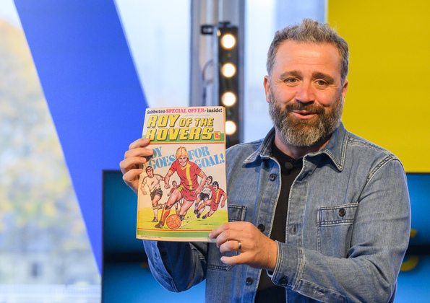

Sports and literacy learning activities
Ideas to bring physical education and literacy together

Age 9-14

CFE Second, Third and Fourth Levels

Resource created by Scottish Book Trust

scottishbooktrust.com
Scottish Book Trust is a registered company (SC184248)
and a Scottish charity (SC027669).

Contents
About this resource 2
Learning activities 2
Further resources 5

About this resource
These resources have been designed to link physical education with reading and literacy. They are all flexible, so we highly encourage you to adapt them based on the children that you work with!
If you’re taking part in Reading Schools, this resource can be used to support delivery of Key Area 2.2.2 of the framework on interdisciplinary book projects.

Learning activities

Activity 1: Invent a new sport
LIT 2-28a, HWB 2-25a, HWB 2-26a
From pod racing in Star Wars to flamingo croquet in Alice’s Adventure in Wonderland, books and films are full of fictional sports and games. Watch a clip from the cartoon The Legend of Korra showing the sport “Pro-bending” (2 minutes, 18 seconds). The game is based around the characters abilities to control different elements (fire, water, air, earth). Ask the pupils to note down:
- How does the scene introduce the sport to us?
- What do they think the rules of the game are? (You can find them on the Legend of Korra’s Wiki page).
- How does the commentator create tension in the game?
- What does the way the Fire Ferrets play tell us about the relationship between the characters?
Now ask the pupils to think about the following questions when they are making up their sport:
- Will it be a team sport, or played individually?
- Is it an athletics-based sport, or a game?
- What will the scoring system be?
- Will it be a timed game? Or is the winner the first to reach a certain number of points?
- What do players have to wear? What kit will they need?
- What are the rules?
You could extend this activity by asking the pupils to reflect on their notes from watching The Legend of Korra to help them write a scene where a group of characters play their sport. Ask them to think about how they can create tension and develop their characters through the scene.

Activity 2: Design your own flag
SOC 2-10a, SOC 2-16a, SOC 2-16c, TCH 2-01a
At the beginning of each Olympic Games, each country’s athletes appear in the opening ceremony flying their national flag. Other sports also have flags or logos to represent their team. Research these together and compare common features or differences.
If you’ve completed Activity 1, each pupil could design a flag based on the sport they created. If not, ask them to design a flag to represent your school. Your pupils may wish to think about your school’s logo or motto (if appropriate), as well as researching features of your school, community or local area such as common wildlife, landmarks or geographical features and any characteristics your school would like to represent (e.g. kindness, sharing, community etc.) Once your pupils have sketched a plan of your flag, they can create a large version on A3 paper and display these on sticks or attached to bunting.

Activity 3: Design your own mascot
EXA 2-05a
The mascot for Scottish football club Partick Thistle divided supporters and the general public alike in 2015. Share the photos of the mascot and ask what they think.
Now ask them to design their own mascot. If you’ve completed Activity 1, they could design the mascot for the sport they have created. If not, their mascot could represent their favourite team, your school, or a particular sport. Get them to think carefully about the qualities they want their mascot to represent, and how these will be reflected in the mascot’s design and behaviour. What clothes (if any) will it wear? Will it use any props? What message would they like their mascot to convey about their team?

Activity 4: Create a news broadcast about sports and exercise
LIT 3-14a, LIT 3-03a, LIT 3-09a, TCH 3-04a
Your pupils can create a sports broadcast with a variety of features and stories. First, split them into groups, and assign each group a different news feature. Some could be given the task of reporting on a sports match, some could be tasked with researching and writing a feature on an aspect of the country’s sporting life (for example, a feature which looks at the opportunities young people have to take up new sports), some could arrange interviews with community sports figures, and others could be asked to present a breaking news story.
If you’ve completed Activity 1, you could also ask them to write a broadcast based on the sport they have created. They could use the commentator in the Legend of Korra clip for inspiration!
The BBC have some great guidance on creating a news broadcast.

Activity 5: Making sports work for you
LIT 3-02a, LIT 3-09a
A lot of young people are put off from physical exercise because of issues such as bullying or discrimination such as sexism. Ask the pupils to design an anonymous survey to gather information on the impression of P.E. and sports in your school. Questions could include:
- Do you enjoy P.E.? Why/why not?
- Do you enjoy being competitive with others?
- What sports or forms of exercise do you enjoy or not enjoy?
- Do you prefer team sports or individual sports? Why?
- What would your perfect P.E. lesson be?

Work with your P.E. teacher(s) to submit this survey around the school, gathering input on what your pupils do and don’t enjoy.
You could extend this conversation by looking at how some people think sport is not “for” them – including how people with disabilities can be excluded from sport. Watch the trailer for the 2016 Paralympic Games (3 minutes, 12 seconds) and this explanation of Paralympic sport by the Australian Paralympic Team (3 minutes, 37 seconds).
Now, bring pupils together into groups and ask them to discuss the following questions:
- Do you think sports can be off putting for some people? Why?
- What do you think are the good things and bad things about team sports and individual sports?
- What options do you think are out there for someone who hasn’t enjoyed mainstream sports such as football and rugby?

Ask pupils to design a marketing campaign conveying the message that sports should be for everyone – you can get them to come up with slogans and design a logo for their campaign.

Further resources
- Our 10 things to do with any books outdoors resource contains more active ideas including Story walks, Breadcrumb trails and Book trips that can help connect physical activity with reading
- Our book list on Books for your P.E. classroom contains loads of sports narratives from football, running and basketball to ice-skating and cheerleading
- Our Authors Live on Demand library contains broadcasts which touch on sports

