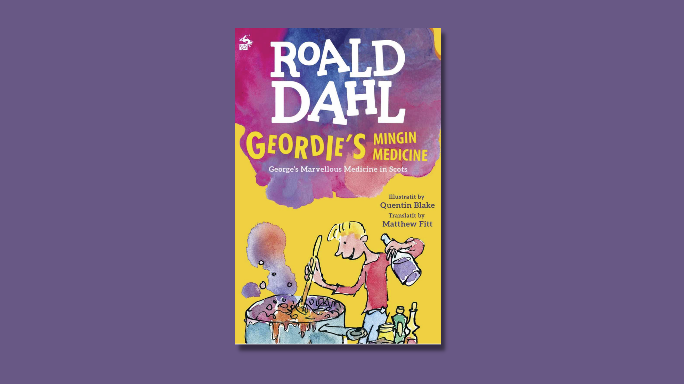

Using Roald Dahl in Scots
Exploring Scots through Geordie’s Mingin’ Medicine translated by Matthew Fitt

Age: 8–11

CFE Second Level

Resource created by Bruce Eunson, Scots Language Consultant

scottishbooktrust.com
Scottish Book Trust is a registered company (SC184248)
and a Scottish charity (SC027669).

Contents
About this resource 2
Listening to Scots 3
Reading in Scots 3
Speaking in Scots 6
Writing in Scots 7
Performing Scots 9
Scots language is 10
Further resources 12

About this resource
This resource will help you to run a project on Scots language in the classroom through reading Geordie’s Mingin Medicine, a Scots translation by Matthew Fitt of Roald Dahl’s George’s Marvellous Medicine, as a class.
The activities within this resource pack link to Geordie’s Mingin Medicine but could easily be adapted to other Scots language translations of Roald Dahl favourites such as The Eejits or Chairlie and the Chocolate Works, published by Scots publisher Itchy Coo.
It is recommended that this resource be used with learners who are already familiar with Scots. For a more general introduction to Scots, take a look at our learning resource on using Scots in the classroom.

Listening to Scots
LIT 2-01a, ENG 2-03a, LIT 2-14a
This section will help you to introduce Scots in the classroom before you start reading Geordie’s Mingin Medicine.
To get your class familiar with the sound of Scots being read aloud, here are some videos and recordings of Scots you could play to the pupils:
- Bookbug songs and rhymes in Scots
- Recordings of excerpts and poems, including Tam O Shanter by Robert Burns, from Scots Language Centre
- The Scots Language Centre’s recording of The Tale O Peter Kinnen, translated into Scots by Lynne McGeachie and published by the Beatrix Potter Society

Reading in Scots
LIT 2-04a, LIT 2-05a, LIT 2-09a, LIT 2-10a, ENG 2-03a
Once pupils feel comfortable and familiar with the sounds of Scots, start reading chapter one of Geordie’s Mingin Medicine, titled ‘Grannie’. If you or any of the pupils are particularly confident with Scots, the chapter could be read aloud.
Read from the beginning up to the first illustration then pause to have a class discussion. Before you start the discussion, ask pupils to explain what has happened so far, to ensure everyone can follow the story.

Discussion
The story is written in prose, entirely in Scots language. What examples of Scots is there from the opening few pages? Do the pupils in the class already use any of these words themselves? Translate and discuss the meaning of each.
Some Scots words are similar to English, such as ‘oot’, ‘jist’, ‘wis’, ‘dug’. Others are quite different from English; for example, ‘wee’, ‘glaikit’, ‘scunnered’, ‘bahookie’. Geordie’s Mingin Medicine also includes words which are the same in Scots and English, like ‘the’, ‘she’, ‘are’, ‘this’.
Ensure the class is aware that Scots and English are “sister languages” and while Scots has a great many unique words, vocabulary, examples of grammar and its own National Dictionary, which make it a separate language from English, there are a great many words that look and sound the same, as well as other words that are exactly the same.

Scots language dictionary
Ask learners to begin keeping a personal dictionary of Scots language words they enjoy, as well as words they don’t recognise. Encourage learners to add at least five words for each page of the book they read (though they can easily add far more than five). This should be continued across each activity in this resource.
In between activities, learners should be given the opportunity to source definitions for the words. You may have copies of Scots dictionaries in you class or school library, and there is also the online Dictionary of the Scots language.

Character descriptions
Read the rest of the first chapter, which establishes the two central characters of Grannie and Geordie. A common and great feature of Roald Dahl’s writing is his delicious descriptions and his use of alliteration and assonance. Matthew Fitt has done a great job of keeping this quality within his Scots translation.
Ask your learners to listen or read closely and tell you their favourite descriptions after you’ve finished reading. Some good ones are:
“She wis a grabbie crabbit auld wumman.”
“She had peeliewally broon teeth and a wee snirkit-up mooth like a dug’s bahookie.”
“. . .she wis aye compleenin, girnin, greetin, grummlin and mulli-grumphin. . .”
Ask learners to draw a picture of Grannie, including labels with some of their favourite adjectives that describe the character. These could be made into a classroom display.

Understanding Scots narration
ENG 2-03a, LIT 2-09a, LIT 2-10a, LIT 2-11a, ENG 2-19a
Explain to the class that a Scots language text – especially a fun one such as this translation of Roald Dahl – is often written the way the author speaks, or the way a writer has heard Scots speakers in conversation.
Read the first paragraph of chapter 2, ‘The Mervellous Ploy’, as a class. The next piece of dialogue is Geordie’s. The line is in Geordie’s voice. Have the class read this line out loud:
‘I’m no gonnae be frichtened by her.’
Geordie is a Scots speaker. Like in many other books, the dialogue is in Scots – but what makes this book stand out, is that the surrounding narration is also in Scots.
This time have the class read the same line, but also the following sentence:
‘I’m no gonnae be frichtened by her,’ he said saftly tae himsel. But he wis frichtened.’
Ensure everyone understands that the entire story is told in a Scots voice. It isn’t just a story where the characters speak in Scots, the narrator is also telling the story in Scots.
Learners should now read the rest of this short chapter to themselves. Once they have finished, discuss what they enjoyed about the story and reading Scots language, as well as what they found difficult and any words they didn’t understand. Encourage pupils to discuss meanings of words amongst themselves and refer to Scots dictionaries and online sources if some words prove a mystery.
Remind pupils to keep adding to their Scots language dictionary mentioned above.

Speaking in Scots
LIT 2-13a, EXA 2-01a
Chapter 2, ‘The Mervellous Ploy’, ends with a fantastically funny poem made up of eleven couplets. Organise the class so that each learner either says a couplet, or together with a partner, says one line of a couplet. Perform the poem and practice the delivery and pronunciation of each line and Scots word.
The third chapter is called ‘Geordie Sterts tae Mak the Medicine’. Read this chapter as a class by the teacher asking someone to begin, then once they have read a few lines, the teacher asks someone else to take over. Read through the chapter out loud, by getting every learner to take a turn at being the reader.

Scots instructions
LIT 2-15a, ENG 2-12a, LIT 2-20a, HWB 2-36a

Geordie’s mingin medicine recipe
This hands-on activity first requires looking closely at the book. Learners should begin by reading the next three chapters, ‘Peels for the Beasts’, ‘Geordie Biles It Up’ and ‘Broon Pent’, as well as re-reading the previous chapter ‘Geordie Sterts tae Mak the Medicine’.
As they read, learners need to write down all the ingredients that go into the mingin medicine and any utensils Geordie requires. So everything from “a big muckle pot” and “gowden breeze hair shampoo” to “a haunfu o creesh” and “a lang widden spoon.”
In pairs, where necessary, learners should re-write the list as a proper step-by-step recipe. They should include details of when to start cooking and what to watch for coming from the pot to indicate when to move onto the next instruction. You can also use online Dictionary of the Scots language to help.

Write your own recipe
Using either a recipe they already know, finding one in a book or on the internet, or even inventing an imaginary one, learners should write their own recipe in Scots language. For inspiration you might like to look at the Food and Drink section of the Visit Scotland website or the Rampant Scotland recipes.
There are lots of Scots words and phrases in Matthew Fitt’s book that can be used, as well as many more the learners may know themselves. Some examples are “a wee daud o”, “a fou tube”, “howk oot the contents o”, “steer”, “skiddle the hail lot in”, “tummle”, etc. You can also use the online Dictionary of the Scots language to help.
Once all the recipes are complete, ask the pupils to read their recipe out to the rest of the class. At the end you could choose one and prepare the ingredients for them to cook what we hope is not a mingin’ medicine but instead a delicious dish!

Writing in Scots: an extra guid pliskie
LIT 2-20a, LIT 2-21a, LIT 2-23a
The first line of the next chapter is “It wis at this point that Geordie aw o a sudden thocht up an extra guid pliskie. . .” – a pliskie is a trick or a prank.
Before reading on and hearing what Geordie does next, have learners create their own piece of Scots writing about what this “extra guid pliskie” of Geordie’s might be. Encourage the pupils to be as creative and imaginative as they like.
This can be done in a variety of ways depending on how confident pupils are with Scots. Pupils could write a step-by-step list of instructions like the above activity, or create a short comic strip using Quentin Blake’s illustrations as inspiration. Pupils that are more confident could be encouraged to write a full piece of creative prose about their pliskie. All pupils should be encouraged to challenge themselves and try to write in Scots themselves, but if they are struggling then they can use exact words and spellings from previous chapters of Geordie’s Mingin Medicine.
The Scots Hoose writing resources might be helpful for this task.

Some guidance on spelling and vocabulary
The experience of writing in Scots can vary depending on which area you live in. Before the pupils start writing, discuss whether the Scots used in Geordie’s Mingin Medicine is a good representation of the Scots used either by the learners in the class, or the families and communities in the areas close to the school.
Are there any words in Geordie’s Mingin Medicine that are not used in your area? Is there a local equivalent? For example, in the Northern Isles, they don’t use the word “wee” for “small”. In Orkney they would say “peedie” and in Shetland they would say “peerie”. What examples are there similar to this for your area?
As a class, you could watch the videos by the Scots Language Centre on different Scots dialects.
A Scots language text is often written the way the author speaks. With that in mind, each learner should decide how the Scots language they are about to write will sound as well as how it will look on the page. Learners should aim for consistency in terms of how they spell their words. Use the personal dictionaries for this task – which should be filling up with many interesting words by this point.
The most important detail to emphasize is to be imaginative. That’s what Roald Dahl did best, and that’s why Matthew Fitt chose this book to translate into Scots – because it is great fun and wildly witty.

Performing Scots
EXA 2-12a, EXA 2-14a, MLAN 2-05b
The next chapter, ‘Grannie Taks the Medicine’, is probably the liveliest, most outrageous part of the book as Geordie feeds the medicine to his unsuspecting Grannie. It is hilarious fun to perform as a piece of drama.
Begin by dividing the lines said by Geordie and by his Grannie to different learners, as well and dividing up the various lines of narration. Remember that it doesn’t need to be a boy who reads for Geordie and it doesn’t need to be a girl who reads for Grannie. We suggest one narrator reads along with Geordie, and another narrator reads along with Grannie, so that in a script for a drama performance, the lines are divided like this:
Narrator 1: Grannie sat humphy-backit in her chair by the windae. The wickit wee een follaed Geordie closely as he crossed the room towards her.
Grannie: “Ye’re late,”
Narrator 1: she snashed.
Geordie: “I dinna think I am, Grannie.”
Grannie: “Dinna interupt me in the middle o a sentence!”
Narrator 1: she shouted.
Geordie: “But ye’d feenished yer sentence, Grannie.”
Grannie: “Ye’re daein it again!”
Narrator 1: she skirled.
Grannie: “Ayewis interruptin and argle-barglin. Ye really are a scunnersome wee laddie. Whit’s the time?”
Geordie: “It’s exactly eleeven o’clock, Grannie.”
Grannie: “Ye’re leein as usual. Stap haiverin and gie me ma medicine. Shak the bottle first. Then poor it intae the spoon and mak sure it’s a haill spoonfu.”
Geordie: “Are ye gonnae gowp it aw doon in the yin gollop?”
Narrator 2: Geordie spiered her.
Geordie: “Or are ye gonnae sook it slowly?”
Grannie: “Whit I dae is nane o yer business,”
Narrator 1: the auld wumman said.
Grannie: “Fill the spoon.”
Narrator 2: As Geordie taen oot the cork and sterted gey slowly tae poor the claggy broon stuff intae the spoon, he couldna help thinkin aboot aw the mingin and mervellous things that had gane intae makkin this dementit stuff...
Different groups of four learners can practice reading a page or so. They should practice the timing of where each reader starts and stops, before and after the next reader. And they should consider their acting skills to give dramatic effect to Geordie, Grannie and the tone of voice of the narrator.
Once the various groups of learners have practiced, they should perform their short play to the class. Each group should stand at the front, or somewhere everyone else can see, and deliver their lines, before leaving the stage and letting the next group perform the next part of the story.

Scots language is. . .
LIT 2-09a, LIT 2-10a, ENG 2-19a, LIT 2-26a, LIT 2-29a, ENG 2-30a
It is now time for learners to read the rest of the book if they have not already done so. Learners should read it themselves in their reading time or time at home.
Once finished, learners should prepare a short presentation reviewing the book which to share with their peers – if possible, in Scots. It should be a personal review on Roald Dahl’s story, the Scots used in the book and the experience of using Scots in the classroom.
Learners may wish to include details from when they read parts of the story in class, comments from discussions, as well as their thoughts and feelings on the plot of the story and how it ends.
The presentation should end with a sentence that starts “Scots language is...” This statement should describe the learners’ own personal opinion on the place of Scots language in Scotland today and its role/importance in their lives today.
Here are some prompt questions to get your learners thinking:
- Do a lot of people in Scotland still speak Scots today?
- What about the people who don’t – is it important for them to know about the Scots language?
- What are some arguments for and against teaching Scots language in Scottish schools?
Finally, the learner presenting should take questions from the audience. Encourage learners who have similar opinions on the place of Scots in society to discuss why they are of this opinion, as well as asking those whose opinions differ to debate why this may be and how people in society with differing views must treat those of others.
Discuss as a class the range of answers and personal opinions on Scots language. Can learners work together to communally write a statement that begins: “Our class believe Scots language is...”
To what extent is the agreement within the class? Why might there be strong opinions on where learners hold differing views from one another?
Each learner should be encouraged to go home and tell their family about the Scots Language and Roald Dahl project they have been working on in their class. Learners should take their personal dictionaries home with them and discuss the words they have been learning with family – possibly getting new/alternative definitions for some of the words.
Back in the classroom, learners should share whom they have told about the project, what the response has been – and whether they have any further questions to ask!

Further resources
- On the Scots section of our website, you’ll find our resources on Using Scots in the classroom, Creative writing in Scots and Writing poetry in Scots
- We also have book lists of fantastic Scots books for 6-8 year olds and books for 9-14 year olds
- Every year, Scottish Book Trust run the Young Scots Writer o the Year Award. Find out more about the award and when to enter on the Young Scots Writer o the Year Award webpage on our website.

