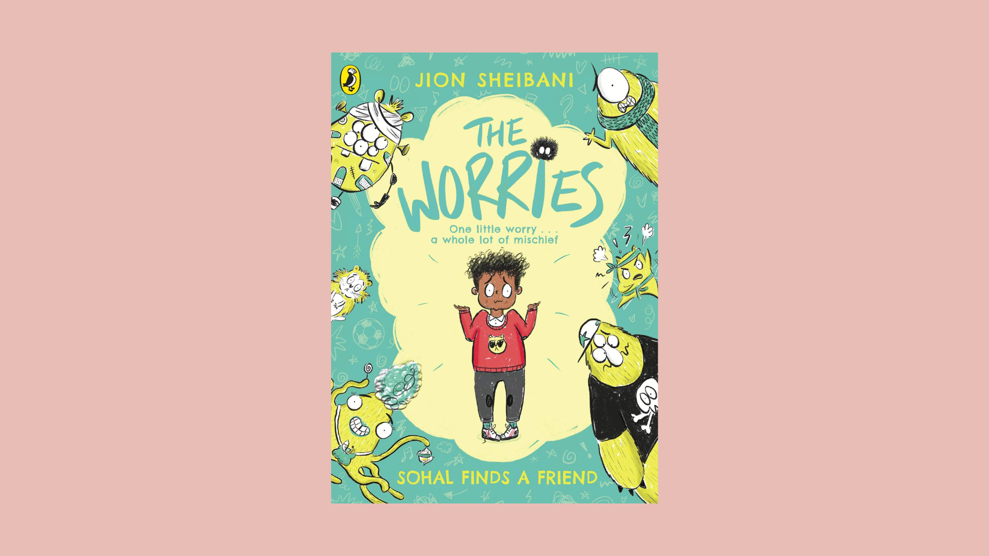

The Worries learning activities
Printable activities to explore The Worries by Jion Sheibani.

Age: 7–11

CFE Second Level

scottishbooktrust.com
Scottish Book Trust is a registered company (SC184248)
and a Scottish charity (SC027669

Contents
About this resource 2
Further resources 2
Puppet template (black and white) 3
Puppet template (colour) 4
Worries wheel template 5
Worries busting wheel template 6

About this resource
This resource collects printable activities you can use in your classroom to explore The Worries. Each page is labelled with a title, or you can use the contents to navigate.

Further resources
- Find more resources including a video of Jion Sheibani talking about The Worries on our Mental health awareness school resources webpage
- Find your next read with our book lists: 12 books that help children explore emotions, children’s books exploring mental health and wellbeing or mental wellbeing books for teens
- Use our Authors Live on Demand catalogue to watch mental health events with Tom Percival and Mark Bradley

Puppet template (black and white)

Print this page
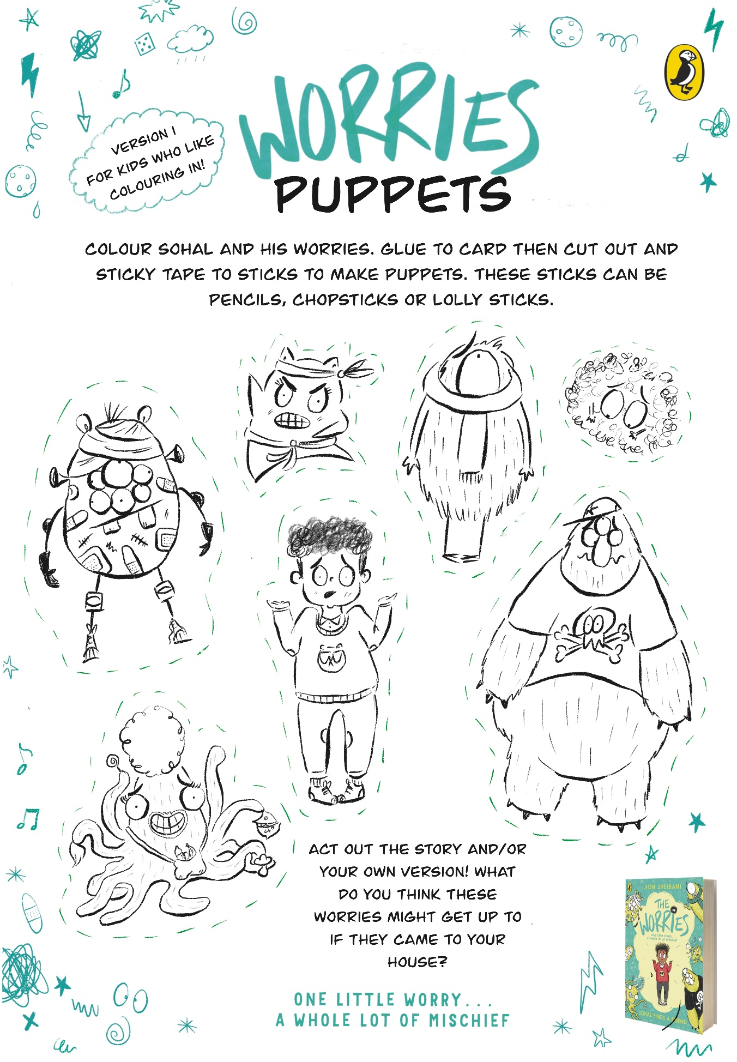

Puppet template (colour)

Print this page
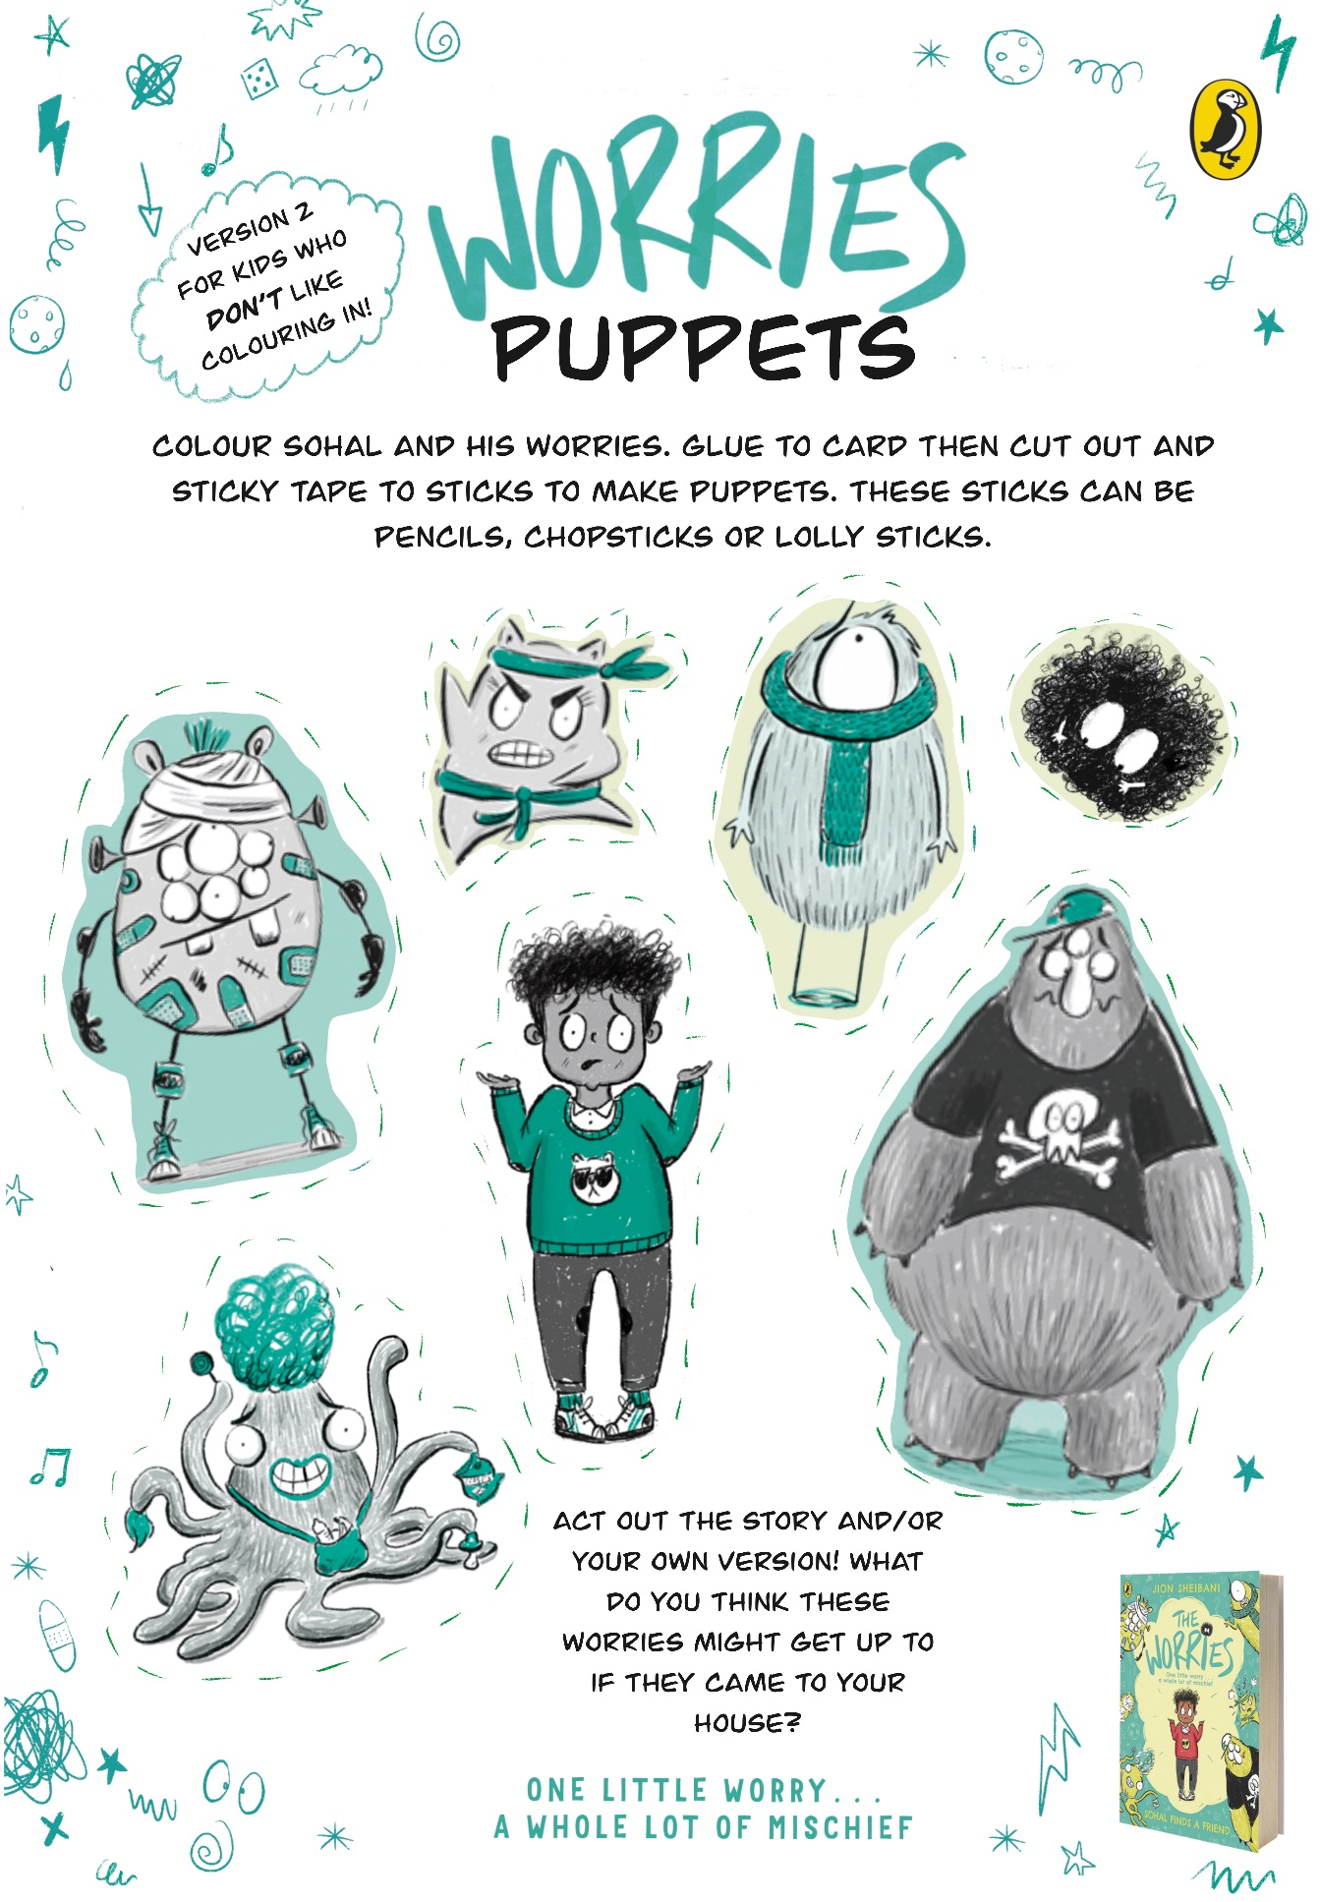

Worries wheel template

Print this page
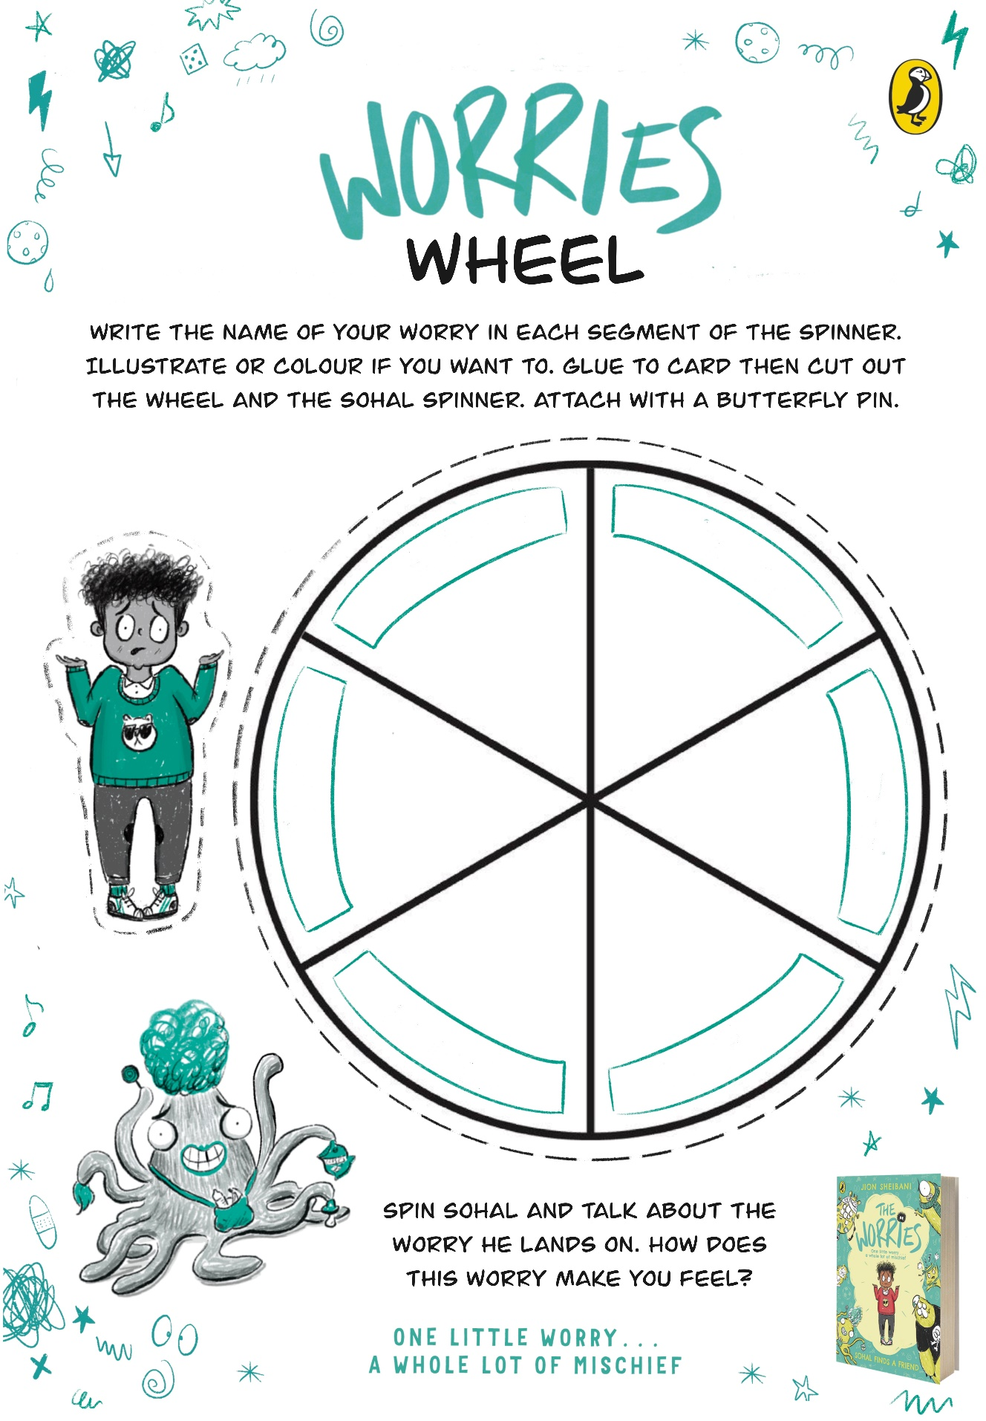

Worries busting wheel template

Print this page