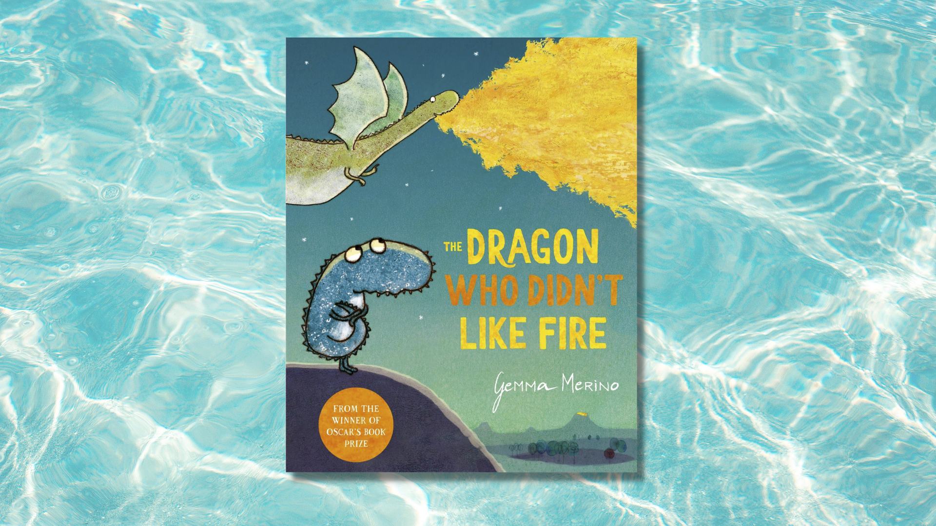

Read, Write, Count: The Dragon Who Didn’t Like Fire STEM learning activities
STEM learning activities based on The Dragon Who Didn’t Like Fire by Gemma Merino

Age 6-8

CFE First Level

Resource created by Raising Aspirations in Science Education (RAiSE)

scottishbooktrust.com
Scottish Book Trust is a registered company (SC184248)
and a Scottish charity (SC027669).

Contents
About this resource 2
Learning activities 2
Further resources 5

About this resource
This resource was developed by Raising Aspirations in Science Education (RAiSE) and provides links to some suggestions for further STEM learning activities to complement and enhance children’s learning from one of the books included in this year’s Primary 2 Read, Write, Count bag. The key themes explored in these activities are: reptiles, forces, engineering, biodiversity and fire.
Please note that some resources, such as the ones from Explorify, require an account to view.

Learning activities

Activity 1: Hatching eggs
HWB 1-50a
Look at the illustrations on the first two pages. Spark a conversation with this Explorify video of reptile eggs hatching. This activity is great for describing observations and applying ideas in unfamiliar contexts.

Activity 2: Who lays eggs?
HWB 1-50a
Use the BBC clip (4 minutes, 8 seconds) to learn more about the animals that lay eggs.

Activity 3: Dragons and reptiles
SCN 1-01a
Dragons aren’t real, but if they were they would probably be from the reptile family.
In this online activity from Explorify, can your class use their reasoning skills to work out what the zoomed in picture is?

Activity 4: The science of fire
SCN 1-04a
“And this little dragon didn’t like fire.” Find out more about the science of fire with this YouTube video (33 minutes, 38 seconds) from British Science Week.

Activity 5: Model dragons
TCH 1-09a, TCH 1-10a
If your class has Lego or building blocks, why not build a model dragon? You can find some inspiration on the Frugal Fun website.

Activity 6: How does a dragon fly?
SCN 1-07a
Investigate forces as you make this dragon “fly” with this activity from Mallard Creek STEM Academy.

Activity 7: Build your own wings!
SCN 1-07a
“So the little dragon decided to build her own wings.” Design and create some wings for the little dragon or explore flight further with this o-wing glider video activity from SSERC Primary on YouTube (3 minutes, 14 seconds).

Activity 8: Safe landings
SCN 1-07a, TCH 1-09a
“But she hadn’t thought about the landing.” Can you design and create a parachute for the little dragon? See the Parachuting Presents guide from The Institution of Engineering and Technology website and the Make a Parachute! YouTube video (1 minute, 4 seconds) from BBC Teach for inspiration and top tips!

Activity 9: Dragon masks
TCH 1-09a, EXA 1-02a
The Institution of Engineering and Technology website has a guide to making your own dragon masks inspired by Chinese culture.

Activity 10: What are reptiles?
TCH 1-09a
Learn more about what makes an animal a reptile with the What are reptiles? resource from BBC Bitesize.

Activity 11: Real vs. fiction
SCN 1-01a
Compare the features and habits of real crocodiles and fictional dragons in the story and make links to maths using a Venn diagram. See BBC Bitesize’s guide to Venn Diagrams for more resources.

Activity 12: Coding
TCH 1-01a, TCH 1-02a
Develop coding skills through 24 dragon themed puzzles in Hour of Code’s activity from Tynker.

Further resources
- Find more learning activities for all the books and resources included in the Read, Write, Count bags on our website:
  - Learning resources for the P2 bags
  - Learning resources for the P3 bags
- Find out more about RAiSE on the Education Scotland website

