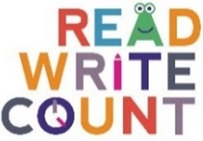
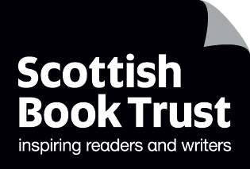

Recommendations for what to read next

What to read after your P2 Read, Write, Count books
If you enjoyed Where Has All the Cake Gone? by Andrew Sanders, we think you might like:
- Jeremy Worried About the Wind by Pamela Butchart and Kate Hindley
- Penelope Snoop, Ace Detective by Pamela Butchart and Christine Roussey
- Journey by Aaron Becker
- The Biggest Story by Sarah Coyle and Dan Taylor

If you enjoyed The Dragon Who Didn’t Like Fire by Gemma Merino, we think you might like:
- You Can! by Alexandra Strick and Steve Anthony
- The Koala Who Could by Rachel Bright and Jim Field
- A Little Bit Lost by Chris Haughton

And here’s some space for you, your librarian or your family to write down some books you might like:

What to read after your P3 Read, Write, Count books
If you enjoyed All Kinds of Friends by Sophy Henn, we think you might like:
- We Are Family, Patricia Hegarty
- Frank and Bert by Chris Naylor-Ballesteros
- Five Bears by Catherine Raynor

If you enjoyed The Worry Tiger by Alexandra Page and Stef Murphy, we think you might like:
- The Worrysaurus, Rachel Bright and Chris Chatterton
- Ruby’s Worry by Tom Percival
- Mr. Tiger Goes Wild by Peter Brown

And here’s some space for you, your librarian or your family to write down some books you might like:

