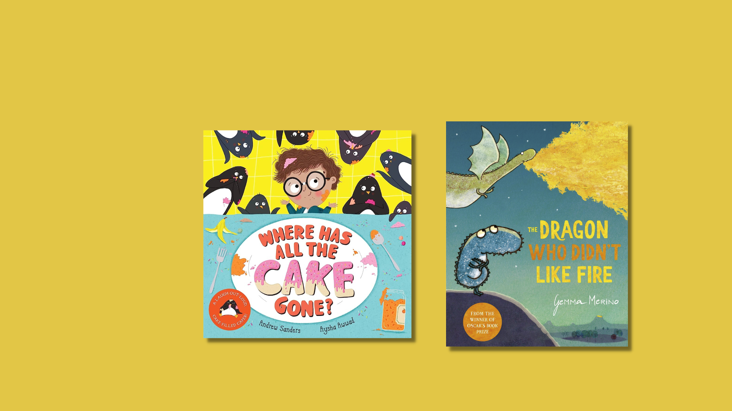

Read Write Count library session: P2 Bag
A library session for the Read Write Count P2 bag including songs, crafts and worksheets and printables

scottishbooktrust.com
Scottish Book Trust is a registered company (SC184248)
and a Scottish charity (SC027669).

Contents
About this resource 2
Welcome to the session 3
Reading the books 3
Songs and rhymes 3
Main activity 5
Goodbye and finding books to take home 5
Printable 1: Make your own paper dragon 6
Printable 2: Penguin cake scavenger hunt 9
Printable 3: What to read after your P2 Read, Write, Count books 10

About this resource
We’ve put together a session for each of this year’s Read, Write, Count bags so you can run interactive family sessions in your library. These can be adapted to suit the duration of storytelling sessions in your library.
Each session includes:
- Reading the book together
- Choices of songs to sing together
- Choices for a main activity or arts and crafts
- Suggestions to help families find their next read
Whilst Read, Write, Count gifts bags to children in P2 and P3, you can keep these sessions open to all families and they don’t rely upon the families having prior knowledge of the books. The contents of this year’s bags are as follows:

P2
- Where Has All the Cake Gone? by Andrew Sanders
- The Dragon Who Didn’t Like Fire by Gemma Merino
- A tangram
- A pack of cards containing the games Shape Shuffle, Act it Out and Talk it Out

P3
- All Kinds of Friends by Sophy Henn
- The Worry Tiger by Alexandra Page and Stef Murphy
- A tape measure
- A pack of cards containing the games Beastie Battle, Story Cards and Dominoes

Welcome to the session
Welcome everyone to the session, saying hello to all the adults and children in turn. You could use “The Hello Song” from the Bookbug Song and Rhyme Library or Bookbug app to warm the group up.

Reading the books
Read Where Has all the Cake Gone? aloud to the group, making sure everyone can see the pages and hear you. Allow the children to stop and ask questions or take time to look at the illustrations. Now, read The Dragon Who Didn't Like Fire aloud to the group. Afterwards, you could ask the children to talk about which of the books they liked more.

Songs and rhymes
For singing together, you could choose between:
- “Zoom, Zoom, Zoom” – looking at the pages of Where Has All the Cake Gone? where Albert goes to space with the penguins.
- “Row, Row, Row Your Boat” – doing your best impression of seeing a crocodile like in The Dragon Who Didn’t Like Fire.

Zoom, Zoom, Zoom (via the Bookbug Song and Rhyme Library)
Zoom, zoom, zoom
We’re going to the moon!
Zoom, zoom, zoom
We’ll be there very soon.
If you want to take a trip,
Climb on board my rocket ship.
Zoom, zoom, zoom.
We’re going to the moon!
5, 4, 3, 2, 1 blast off!

Row, Row, Row Your Boat (via the Bookbug Song and Rhyme Library)
Row, row, row your boat,
Gently down the stream,
Merrily, merrily, merrily, merrily,
Life is but a dream.
Row, row, row your boat,
Gently down the stream,
If you see a crocodile,
Don’t forget to scream (Aaagh!)
Alternative verses (ask the children to create their own!):
- Gently down the river, if you see a polar bear don’t forget to shiver
- Gently to the shore, if you see a lion don’t forget to roar
- Gently down the lake, if you hear a hissing sound, it’s probably a snake

Main activity

Option 1: Arts and crafts
Using sheets of A4 paper, make your own paper dragons and decorate them to look like dragons! You can then explore how far they fly. See pages 6-8 for a printable template and guide to making paper dragons which you can print before your session.

Option 2: Cake scavenger hunt
Before the session, hide matching pictures of penguins and cakes around the library. You could even hide some of these in picture books to encourage the families to look at some books they could borrow after the session. Once all the cakes and penguins have been found, ask the children to match each penguin to each cake! See page 9 for printable containing the penguins and cakes to hide.

Goodbye and finding books to take home
At the end of your sessions, you can explore some books that are similar to Where Has All the Cake Gone? and The Dragon Who Didn’t Like Fire in theme or topic. These could be books about animals like penguins or crocodiles, books about family or feeling left out, or books about going on an adventure! Explain to the children they can borrow them and take them home.
See page 10 for a printable collection of books we’d recommend as next reads.

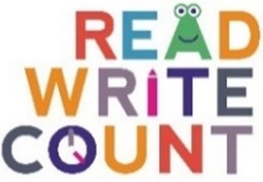

Printable 1: Make your own paper dragon
Make your own paper dragon
(Instructions on next page or watch our online video for how to fold)
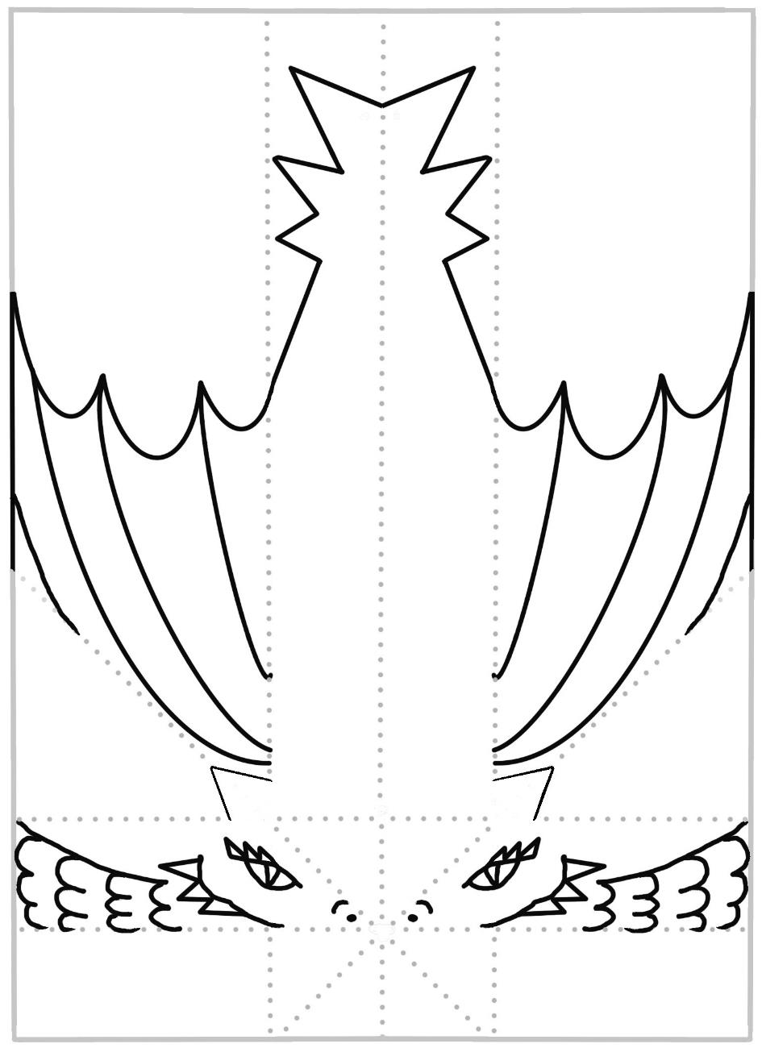
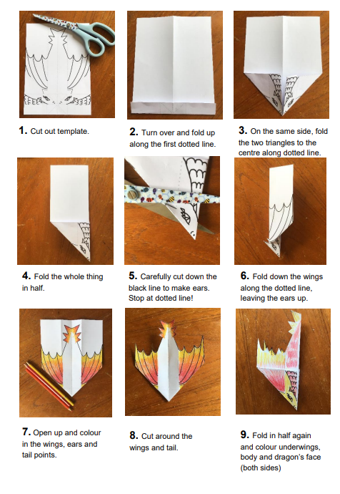

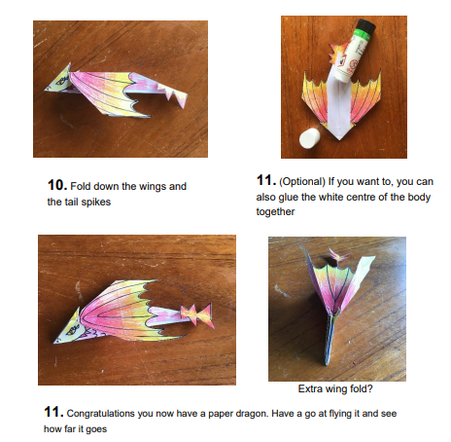

Try experimenting
You might want to experiment to get the best flight. Try folding the outer edges of the wings upwards, or weighing down parts of the body with a paper clip and see what happens. You could also try sticking on some cut out claws, or even designing your own dragon plane with different wings or tail?

Printable 2: Penguin cake scavenger hunt
Cut out the penguins and cakes and hide them throughout your library. Ask the families to try and find them together. Once they’ve found them all, see if they can match the penguins to the same coloured cake!
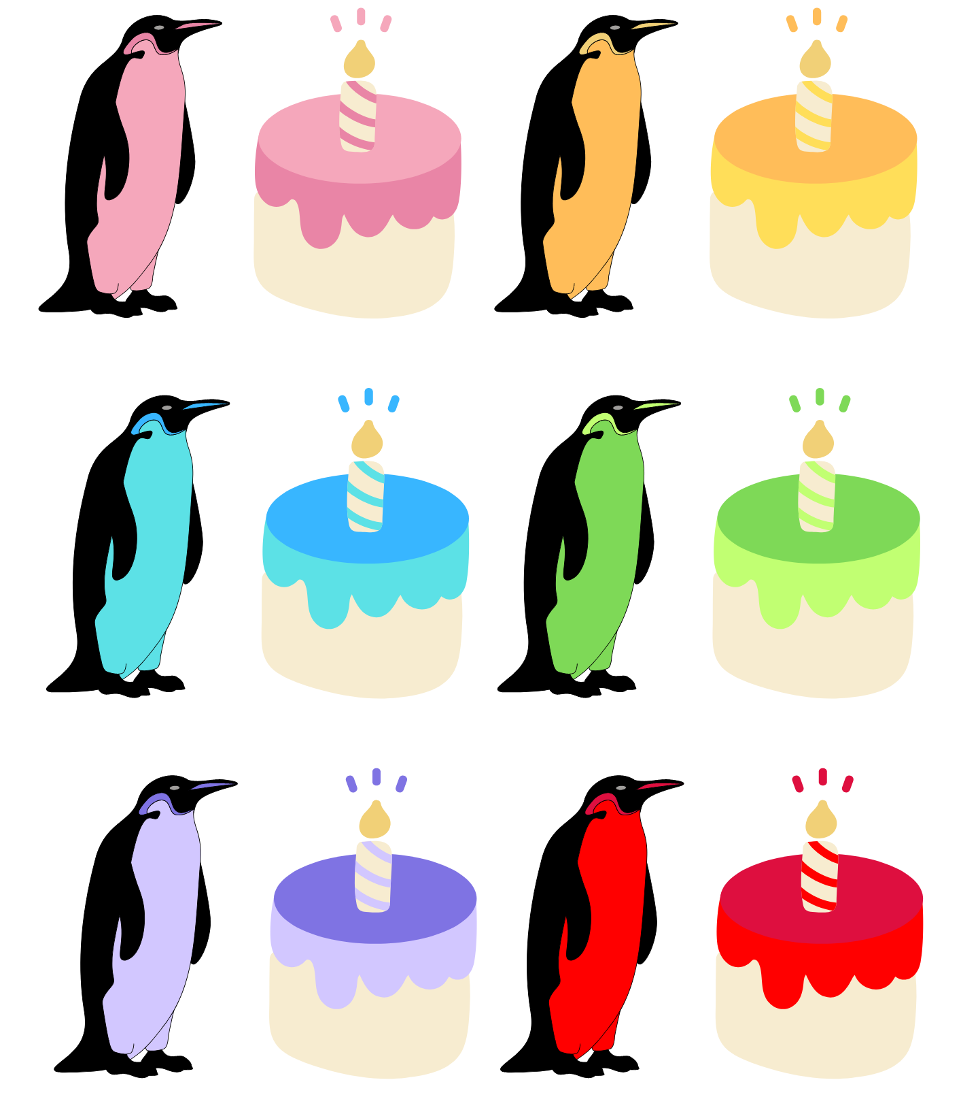

Printable 3: What to read after your P2 Read, Write, Count books
If you enjoyed Where Has All the Cake Gone? by Andrew Sanders, we think you might like:
- Jeremy Worried About the Wind by Pamela Butchart and Kate Hindley
- Penelope Snoop, Ace Detective by Pamela Butchart and Christine Roussey
- Journey by Aaron Becker
- The Biggest Story by Sarah Coyle and Dan Taylor

If you enjoyed The Dragon Who Didn’t Like Fire by Gemma Merino, we think you might like:
- You Can! by Alexandra Strick and Steve Anthony
- The Koala Who Could by Rachel Bright and Jim Field
- A Little Bit Lost by Chris Haughton

And here’s some space for you, your librarian or your family to write down some books you might like:

