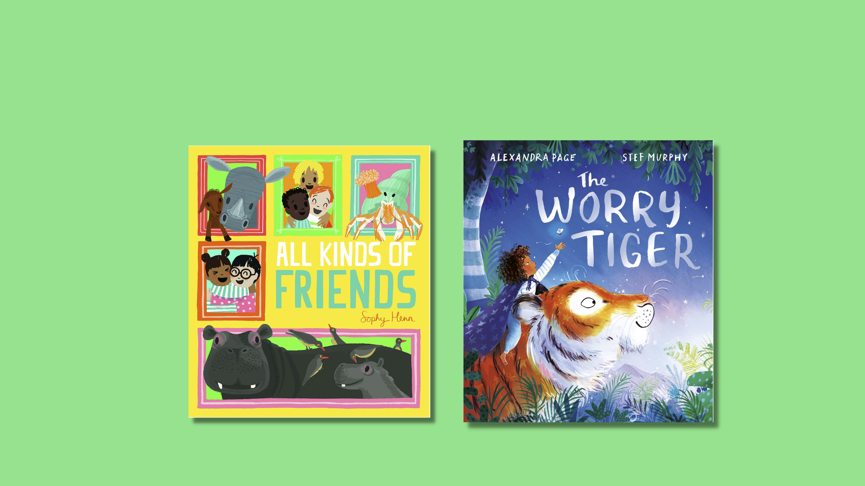

Read Write Count P3 inclusive activities
Activities for the Read Write Count P3 bag, designed for children with additional support needs.

Resource created by Ailie Finlay

scottishbooktrust.com
Scottish Book Trust is a registered company (SC184248)
and a Scottish charity (SC027669).

Contents
About this resource 2
All Kinds of Friends activities 2
The Worry Tiger activities 5
Beastie Battle activities 8
Dominoes activities 9
Story Cards activities 9
Measuring tape activities 10
Further resources 11

About this resource
The aim of this resource is to make the items in the Read Write Count P3 bag accessible to all. The activities can be used with pupils with a variety of needs, including additional support needs, English as an additional language or those who are disengaged from or struggle with reading.
These activities are flexible and we encourage you to adapt them, whether in school, community groups or at home.

All Kinds of Friends activities

Activity 1: Wet or dry?
Look at the illustrations with your child and decide whether each of the animals is wet, dry – or both! If your child would enjoy it you could have a spray bottle with water in it… turn each page slowly, building up the suspense by saying ‘is it going to be wet or is it going to be dry…?’ Then if it is a ‘wet’ page you could spray the back of your child’s hand with water. (Or they could spray you!) Alternatively use something like a blue scarf and waft this over your child’s head if it is a ‘wet’ page.
If you are playing this simple game in the classroom, it will be easier if you have a helper; one of you has the book and the other the spray bottle.

Activity 2: Crafty friends
Your child might enjoy creating their own versions of some of the animals in the book. Here are some simple ideas:
- Sea anemones can be made from toilet rolls with cut or torn up strips of paper, newspaper or tissue paper stuck into the one end and a face drawn or stuck on the side. (Look online for ‘tissue paper sea anemone craft’ for images of this).
- Crabs can be made from two handprints facing in opposite directions, wrists in the middle. (Look online for “crab handprint craft”).
- Ants can be made from a strip of three egg ‘holes’ from an egg box. Stick on paper legs and antennae and draw on a face. (Look online for “eggbox ant craft”).

Activity 3: Count the zebras
Try counting all zebras in the book with your child. (Watch out for the ones hiding at the beginning and end of the book!) You could count the other animals (and people) as well.

Activity 4: Our special people
The story is all about special friendships. Talk with your child about two or three people who are special to them. You could draw together or use photos. Or your child might enjoy it if you use objects to ‘represent’ each friend (e.g. ‘Here’s one of Grandma’s scarves. It smells just like her.’ or ‘Here’s a football like Robbie’s football. Robbie loves to play football.’)

Activity 5: Will you be a friend of mine?
Share the book together using this rhyme instead of the text:
‘Will you be a friend of mine?
Friend of mine?
Friend of mine?
Will you be a friend of mine?
(name of the animal)’

Start by naming one of the animals on the page (e.g. crab). Then repeat the rhyme with the other animal from the page at the end of the rhyme (e.g. anemone). So, the first page would be:

Crab says:
‘Will you be a friend of mine?
Friend of mine?
Friend of mine?
Will you be a friend of mine?
Anemone!’
Next page would be:
‘Monkey says:
Will you be a friend of mine?
Friend of mine?
Friend of mine?
Will you be a friend of mine?
Chital deer!’

And so on. After you have gone through the book in this way you could point to your child as you say the rhyme and then name them. Or if you are re-telling the story in a classroom, you could get each child to take it in turns to choose a friend from the class until everyone has been chosen. (The “chosen” child becomes the chooser):
Will you be a friend of mine?
Friend of mine?
Friend of mine?
Will you be a friend of mine?
[child’s name]!

The “chosen” child may enjoy it if you tap them on the back of the hand as you repeat the rhyme, rather than pointing.

The Worry Tiger activities

Activity 1: I spy a frog!
There are lots of frogs in this book… how many can you and your child can spot together?

Activity 2: What Rory saw: a sensory story
Create a sensory story with props. Try starting from the page that begins: “Rory crept quietly…”
Use a little bit of soil in a tub for the “soft squelchy earth”. If you want something a bit more squelchy (but without too much mess) you could mix up some soil and water and put it in a zip lock bag. Let your child feel the squishiness through the plastic.
If you happen to have some fairy lights you could use these for the fireflies. (Put them in a box or tin to make them shine brighter if it is daytime). Try making the buzzes, clicks, whirrs and monkey noises yourself. Or alternatively look online for some of these noises to download. If you are telling the story at school, you could raid the music box to see if there is anything there that makes the right kind of noise.
Make the action of stretching to the sky – your child may want to join in. Use lemons and oranges and cut open to “let out” the smell – but be careful not to get juice in someone’s eye. Add in any sweet-smelling flowers you have available.
Fill a Tupperware tub with some rice or lentils and give this a shake for the rain. Your child may also enjoy it if you make it “rain” gently with your fingertips on the backs of their hands, their arms, shoulders and even the top of their head.

Finish the short sensory story at the line: Rory snuggled into her soft warmth. You might want to finish by wrapping your child in a soft blanket. Or you could even use a handwarmer as a special treat. (You can buy these online or during the winter months they are often available in outdoor equipment shops).

Activity 3: A tiger tactile tale
Use the section of the story with the tiger for this tactile story. Encourage your child to lie on their tummy or side. Then “tiptoe” a path around their back with your fingers saying: ‘The tiger tiptoes round the jungle and sees…’
“Draw” what the tiger sees on your child’s back with your index finger. You can draw things from the books (butterflies, monkeys, the moon, trees) or make things up. (Your child might like to guess what you are drawing).
Repeat the sentence ‘The tiger tiptoes round the jungle and sees…’ between each “drawing”. Then finish the activity by slowly drawing a spiral on your child’s back, saying ‘…and then the tiger curled up and went to sleep.’

Activity 4: A tiger action tale
This activity also uses the tiger section of the story. Try sharing this section of the book with your child but focus just on the tiger’s actions. Your child might like to do the actions with you:
‘The tiger stretches.’ (Stretch up to high. You could take your child’s hands and stretch up together).
‘The tiger tiptoes.’ (Tiptoe or use your hands to gently ‘tiptoe’ on your child’s knees).
‘The tiger listens.’ (Say “shh” and cup your ear with your hand).
‘The tiger climbs.’ (Mime climbing or ‘climb’ your fingers up your child’s arm).

‘And climbs.’ (As above).
‘The tiger runs.’ (Stamp your feet in a ‘run’ or gently ‘run’ with your hands on your child’s knees).
‘The tiger sleeps.’ (Mime going to sleep).

Activity 5: Jungle tangle
There are lots of shoots and leaves growing in this book. Try drawing a tangle of shoots and leaves together with your child on the same sheet of paper. You could use this rhyme and draw quickly:

‘Quickly very quickly grows this little shoot,
Quickly very quickly lots and lots of shoots.’

Then try doing this again but this time draw as slowly as possible, saying:

‘Slowly very slowly grows this little shoot,
Slowly very slowly lots and lots of shoots.’

Alternatively, you could “draw” the tangly shoots on your child’s back with your index finger as you say the rhyme. If you start fast and become slower and slower this can be quite calming for your child.

Beastie Battle activities

Activity 1: Beastie challenge
Try asking your child:
- Which animal would you like to pat on the head?
- Which animal would you like to take to school with you?
- Which animal could you keep hidden in your bedroom?
- Which animal would be scary to meet on a dark night?
It can be fun to answer the questions from a choice of just two randomly picked cards.

Activity 2: Tactile beasties
This activity is for children who enjoy tactile fun. Choose three or four of the beastie cards and put them face down. You or your child choose cards in turn and then act out the animals in a tactile way for each other. Suggestions for tactile actions could be:
- Mouse – two fingers “running” up your child’s arm.
- Snail – same as above but moving slowly.
- Daddy Long Legs or spider – same as above but using more fingers.
- Midge – one finger “hopping” from place to place on your child.
- Worm or caterpillar – trace a wriggly worm shape on your child’s palm.
- Adder – similar to above but larger movement going right up your child’s arm.
- Robin or puffin – very soft “pecking” with thumb and index finger on your child’s arm (a very gentle pinch).
- Wildcat – use your flat hands to “pad” softly on the backs of your child’s hands.
- Pony – as above but beat out a rhythm with slightly firmer hands.
- Wolf – “catch” the child with howling noises etc! (Only if they enjoy this kind of play).

It can be fun to mix the wolf in with some gentle animals so that this tactile game contains an element of suspense. In this version put three or four cards face down in front of your child and turn them over one by one. (Uh-oh – is it going to be the wolf?) Make actions as above – then when it is the wolf card “catch” your child.

Dominoes activities

Activity 1: Spotty dogs!
The dominoes are stacked face down. You and your child both pick a card. Count the dots on the cards. The “dog” with the most spots is the winner and takes both cards. The player that ends up with the most cards at the end of the games is the overall winner.

Activity 2: Action cards
Stack the dominoes face down. One player chooses an action (e.g. clapping, nodding, star jumps, touching toes) The other player chooses a card and then does the chosen action the same number of times as the number of dots on the card.
(If your child would enjoy simpler “dominoes” cut some rectangles from paper or card and put just one, two or three dots on each).

Story Cards activities

Activity 1: Mime a character
Lay the character cards face up in front of you. Try taking it in turns to mime being one of the characters – the other person tries to guess who you are. You could try this for the setting cards as well – mime being in the setting.

Activity 2: Silly stories
Make up a silly story with your child. First of all, write out a very simple little story leaving some blanks. For example: One day a [blank] went to a café [blank]. She met a [blank] and together they went to [blank].

Separate the character and setting story cards into piles. Then either let your child choose characters and settings for your mini story or pull them randomly from the pile.
So, your story might become: One day a unicorn went to a café in the mountains. She met a robot and together they went to a haunted house.
Some children might enjoy this activity more if you use their toys rather than the cards for the characters.

Measuring tape activities

Activity 1: Measuring tape snake
The measuring tape can be turned into a snake! Cut a snake head out of an old cereal packet and attach it with tape to one end of the measuring tape. Your child could be in charge of the snake as you creep past saying:
‘There’s a big snake in the grass
Do you think they’ll let me pass…’

Then your child can decide whether to pounce with the snake or not!

Further resources
- For further resources to support children with additional support needs, see the Disability and Neurodiversity section of our website including our Make your own sensory story resource, created by Ailie Finlay.
- For further resources to support use of the Read Write Count bags see the Read Write Count section of our website.
- You can find more of Ailie Finlay’s work on the Flotsam and Jetsam and My Kind of Book websites.

