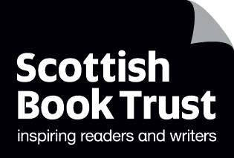
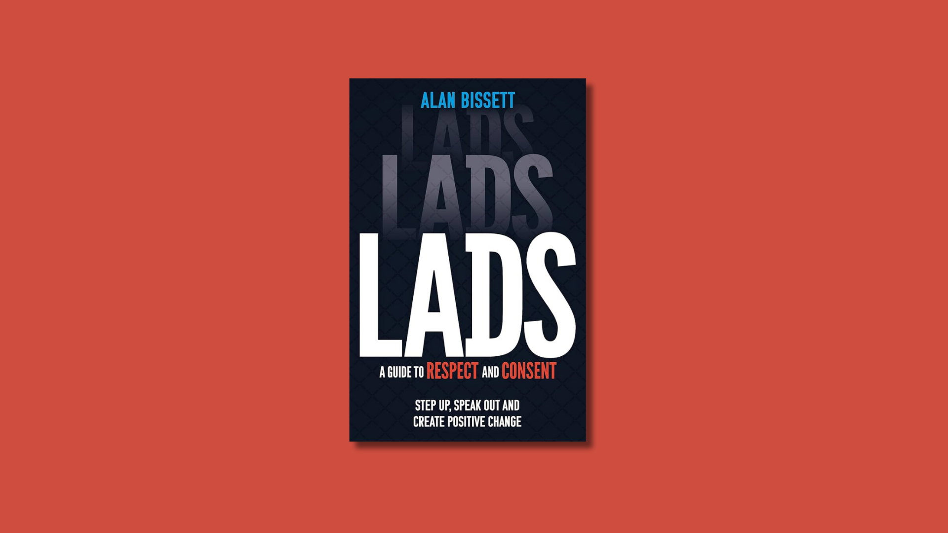

Understanding and challenging sexism in school
Learning activities and further resources for discussing and challenging misogyny in classrooms and schools

CFE Level Third to Senior Phase
Suitable for secondary pupils

scottishbooktrust.com
Scottish Book Trust is a registered company (SC184248)
and a Scottish charity (SC027669).

Contents
About this resource 2
Learning activities 2
Further resources 7
Worksheet 1: Stock photo images 9

About this resource
This resource has been created to support our Authors Live broadcast with Alan Bissett where he discusses his book Lads: A Guide to Respect and Consent. These activities are adaptable and you do not need access to the book to use them in your classroom.
This resource, and the Authors Live broadcast, touches on the following topics:
- Sexism and misogyny
- Toxic masculinity
- Consent and respect
- Harassment and assault

This resource also collects further resources that you can use to support pupils learning about consent, respect as well as understanding and challenging misogyny. For more information or support on the topics in the broadcast, book and resource, see BBC Action Line.

Learning activities
Whilst engaging in these activities, we recommend you:
- Use your discretion about which activities are appropriate for the children you work with based on their context and experiences. Throughout, ensure you make pupils aware of who they can talk to if they see or experience sexist behaviour, bullying or harassment at school.
- Avoid asking pupils to share their personal experiences, especially of misogyny or bullying, as this can put them in a vulnerable position.
- Avoid only mentioning specific online influencers, such as Andrew Tate, as this can glorify them or mark them out as special. If you are talking about them ensure you contextualise them as part of a wider harmful patriarchal system.
- Always ensure you include trans and non-binary identities as part of the discussion. Misogyny also harms trans and non-binary people, including trans girls who face transmisogyny, trans men who are often excluded from being accepted as boys or men, and non-binary people who are often misgendered or bullied for not complying with stereotypical gender roles. For more advice on supporting trans pupils, see: Scottish Trans or LGBT Youth Scotland.

Activity 1: Setting definitions
LIT 3-09a/4-09a, LIT 3-15a/4-15a, SOC 3-16a, SOC 4-16b/4-16c, HWB 3-44c/4-44c, HWB 3-45a/4-45a
Purpose of activity: help pupils develop a clear sense of what sexism is, its presence in all aspects of life and how it harms everyone - not just women.
Start by asking the class if anyone knows what the words “sexism” and “misogyny” mean.
- Does anyone know of any examples of sexism – either historical or contemporary?
- Does anyone know how sexism harms women or trans and non-binary people?
- Does anyone know how sexism harms men, including trans men?

It’s important to establish that sexism harms everyone, not just women and that it is present in every aspect of our lives, including work and employment, education, relationships, entertainment and culture, sports, technology and so on.
Split the class into groups and ask them to decide whether the following statements are true or false.
- Gender inequality is one of the main causes of hunger and poverty.
(True – 60% of chronically hungry people are women and girls, their hunger and poverty is not only caused by the fact they are marginalised, but makes it harder for them to fight against sexism)
- Women and girls represent half of the world’s illiterate people.
(False – they represent two-thirds, so more than half)
- Nowadays, men’s contribution to work at home (e.g. childcare, cleaning, cooking) is about equal with their female partners.
(False – women spend at least twice as much time on average)
- 1 in 3 women experience violence.
(True – and in most cases, when women experience violence its by someone they know, such as a family member or partner)
- Women own 30% of the world’s land.
(False – women only own about 15%)
- The highest suicide rates in the UK are men aged between 40 and 49.
(True – and a large contributing factor is the expectation of men to be “tough”, not cry or show their emotions. The belief that women are more emotional than men hurts both men and women)

Discuss:
- Did any of these surprise them?
- Were there any that most groups got wrong?
- Can they see how the context behind these facts cause harm on both sides?
  - For example, the fact about male suicide shows men are harmed by emotional expectations. Women are also penalised – they are often characterised as overly emotional or hysterical, which can lead to harms such as being less likely to receive painkillers or proper medical care.
  - The fact about work at home shows men are more alienated from their children, because they don’t spend as much time with them, and women are overworked because they are expected to do more.

After this activity, set aside time to reflect. What’s the key thing they have learned? Do they feel more comfortable in being able to define sexism and misogyny?

Activity 2: Lads and men
LIT 3-02a/4-02a, LIT 3-15a/4-15a, SOC 3-16a, SOC 4-16b/4-16c, HWB 3-49a/4-49a
Purpose of activity: Develop understanding of gender stereotyping, discuss values or traits that are positive regardless of gender.
Using two large pieces of paper, split the class into groups. Give each group a word to write in the centre of their piece of paper:
- Man
- Lad
- Masculinity
- Femininity
Now, give them 10-15 minutes to write down all the words they associate with that word. You could rewatch the section of the broadcast where Alan reads aloud the opening of his book (around 9 minutes into the video).
Then, ask them to go through their words – underline or circle all the positive words in green and all the negative words in red. If there are any words, they think could be neutral, ask them to circle them in grey. Allow some time for the groups to look at one another’s mind maps.
Now, as a class, discuss:
- Which word has the most positive connotations?
- Which word has the most negative connotations?
- Which word has the most neutral connotations? Discuss these words – do they say something about how men’s perspectives or experiences are often considered the default?
- What’s the main differences they notice between a “lad” and a “man”?
- Are there any traits that appear on the “masculinity” and “femininity” that people disagree with? Or think could appear on both?

Activity 3: Sexism and human rights
LIT 3-04a/4-04a, LIT 3-06a/4-06a, LIT 3-15a/4-15a, SOC 4-04c, SOC 3-16a, SOC 4-16b/4-16c, HWB 3-09a/4-09a, HWB 3-48/4-48a
Purpose of activity: Examine sexism from a human rights perspective, extend learning around sexism’s presence in all aspects of life, using writing to develop an empathetic approach.
Watch the video on sexism on the Human Rights Channel website (2 minutes, 18 seconds). Look at the list of human rights on the UN website. Ask them to consider how sexism:
- Denies people (men, women, non-binary people) their human rights.
- Which human rights it denies them – asking them to think about specific contexts or examples.

Now, ask them to come up with a character and write a specific case study about them. On page 9-11 you’ll find worksheets with stock photos of people. Print out copies of these which pupils can cut out and stick on a piece of paper. Then, ask them to write about this person, thinking about:
- Who is this person? What is their name? Age? Where do they live? Are they at school or do they have a job? What is their job, or their favourite subject at school? What do they do for fun? What do they like or dislike? What kind of music do they listen to? What kind of films do they like to watch?
- What are the ways sexism could play a part in their life? Think about their life at home, or at their school or work. Maybe they experience sexism as bullying or harassment, or maybe they’ve been sexist themselves.
- What are the ways sexism could harm them? Again, reflect on their life across their home, school/work, hobbies, the messages they absorb from pop culture – specifically thinking about how it might block them from living a healthy and happy life or achieving their goals.
- What other forms of marginalisation do they face? You could discuss the other forms of structural oppression they face (e.g. racism, homophobia etc). How might this interact with sexism? For example, the woman in the wheelchair might be face both ableism and sexism.

You could leave this as piece of creative writing, or ask the class to present their person to the room, asking the pupils to feedback or add to the character. It’s key that there’s no correct answer here, everyone faces different forms of marginalisation based on their context.

Further resources
These resources from various organisations and charities can be used to deliver further learning opportunities around sexism and misogyny or examine and improve the environment in your school.
UK Feminista focusses on tackling sexism in schools, combatting sexual exploitation and supporting activism. Their schools resources include:
- An audit tool that can be used to build a whole school plan to tackle sexism in your school
- Guidance articles for both primary and secondary teachers
- Guidance and classroom activities for dealing with online influencers, such as Andrew Tate, and their impact on young people

Equaliteach’s guide “Outside the Box: Promoting Gender Equality & Tackling Sexual Harassment in School” contains information on recognising and responding to sexist incidents in your school, including a step-by-step guide on how to respond, investigate and report claims.
Votes For Schools article on “Misogyny and Andrew Tate” contains useful advice for how to talk to young people about online misogyny, including online influencers and sexist bullying and harassment online.
Oxfam’s International Women’s Day resources encourage global considerations of equality, looking at gender stereotyping, structural oppression and violence against women.
Misogynistic bullying often hurts trans pupils, including young trans girls who can be subjected to both sexist and transphobic bullying, or the exclusion of trans boys and non-binary pupils. Stonewall’s “Getting Started” resource outlines how to tackle transphobic bullying in schools and how to support LGBTQ+ pupils.
The Young Women’s Movement is Scotland’s national young women’s feminist leadership and collective action against gender inequality. Their website contains information about the status of young women and girls in Scotland, as well as initiatives with your pupils can follow or get involved with.

Worksheet 1: Stock photo images
Print this page
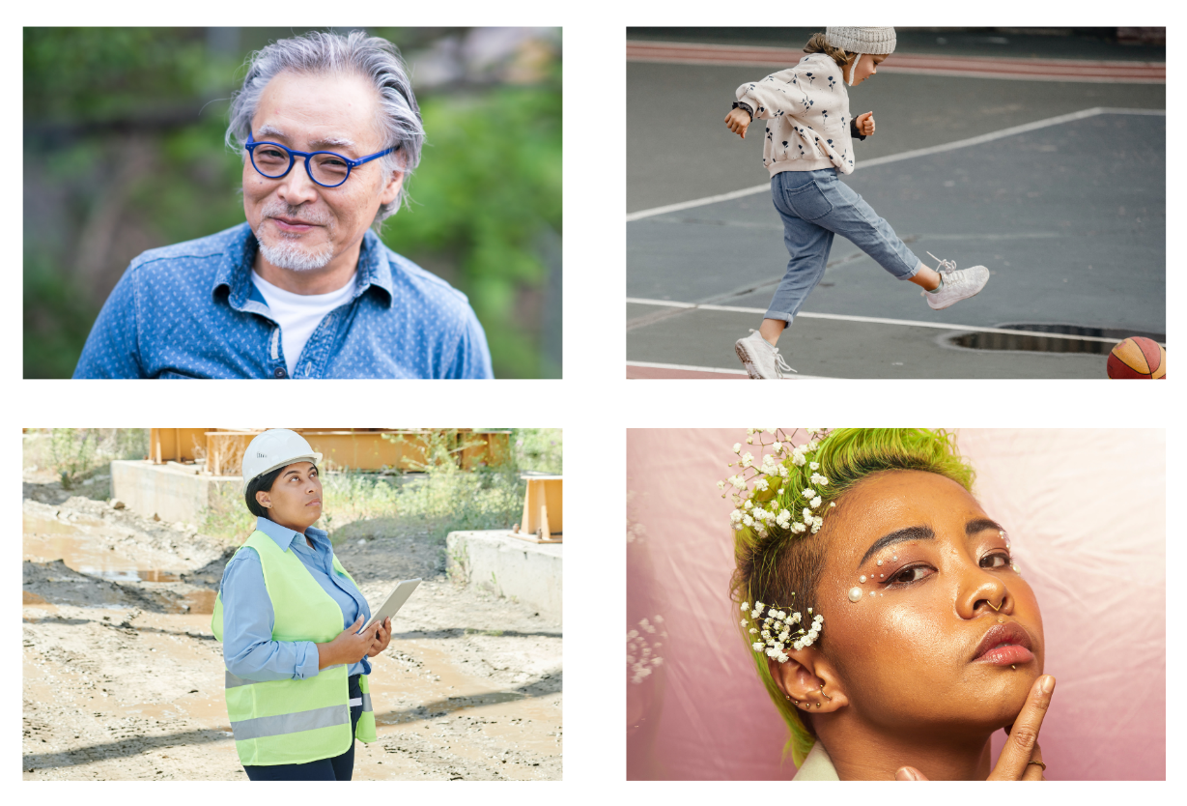

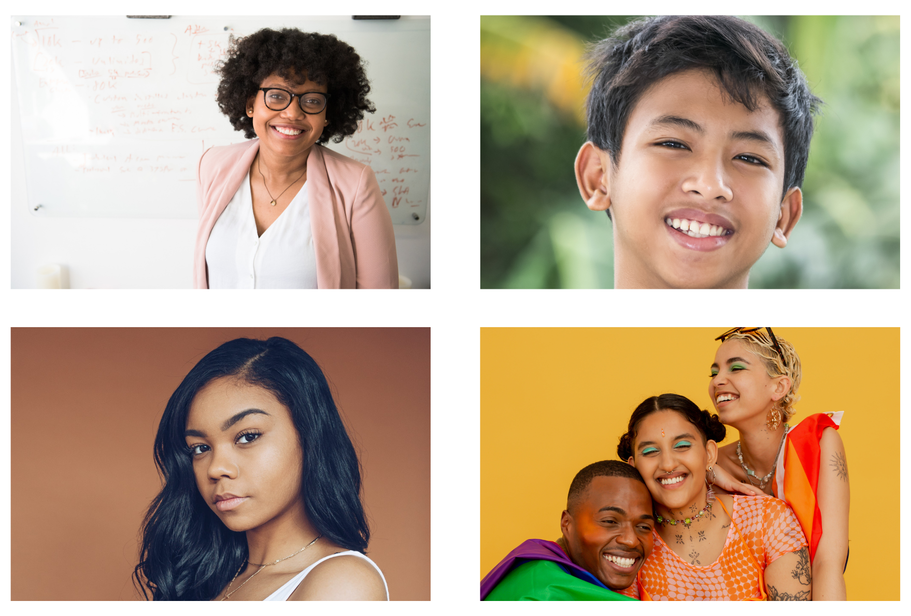

Sources for facts in this section: WomanKind Worldwide and UN Women.
Source: “Pain bias: the health inequality rarely discussed” from BBC

