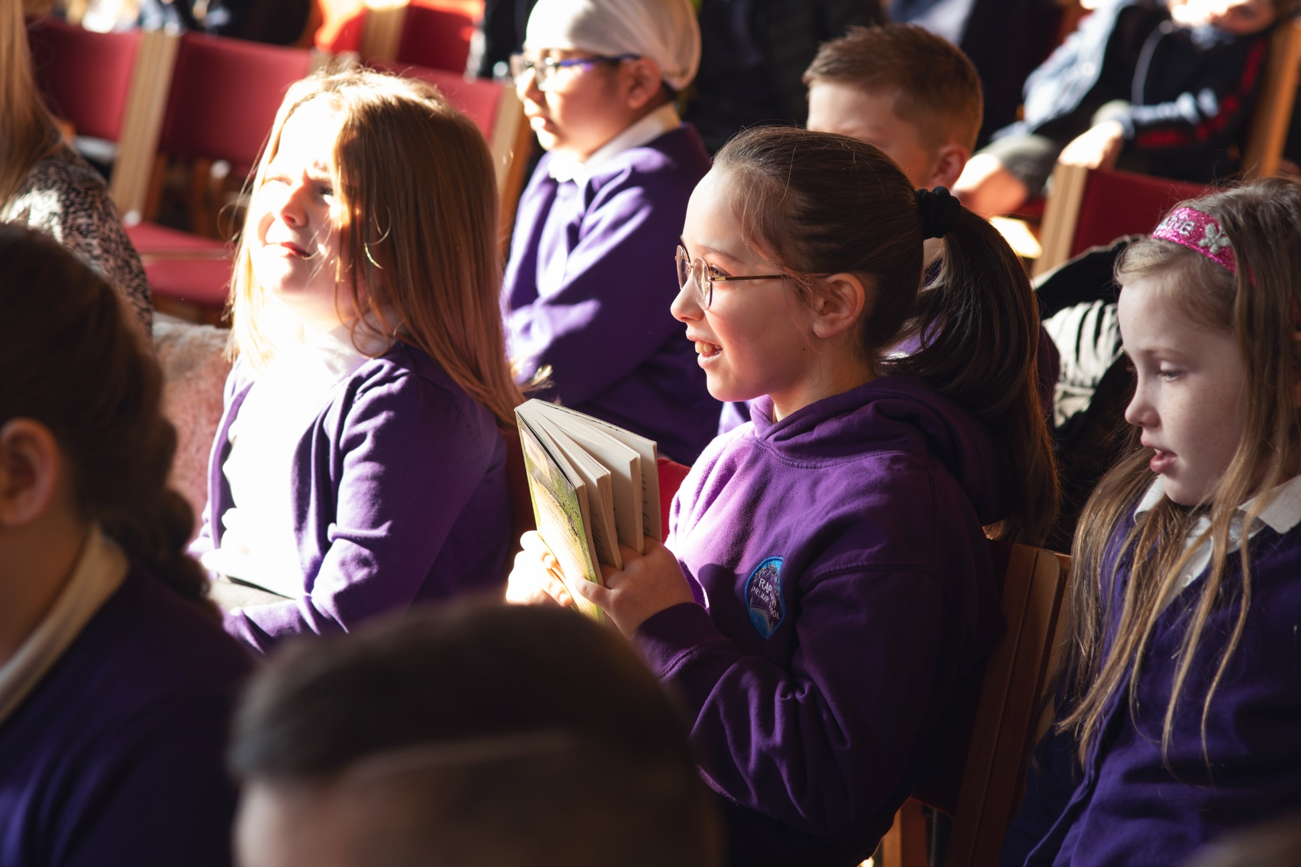

Celebrating World Book Day: primary resource
A guide to World Book Day including suggested activities and ideas for your class and school

Suitable for primary schools

Resource created by Scottish Book Trust and World Book Day
scottishbooktrust.com
Scottish Book Trust is a registered company (SC184248)
and a Scottish charity (SC027669).

Contents
About this resource 2
Why celebrate World Book Day? 3
Preparing month by month 3
Suggested activities for World Book Day 6
Next steps 8
Sample letter to parents/families (dressing up) 9
Sample letter to parents/families (not dressing up) 11

About this resource
World Book Day 2024 is Thursday 7 March. This resource, created in partnership with World Book Day, contains advice and ideas for celebrating World Book Day in your class and school. Throughout, we’ve highlighted Scottish Book Trust resources you can use as part of your celebration, or to deliver further opportunities to read for pleasure.
The key areas of this resource are:
- How to support pupils, and families, to use their £1 book token to choose a book and read together at home.
- How to work with staff and pupils to plan activities and delivery for World Book Day on Thursday 7 March.
- How to continue to support reading for pleasure in your school, build a reading culture and making reading fun using World Book Day and Scottish Book Trust resources and programmes.

Why celebrate World Book Day?
Reading for pleasure is a key indicator of a child’s future success, in fact, studies show its more important for a child’s educational success than the socio-economic class they grow up in. Reading for pleasure has benefits across the curriculum for a child’s skills and learning, as well as their motivation to learn. It also helps develop key life skills such as empathy, imagination, problem-solving and communication skills.
By celebrating days like World Book Day and giving reading for pleasure a high profile in your school, you are demonstrating to pupils that reading is a fun and worthwhile way to spend their time. By sharing your habits and preferences as a reader, you are also acting as reading role model, which is something that they may not have at home. Throughout this resource, we suggest ways to make reading engaging and fun, especially for reluctant readers, as well as how to extend these ideas in your school beyond World Book Day.

Preparing month by month

December
- Familiarise yourself with the World Book Day £1 book selection on the World Book Day website. You could show the covers to the pupils and ask them to describe what they think might happen in the book. Or you could read their blurbs aloud and ask them to pick which one they would like to read the most.
- Distribute the £1 tokens to children early to give them the best selection of books. £1 tokens can be exchanged from Thursday 15 February.
Don’t forget, your local bookseller can help you source books for children in your setting, for free. Early conversations make this more possible.

January

Staff briefing
To get your staff on the same page, we recommend running a staff briefing using the editable PowerPowerpoint template. Some key things to consider are:
Will you encourage pupils to dress up?
If so, read World Book Day’s Dressing Up guide for more information on how to make this accessible for families who cannot afford costumes. For example:
- Host a costume swap-shop.
- Ask pupils to dress up using only three items of clothing.
- Consider alternatives such as drawing a favourite character.

How does this tie into existing delivery at your school?
If you’re taking part in Reading Schools celebrating World Book Day could deliver key areas such as:
- 1.3.2 – School environment.
- 2.2.1 – Regular opportunities to read for pleasure.
- 2.2.3 – Creating learner social networks.
- 2.5.1 – Raising the profile of reading with families.

If you’re still looking to improve the reading culture in your school, you could use the Building a reading culture and Creating reading groups and events resources on the Scottish Book Trust website to begin planning what you’d like to deliver in your school. This resource includes suggestions for delivery as well as fun activities you could run on World Book Day such as Book Jenga, Extreme Reading or Book Speed Dating!
What do you want to run on the day?
See pages 6-8 of this resource for our suggested activities for World Book Day, use this with your colleagues and pupils to plan what you’d like to deliver on the day.
How can you involve pupils in organising events or activities for the day?
If you’re taking part in Reading Schools, your Reading Leadership Group’s could help plan and organise your celebrations on the day. Alternatively, you could use surveys to ask pupils what they’d like to do on the day or ask older pupils to create book boxes for the year below.

Promote all reading is good reading
Allow children full choice of what they’d like to read, including books, audiobooks, comics, graphic novels, and other texts. Read about why free choice of reading material is key in this article from Sarah Coyle on the Book Trust website.

Plan the events you’ll join in with
- Preparing for World Book Day 2024
- Overcoming barriers to Reading for Pleasure with The Open University
- BBC Live Lesson
- Great World Book Day Footy & Booky Quiz with The National Literacy Trust

How will you communicate with parents or families?
On pages 9-13 of this resource, you’ll find an editable letter template for parents with information about World Book Day and the £1 tokens. We’ve also gathered some links to activities and advice for families to support them to read at home.

February
- Check your World Book Day £1 tokens have arrived.
- Order your braille, audio, or large print £1 books via Guide Dogs, RNIB, NCBI and Calibre Audio. Visit World Book Day’s FAQs page for more information.
- If you haven’t already, look through the £1 books together in class. Talking about which book you’d pick, and why, could be a great way to role model reading.
- Look through the author’s websites together – have you heard of them before? Have you read any of their other books? You could check to see if you have any of them in your school or local library.

Suggested activities for World Book Day

As pupils arrive
Set up large pieces of paper at drop-off for children and parents to make recommendations – you could photograph these and send them out or combine them to make a whole school list. For older children you could invite them to recommend in categories – either by genre (comics, graphic novels, fiction, non-fiction etc.) or by when they like to read (to relax, to learn, to escape etc.)

Start of school assembly
Use World Book Day’s assembly pack, developed with Shapes for Schools to deliver a whole school assembly.

Throughout the day
Use the World Book Day Look insides on the £1 Book Pages to share the beginnings of the £1 books with your class or pick a story to read in instalments throughout the day. You could also use Scottish Book Trust’s Paired reading toolkit to support older pupils reading to younger groups.

A World Book Day lesson
Invite your students to run reading interviews with peers and/or members of staff. These are the questions our authors answer in the Assembly so these videos can be used as models too. Divide the children into 4 groups and give each group one question to research.
- What is your top tip for enjoying reading?
- Can you share something you’ve read in the last year and enjoyed?
- Where is your favourite place to read?
- What do you want to read more of this year?
Redivide the children so they are in a group with one person asking each question. Run the interview – children collect the answers to their questions. Return children to their groups to create summaries of what they’ve learned and share with the class.
You could also download Scottish Book Trust’s app Bookzilla where pupils can choose a reading challenge and keep a log of the books they read.

Follow up activities:
- Creatively displaying the recommendations – how do children want to discover them?
- Create posters out of the top tips to share in the classroom or around school.
- Using the responses to questions 1 and 4 invite the children to write their own reading challenges – trying out one of the tips or something different to read.
- Using the responses to question 3, (re)design your reading area to match their favourite reading spaces more closely.

11am: Join the BBC Teach World Book Day Live Lesson
Tune into the World Book Day Live Lesson on the BBC Teach website at 11am to learn a bit more about the £1 book authors and illustrators. You could also watch Authors Live broadcasts throughout the day – Scottish Book Trust’s Making the most of Authors Live resource shares tips for watching the broadcasts and extending learning.

Drop everything and read!
Surprise children with some reading time – lay out a range of books on the carpet or table and encourage them to choose. Then make some time for them to read. You could set up a cosy reading area with blankets and cushions!

At the end of the day
If you haven’t already, give out the £1 tokens and explain how to redeem them. Invite parents or families to stay for a bedtime story. You could invite a local bookseller to bring the £1 books so the children could exchange their tokens. You could also watch an Authors Live broadcast together – make it an event by making popcorn or snacks to eat whilst you watch!

Next steps
Promoting reading for pleasure in your school is important all year, not just on World Book Day! For more support to build a reading culture in your school see:
- Our free Reading Schools programme which offers an accreditation for building a reading culture in your school, as well as support and resources to help you with delivery.
- Our Schools guide contains more information on the programmes, CLPL and resources from Scottish Book Trust created to support teachers, educators and librarians in schools.
- Our Building a reading culture webinar and resource contains a guide to building a reading culture in your school, including supporting pupils to read for pleasure, developing your staff’s knowledge and ideas for groups and activities.
- World Book Day’s Resources Hub contains lots more reading for pleasure ideas, resources for World Book Day and all year round!

Sample letter to parents/families (dressing up)
Dear parents and caregivers,
World Book Day takes place on Thursday 7 March this year, and we hope you’ll join us to celebrate World Book Day across the school.
Dressing up or bringing books into school is a big part of World Book Day celebrations, and is something that children and families particularly enjoy. We are inviting children to dress up this World Book Day as it’s an exciting way for children to get book recommendations from each other.
The book choice is key – even if it’s just a prop or a clue make sure your child is recommending something to read with their costume.
We are aware that the cost of living crisis might make this difficult for some families, so we have organised the following events to make sure that our World Book Day is fun and inclusive for all.
We encourage you to use things you already have at home to make a creative costume.
We will also be hosting a costume swap on DATE/TIME.
We will be opening the setting with a selection of materials to make costumes on DATE/TIME
We’d love to include you in our celebrations by coming into school to:
- Read to them
- Come along to our bedtime story at XXXX
- Be one of our book corner special guests.
- Sending your child’s chosen book in with them on the day so we can read it to them and their friends

Access to books
Getting a free £1/€1.50 book for your child is easy – simply take your £1/€1.50 book token to your nearest bookseller and swap it for a World Book Day £1/€1.50 book OR use it to get £1/€1.50 off any ANY book or audiobook costing £2.99/€3.99 or more. You can find your nearest bookseller at worldbookday.com/participating-retailers
We’ll also be hosting a very special book swap. Drop off any unwanted books in the box outside XXX, then come and browse! Please feel free to take something you would like to read whether you’ve donated a book or not.
Join our open library session on XXX and help your child choose their next book to read at home. This is a chance for you to become familiar with the books in school too.
We’re very much looking forward to celebrating World Book Day, which could not happen without the support of parents and carers – thank you.

Sample letter to parents/families (not dressing up)
Dear parents and caregivers,
World Book Day takes place on Thursday 7 March this year, and we hope you’ll join us to celebrate World Book Day across the school.
Dressing up or bringing books into school can be a big part of World Book Day. This year we are aware that the cost of living crisis might make this difficult for some families, so we are doing things a bit differently!
Instead of coming to school in costume, we will:
- Be making costumes at school – join us to see what they’ve made DATE/TIME.
- Be making spoon puppets/potatoes of the children’s favourite characters. We can’t wait to see what the children’s creativity unleashes and to meet all of the spoon/potato characters. How many will you recognise?
- Decorate our doors.
- Invite children to wear their pyjamas.

We’d love to include you in our celebrations by coming into school to:
- Read to them
- Come along to our bedtime story at XXXX
- Be one of our book corner special guests.
- Sending your child’s chosen book in with them on the day so we can read it to them and their friends

Access to books
Getting a free £1/€1.50 book for your child is easy – simply take your £1/€1.50 book token to your nearest bookseller and swap it for a World Book Day £1/€1.50 book OR use it to get £1/€1.50 off any ANY book or audiobook costing £2.99/€3.99 or more. You can find your nearest bookseller at worldbookday.com/participating-retailers
We’ll also be hosting a very special book swap. Drop off any unwanted books in the box outside XXX, or just come and browse! Please feel free take something you would like to read whether you’ve donated a book or not.

Join our open library session on XXX and help your child choose their next book to read at home. This is a chance for you to become familiar with the books in school, too.
We’re very much looking forward to celebrating World Book Day, which could not happen without the support of parents and carers – thank you.

Source: “Reading for Change: Performance and Engagement across Countries”, PISA 2020
Source: “Motivation During an Excessively Challenging Reading Task: The Buffering Role of Relatvie Topic Interest”, The Journal of Experimental Education. 2011.
Source: “The role of home learning environment and emerging insights into the impact of the pandemic”. National Literacy Trust. 2022.

