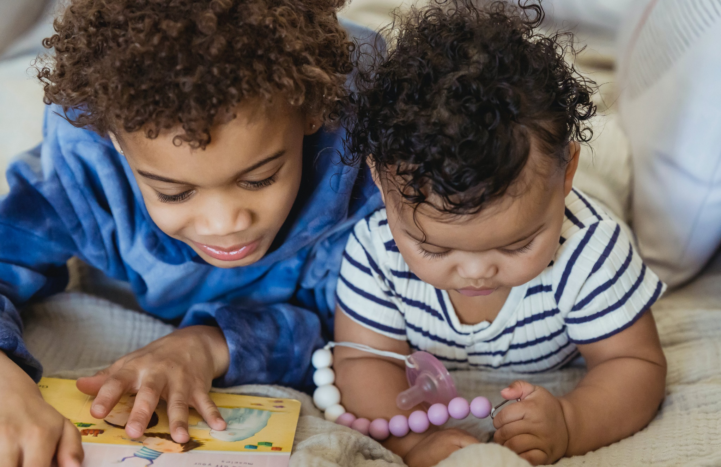

Celebrating World Book Day: early years
A guide to World Book Day including suggested activities and ideas for your setting

Suitable for early years settings

Resource created by Scottish Book Trust and World Book Day
scottishbooktrust.com
Scottish Book Trust is a registered company (SC184248)
and a Scottish charity (SC027669).

Contents
About this resource 2
Why celebrate World Book Day? 3
Preparing month by month 3
Suggested activities for World Book Day 5
Next steps 6
Sample letter to parents/families (dressing up) 7
Sample letter to parents/families (not dressing up) 9

About this resource
World Book Day 2024 is Thursday 7 March. This resource, created in partnership with World Book Day, contains advice and ideas for celebrating World Book Day in your early years setting. Throughout, we’ve highlighted Scottish Book Trust resources you can use as part of your celebration, or to deliver further opportunities to explore reading.
The key areas of this resource are:
- How to support children and families to use their £1 book token to choose a book and read together at home.
- How to work with staff to plan activities and delivery for World Book Day on Thursday 7 March.
- How to continue to support reading for pleasure in your setting, build a reading culture and making reading fun using World Book Day and Scottish Book Trust resources and programmes.

Why celebrate World Book Day?
Reading for pleasure is a key indicator of a child’s future success, in fact, studies show it’s more important for a child’s educational success than the socio-economic class they grow up in. Babies who are read to every day on average perform better at school and have higher levels of wellbeing. Reading for pleasure, as well as supporting literacy also develops key skills such as empathy, imagination, problem-solving and communication skills.
Reading for pleasure is a lifelong habit, and it’s never too early to start! Even before they are born, babies can hear in the womb. This short video with Suzanne Zeedyk on the Scottish Book Trust website looks at how shared experiences of reading and singing help babies brains to develop (2 minutes, 49 seconds. As a practitioner, supporting reading for pleasure and celebrating books can have a huge impact on a children’s confidence with reading, as well as making books more fun and engaging!

Preparing month by month

December
- Familiarise yourself with the World Book Day £1 book selection on the World Book Day website. You could show the covers to the children and ask them to describe what they think might happen in the book. Or you could read their blurbs aloud and ask them to pick which one they would like to read the most.
- Tokens will be sent to your setting. Distribute the £1 tokens to children early to give them the best selection of books. £1 tokens can be exchanged from Thursday 15 February. You can also find digital tokens on the World Book Day website.
Don’t forget, your local bookseller can help you source books for children in your setting, for free. Early conversations make this more possible. You could also talk with your local librarian or your local Bookbug Co-ordinator – you can find this out via the Scottish Book Trust website.

January

Staff briefing
To get your staff on the same page, we recommend having a conversation with staff to work out your priorities for the day. Some key things to consider are:
- Are the children in our setting being read to regularly – both at home and in the setting?
- What access do they have to books – both at home and in the setting?
- How confident are they in choosing books they like?
- How do we recommend books to children and families?
- How do we communicate about the value of reading together?
- How do we receive book recommendations from children and families?
- Do we make time for them to read?
- How can we make World Book Day a fun celebration that promotes reading for pleasure?
- If you already deliver a lot of reading and story experiences – how can you tie these into World Book Day? Consider celebrating the books the children in your setting love!
Deciding what you want to run on the day:
See pages 5 and 6 of this resource for our suggested activities for World Book Day, use this with your colleagues and children to plan what you’d like to deliver on the day.

Communicating with families:
On pages 7-10 of this resource, you’ll find an editable letter template for parents with information about World Book Day and the £1 tokens. We’ve also gathered some links to activities and advice for families to support them to read at home.

February
- Check your World Book Day £1 tokens have arrived.
- Order your braille, audio, or large print £1 books via Guide Dogs, RNIB, NCBI and Calibre Audio. Visit World Book Day’s FAQs page for more information.
- If you haven’t already, look through the £1 books together in the setting. Talking about which book you’d pick, and why, could be a great way to role model reading.
- Look through your setting’s library together – do you have any other books by the authors? Or any that might be similar?

Suggested activities for World Book Day

As children arrive
At drop off, ask the families to share what their child’s favourite book is. You could write these down on tags as they arrive and attach them to the books themselves, or pictures of the children on display.

Create a book zone
Make book zones throughout your setting by setting up the following:
- Garden – Play story hide and seek! Hide objects relating to a story around your garden. Once you’ve found all the objects, share the story together.
- Home or role play area – Create a food character to share your day with – stick eyes on some of your play food and spend the day together.
- Creative area – Invite children to draw, paint, make a character they would like to be in a story. You could display illustrations from the children’s favourite books to inspire them.
For more inspiration, see our article on Creating a book corner in your early years setting.

Make time to read
Snuggle up and watch one of the video stories on World Book Day’s Share A Story Corner including Bee & Me by Alison Jay, Ruby’s Worry by Tom Percival, Dear Zoo by Rob Campbell and more. We’ve also partnered with World Book Day to host three of these lovely stories on the Bookbug app! The Bookbug app also includes hundreds of songs and rhymes for families to enjoy together, or for more story content, we also have our brand new the Bookbug Story Library!
You could also use our resource 10 things to do with any book at early level to plan some fun activities, either with the World Book Day books, your Bookbug Explorer books or books in your setting’s library.

At the end of the day
If you haven’t already, give out the £1 tokens and explain how to redeem them. Invite parents or families to stay for a bedtime story. You could invite a local bookseller to bring the £1 books so the children could exchange their tokens.

Home time
Host a bedtime story for children and their parents – model supporting children to choose books based on family interests, and offer tips about how to share, or better still show them, with your own bedtime story at the end of the event. For inspiration, see our book list of Night-time books for babies and toddlers.

Next steps
Promoting reading for pleasure in your setting is important all year, not just on World Book Day!
- See the Bookbug section of the Scottish Book Trust website for webinars and resources to support staff understand and knowledge about using books with early years children.
- Find out more about Bookbug sessions in your area – this is a great resource for families, as all sessions are free and designed to help families read, sing together and bond.

Sample letter to parents/families (dressing up)
Dear parents and caregivers,
World Book Day takes place on Thursday 7 March this year, and we hope you’ll join us to celebrate World Book Day across the setting.
Dressing up or bringing books into settings is a big part of World Book Day celebrations, and is something that children and families particularly enjoy. We are inviting children to dress up this World Book Day as it’s an exciting way for children to get book recommendations from each other.
The book choice is key – even if it’s just a prop or a clue make sure your child is recommending something to read with their costume.
We are aware that the cost of living crisis might make this difficult for some families, so we have organised the following events to make sure that our World Book Day is fun and inclusive for all. We encourage you to use things you already have at home to make a creative costume.
We will also be hosting a costume swap on DATE/TIME.
We will be opening the setting with a selection of materials to make costumes on DATE/TIME
We’d love to include you in our celebrations by inviting you to:
- Come into the setting to read to the children
- Come along to our bedtime story at XXXX
- Be one of our book corner special guests.
- Send your child’s chosen book in with them on the day so we can read it to them and their friends

Access to books
Getting a free £1 book for your child is easy – simply take your £1 book token to your nearest bookseller and swap it for a World Book Day £1 book OR use it to get £1 off ANY book or audiobook costing £2.99 or more. You can find your nearest bookseller at worldbookday.com/participating-retailers
We’ll also be hosting a very special book swap. Drop off any unwanted books in the box outside XXX, then come and browse! Please feel free to take something you would like to read whether you’ve donated a book or not.
Join our open library session on XXX and help your child choose their next book to read at home. This is a chance for you to become familiar with the books in the setting too.
We’re very much looking forward to celebrating World Book Day, which could not happen without the support of parents and carers – thank you.

Sample letter to parents/families (not dressing up)
Dear parents and caregivers,
World Book Day takes place on Thursday 7 March this year, and we hope you’ll join us to celebrate World Book Day across the setting.
Dressing up or bringing books into the setting can be a big part of World Book Day. This year we are aware that the cost of living crisis might make this difficult for some families, so we are doing things a bit differently!
Instead of coming to the setting in costume, we will:
- Be making costumes at our setting – join us to see what they’ve made DATE/TIME.
- Be making spoon puppets/potatoes of the children’s favourite characters. We can’t wait to see what the children’s creativity unleashes and to meet all of the spoon/potato characters. How many will you recognise?
- Decorate our doors.
- Invite children to wear their pyjamas.

We’d love to include you in our celebrations by inviting you to:
- Come into the setting to read to the children
- Come along to our bedtime story at XXXX
- Be one of our book corner special guests.
- Send your child’s chosen book in with them on the day so we can read it to them and their friends

Access to books
Getting a free £1 book for your child is easy – simply take your £1 book token to your nearest bookseller and swap it for a World Book Day £1 book OR use it to get £1 off ANY book or audiobook costing £2.99 or more. You can find your nearest bookseller at worldbookday.com/participating-retailers
We’ll also be hosting a very special book swap. Drop off any unwanted books in the box outside XXX, or just come and browse! Please feel free take something you would like to read whether you’ve donated a book or not.

Join our open library session on XXX and help your child choose their next book to read at home. This is a chance for you to become familiar with the books in the setting, too.
We’re very much looking forward to celebrating World Book Day, which could not happen without the support of parents and carers – thank you.

Source: “Reading for Change: Performance and Engagement across Countries”, PISA. 2020
Source: “Reading for pleasure at home with babies and toddlers”, Waltham Forest. 2020.
Source: “The role of home learning environment and emerging insights into the impact of the pandemic”. National Literacy Trust. 2022.

