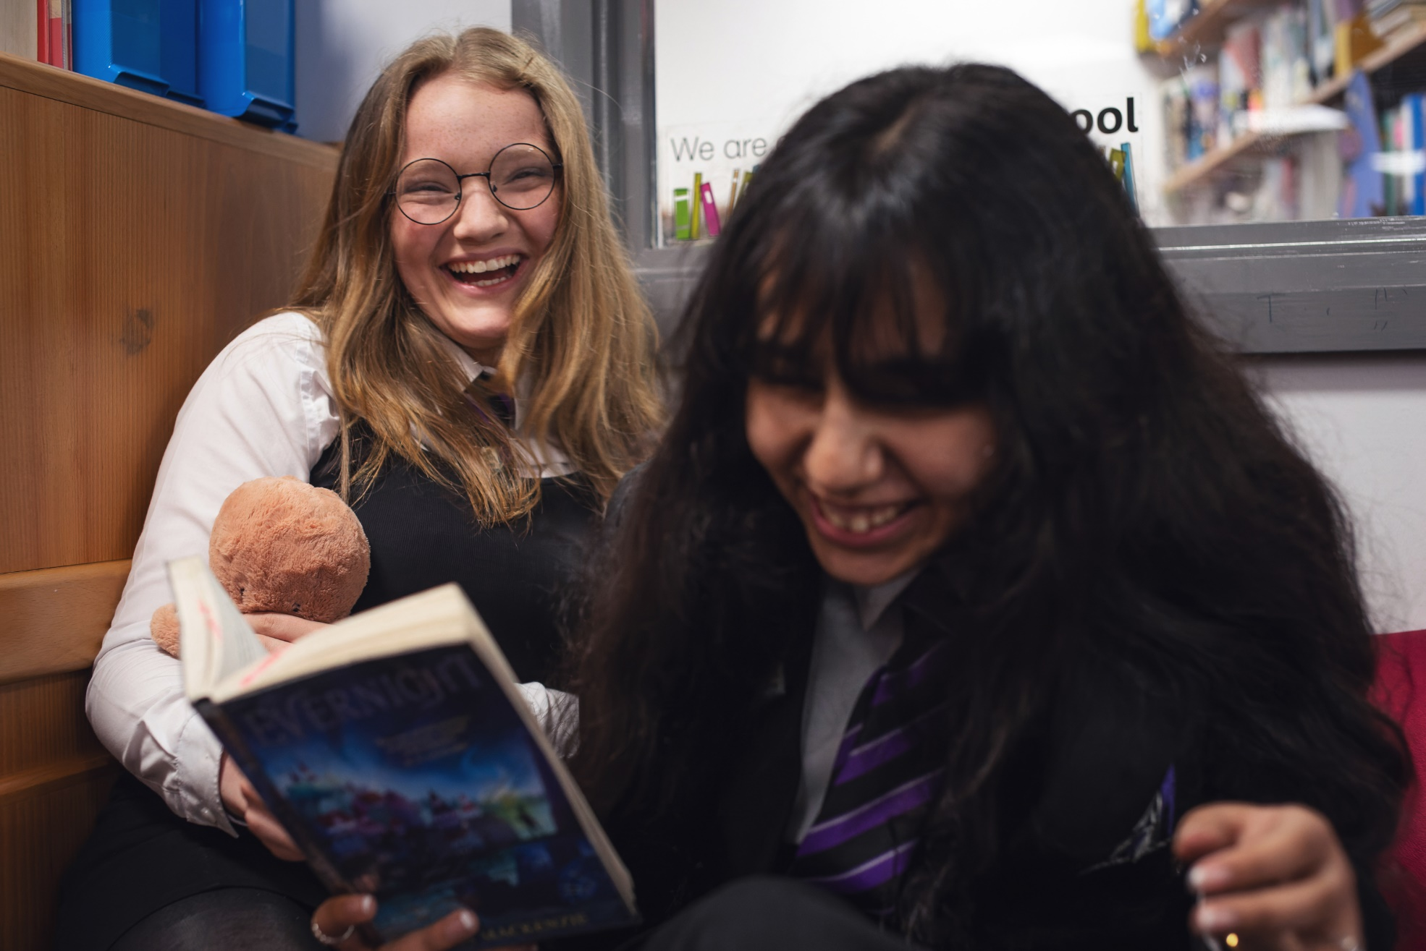

How to make a book trailer
A guide to using filmmaking to explore books and other texts in your class

Age 8-18
CFE Levels Second to Senior Phase

Resource created by Scottish Book Trust

scottishbooktrust.com
Scottish Book Trust is a registered company (SC184248)
and a Scottish charity (SC027669).

Contents
About this resource 2
Learning activities 2
Further resources 7
For teachers: assessing book trailers 8
Worksheet 1: Mind maps 9
Worksheet 2: Pupil peer feedback 10
Worksheet 3: Sounds and images 11

About this resource
Book trailers are just like movie trailers, giving a “taster” of a book’s story but designed to leave them wanting to read on! They encourage pupils to read a book critically, so they have a strong idea of what their trailer needs to convey. This resource will take you through researching, creating and editing a film trailer for pupils from Second to Senior Phase.

Learning activities

Lesson 1: Introducing book trailers
LIT 2-16a/3-16a/4-16a, LIT 2-25a/3-25a/4-25a, ENG 2-19a/3-19a/4-19a
In pairs, ask the pupils to discuss:
- What is the purpose of a trailer?
- How long should it be?
- What kind of things will people need to know about the book before they buy or borrow it?
- How much should give away about the story?
Now have a class discussion, creating a list of five things you think a book trailer should contain.

Lesson 2: Watching trailers
LIT 2-01a/3-01a/4-01a, LIT 2-04a/3-04a/4-04a, LIT 2-07a/3-07a/4-07a
Watch the following trailers as examples – you could use the comments to prompt a discussion with your class. Then give pupils a copy of Worksheet 1 on page 9.
Book | Age rating | Comments
The Paper Dolls by Julia Donaldson and Rebecca Cobb  Trailer via YouTube (1 minute, 25 seconds) | 3-7 | Notice how this trailer uses animation, including stop motion animation.
We Are Water Protectors by Carole Lindstrom and Michaela Goade  Trailer via YouTube (42 seconds) | 5-8 | Notice how this trailer uses animation and music to create a setting and tone. You could also discuss how this one doesn’t give a lot away in terms of plot.
Codename Verity by Elizabeth Wein  Trailer via YouTube (1 minute, 27 seconds) | 12-16 | Notice how this trailer creates the setting and era of the book, as well as how it uses sounds and music.
Radio Silence by Alice Oseman  Trailer via YouTube (1 minute, 33 seconds) | 13-16 | Notice how this trailer uses radio sounds and music. You could also discuss how this one doesn’t give a lot away in terms of plot.
Boy Nobody by Allen Zadoff  Trailer via YouTube (59 seconds) | 16+  Please note this trailer may be inappropriate for younger pupils | Notice how this trailer uses a voiceover.

Discuss the following questions with your class:
- How do you think they choose what parts of the story to include, or not include, in the trailer?
- Do you need a mixture of different types of scenes or moods in a trailer?
- How much of the story should you reveal?

You could watch the following film trailers to expand your discussion:
Film | Age rating | Comments
Ponyo - Trailer via YouTube (1 minute, 56 seconds) | U (4+) | Discuss the feeling of this trailer. What kind of story do the pupils think this is going to be?
Ratatouille - Trailer via YouTube (1 minute, 50 seconds) | PG (8+) | Discuss how this trailer shows very little of the plot and focuses instead on setting up the main character and his conflict.
Nimona - Trailer via YouTube (2 minutes, 47 seconds) | PG (8+) | Discuss how this trailer sets up the relationships between the different characters as well as the world they live in.
Turning Red - Trailer via YouTube (2 minutes, 24 seconds) | PG (8+) | Discuss how this trailer introduces us to Mei’s world. What do we learn about her before and after she becomes a red panda?
Dungeons and Dragons: Honour Among Thieves -  Trailer via YouTube (2 minutes, 15 seconds) | 12A (12+) | Discuss how this trailer sets up the main characters and their different abilities, as well as the world it’s set in.
Star Wars: The Force Awakens - Trailer via YouTube (2 minutes, 35 seconds) | 12A (12+) | Discuss how this trailer sets up the main characters (especially Rey, Finn and Kylo Ren).
You could also discuss a film a few pupils in the class have seen, then watch is trailer – discussing how much of the plot it gave away, how it captured the film’s feelings or characters or what the trailer chose to focus on.

Lesson 3: Planning your book trailer
Script: LIT 2-06a/3-06a/4-06a, LIT 2-15a/3-15a/4-15a, LIT 2-20a/3-20a/4-20a
Storyboard: LIT 2-06a/3-06a/4-06a, LIT 2-15a/3-15a/4-15a, EXA 2-04a/3-04a/4-04a

Option 1: Write a script
A script is quite detailed as it describes each shot of the book trailer, including:
- Images
- Music and/or sound effects
- Transitions (e.g. are there cuts, fades or wipes?)
- Voiceovers
- Text on screen
- Visual effects
For example, a book trailer for Dracula by Bram Stoker could look like this:
Shot 1: image of a stormy landscape, storm sound effects
Shot 2: cut to a black screen with grey text that reads “In 1897 I was sent to Castle Dracula in Transylvania on routine business…”
Shot 3: Quick fade to a close up shot of a vampire staring straight at a camera
Shot 4: Quick fade to a wide shot of an old castle, black and white visual effect, voiceover of Cout Dracula welcoming the narrator into his castle

Option 2: Creating a storyboard
Storyboards are used all the time by filmmakers. A storyboard is a series of sketches which show what the scenes of the film would look like. Here is an example of a storyboard by Sav Akyüz, illustrator and storyboard artist. To learn more about his work, you can watch his Authors Live broadcast on our website.
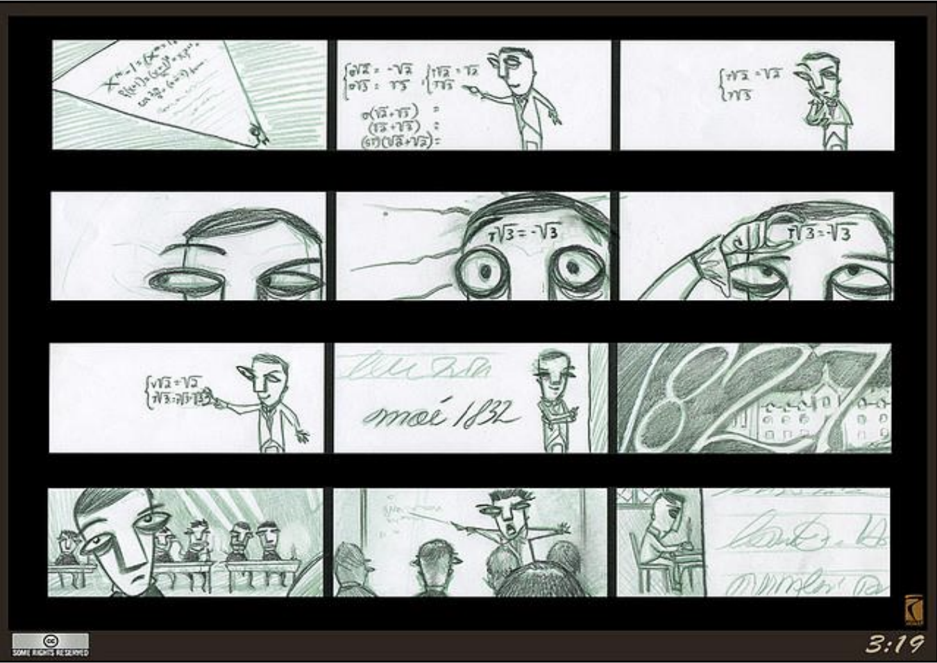
Print Worksheet 2 on page 10 and distribute one per pupil for them to create their own storyboard.

Lesson 4: Filming and editing trailers
LIT 2-14a/3-14a/4-14a, LIT 2-23a/3-23a/4-23a, LIT 2-24a/3-24a/4-24a,
ENG 2-27a/3-27a/4-27a, ENG 2-31a/3-31a/4-31a, TCH 2-01a/3-01a/4-01a,
TCH 2-02a/3-02a/4-02a, EXA 2-14a/3-14a/4-14a
Ask pupils to make a list of the scenes or pages from the book they would like to include in their trailer. Use the following tools to create your trailer:

Videos, images, sounds and music
For open access images, videos, sounds and music see Creative Commons’ Search Portal You can also find music and sound effects on YouTube Studio (you will need a Google or YouTube account, which you can sign up for for free).

Video editing
- WeVideo is online video editing software
- For devices with Microsoft software, you can also use ClipChamp
- For devices with Apple software, you can also use iMovie

Give each pupil a copy of Worksheet 3 on page 11 where they can track what they need for their trailer.

Next steps
- Celebrate the finished book trailers by holding a screening – you could invite other classes to come along and watch what you’ve made!
- Hold an award ceremony for the book trailers with different categories, such as best editing, best soundtrack or best tagline
- Work with your local librarian to allow your pupils to borrow the books from the library once they’ve watched the trailers
- Share a book trailer each week at the end of assembly
- Share the book trailers on social media, or on any internal sites your school pupils have access to
- Ask older pupils to make book trailers to recommend a book to a younger year

Further resources
- For more resources on using film-making in class, see IntoFilm. You can also find further worksheets on our webpage of Book review and trailers on film
- See our resource on Creating your own stop-motion animation
- For further learning activities to explore film, see our How to Train Your Dragon film resource for Second Level
- To learn more about storyboarding, watch our Authors Live with Sav Akyüz
- Explore our Live Literature database to find screenwriters in Scotland - you could apply for Live Literature funding to bring a screenwriter into your school to deliver a workshop with your staff or pupils

For teachers: assessing book trailers
Book trailer activities demand the same kind of critical reading skills which are used
when writing a critical essay: pupils must demonstrate an understanding of plot but
also character, setting, atmosphere and genre.
Writing skills are also assessed: book trailers make sparing use of text, so pupils
have to be concise and careful with their expression so as to have maximum impact
on their audience. Careful decisions also need to be made about structure and
layout of the trailer.

Characters, setting and atmosphere | Does the trailer demonstrate an understanding of the central concerns of the text?  Does it demonstrate an understanding of the main characters and how they are characterised in the book?  Does the trailer give a strong impression of the setting an atmosphere of the book?
Layout and structure | Is the length of the trailer appropriate (3 minutes max)?  Has the pupil ordered the images, sounds and text in a way that creates impact?
Use of images, sounds and text | Does the trailer demonstrate an ability to use language to achieve particular effects?  Is the use of sounds, images and/or footage apt for purpose?

Worksheet 1: Mind maps
Print this page
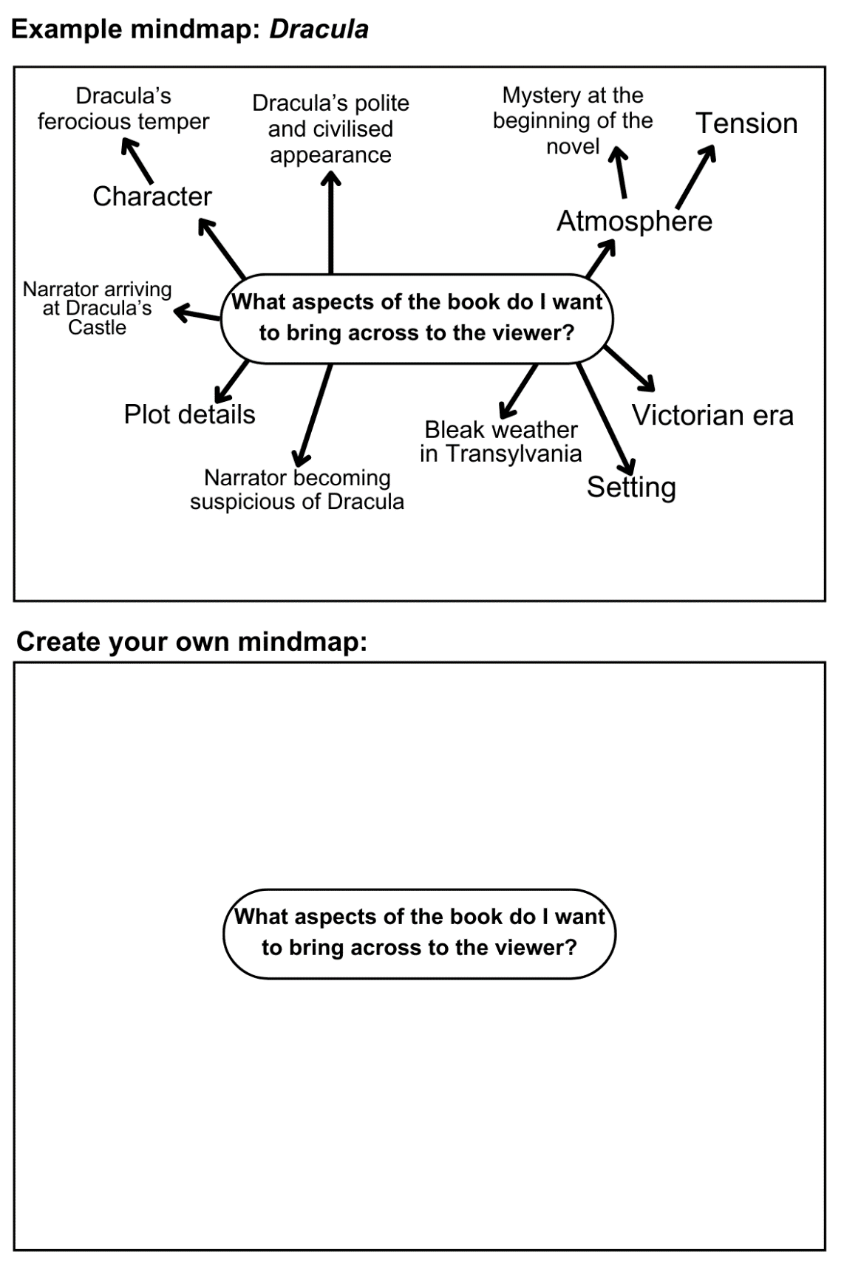

Worksheet 2: Pupil peer feedback
Print this page
Questions | Notes
How has the trailer given an impression of what the main character is like?

How has the trailer given an impression of what the setting is like?

How has the trailer captured the mood/tone of the book?

How does the trailer make its audience want to read the book?

What did you particularly like about the trailer?

What would you change, add or omit from the trailer?

Worksheet 3: Sounds and images
Print this page
Use this table to help you to get accustomed to recording the relevant details when you are downloading images and sounds.
In the right-hand column, you will find instructions telling you to look for an image or sound. Look through Flickr, mp3.com and Soundbible to find images and sounds. When you have found something suitable for each instruction, write down the username and website in the columns next to it.
Instruction | Username of person who owns the image/sound | Website
Find an image of an old castle | Dave Stokes | Flickr
Find a sound effect of a bomb exploding

Find a sound effect of a crowd cheering

Find some dramatic music

You can use the below table to make notes of what you’ll need for your own trailer:
Sound, image, video or music to find | Username of person who owns the image/sound | Website

