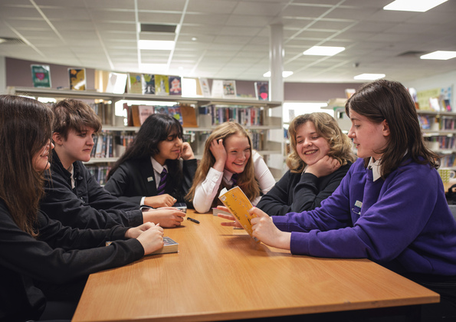

10 things to do with any book (secondary)
Creative activities for the classroom and library

CFE Second and Third Levels

Age 11-15

Resource created by Rachel Latimer, English teacher at Portobello High School

scottishbooktrust.com
Scottish Book Trust is a registered company (SC184248)
and a Scottish charity (SC027669).

Contents
About this resource 2
Before reading 3
During reading 3
After reading 5
Further resources 8
Worksheet 1: You can’t judge a book by its cover 8
Worksheet 2: The Blurb and the Book Detectives 10
Worksheet 3: Reading diary 11
Worksheet 4: Reading Role Cards 13
Worksheet 5: The Challenge 14
Worksheet 6: Dice template 15
Worksheet 7: Character Cards 16

About this resource
I cannot claim originality, but I have tried to gather a collection of ideas to encourage active learning in the classroom. I have been inspired by colleagues over the years and shamelessly borrowed ideas from the real world and the virtual one and applied them to learning in the classroom.
Pick and choose from activities that appeal to you and your learners. There is always scope for simplifying or providing more scaffolding or giving free rein to learners once they are motivated by an idea. Sometimes I am just trying to improve group work skills, but talking and listening assessments can be derived from the group discussion. The resource is aimed to encourage participation, motivation and enjoyment of reading. Many activities have been carried out with great enthusiasm, not just with my BGE classes, but as revision tasks for exam classes.

If you are taking part in Reading Schools, the activities in this resource could support delivery of Key Area:
- 2.2.2: Interdisciplinary book projects
- 2.3.3: Creating learner social networks
- 2.3.4: Opportunities for learners to respond to what they’re reading

Before reading

Activity 1: Book detective
LIT 3-02a, LIT 3-07a, LIT 3-09a, LIT 3-13a, LIT 3-16a, HWB 3-09a, HWB 3-10a, HWB 3-11a, HWB 3-14a
Using Worksheet 1 on page 9 and Worksheet 2 on page 10, put the pupils into groups and ask them to present their work to the class. Pick a random page and select an exciting moment in the story, ask the pupils to continue the story.
- What will the characters do next?
- How could the setting affect the plot?
Be creative but look for clues in the text to guide your writing.

During reading

Activity 1: Reading diary
LIT 3-02a, LIT 3-07a
Use Worksheet 3 on pages 11 and 12. This helps pupils to focus on their reading and process the content. Pupils could work together and share the reading of a chapter using the diary questions to provoke questioning and prediction.

Activity 2: Balloon debate
LIT 3-02a, LIT 3-07a, LIT 3-09a, LIT 3-27a, HWB 3-09a, HWB 3-10a, HWB 3-11a, HWB 3-14a
All characters have been transported to a hot air balloon, which is losing heigh rapidly. Characters will be thrown overboard unless they can justify their importance. This will encourage learners to be inventive about minor characters and develop their reasoning skills. It will also introduce the idea of thinking of the text as a construct with characters necessary to plot development.
Which characters are most important? Assign characters to pupils. They have to justify the importance of their character in the story. Some questions to get you started:
- How important is your character to the main plot/story/chapter?
- Is your character a good or bad influence on the other characters?
- Is the setting of the story important to your character?
- If your character did not exist, which events in the plot/story/chapter would not happen?
- How does your character react to important/key events?
- What do you learn from your character?
- What do the other characters learn from your character?
- What is the main purpose of your character in the story?
- If your character is a minor character, why have they been created?
- Does your character make you think about your own life?

Activity 3: Video diary
LIT 3-02a, LIT 3-06a, LIT 3-07a, LIT 3-14a, LIT 3-16a, LIT 3-25a, LIT 3-27a,
EXA 3-01a, HWB 3-09a, HWB 3-10a, HWB 3-11a, HWB 3-14a
This works well with phones and tablets. Learns can talk “secretly” In the diary room demonstrating their knowledge of the character, or this can be a group discussion task.
Groups can specialise in their knowledge of a particular character and write the questions that they would like to direct to other characters in the story. This will encourage pupils to evaluate characters with greater depth. Here are some starter questions, beginning with recall questions but progressing to analysis and evaluation:
- What is your name?
- How old are you?
- Where do you live?
- Why did you…?
- What do you really think about?
- How did you react to…?
- What are you going to do about…?
- How did you feel when…?
- What would you like to change…?
- When did you realise…?

Activity 4: Reading roles
LIT 3-02a, LIT 3-07a, LIT 3-09a, LIT 3-14a, LIT 3-28a, HWB 3-09a, HWB 3-10a, HWB 3-11a, HWB 3-14a
Read a chapter as a group. Assign reading roles to check understanding. Use the reading role cards on Worksheet 4 on page 13 for this task.

After reading

Activity 1: Tweet
LIT 3-14a, LIT 3-15a, LIT 3-24a, LIT 3-25a, LIT 3-27a
Write a summary of a chapter or whole book using just 140 characters. Pupils can use words or emojis to create their summary. I find that learners are much better at this than I am! Change the task to suit your learners.
Summary skills are increasingly important and you might want to encourage concise vocabulary rather than emojis.

Activity 2: Make a game
LIT 3-02a, LIT 3-07a, LIT 3-09a, LIT 3-10a, LIT 3-14a, LIT 3-15a, LIT 3-16a,
LIT 3-20a, LIT 3-24a, LIT 3-25a, LIT 3-27a, LIT 3-28a, MNU 2-09a, HWB 3-09a, HWB 3-10a, HWB 3-11a, HWB 3-14a
Using Worksheets 5 on page 14 and Worksheet 6 on page 15, learners work in groups to create a Monopoly style game. Some learners might need a reminder of how the game works. I show pictures of game boards from the internet. Learners can design a board using their imagination or model their ideas on an existing game.
For Snakes and Ladders, learners can mark key events onto the game board. Some learners might require support with key events – I would give them a list of 5 or 10 events, perhaps in the wrong order to get them discussing priorities. Landing on a square might move you up the board or down the board.
My fourth years made a revision game for Lord of the Flies by William Golding. Players moved down creepers and up pig runs. The counters were characters. Key events were marked on the board.
Second years made Monopoly style games for Fleshmarket by Nicola Morgan. Locations in the novel were listed first, then marked around the board. For differentiation, you could agree a list of places as a class. Fleshmarket Close, Tron Kirk, The Tolbooth Jail, Edinburgh Castle, Holy Rood Park, Infirmary Street and Dr Knox’s Anatomy School. Saxe Coburg Place, Burke and Hare’s graveyards.
Next step is to list key events and how this affects the characters. So, for example, Essie in Fleshmarket helps Robbie keep his job. Move forward 3 spaces. Robbie’s father sells the violin, to buy whisky, move backwards 3 spaces.
I ask learners to write their own set of rules as this allows them to change rules according to their knowledge of the game. The learning occurs as they make the game, I’m not too worried about the final result. I have had some learners follow the Monopoly rules with property cards, rents and houses, but usually I aim for a simplified version limited by time. With some classes, we read for half the lesson, then I give them half the lesson to develop their game as we reach the final chapters of the novel.
The activity will use their numeracy skills to design a board layout and is a good opportunity for talk assessment. This is a good revision task that older students will really enjoy. For pupils who are less artistic, I print out images to help them create a text that looks impressive. They can make dice – this can be quite an achievement (see Worksheet 6 on page 15). Opposite sides add up to 7. Encourage pupils to review their progress and set targets for each lesson.

Activity 3: Character cards
LIT 3-02a, LIT 3-07a, LIT 3-09a, LIT 3-15a, LIT 3-20a, LIT 3-25a, HWB 3-09a,
HWB 3-10a, HWB 3-11a, HWB 3-14a, TCH 2-03a
Use Worksheet 7 on page 16. This activity is inspired by Top Trumps. I have used this for effective character discussion whilst pupils discuss scores and summaries for their character cards. Depending on your pupils you can leave pupils to design the cards themselves with a model, or with a lower ability class provide more structure. I made cards on File Maker Pro (with the help of IT Faculty Leader), inserted pictures and laminated after a film study. This means pupils can write on the cards with whiteboard pens. We discussed what our categories should be, which ties in with themes of the book. Pupils choose a number between 1-100 and discuss each character’s numerical values for the categories. I asked my pupils to write 3 points about the character in the description box.

Activity 4: Timeline of events
MNU 2-10a, LIT 3-09a, LIT 3-14a, LIT 3-15a, LIT 3-20a, LIT 3-24a, LIT 3-25a,
LIT 3-28a
This appeals to pupils with a visual memory. Make a list of significant events. Ask pupils to mark these in chronological order. Depending on the novel you are studying, you might include important historical events, or you might have multiple narrators. If the plot uses flashback, this activity will help pupils gain a better understanding of the text. You can use your graph to indicate whether events have a positive or negative impact on the plot or characters – mark events above or below the x axis.

Activity 5: Write a quiz
LIT 2-16a, LIT 3-14a, LIT 3-15a, LIT 3-20a, LIT 3-28a, ENG 2-31a, ENG 2-19a,
TCH 2-03a, ENG 3-17a, HWB 3-09a, HWB 3-10a, HWB 3-11a, HWB 3-14a
Put pupils into groups. Ask them to write six questions with answers on a chapter or a character or a key event. Their questions will be more searching depending on your group. Encourage them to challenge the other pupils. You or a pupil can be the quiz master. Each group is allowed a joker when they will get double points for that round (usually for the questions they wrote). You will then have 4-6 rounds of questions for the whole class. Pupils enjoy the competitive element. If you have time, you could set this up on-line with Cahoots or Socrates apps.

Further resources
- For more ideas and activities on supporting reding for pleasure and setting up reading groups and events see our Building a reading culture resource
- All of our learning resources can be filtered by age group, including 9-11 year olds, 12-14 year olds and 15-18 year olds
- To support creative writing, see our Creative writing for secondary resource or the Young Writers section of our website

Worksheet 1: You can’t judge a book by its cover
Print this page
Sometimes book covers can give us our first clue of what a book will explore. We can often tell the genre of the book, the age and level of readers, the information that the book might discuss and even what other readers think of the book.

Front cover
- What main colours are used?
- What images or pictures are used in the cover art work?
- Are the pictures or images symbolic or realistic?
  - Places
  - People
  - Animals
  - Actions
  - Other – explain
- What is the title of the book?
- What mood or feeling do you get from the art?

Pick out one thing in particular that creates this feeling or mood and explain why.
Is the character shown on the cover. What predictions can you make about this person?
What clues are there about the novel’s setting?
Does the cover give any hints to the plot or main themes in the story?

Worksheet 2: The Blurb and the Book Detectives
Print this page
What information can we discover from the back of the book?
- Read the blurb carefully.
- Can you guess the genre?
- Where is the story set?
- What do you learn about the characters?
- What key events are introduced to interest the reader?
- Are there any recommendations from people who have read the book already?
- In what way do they recommendations encourage you to read the book?
- Having read the blurb, do you have any questions about:
    - The characters?
    - The setting?
    - The plot?

Predictions
Make three predictions about what might happen in your novel.
1.

2.
3.

Worksheet 3: Reading diary
Print this page
Date:
Pages read:
Text:
Genre:
Would I have chosen this text? Yes / No
Please give a reason for your choice:

Stress levels at the beginning of lesson:
0 1 2 3 4

Stress levels at the end of lesson:
0 1 2 3 4

Personal response
Summarise key points that happened in your story:
>
>
>
Which events interested you?
>
>
>

What annoyed or confused you?
>
>
>

Who would you recommend this book to and why?
Age group:
Interests:

Worksheet 4: Reading Role Cards
Print this page
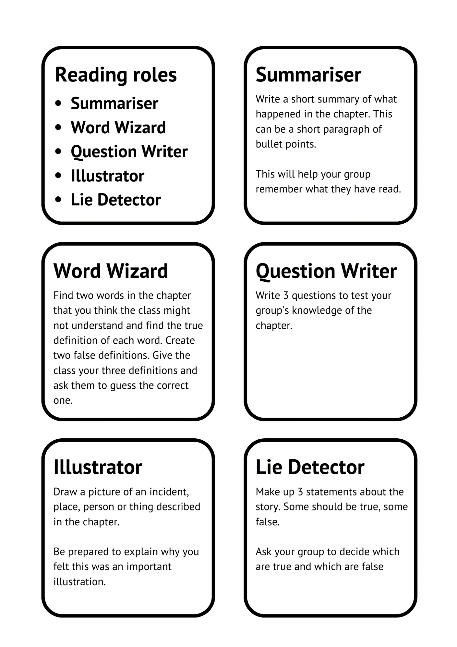

Worksheet 5: The Challenge
Print this page
In your groups, you must agree to share out the tasks.

Tasks
- Draw a game board
- Make a list of places that are important in the novel
- Make them on the game board
- Make up some Chance Cards
- Make a list of questions or statements to write on the Chance Cards using your list of events to give you ideas. Example from Fleshmarket by Nicola Morgan:
Robbie is arrested and spends a night in jail  Move back 5 spaces | Robbie’s hand is stitched by Joseph  Move forward 5 spaces

- Make a list of Community Chest cards, e.g.:
Essie is fined 2d for throwing her chamber pot out of the window  Move back 2 spaces | Dr. Robert Knox gets a grant for his medical research  Move forward 5 spaces

- You need to make one or two dice using Worksheet 6
- You need to make character counters or cards
- You might want to make money to pay out or put into the bank

Success criteria
- You demonstrate knowledge and understanding of the text
- You work sensibly in a group
- You make a game that can be played

Worksheet 6: Dice template
Print this page

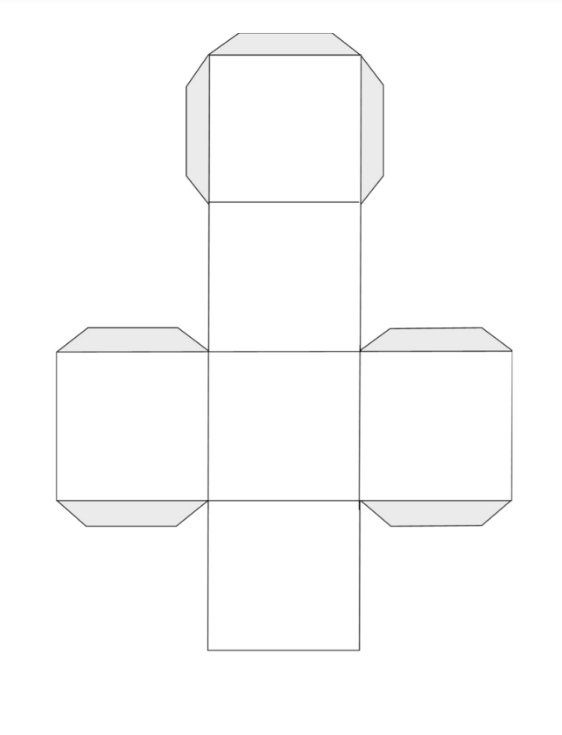

Worksheet 7: Character Cards
Print this page
