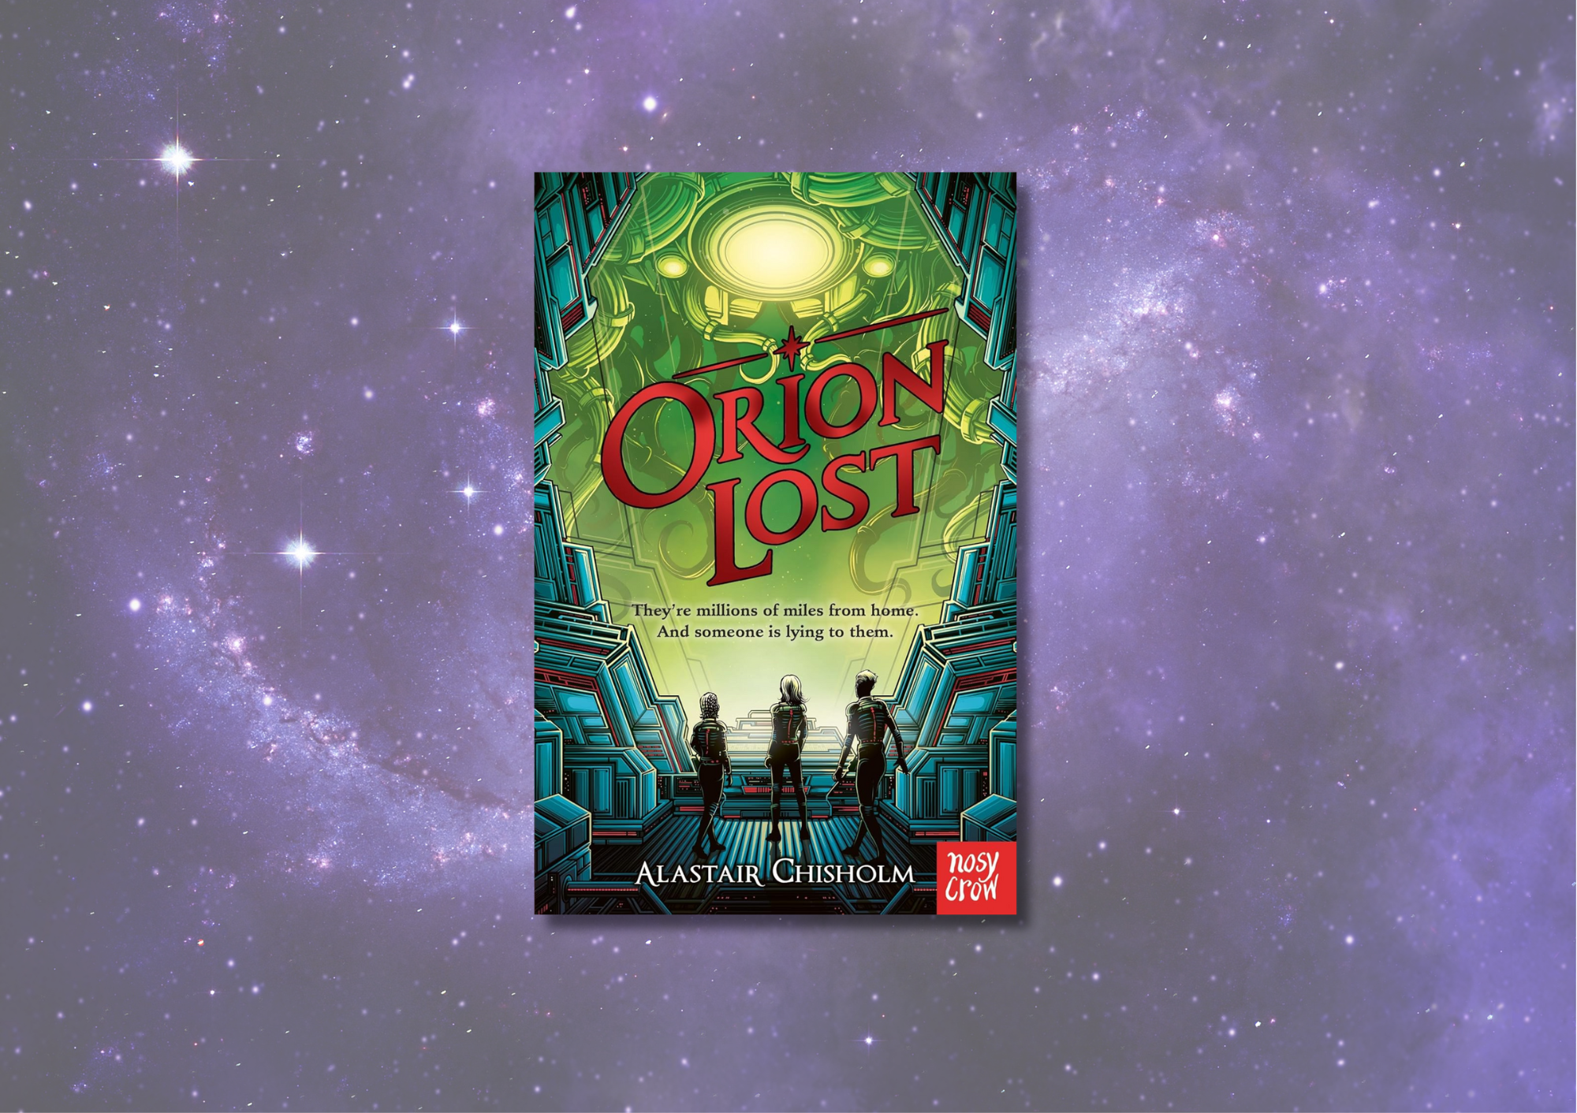

# *Orion Lost* learning resource

Creative activity inspired by Alastair Chisholm’s novel *Orion Lost*

## Age 8-12

## CFE Second Level

## Resource created by Scottish Book Trust

scottishbooktrust.com



Scottish Book Trust is a registered company (SC184248)

and a Scottish charity (SC027669).

## Contents

About this resource 2

About *Orion Lost* 2

Learning activities 3

Further resources 5

## About this resource

This resource features a cross-curricular activity to help you explore *Orion Lost* with your students, as well as explore topics including science, space and robotics. With all our resources, we highly recommend that you **read the book before using it with your class** and use your best judgement on whether teaching about this topic is appropriate for the children in your class.

## About *Orion Lost*

The transport ship Orion is four months out of Earth when catastrophe strikes - leaving the ship and everyone on board stranded in deep space. Suddenly it's up to thirteen-year-old Beth and her friends to navigate through treacherous and uncharted territory to reach safety. But a heavily damaged ship, space pirates, a mysterious alien species, and an artificial intelligence that Beth doesn't know if she can trust means that getting home has never been so difficult... Hugely gripping, with incredible twists and a fast-paced, action-packed story, this is an unputdownable science fiction adventure - perfect for fans of *Mortal Engines* and *Star Wars*.

## Learning activities

### Activity 1: Robots in space

LIT 2-13a, LIT 2-14a, LIT 2-26a, TCH 2-01a, TCH 2-09a, TCH 2-11a, SCN 2-20a, SCN 2-20b  
Imagine a future where there are robots in space doing amazing things. Well, what you are imagining is happening today!   
  
[Use](https://www.nasa.gov/astrobee) NASA’s website to learn about Astrobee. Astrobee is NASA’s new free-flying robotic system, help astronauts reduce time they spend on routine duties, leaving them to focus more on the things that only humans can do. They’re quite cute too!   
  
Astrobees are not the first robots to go into space. You can find some more robots which are each designed for specific tasks and environments on the [Robotics section of NASA’s website](https://www-robotics.jpl.nasa.gov/how-we-do-it/systems/). Split your pupils into groups and assign each group a different robot that they will research online. Pupils can draw their robot and make a model out of recyclable material. They can also research online to find out as many amazing facts about their robot, which planet it has been to, and what makes their robot useful in space.  
  
Pupils can then use a robot fact file to share information about their robot including information about:

* Robot name
* Applications
* Mission
* Achievements
* Fantastic facts
* Special abilities

Display the robot models/drawings and fact files as a space museum exhibition. Your exhibition could also include a map of the solar system showing where each robot has been.

### Activity 2: Museum labels

LIT 2-13a, LIT 2-14a, LIT 2-26a, TCH 2-01a  
Write museum labels to accompany all the items to be displayed in your space exhibition. Museum labels tell the viewer essential information about the object to on display, such as production date, where it came from or who it was made by, and usually give a small summary (30-50 words) about the history of the object. You can look at the [National Museum of Scotland’s collection database](https://www.nms.ac.uk/) to help you identify the key information and write your labels.   
  
Key questions to think about are:

* What does the viewer need to know about this object?
* What is the most interesting thing about this item?

Invite families and other classes to visit your exhibition!

### Activity 3: Dynamic Earth’s Space Resource

SCN 2-20a, SCN 2-20b  
Dynamic Earth is a state-of-the-art family attraction and science centre which takes visitors through the history of our planet, from the Big Bang to modern day. Based in Edinburgh, it is the largest interactive visitor attraction in Scotland and welcomes schools all year round to learn about Earth science, fossils, dinosaurs, space and more.  
  
In their [Space learning resource](https://www.dynamicearthonline.co.uk/space)s, you will find a range of activities, crafts, experiments and more to inspire your pupils.

### Activity 4: Create a sci-fi book group

LIT 2-02a, LIT 2-07a, LIT 2-11a   
If your pupils enjoyed *Orion Lost*, why not start a sci-fi book group? You could explore other science fiction titles or non-fiction books about science and space. You could use our [Space adventures book list](https://www.scottishbooktrust.com/book-lists/space-adventures) for inspiration! If you’re not sure where to get started with running a book group, see our [Running a pupil book club resource](https://www.scottishbooktrust.com/articles/running-a-pupil-book-club).  
  
Visit [Alasdair Chisholm’s website](https://alastairc.com/books/) to find out more about some of his other science fiction titles including *Adam-2*, *Reek* and more!

## Further resources

* See our [Space adventures book list](https://www.scottishbooktrust.com/book-lists/space-adventures) for more books to take you into outer space! For older readers, you could also explore our [Books for your science classroom book list](https://www.scottishbooktrust.com/book-lists/books-for-your-science-classroom).
* If you’re taking part in [Reading Schools](https://www.readingschools.scot/), see our guide to [Interdisciplinary book projects](https://www.readingschools.scot/resources/interdisciplinary-book-projects) for more ideas for using texts and stories across the curriculum
* For more space activities, explore [Dynamic Earth’s learning resources](https://dynamicearth.org.uk/) on their website