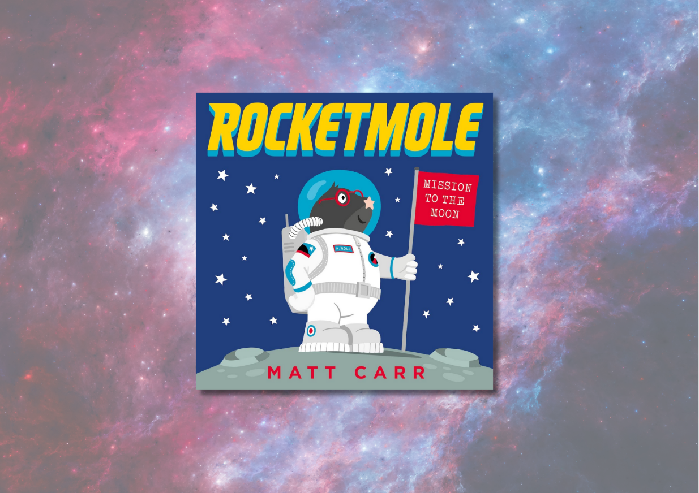

# *Rocketmole* learning resource

Learning activities to explore *Rocketmole* by Matt Carr

## Age 4-7

## CFE First Level

## Resource created by Scottish Book Trust



scottishbooktrust.com



Scottish Book Trust is a registered company (SC184248)

and a Scottish charity (SC027669)

## Contents

About this resource 1

About *Rocketmole* 1

Learning activities 1

Further resources 3

## 

## About this resource

This resource features cross-curricular activities to help you explore *Rocketmole* with your students. Adapt and use as you see fit! With all our resources, we highly recommend that you **read the book before using it with your class** and use your best judgement on whether teaching about this topic is appropriate for the children in your class.

## About *Rocketmole*

*Rocketmole* by Matt Carr was in our Read Write Count bag in 2020. You can watch a readalong of the book on [the Scottish Book Trust YouTube channel](https://youtu.be/wTHq8vpL8wI?si=YHIbClh0CgYbzC9Y) (4 minutes, 55 seconds).  
  
Armstrong the star-nosed mole doesn't dig living underground. His friends think building a rocket to go to the moon, alone, is an astronomically bad idea, but Armstrong is determined to boldly go where no mole has gone before. On the moon, Armstrong bounces around in his space suit but soon starts to miss his cautious mole mates. How can a mole with big dreams have it all: adventure AND friendship?

## Learning activities

### Activity 1: Fly me to the moon

TCH 1-10a, TCH 1-11a, TCH 1-12a, LIT 1-09a, LIT 1-10a  
Armstrong builds his own rocket and boring machine; he even experiments with different ways to travel to the moon.   
  
Design and draw your own spaceship that you would use to travel to the moon. You could use an idea from the story or create your own. What would it look like? What material should it be made from?   
  
Think about what it would be like in space. What home comforts might you like to take with you? If you only had space for five things in your suitcase, what would you take?  
  
Once you’ve designed your spaceship and packed your space suitcase, tell a family member or friend about your spaceship and what you will take with you. You could even have a go at building your spaceship using recycled materials!  
  
Present your spaceship in class. Think about:

* Name
* Mission objective
* Fuel type
* Top speed
* Gadgets onboard
* Meet the Crew

### Activity 2: How far away is the moon?

SCN 0-06a/1-06a, TCH 1-01a, TCH 1-02a, MNU 1-11a  
Use [Dynamic Earth’s How Far is the Moon? resource](https://www.dynamicearthonline.co.uk/space) to learn about how far away the moon is from Earth. Their resource helps develop a sense of distance and scale by using everyday objects. You could also use a digital technology to look up how large a mole is. How many moles lengths is the moon from Earth?

### Activity 3: What did Armstrong see?

TCH 1-01a, TCH 1-02a  
Use [Google Earth](https://www.google.co.uk/intl/en_uk/earth/) to look at the Earth from outer space. Try and look at where your school is!

### Activity 4: What should Armstrong pack?

EXA 1-03a, EXA 1-04a, SOC 1-16a  
In groups, discuss what you’d want to take with you if you were travelling into space. Remember: space is limited, so you might have to prioritise certain things! Draw a suitcase outline and fill it with what you’d take with you.  
  
You could also learn about moles – where do they live? What kinds of things do they eat? What might Armstrong like to take into space?

### Activity 5: Historical mathematicians

SCN 0-20a/1-20a, SOC 1-06a  
Numbers play a big part in helping humans travel to space safely. Find out about the mathematicians such as [Katherine Johnson](https://www.nasa.gov/centers-and-facilities/langley/katherine-johnson-biography/) or [Margaret Hamilton](https://www.dynamicearthonline.co.uk/space) who helped man get into space and discuss their work with your classmates.

## Further resources

* See our [Space adventures book list](https://www.scottishbooktrust.com/book-lists/space-adventures) and our [STEM books for 6-8 year olds](https://www.scottishbooktrust.com/book-lists/stem-books-for-6-8-year-olds) book lists for more inspiration of what to read next!
* If you’re taking part in [Reading Schools](https://www.readingschools.scot/), see our guide to [Interdisciplinary book projects](https://www.readingschools.scot/resources/interdisciplinary-book-projects) for more ideas for using texts and stories across the curriculum
* For more space activities, explore [Dynamic Earth’s learning resources](https://dynamicearth.org.uk/) on their website