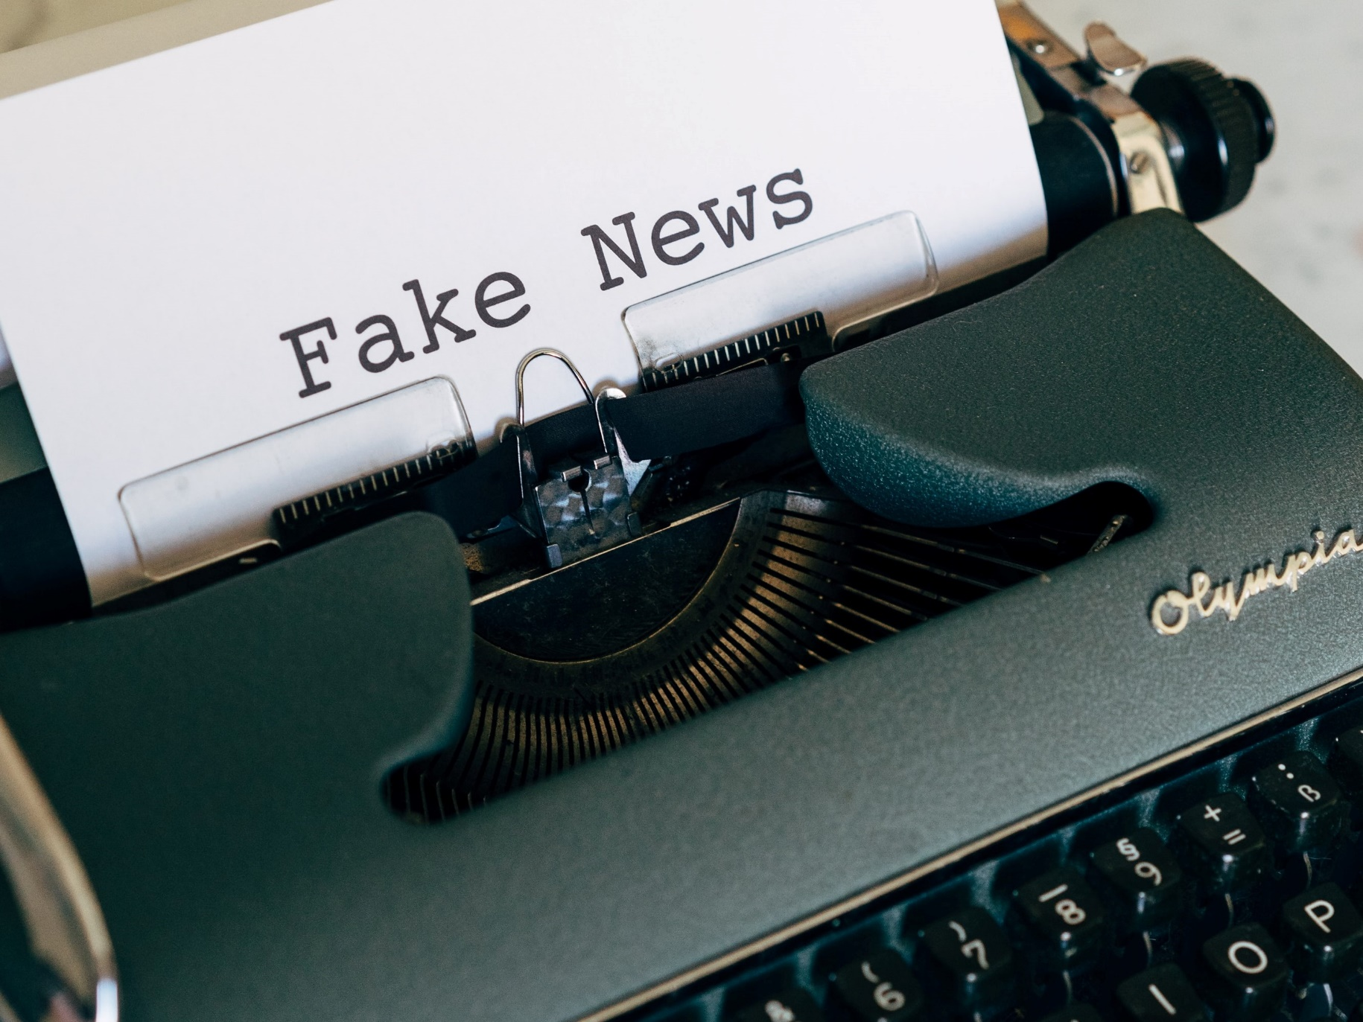

Exploring misinformation and fake news
A resource to support pupils to look at and discuss fake news and misinformation critically in the classroom.

CFE Levels: Second and Third Level

Report created by Eilish Mackinnon

scottishbooktrust.com
Scottish Book Trust is a registered company (SC184248)
and a Scottish charity (SC027669).

Contents
About this resource 2
About the author 3
Activity 1: Information seeking and discovery 3
What is information? 3
Sources of information 3
Engaging with sources of information 3
Activity 2: Misleading headlines 4
Accuracy of information 4
Looking at real life examples 4
Activity 3: Detecting misinformation online 6
Looking at a website 6
Assessing vital or popular content 6
What is a deep fake? 7
Activity 4: Detecting misinformation on social media 7
Health misinformation 8
How to check the accuracy of a post on social media 8
Closing discussion 9

About this resource
This resource contains activities which address the prevalent issue of misinformation, paying particular attention to misinformation in the media. These activities are designed to develop critical thinking skills in older children and teens, as it encourages students to question the information they read and see in a way which should give them greater confidence and control when seeking information. Images and discussion prompts are available in a PowerPoint presentation that can be downloaded from the resource page.

About the author
Eilish Mackinnon is a recent graduate of the University of Strathclyde, completing a Master's in Information and Library Science. Eilish is particularly interested in the topic of 'Misinformation', having completed a dissertation on the topical issue of health misinformation, looking specifically at pseudoscience. Eilish is currently working at Anderson Strathern as a Knowledge Management Officer.

Activity 1: Information seeking and discovery

What is information?
Begin a discussion with pupils by asking what information is, and whether they can give an example of information they have come into contact with? Ask the pupils to give a definition and come up with a list of as many examples as they can within 1/2 minutes.
Definition: Effectively, information is everything we come into contact with so there are no wrong answers. It could be looking at a traffic light, asking a question to a friend, looking at the weather forecast (or out the window to check the weather). The examples given by the students should inform the direction of the discussion. It is worth circling back on the examples that pupils give in order to relate it back to their own context, as this is the most effective way to develop critical thinking skills.

Sources of information
The type of information we want to focus on is related to the news media. Ask the pupils where they find their own information. Invite the pupils to discuss in groups and share their answers. This can include active and passive information seeking, e.g. listening to a news bulletin on the radio, scrolling on TikTok, watching the news, going on Twitter, etc.

Engaging with sources of information
Ask the pupils what they consider when choosing the information/news they consume. Is it an active exercise or a passive one? Do you trust what you read and accept it as fact or do you question what you see? What are the most important aspects in deciding (or not deciding) what news you consume, e.g. is layout important, the format, the source?
This is a helpful exercise in determining the groups’ level of awareness regarding misinformation/disinformation, informing the direction that the activities should be carried out.

Activity 2: Misleading headlines

Accuracy of information
To introduce the next activity, ask the pupils: why is it an issue if the information we see or read is not true or completely accurate? Introduce the idea of ‘questionable’ sources/information and consider why this might be an issue.
As you progress through the activities, the pupils will see real life examples of misinformation, and so, this question will in effect be answered. It acts as a primer to begin this ‘questioning’ state which we want to achieve.

Looking at real life examples
Divide the class into small groups and give them a newspaper to look at real life examples of headlines that have been in the press. You can use the example included in the PowerPoint accompanying this resource pack, or choose your own newspaper cover to share. If you do use our example, share the photo and the text below.
“Revealed: Queen backs Brexit as alleged EU bust-up with ex-Deputy PM emerges
THE Queen has been hailed as a backer of Brexit tonight after details emerged of an extraordinary alleged bust-up between her and Nick Clegg over Europe.
Her Majesty let rip at the then Deputy PM during a lunch at Windsor Castle,
The Sun has been told.” The Sun Newspaper, Wednesday 9 March 2016.
Ask pupils to discuss the following:
- Do you trust this article and its claims?
- Is there anything that you might question or look up to find out more information on? (Pupils can find out more if they wish, sites such as Full Fact can help with this)
- Why might stories be exaggerated? What effect does this have?
- Is there a need for a bit of an explanation here?
After the discussion, key points to share with pupils is that are:
- The Queen is impartial head of state, which makes this unlikely to be true
- The paper uses sensationalist language like ‘let rip’ and ‘bust-up’, again making this unlikely to be true
- No source is credited, again making this unlikely to be true
- The newspaper is a business and is profit driven, so it has a monetary interest selling papers
After this discussion, ask pupils to think about how we detect whether a source is reliable. Discuss the points in the CRAAP. CRAAP stands for: Currency, Relevance, Authority, Accuracy and Purpose. In the PowerPoint presentation, this has been changed to TRAAP (currency has been changed to timeline), as CRAAP may not be appropriate for the age group you are working with.

Ask pupils to return to the newspaper article they are looking at and use the TRAAP framework to help them assess the article. What do they think after using TRAAP?

When looking out for or thinking critically about ‘fake’ or ‘bad’ news stories, here are some other things to consider:
- Exaggerated or emphatic language/headlines
- Bias or misleading reporting
- Lack of references, use of an unnamed author, or links to sources that don’t back up what is being said
- Has it been reported anywhere else? Are there similar headlines in the press already?
- Where is it being reported – is it a reputable source/news outlet?
- Read beyond the headline – are any of the claims backed up in the text?
- Double check any claims of authority, e.g. you will often see in fake ‘scientific’ articles where the claims are backed up by a doctor

Activity 3: Detecting misinformation online
Detecting false information online can be tricky and the pace of technology and technological development is only going to make it even harder for us to recognise false information online.

Looking at a website
Share the Dog Island website (or the screen shot available on slide 12 in the accompanying PowerPoint) with pupils. Ask pupils:
- Is there anything unusual about it?
- Use the TRAAP fact checker to help assess the website

Assessing vital or popular content
Share an image of the MGM lion logo that appears at the beginning of MGM films (these can be found on Google or on the Leo the Lion Wikipedia page). Ask pupils if any of them recognise the logo. Where have they seen it? Can they remember the film?
Share the next slide. This photo went viral, claiming that media company and film producer, MGM, had sedated a lion and strapped it to a table with its head through the logo in order to take their iconic intro scene.
This claim has been debunked on various fact checking websites:
- Article on Snopes fact checking the ‘Cat Scam’
- Article on Reuters debunking the MGM lion Photoshop. This article contains a video on the history of the MGM logo.
- Short article on Africa Check also shows how the photograph can quickly be debunked by a reverse image search
These fact-checkers state that the creator has used image manipulation (likely through using Adobe Photoshop) to display the MGM logo. A quick Google search for the MGM lion logo will also bring up a photo from 1928, showing the filming of the lion roaring taking place. This photos is in the PowerPoint to share with pupils.
The doctored or changed image is actually depicting a lion, Samson, who was sedated for a CAT scan after he had some trouble walking at the Hai-Kef zoo near Tel Aviv. After a six-hour operation to remove part of Samson’s thickened skull tissue and ten days of rest Samson recovered and was able to walk again. A Telegraph article reveals the story of this pioneering big-cat operation. So as we can verify, not everything you read online is true.

What is a deep fake?
Images similar to Leo the Lion (please see the accompanying PowerPoints, slide 14) are available all over the internet and can be shared regularly, and it’s easy to be taken in by them as they look so convincing. Another example of this type of visual deception are ‘deep fakes’. But how do we spot one? After looking at the MGM example above, share one of the videos below with your pupils.
- This NBC News summarises what deep fakes are, and why they are dangerous.
- Video by Al Jazeera explains the process of making a deep fake. Content warning: this video is only for secondary pupils as it refers to pornography. Please watch before sharing with your pupils.
After watching one or both of the videos, ask pupils if they think they would be able to detect whether the image or videos are fake.

Activity 4: Detecting misinformation on social media
Whether you work with primary or secondary pupils, all will have an awareness of social media even if not all have access to their own accounts. Most social media platforms require members to be 13-years or older before they can make an account. This is an important point to make when discussing social media in primary school.
However, we live in a world where social media is commonplace. This activity is designed to make pupils think critically about the information they encounter on social media.

Health misinformation
Divide the class into groups and share the screenshots of posts from social media (included in the accompanying PowerPoint). Allow the pupils to read and discuss what they see in these posts, and remind pupils that they don’t actually need to have previous knowledge of content in these posts. Instead they should pay particular attention to the language, source, and date of the posts.
Key questions for pupils to ask of each post are:
- Looking at the sources, can you trust them? Why?
- Look at who posted them, are they trustworthy and verifiable?
- What might be the creator’s intention behind the post? How could this influence their claims?
They can return to the TRAAP fact checker too to help them assess the post.

How to check the accuracy of a post on social media
During their discussions of each image or TRAAP, pupils might have started to think about how to verify or check this information. But platforms such as Instagram, Tiktok and others leave no room for citations because they are often visual based platforms, or have limited characters or space. So, what can we do to verify a source?
- It’s worthwhile double checking the source by clicking onto their Instagram account to check their credentials, as well as googling the name of the business or person. Look for the verification tick in some instances to make sure it is an official account. However, it is important to note that we still need to remain vigilant to misinformation, even on verified accounts. The TRAAP test should help to identify whether the information really is credible.
- Have they given any indication of where their information is from? Can you follow from the post to find out more? The first example is published by the NHS and links to the NHS website for more information, whereas the second is a business advertisement which doesn’t link to anywhere to support their claims.
- You can check other news articles for similar stories (again, checking the source).

Closing discussion
After working through some or all of activities with your pupils, finish with a closing discussion. Ask pupils:
- What key points will they take away from their learning about information, misinformation in newspapers, online and on social media?
- What will they do now when they encounter new information?
- What tool or strategies have they found most useful?
- How to they feel about the information and sources of information they interact with on a daily basis?
Finally, end by reminding pupils it is important to think before they share, whether that is an article in print or online, or a post on social media. As they have found from the examples, it is easy to be taken in my fake news, misinformation or deep fakes. But that’s why it is so important to think critically about the information they share, or they could unwittingly be spreading misinformation too.

