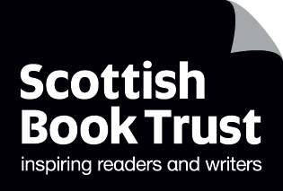
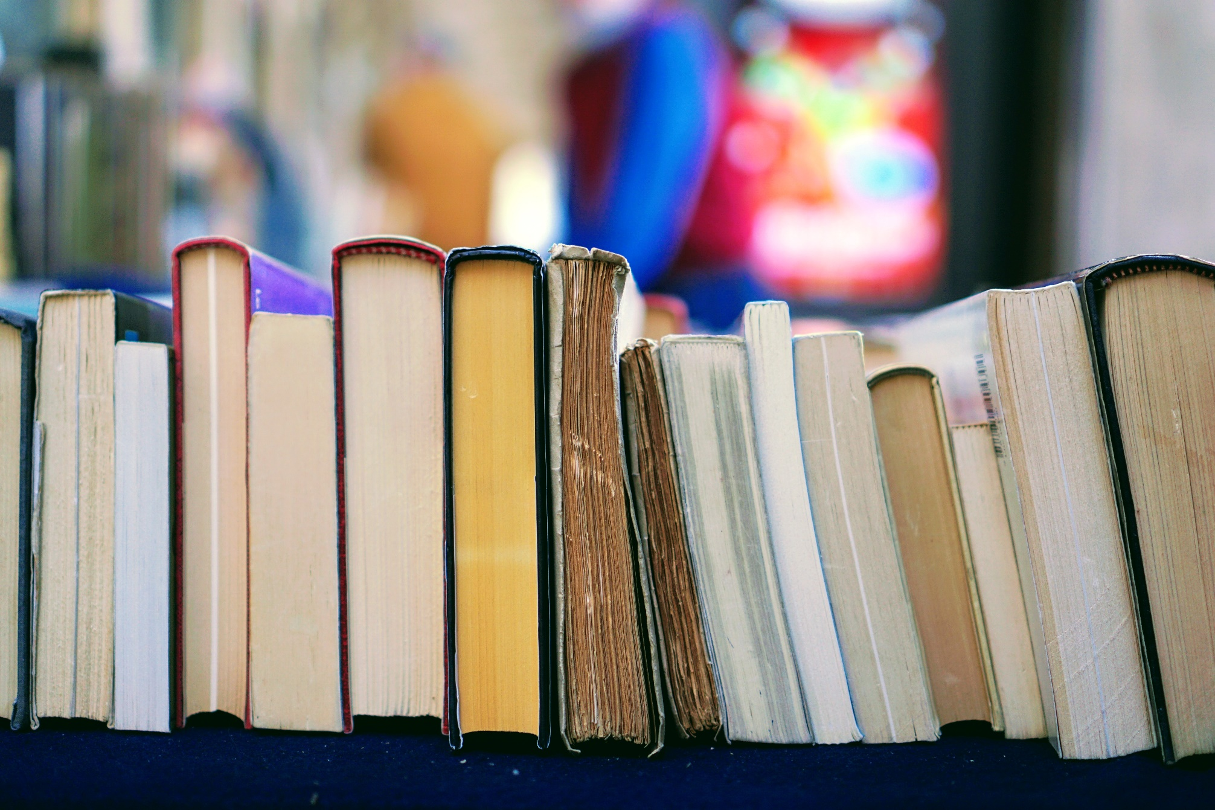

Keeping your library up to date
Activities and questions to help school staff audit and refresh their libraries, ensuring texts are engaging, diverse and representative

Resource created by Scottish Book Trust, with guidance from Glasgow School Library Outreach

scottishbooktrust.com
Scottish Book Trust is a registered company (SC184248)
and a Scottish charity (SC027669).

Contents
About this resource 2
Remember: it’s okay to say goodbye! 2
Representative texts 3
Create a plan 4
Audit questions 5
Auditing with pupils 6
Organise your library 7
Recycling books 8
Celebrate your library 9
Further resources 9

About this resource
This resource is for school staff and/or parent councillors who do not have a librarian or school librarian to support them. The activities will take you through the texts in your library asking you to consider if they’re up-to-date and inviting, encouraging quality over quantity.
Throughout this resource we refer to “texts” as well as books. Texts can be used to refer to books but can also include other reading material such as audiobooks, magazines, comics, newspapers and so on.
If you are taking part in Reading Schools, the activities in this resource could support delivery of Key Area 1.5.1: Access to high quality books.

Remember: it’s okay to say goodbye!
A key thing to remember is that it’s okay to get rid of a book. A smaller selection of high-quality books that are easier to find will be much more engaging for children than more books which are outdated or inaccessible. You wouldn’t ask children to use a webpage that’s over 20 years old – it’s the same for books!

Considering all the texts in your library, go through the following questions. These will help you identify any gaps that you might like to purchase, or raise funds for:
- Are your texts representative of a wide range of lived experiences? (See the next section for more on this question).
- Do the texts offer a wide variety of reading experiences? Do you have different formats of text beyond traditional chapter books?
- How many of your texts have a visual element – i.e. are highly illustrated or graphic novels?
- Do you have mostly fiction or non-fiction? Are there any genres you’re missing?

Representative texts
Representation in your library is essential. It helps your readers learn more about the world around them, develop social awareness, promotes empathy and is crucial to helping children engage with your library. The more children see characters like themselves in the books they can read, the more likely they are to read them.
When considering the books in your library, make a note of how many of your books feature protagonists:
- From different races and cultures;
- With different religious beliefs;
- Who aren’t confined by gender stereotypes, or protest against them;
- Who are LGBTQ+;
- Who are disabled or neurodiverse;
- Who are from different social classes;
- Who have different types of bodies;
- Who come from non-traditional families (e.g. are in care, raised by grandparents or non-heteronormative parents).
It’s also important to prioritise own voice narratives as this will ensure that representations are as authentic as possible because they come from true experience. So, for example, if you have a book featuring a disabled protagonist, but it was written by someone able-bodied, it is still worth reviewing it.
The CLPE report “Reflecting Realities” contains a list of useful questions to use when considering how a representative a text is – it focuses on people of colour, but some questions can be used to consider universal representation. We also recommend Zero Tolerance’s “You Can Be” book audit toolkit which can be used to take note of the representation in your library’s texts.
We highly encourage you to share this process with the children that use your library. Discuss why you are keeping a track of the representation in the books you own and why representation is important. This will help them develop literacy skills and interrogate the texts they are using. For more on this, see page 8 of this resource – we have suggested an activity using books that are outdated or prejudiced to teach fact-checking and discuss misinformation and fake news.

Create a plan
The next key things to decide are:
- What is the goal of the books in your library? (e.g. inviting, representative)
- What will help you achieve that goal? (e.g. displays, comfy spaces to sit, diverse formats and authors)
- Who is going to work on this audit? (e.g. staff, children, parents)
- What is your deadline? Top tip: planning a library relaunch party is a great way to celebrate the library space, but also gives you a date to work towards.

Process
The key part of your audit is to sort books into three different piles, or categories: keep, review and recycle. Recycling can include repurposing the books for crafts, or blackout poetry, donating or selling the book, or physically recycling it (make sure your local authority allows books in your paper recycling).
Ensure you plan who is responsible for what part of the audit – as your audit will probably take place over several days, it’s good to establish a system so the same section of books don’t get audited twice. This could be giving everyone a specific shelf or area, or using pencil to mark in the front pages of a book.
Remember: keep multiple copies of the same book! This allows you to do shared reading or book groups.

Audit questions
Consider each book with the following questions. The non-fiction audit is slightly different, as these books are more likely to be inaccurate as updates and new discoveries are made.

Fiction
Is the book less than 5 years old?
- If yes, keep it
- If no, review it

Is the book over 20 years old?
- If yes, recycle it – unless it’s a classic, in which case review
- If no, review it

Is the book popular or well used?
- If yes, keep it
- If no, review

Does this book contain harmful depictions of specific groups or communities?
(For example: sexism, racism or xenophobia, classism, homophobia, transphobia, ableism, fatphobia, or prejudices against specific religions)
- If yes, recycle – do not donate
- If no, and its older than 5 years review
- If no, and it less than 5 years old, keep it

Non-fiction
Is the book less than 5 years old?
- If yes, keep it
- If no, review it

Is the book older than 15 years old?
- If yes, recycle it
- If no, review it

Is the book accurate?
- If yes, keep it
- If no, recycle – consider using it for collage/crafts rather than donating

Auditing with pupils
The following activities are designed to help engage your pupils with the audit.

Activity 1: Prior picks
Ask the pupils to identify any books they’ve read and enjoyed. Even if a book is worn it should be kept until it can be replaced!

Activity 2: Big questions
Chose a selection of books to be considered by a class or group of pupils. Provide each pupil with a printed bookmark to record their decisions (available on the same webpage as this resource). To make their decision, ask each pupil to:
- Consider the appearance of the book, front cover and any illustrations
- Read through the blurb
- Try reading the first few pages or chapter of the book

Activity 3: My dream library…
Working in pairs or groups, ask the children to create a mind map or list of what they would like from their dream library. Use this to create a wish list of books, or consider the layout of your library.

Activity 4: Book speed dating
Put the pupils into pair. Using a timer, give them 2 minutes with a book. After the two minutes, ask them whether they would keep or read this book. Make a note of decisions – if no pupils want to read a specific book, you can recycle it. If one or two want to read it, you can give it to them. If a book has a lot of interest, keep it.

Organise your library
Once you have a sense of what to keep and what to donate – it’s time to organise your library. Here are some ideas for categorisation:

Length of read
Categorise your books by short, medium and long reads. This means your library is in three sections, with picture books and non-fiction kept separate. You can label books spines with a colour coded sticker so it’s clear where each book goes.

Genre
Organising by genre has the benefit of allowing older readers to pick younger reading age books without having to go to the “younger” area of the library – this can help remove stigma around reading “younger” than their age.
On the same webpage as this resource you can find some shelf labels. These correspond to our Bookzilla app which is downloadable for use in your school or library.
If you notice you don’t have many titles of a certain genre, you can start a wish list of books you might like to purchase. Our book lists and Book Discovery Guide can help you find up-to-date and diverse recommendations.

Recycling books
Recycling or removing books can be a sensitive issue. Some books that have been removed can be offered to pupils or members of the community to take home. However, depending on the content, this might not be appropriate for all titles.

For books that can be passed on
- Donate them to a local charity shop or foodbank
- Hold a bring and buy sale to raise funds for your library
- Offer them to pupils or community members
- Run a book fairies project where you hide them around your local area
- Use organisations like Ziffit or WeBuyBooks to sell them to raise funds, or Better World Books which donates profits to charityprofits to charity

For books that cannot be passed on
- Use them as part of a lesson on fact-checking to explore why and how these books are no longer up to date. You could do this alongside our resource on Misinformation and fake news
- Use them for collaging or crafts to decorate your library space
- Use them to create book hedgehogs or other sculptures
- Use them to create blackout poetry

Celebrate your library
Now your library is audited and organised – it’s time to celebrate! Work with pupils to plan the event. You could use our Live Literature database to apply for an author visit as part of the celebration.

Further resources

Further information on the importance of representative texts
- The CLPE report “Reflecting Realities” report shares key data on the representation of BIPOC people in children’s fiction in the UK.
- Zero Tolerance’s “You Can Be” Book Audit tool gives you information on how to track the books in your library in regards to representations of gender and stereotypes.
- The New Education Association’s article “Why We Need Diverse Books” goes into detail on why diverse books are important for all children.
- The New Education Union’s toolkit on Decolonising the curriculum can be used to start thinking about what decolonising and anti-racism looks like in your library space.

Further information on finding high-quality texts for your library
- Our Book Discovery Guide contains book recommendations from recent publications and can be downloaded as a PDF or used as a PowerPoint to allow you to share recommendations with other staff or pupils.
- Our Book lists on the Scottish Book Trust website collect books on specific themes or topics and can be filtered by age and genre.
- Our Bookzilla app for primary and early secondary encourages pupils to find new books, track what they’re reading and engage in reading challenges.

