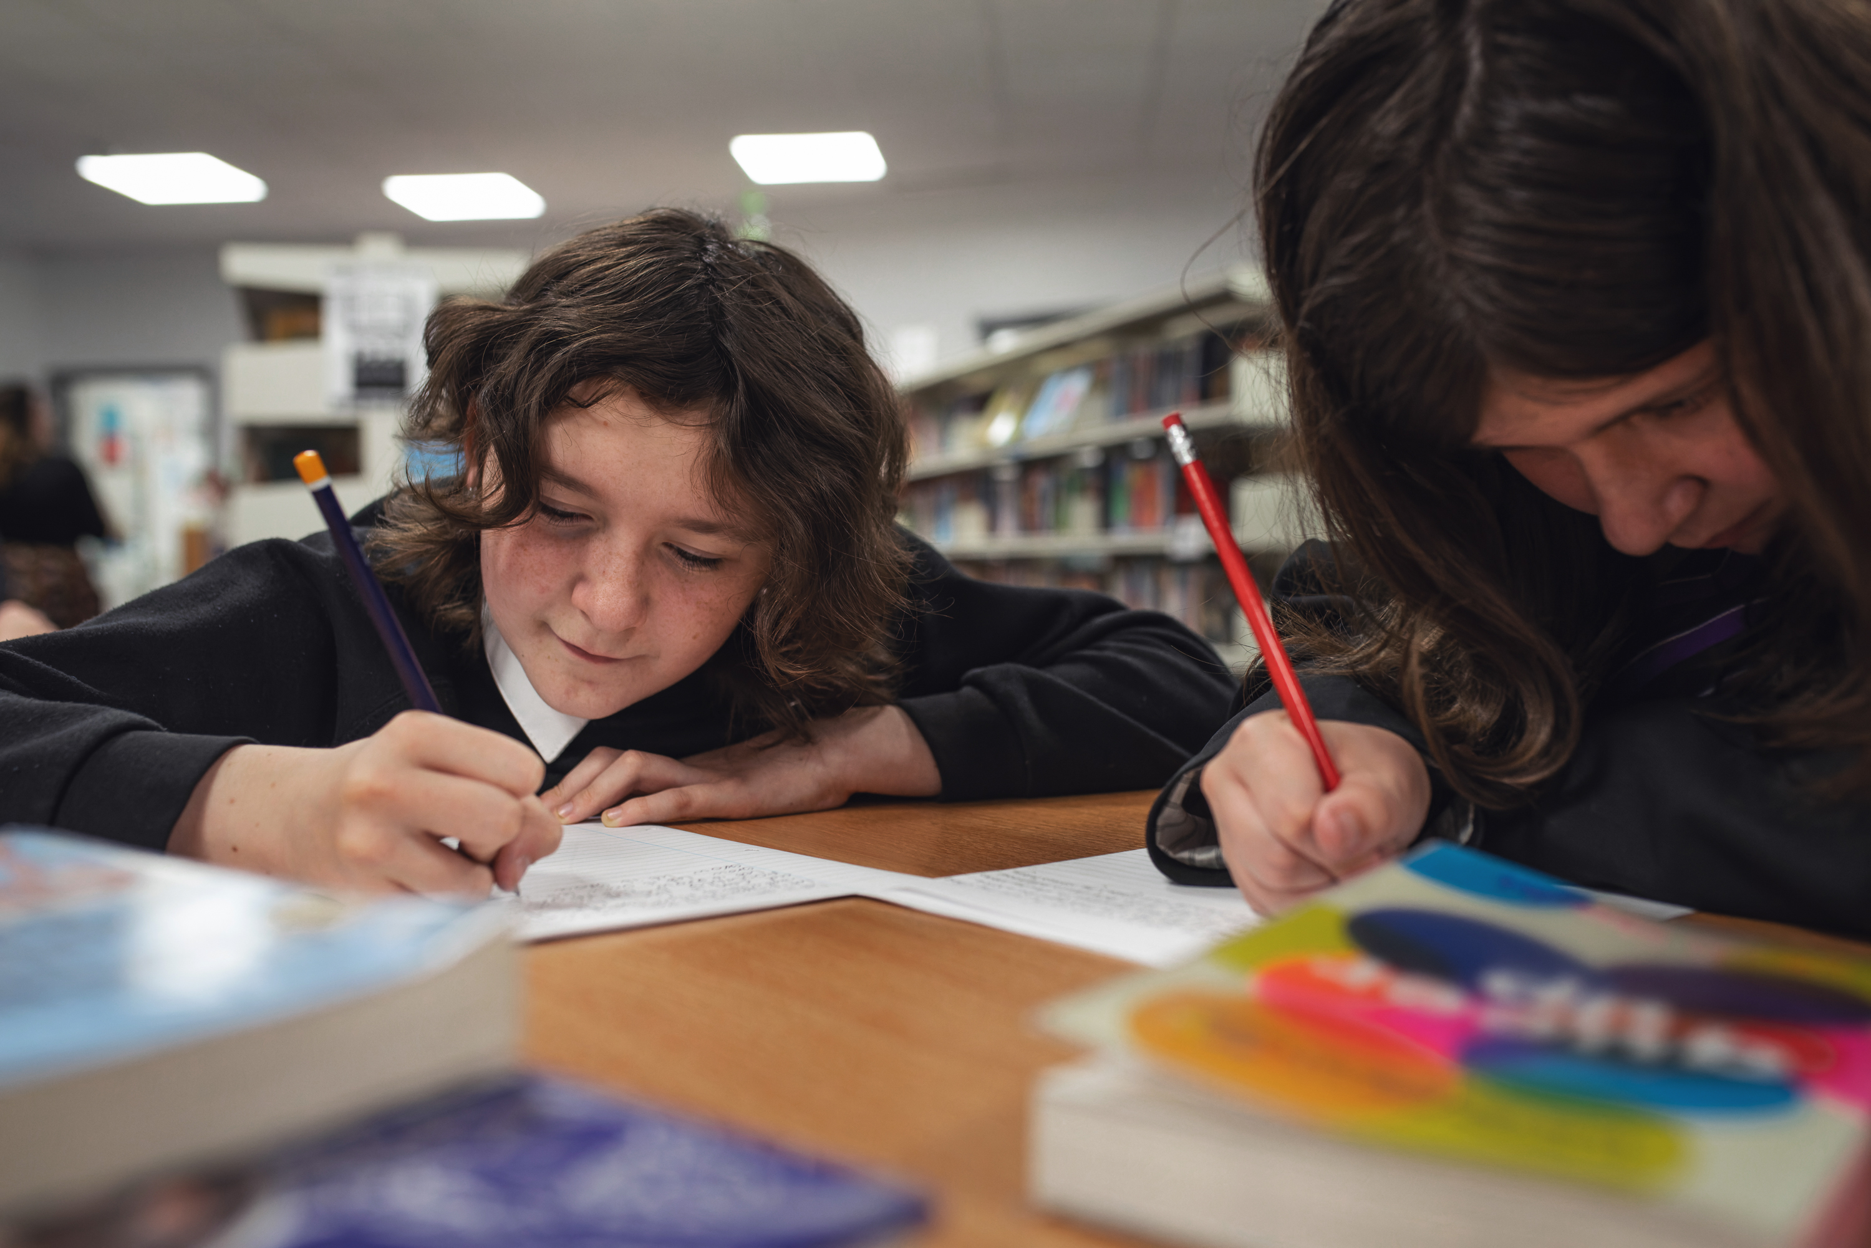

Creative writing planning and evaluation toolkit
A self-evaluation toolkit to support school improvement and embed creative writing into school life

Aligned to How Good is Our School 4

Resource created by Scottish Book Trust
scottishbooktrust.com
Scottish Book Trust is a registered company (SC184248)
and a Scottish charity (SC027669).

Contents
How does it work? 2
1.2 – Leadership of learning 3
1.3 – Leadership of change 4
1.5 – Management of resources to promote equity 5
2.2 – Curriculum 6
2.3 – Learning, teaching and assessment 7
2.5 – Family learning 8
2.7 – Partnerships 9
3.2 – Raising attainment and achievement 10

There are many benefits of creative writing, including improvements in health and wellbeing, positive destinations, and attainment across the curriculum through improved literacy skills. This toolkit has been designed to support schools looking to meaningful embed creative writing into their school environment. Its aim is to be useful for practitioners, and flexible to individual school aims.

How does it work?
The quality indicators (QIs) chosen are those agreed to be most relevant to creative writing. However, activities will often link to additional QIs from HGIOS? 4.
Challenge questions can be used by individual practitioners, but will lead to more meaningful reflection when used by groups of learners, staff, partners and other stakeholders to support a shared understanding of strengths and next steps.
Examples have been included of activities you undertake to that support that QI and how practitioners might address the challenge questions. However, practitioners have choice over their activities and this is not a checklist. Rather, it’s a starting point for you school creative writing journey.

1.2 – Leadership of learning
Challenge questions:  - Are learners given the opportunity to lead creative writing initiatives?  - Do staff role model creative writing?  - How can staff develop their skills and knowledge for supporting creative writing? | Examples of actions to support this QI:  - Encourage learners to run clubs or groups  - Encourage learners to chair author events / ask authors questions  - Create opportunities for learners to organise and programme events  - Join in during creative writing sessions  - Join in during author visits  - Talk about your own writing, modelling reflection and the giving and receiving of feedback  - Develop your own creative writing skills through CLPL etc.  - Invite members of the community in to talk about how they use writing in their lives / jobs  - Undertake regular CLPL around teaching creative writing  - Access high-quality resources on how to teach creative writing  - Be able to signpost colleagues and learners to relevant support and materials

Resources:
- Scottish Book Trust’s CLPL for learning professionals – see our website for more information on upcoming sessions
- Creative writing for schools resources on the Scottish Book Trust website

1.3 – Leadership of change
Challenge questions:  - Is creative writing valued and prioritised in school?  - Are learners given the opportunity to take part in local or national creative writing initiatives?  - How does the physical school environment highlight and support creative writing? | Examples of actions to support this QI:  - Include creative writing in improvement planning  - Ensure buy in from SMT and whole staff group  - Allocate budget for creative writing resources and opportunities  - Pay the authors you work with per SBT guidelines  - Take part in sharing initiatives (e.g. sharing work on social media etc.)  - Take part in competitions (e.g. 50 Word Fiction)  - Take part in author events out with the school (e.g. Authors Live, festival events)  - Encourage learners' to take part in development opportunities  - Create displays of learners' work, writing prompts, free writing walls  - Provide comfortable and appealing writing areas  - If possible, make writing visible in the community through displays or use of community spaces
Resources:
- Find out more about 50 Word Fiction on our website as well as our resource on Using 50 Word Fiction to support creative writing in school
- Explore our Authors Live library of on demand broadcasts with authors and illustrators
- Find out about upcoming opportunities for young writers on the Young Writers section of our website

1.5 – Management of resources to promote equity
Challenge questions:  - Do you provide a range of resources to support creative writing? | Examples of actions to support this QI:  - Provide a choice of appealing writing materials (e.g. journals / notepads, stationery, iPads / computers / phones / recording devices)  - Provide a range of prompt materials (e.g. visuals, everyday objects, story cubes, doodle-a-day, 364 Things etc., fun worksheets, story sticks, poetry stones)  - Provide a variety of high-quality texts in different genres / formats (e.g. storytelling, graphic novels, epistolary texts, non-fiction, prose, poetry, scripts, performance, spoken word, film, illustration, computer games, board games)  - Ensure resources reflect the range of learners' interests, identities and circumstances
Resources:
- Learn about how to create a reading culture in your school with our resources on Building a reading culture and Running reading groups and events
- Download our resources which can provide useful creative writing prompts: poetry stones, story sticks, historical objects, as well as our Creative writing for schools resources

2.2 – Curriculum
Challenge questions:  - Do learners have regular time to write creatively? | Examples of actions to support this QI:  - Integrate regular and planned creative writing into all subjects  - Allocate time for 'free writing' – at least once a week across the whole school  - Create mechanisms that allow learners to capture ideas as and when  - Embed creative writing in Broad General Education lessons  - Provide opportunities across subjects for creative writing (e.g. creative responses to topics such as climate, history, geography)
Resources:
- Explore Scottish Book Trust’s Creative writing for schools resources
- Use our resources to support creative writing in class: Creative writing for upper primary and Creative writing for secondary

2.3 – Learning, teaching and assessment
Challenge questions:  - How are learners supported to find their own creative voices?  - Do learners have opportunities to share their creative writing work?  - How are learners supported to create social networks around creative writing?  - How do learners learn about and access to authors? | Examples of actions to support this QI:  - Avoid being overly prescriptive when setting creative writing tasks  - Encourage learners to write about things that interest them / they have knowledge of  - Encourage learners to write in their own / native language  - Encourage 'messiness', do not focus on technical correctness  - Ensure staff can recommend reading relevant to learners' interests / experiences  - Allocate time for learners to talk to each other about their writing informally  - Offer more formal opportunities, such as paired writing etc.  - Offer opportunities to read work aloud, managed sensitively  - Offer opportunities to share work with others via events, displays, publications, social media etc.  - Encourage effective, sensitive peer review  - Offer interest-based clubs / groups (e.g. manga club, comic con, free writing club, digital storytelling)  - Hold special events with the wider school (e.g. a poetry slam)  - Research an author's life as a project and make a display  - Watch Authors Live  - Invite authors into school through Live Literature or other schemes  - Attend festival events if possible  - Work on a longer-term project with an author if possible  - Appoint a writer-in-residence if possible
Resources:
- Use our resources to support creative writing in class: Creative writing for upper primary and Creative writing for secondary
- Learn more about Live Literature funding for author events in schools

2.5 – Family learning
Challenge questions:  - How is the profile of creative writing being raised with families? | Examples of actions to support this QI:  - Share creative work with families (e.g. events, displays, take home 'books', parent nights)  - Invite families to author visits  - Encourage families to write / create stories together through providing or signposting resources (e.g. story dice, notebook, Authors Live)  - Encourage families to act as writing role models
Resources:
- Explore our Authors Live library of on demand broadcasts with authors and illustrators
- Print pages from our transition notebook to encourage writing together at home
- Learn about how to create story cubes that families can share

2.7 – Partnerships
Challenge questions:  - Could you form partnerships to strengthen your creative writing offer? | Examples of actions to support this QI:  - Involve community partners in creative writing projects  - Build partnerships with local and national agencies to support creative writing (e.g. Super Power Agency, Scottish Youth Poetry Slam)  - Work with a local practitioner on a creative writing project  - Collaborate with your local library to showcase creative writing in the community  - Share creative writing with local groups (e.g. local care home, primary schools, secondary schools)  - Create a ‘story chain’ with a local school
Resources:
- Use our resource on How to run an intergenerational writing project to connect with your community
- Use our resource on Creating a picture book in class to create a book with your local community:

3.2 – Raising attainment and achievement
Challenge questions:  - How is learners' progress and achievements in creative writing recognised and celebrated? | Examples of actions to support this QI:  - Celebrate learners' writing achievements (eg. displays, assemblies, certificates, prizes, opportunities to showcase, publications such as school anthologies, school communications such as social media and newsletters)  - Showcase a Writer of the Week/Month in school  - Link in with national themed days (e.g. National Poetry Day) and showcase creative writing as a school
Resources:
- Learn more about celebrating writing achievements with our Building a reading culture resource

