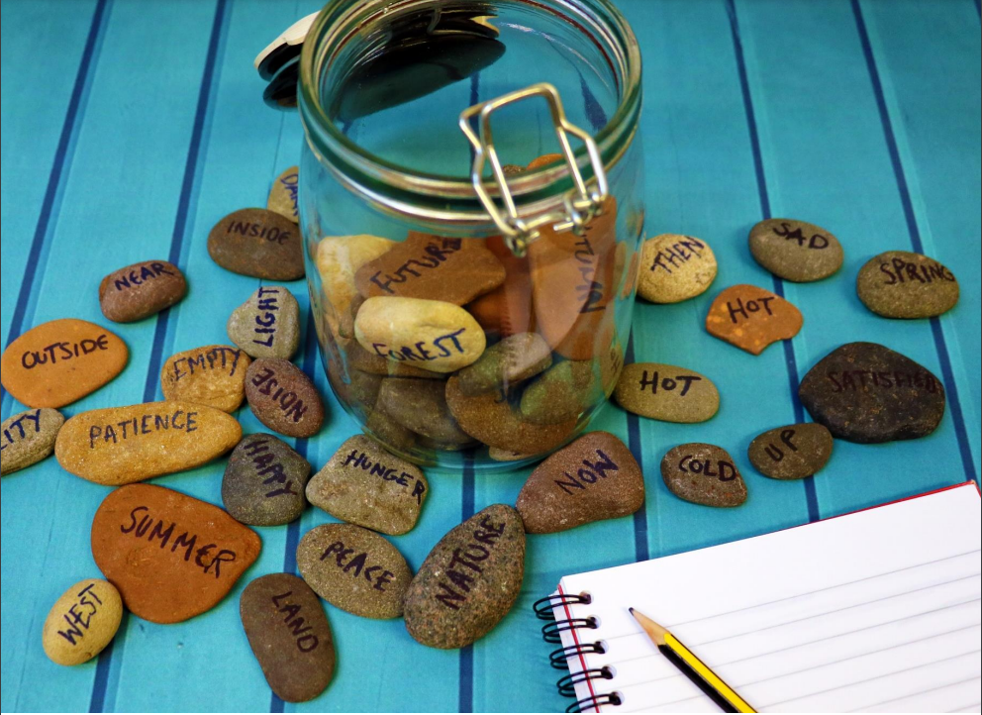

How to make poetry stones
A guide to making and using poetry stones for creative writing

Age 8-18

CFE Second to Fourth Level

Resource created by Scottish Book Trust

scottishbooktrust.com
Scottish Book Trust is a registered company (SC184248)
and a Scottish charity (SC027669).

Contents
About this resource 2
How to make your poetry stones 2
Suggested words 3
How to use poetry stones 4
Further resources 5

About this resource
Poetry stones are a fun and creative way to generate ideas for creative writing, especially poetry. When faced with a blank page and asked to write a poem, young people can sometimes feel overwhelmed and find it challenging to come up with ideas, or know where to start. Poetry stones are a great way to spark ideas. They can be used as an impetus for writing, or as a starter activity for a lesson. They are versatile and can be used with any age group and made more or less complex, as you require.

If you are taking part in Reading Schools, the activities in this resource could support delivery of Key Area 2.2.2: Interdisciplinary book projects.

How to make your poetry stones
All you need for your poetry stones are some pebbles that are relatively round and flat so you can write on them and a permanent marker. You can go for a walk with your pupils to find them. If you can’t find enough pebbles, you can also use grey or brown card cut into pebble shapes.

Suggested words
These are some suggested words you can use, feel free to create your own! We have put them in pairs of opposites so that your poems can contain conflict.

Emotions
Joy | Despair
Love | Apathy
Anger | Patience
Happy | Sad

Feeling
Peace | Noise
Hunger | Satisfied
Rich | Poor
Little | Much
Empty | Full

Seasons and weather
Hot | Cold
Summer | Winter
Autumn | Spring
Cloudy | Clear

Time
Dark | Light
Moon | Sun
Now | Then
Past | Future
Night | Day

Place
East | West
North | South
Forest | City
Sunset | Sunrise
Desert | River
Ocean | Land
Far | Near
Inside | Outside
Up | Down

Topical
Nature | Manmade
Plastic | Natural
Organic | Metal

How to use poetry stones
There are a number of different ways you can use the poetry stones to inspire creativity in young people. Here are some activity suggestions.

Activity 1: Find a title
ENG 2-31a/3-31a/4-31a
Ask your young people to select two pebbles each. Go around the group until everyone has selected two pebbles. These can now be used as a title and inspiration for a poem, or they could be the core themes of the poem.

Activity 2: Poetry word bank
LIT 2-25a/3-25a/4-25a, LIT 2-26a/3-26a/4-26a
Ask your young people to pick two pebbles each. Then give them one minute per word to write down all the words that they can think of which relate to that word. It could be the first words that spring to mind, or something that brings back a memory related to that word. By the end of the two minute, your young people should have a bank of words that can be used to create a poem.

Activity 3: Word association game
LIT 2-26a/3-26a/4-26a, ENG 2-30a/3-30a/4-30a
Ask your young people to pick one pebble. This word is their starting point. They must think of a word they associate with that word and write it down. Then they must think of a word that is associated to the second word, and then the third, so on. At the end of the activity, your young people will have list of words that ends a long way from where they started. Your young people will have a wealth of themes and words to use either as inspiration for further creative writing, or words to be included in their poem. You can set a time limit and see how many associated words your young people can collect in an allocated period.
Activity 4: Free writing
ENG 2-27a/3-27a/4-27a, LIT 2-28a/3-28a/4-28a, ENG 2-31a/3-31a/4-31a
Ask your young people to select one or two pebbles. Then give them five minutes to “free write”. Free writing is a continuous stream of consciousness, where they do not worry about spelling, grammar or punctuation. The aim is just to get ideas and words straight onto a page. Once these are finished, ask pupils to cut the paragraph or page up, keeping short phrases, sentences or words they particularly like. They can then move these words and phrases around and use them to create a poem.

Further resources
- You can extend this activity using our Creative writing for upper primary and secondary resources
- For more poetry activities, see our Introducing and exploring poetry learning resource, Performance poetry learning activities and our book list of Poetry for teen and young adults
- For more quick activities see our How to make a mini book, How to make story sticks and our guide to Creating reading groups and events

