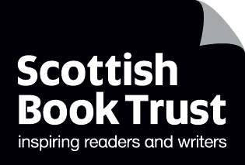
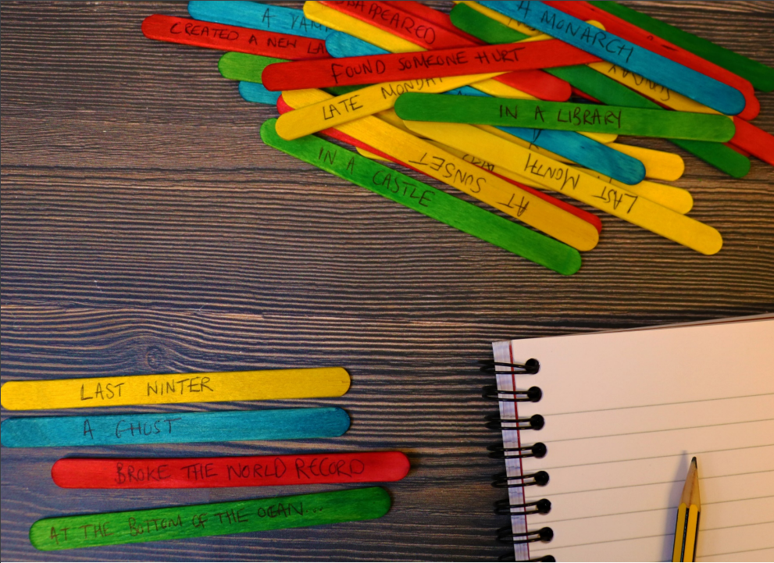

How to make story sticks
A guide to making and using story sticks for creative writing

Age 8-18

CFE Second to Fourth Level

Resource created by Scottish Book Trust

scottishbooktrust.com
Scottish Book Trust is a registered company (SC184248)
and a Scottish charity (SC027669).

Contents
About this resource 2
How to make your story sticks 2
How to use story sticks 6
Further resources 9

About this resource
When presented with a blank page and asked to write a story, young people can sometimes feel overwhelmed and find it challenging to come up with ideas, or know where to start. Story sticks are a great way to spark ideas! This resource will tell you how to make your story sticks and share some ideas for how to get started.
If you are taking part in Reading Schools, the activities in this resource could support delivery of Key Area 2.2.2: Interdisciplinary book projects.

How to make your story sticks
All you need are some lollipop or crafting sticks and a pen that can write on them. Below you’ll find a list of suggested phrases – you’re welcome to come up with your own! We’ve divided these into time, setting, character and action.

Time
- Last winter
- Last summer
- This morning
- This afternoon
- Today
- Yesterday
- Early in the morning
- Late in the evening
- At sunrise
- At sunset
- Last night
- Two days ago
- Last month
- Next week
- Two days from now
- Christmas Day
- Hallowe’en
- New Year’s Eve
- Sunday afternoon
- Late Monday night
- 21st September
- 12th July
- 29th February

Setting
- In a castle
- In a desert
- On an island
- At the bottom of the ocean
- At a supermarket
- At the corner shop
- In the forest
- On a football pitch
- In the basement
- Under the stairs
- On the roof
- In a park
- In an attic
- At the beach
- At the cinema
- On the moon
- At school
- Near a mountain
- In a city
- In a library
- In a shop
- In a bookshop

Character
- A man
- A woman
- A person
- A child
- A mouse
- A train
- An owl
- A fox
- A teacher
- A baby
- A vampire
- A kitten
- A sports team
- A werewolf
- A monarch
- A mythical creature
- An ant
- A ghost
- A zookeeper
- A poet
- A day dreamer
- A cat
- A dog
- A celebrity

Action
- Broke the world record
- Were all alone
- No one listened
- Got into trouble for…
- Got on a train to…
- Had to hide
- Found a…
- Had a secret
- Needed money
- Were lost
- Learnt something new
- Found someone hurt
- Missed someone
- Got stuck
- Found something unusual
- Wanted something they could not have
- Disappeared
- Got on a plane to…
- Got into a boat
- Wrote a book about…
- Planted a tree
- Created a new language
- Were happy until…

How to use story sticks

Activity 1: Verbal storytelling
LIT 2-02a/3-02a/4-02a, LIT 2-08a/3-08a/4-08a, ENG 2-03a/3-03a/4-03a
This activity can be done in pairs or in small groups. Pick four of the story sticks at random, one from each category the four categories. One person reads the story starter out. For example, “Yesterday, in a shop, an owl disappeared”. The first person adds a sentence onto this, explaining what happens next. Another person using the phrase “And then…” continues the story. The story goes on until the group are happy with the direction of the story, or it comes to a natural end. Alternatively, you could set a limit, such as six “And then” additions to the story starter.
To make it more challenging, you could ask pupils to repeat what has happened in the story thus far before they add to the story using “And then…”

Activity 2: Creating characters
LIT 2-26a/3-26a/4-26a, LIT 2-25a/3-25a/4-25a
This activity can be done in small groups. Each pupil picks a character stick only. The group must work together to create a character profile for each character. They can think about:
- Likes and dislikes
- Description - what does the character look like?
- Hobbies
- Friends and family members
- Any motivations/beliefs
Once each character has a profile, ask the pupils to put the character profiles next to each other. Ask them to discuss how they think the characters might know each other and how they will interact. Will they get on? Or will they disagree? Why? Do they have any similarities or are they more different than they are alike?
Next, ask pupils to select a time, setting and action story stick. This is the base for their story. From this, pupils must create a short story, with a beginning, middle and end, which includes all of the characters. They can work in a group to plan their story, ensuring all characters feature. Remind pupils that not all the characters need to appear at the beginning, some could appear in the story in the middle, or at the end. Once the plan is complete, it can be presented verbally to the rest of the class. As an extension, pupils can write up their story in full.

Activity 3: Story mapping
EXA 2-04a/3-04a/4-04a, EXA 2-05a/4-05a
Story mapping is a fun and creative way to help pupils plan their story. Ask pupils to select four story sticks, one from each of the four categories. You could select one story for all the class to work on, or each pupil could select their own story sticks. This is the opening line for their story.
Ask pupils to divide their page into eight squares, writing their opening line at the top of the page (they can turn their page landscape). These squares are the eight key points of the story. Rather than writing, ask pupils to draw what happens at each point in the story. Recommend that they draw the first and last panel to start, as this will enable them to see where the story begins and ends. They can now fill in the middle panels, planning visually what happens in their story.
If pupils are struggling, you could play the “And then” game (see Activity 1) with other members of the class to generate ideas. You could also ask pupils to think about how they get from the first to last pane- does their character meet someone? Does the setting change? Is there another action? Does the story move forward or backward in time? Pupils could select another story stick from the bundle to help generate ideas for their story.
As an extension, once the story map is complete, pupils can create a written story to accompany it. Alternatively, pupils could think about how the image and text might work together and create a comic strip of their story.

Activity 4: Genre discussion
LIT 2-02a/3-02a/4-02a, LIT 2-04a/3-04a/4-04a
Ask pupils to select four story sticks, one from each category. In pairs, ask pupils to discuss the story starter in front of them. What genre do they think it might be? Would they like to read it? How do they know what genre it could be? What are the clues from the story sticks? For example, it could be a jumbled line of different things, which might make them think it is a humorous story. Or it could include a character such as vampire or werewolf which might give them a clue.
To encourage pupils to think more critically, ask them to think about the stereotypes and assumptions they are making when categorising the genre - what other books have they read or films they have seen that make them think that way, for example that a vampire would be in a horror story. Can they think of any books that challenge these stereotypes? How could they challenge stereotypes in their own writing?

Further resources
- You can extend this activity using our Creative writing for upper primary and secondary resources
- For more quick activities see our How to make a mini book, How to make story sticks and our guide to Creating reading groups and events

