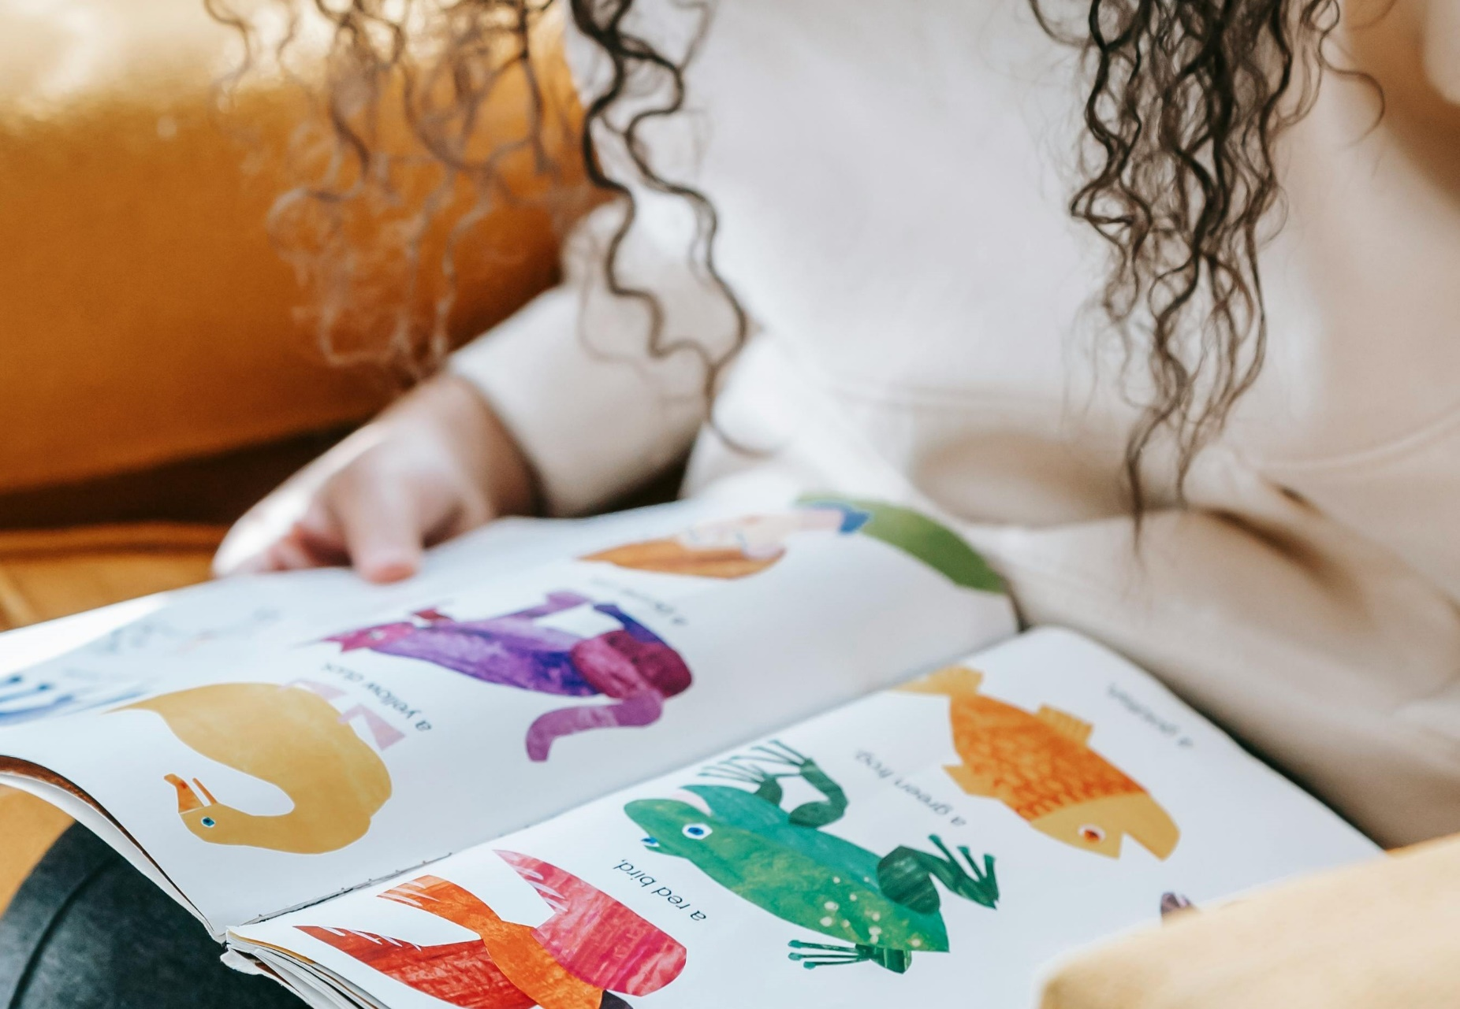

Turning picture books into sensory stories
A resource to support adapting books into multi-sensory stories

Age 3-18

CFE Levels Early to Fourth

Resource created by Ailie Finlay

scottishbooktrust.com
Scottish Book Trust is a registered company (SC184248)
and a Scottish charity (SC027669).

Contents
About this resource 2
Choosing a book to turn in to a sensory story 2
Decide on the main objective 3
Keep things simple 3
Choose the props 3
Find your style 5
Reading the story 6
Recommended books 6

About this resource
Sharing a picture book is a joyful experience that can enrich the life of any child. However, for some children, particularly those with additional needs, the text and images of a book are not quite engaging enough on their own. For these children we need to turn our picture books into sensory stories that include props to look at and handle, interesting noises to listen to and maybe even some lovely smells! These ‘sensory packages’ will allow us to share the picture books we love with every child.

If you are taking part in Reading Schools, the activities in this resource could support delivery of Key Area:
- 2.2.1: Regular opportunities to read for pleasure
- 2.2.2: Interdisciplinary book projects
- 2.3.1: Modelling reading behaviours

Choosing a book to turn in to a sensory story
Choosing the right book to turn in to a sensory story will make our task much easier. There are many wonderful picture books, which just would not work as sensory tales. I find it is best to choose a book with a short simple narrative and not too many abstract concepts.

Decide on the main objective
How we ‘translate’ the book to make it more sensory will depend on who we are telling the story to and why. For some children we may simply be adding in some objects to make the story more comprehensible. (A bean plant seedling for Jack and the Beanstalk, a noisemaker toy that woofs for Hairy Maclary).
Children with complex needs however may experience the story primarily as a series of sensory sensations. For these children it is important to consider the shape of the story as well as the meaning when we are choosing our props. The ‘biggest’ sensory experience should come at the climax of the story, so we need to save our shiniest bling and funniest noise for this point! When the Very Hungry Caterpillar turns into a butterfly the butterfly prop needs to ‘outshine’ all the props that have gone before (a butterfly kite for example). When we meet the bear in We’re Going on a Bear Hunt the bear needs to be the most exciting experience so far. (Perhaps we become the bear covered in a big brown furry blanket and with lots of growling and stamping.)

Keep things simple
It is not necessary for us to have a prop or sensory stimuli for everything that is in the book. In fact, if we try to do this we may end up overloading the children by offering too many sensory experiences at once. We may also find that our story becomes quite jerky and we lose the rhythm of the text. Unless we are reading a very simple story it is best if we can pick out just the key elements to ‘translate’ into sensory experiences.

Choose the props
When choosing our props we need to think about what it is we are we trying to express. Sometimes this is very straightforward (a teddy for the teddy in Katie Morag and the Tiresome Ted, a tea set for teatime in The Tiger Who Came to Tea). But often we need to choose something that symbolically represents the object or character in the book. When we do this, we will usually need to choose one particular sensory quality that we are trying to convey.
For example, if there is water in the story, we need to decide what property of the water is important. It might be the wetness of the water that is important, or the vastness (if it is an ocean) or the feeling of being transported to a different realm (if the story takes place under water). In each of these instances our choice of prop or stimuli would be different; we might choose a spray of water on the back of the child’s hand, a huge piece of blue silky fabric, some peaceful music…
If we are reading the story to a group of children with a variety of different additional needs, then we need to remember to be as multi-sensory as possible. None of the senses should be neglected. I often try to include objects that engage more than one sense at a time. For example, a transparent rain stick where you can see as well as hear the beads falling; a brightly coloured fan that makes a lovely breeze when unfolded.
Our props are our friends! If we know there is a certain prop that will help a child focus on a story, then I think a little ‘shoehorning’ is fine! By this I mean that if a prop is helpful (and somewhat relevant) I sometimes add it in even if it is not mentioned in the text. It can be particularly useful as you begin the story to include an intriguing noise, spinning toy or something similar to act as an ‘invitation’ to the children to listen…The birds could be singing as the three little pigs set off down the road. A breeze (fan) could be blowing as Goldilocks goes into the woods…

Tips on choosing and using props:
- When using tactile or smelly props with a group of children, it can be very useful to have multiple copies. It is a slow process letting everyone have a smell or feel of an object; passing round extra copies speeds things up.
- Try extracting the noises and rattles from baby toys and put them in little bags to make them more age appropriate.
- Include movement! An object that moves attracts our attention. Shake a quilt, waft a silk square, ‘drive’ a toy car, make a puppet dance, throw confetti…
- Remember that a book keeps its own secrets…until we start to turn the pages. Try to do the same with your props! Keep them hidden in boxes or bags until it is time to reveal them.
- Soft toys may not particularly helpful or engaging when telling a story to children with a visual impairment or complex additional needs. Unless the toys contain particular sensory experiences (for example a significant weight or a hidden noise) they will not give these children much information. Rather than using a cow cuddly toy we might want to use a ‘moo’ noise maker; a fierce lion might be better represented by snapping our hands together and roaring than by a soft toy lion.
- Many children love the following: music boxes, bird toys that sing, bicycle bells, wind chimes, folding fans, confetti, space blankets and feather dusters. Slide whistles are good for flying, throwing, climbing or falling….and children always seem to find them funny.
Remember too that multi-sensory does not have to mean very expensive! Once you get into the habit, you will discover sensory story props everywhere. Your recycling box will be full of things that rustle, scrunch, pop or bang. What happens if you bang two lids from laundry detergent bottles together, or if you hit that big cardboard box with a wooden spoon? The supermarket is also a sensory treasure trove. There are many things to shake and rattle. (Experiment with a variety of dried goods such as lentils, rice, pasta and cereal in different kinds of containers.) Once you have finished in the food aisles you can wander over to the yellow dusters, mop heads, smelly soaps and marigold gloves!

Find your style
We need to be thinking of the child/children when we are creating our sensory stories, but we can also choose stories and props that suit our particular style. There is no right or wrong style; perhaps we love leaping around with puppets and doing lots of funny voices, or maybe we have a quieter style and prefer soft silks and gentle musical accompaniment… Experiment with different styles until you find one that suits you. Remember – it is your story too!

Reading the story
When reading the story remember that the language is a sensory experience as well. As mentioned before we may choose not to try to ‘fit in’ sensory props to accompany all of the narrative but this does not mean that we do not want the child to experience the whole story. Language can convey much even if a child in not understanding every word; it can convey an atmosphere, a sense of time passing, the pace of the story. That said I think for some books it can sometimes be useful to insert a simple short summing up sentence as the story is being read, to help the child’s understanding. For example, in Julia Donaldson’s Stick Man I might read out the page where the Stick Man is used for a game of fetch with all the lovely rhyme and rhythm and then at the end I might sum up by saying: ‘The dog plays with Stick Man’.

Recommended books
Some of the books listed below have been mentioned in this resource, or are a good place to start when adapting picture books into sensory stories.
- Jack and the Bean Stalk, folk tale
- Hairy Maclary, Lynley Dodd
- The Very Hungry Caterpillar, Eric Carle
- We’re Going on a Bear Hunt, Michael Rosen
- The Tiger Who Came to Tea, Judith Kerr
- Katie Morag and the Tiresome Ted, Mairi Hedderwick
- The Three Little Pigs, folk tale
- Goldilocks and the Three Bears, folk tale
- Stick Man, Julia Donaldson
- Peace At Last, Jill Murphy

Further resources
This resource was created by Ailie Finlay. Find out more about her work on the Flotsam and Jetsam website.
Find all our resources on storytelling on the Scottish Book Trust website, including:
- Oral storytelling with Claire McNicol
- Getting started with sensory stories
- Make your own sensory story

