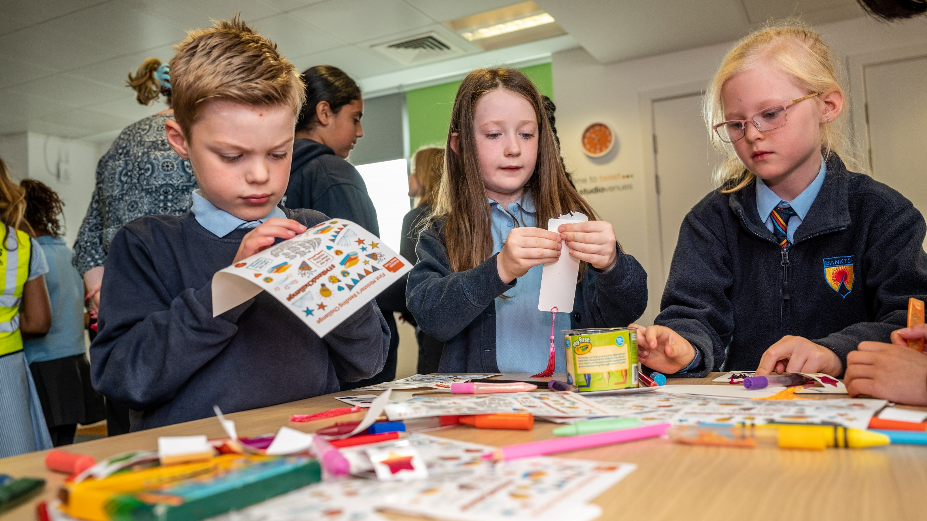

Creative writing for upper primary
Individual, paired and group writing tasks inspired by books and authors

Age 8-12

CFE Second Level

Resource created by Susannah Jeffries, classroom teacher at Canal View Primary School

scottishbooktrust.com
Scottish Book Trust is a registered company (SC184248)
and a Scottish charity (SC027669).

Contents
About this resource 2
Learning activities 2
Further resources 11
Worksheet 1: Note taking frame 11
Worksheet 2: Storyboard 12

About this resource
The activities in this resource are designed to use a favourite author as a starting point for individual work, paired work and group work. The activities can be used as a continuous scheme of work or any given activity can be used as a stand-alone writing session. The activities encourage the development of a range of different skills and ask children to consider many aspects of the work of an author and the creation of different kinds of text. The resource also offers a range of opportunities for personalisation and choice within the activities and in the different starting points and outputs the children may select.

If you are taking part in Reading Schools, the activities in this resource could support delivery of Key Area 2.3.4: Opportunities for learners to respond to what they’re reading.

Learning activities
Activity 1: Author audio
Individual work: LIT 2-05a, LIT 2-25a, LIT 2-26a, LIT 2-24a
This activity develops children’s listening and note taking skills as well as asking them to create a text of their own.
The children will be listening for information and gathering supplementary information through research to help them make a profile of an author. The children can choose how they create and present their profile. Depending on available resources and skill-set this could be:
- Handwritten
- Presented digitally e.g. Word, Powerpoint, Book Creator
- Presented verbally e.g. as a presentation, recorded audio, recorded video

Select your author
Within the Scottish Book Trust Authors Live On Demand Library there are a range of different authors talking about their process for writing, how they became writers and what inspires and excites them (there are a list of links to excellent options at the end of this pack). Alternatively, you could choose any audio or audio/visual clip of a preferred author talking about their work.

Listening for information
Give the children the note-taking frame (Worksheet 1 on page 12) if required or whatever note-taking materials are most appropriate and ask them to listen to the audio / video.
They should take notes gathering together the relevant ideas and information and then spend some time thinking about further questions they might have about their subject.

Filling in the blanks
If time and available resources/facilities allow the children should then be given the opportunity to undertake further research, most likely online, to find answers to their questions.
Some authors are very active online and if your school/class has a twitter account this can be a really exciting and engaging way to reach out with any particularly interesting questions you can’t find an answer to!

Author profiles
When the children have found the answers to their questions and feel they have enough information they can start to build their author profiles. The range of ways in which the children can choose to create and present their profiles should maximise personalisation and choice within the process and give children experience of creating texts in a range of different formats – some children will actively prefer to create their profiles on paper where as others will prefer digital formats such as PowerPoint or ‘Book Creator’. Some may choose to put together a presentation for the class.
At the end of the process it’s important to allow the children to share and discuss their profiles and see the variety of information the class as a whole has collected about their author. The profiles might even form the basis for a display aimed at sharing their knowledge of their author with the wider school community – a great way to encourage other children to find out more.

Variation
Again if facilities allow then children could be given the opportunity to choose from a small selection of different authors to be the subject of their profile. This would require that the different groups of children are able to listen to the different audio/video files at the first stage but it would also allow for the children to share their findings with their peers and for the class as a whole to develop an in-depth knowledge of more than one author.

Activity 2: Character creation
Individual work: ENG 2-31a
Alongside the development of the author profiles in activity one, or simply as preparation for this as a stand-alone activity the children will need to become familiar with a story by the chosen author.
For the purposes of this activity it is not necessary to have finished reading the whole book, in fact it might be useful to try this activity part-way though the story.

Setting the scene
As a class, or in groups or individually, consider the setting and the main character(s) of the story you have been reading. You could just discuss the elements of the story so far, or you could make notes, or you could draw a large scale diagram – whatever works for you.

Adding a character
Having established what they know about the story so far each child should be asked to imagine that a new character is going to be introduced into the setting. They have, or develop, a close relationship of some kind with the main character(s) in the existing story.
They should be able to answer the following key questions about their character:
- What is their name?
- What do they look like?
- What is their relationship to the existing characters?
- Why have they suddenly arrived in this story?
- Why have they suddenly arrived in this location?
- What changes for the other characters when they arrive?
- What is the most important thing in the life of this character?
- What does this character want?
- What emotion do they feel most often in this setting? Are they happy to be here? Or sad? Or angry? Or excited? Why is that?
- Now that they have arrived in the story they are going to make something happen – what will it be? Do they want that thing to happen? Why? This new character could either be a help or a hindrance to the main character achieving their goals!

There may be other themes under discussion in other areas of learning at this time which could be connected in to this piece of work at this point – it might provide additional coherence and relevance to the process if you provide an answer to one or other of these key questions and make that a pre-requisite of the character design. For example – if the class were engaged in an IDL project about refugees and displacement then you could state that the new character has arrived in this location as a result of displacement and this might generate discussion about how that impacts on the character.
As an extension the children could create a key question of their own about their character – and find their own answer to it. As with the author profiles in Activity 1 the answers to these questions could be presented in any number of ways depending on the available time and resources.
This could be a written piece of work or it could be presented verbally or digitally. It would be beneficial if the children were given the opportunity to share their character profiles with their peers and, if they have created their own key questions, they could ask the questions they created of each other. The more questions a child can answer about their character the more rounded their understanding of the character will be.
The next activity will ask the children to take their character on its own narrative journey.

Activity 3: Shared stories
Paired work: ENG 2-27a, EXA 2-05a
This activity follows on neatly from activity two but can also be used in isolation as a shared writing exercise designed to encourage children to think about their reader and what kind of language is appropriate and engaging for them.
The aim of this activity is to allow the children to experience both the role of an author and an illustrator and to engage in creating picture books for younger readers. The activity could be completed in two sessions - one for story planning and one for writing/illustrating each other’s stories - or it could become a longer scheme of work over a number of sessions. This might dictate the length of the story to be created and the storyboard format may need to be adjusted accordingly.

Understanding your audience
If the class has a younger ‘buddy class’ or has ‘paired readers’, or similar, lower down the school then they could aim their stories at those particular children. If they do not have a pairing of this kind, then it might be beneficial to arrange 2 half-hour sessions with a P1 or P2 class in your school. The first half hour could be spent with the children reading stories from the P1/P2 class library to their younger counterparts so that they can refresh their understanding of picture books and what might constitute appropriate language for this age group. The second half hour would be after the activity when the children could return to the younger class to share their stories with them.

Story planning
For the purposes of the activity itself the children should be organised into pairs. They should begin by each story-boarding a short, simple story for the character they created in activity two (if you have not completed activity two then the children could just take a few minutes to create a character to work with – the list of key questions at the end of activity two above could be used as a quick-fire quiz to help the children generate ideas).
There is a storyboard format included in Worksheet 2 on page 13 which provides for a five-step story – who and where, how did it begin, what happened, and then, and how did it end. This could be extended or reduced as you wish but this provides a simple story arc.

Author and illustrator
Once each child has completed their storyboard and discussed it with their partner they both start work as authors. You can decide on the time period allowed for each step of this process depending on your own needs and plans - the children could do each step in as little as five minutes doing quick sketch illustrations to practise representing and conveying ideas as simply as possible, or they could be asked to do detailed illustrations for each other’s writing over a number of sessions. It is up to you. The suggested format for the collaborative process is as follows:

Time period | Child A | Child B
1 | Writes 1st sentence of story A. | Writes 1st sentence of story B.
2 | Illustrates 1st sentence of story B. | Illustrates 1st sentence of story A.
3 | Writes 2nd sentence of story A. | Writes 2nd sentence of story B.
4 | Illustrates 2nd sentence of story B. | Illustrates 2nd sentence of story A.
5 | Writes 3rd sentence of story A. | Writes 3rd sentence of story B.
6 | Illustrates 3rd sentence of story B. | Illustrates 3rd sentence of story A.
7 | Writes 4th sentence of story A. | Writes 4th sentence of story B.
8 | Illustrates 4th sentence of story B. | Illustrates 4th sentence of story A.
9 | Writes 5th sentence of story A. | Writes 5th sentence of story B.
10 | Illustrates 5th sentence of story B. | Illustrates 5th sentence of story A.

When the stories are complete they can be bound together as mini picture books and shared with peers or buddy classes.
For more ideas about how you can introduce picture books to older readers and help them understand how to share these with younger pupils, check out Scottish Book Trust’s shared reading resource which can be found in the learning resources section of the website.

Activity 4: DIY kamishibai
Group Work: LIT 2-16a, LIT 2-26a
This activity is designed to be completed when you have finished reading a particular story or class novel that all of the children have experienced – a story which they all know well. The process of creating a kamishibai version of the story will require the children to identify the key parts of the story and create a summary which tells the story using text and imagery to convey the main ideas and supporting details.

About kamishibai
Kamishibai, (kah-mee-she-bye) or “paper-play” is Japanese form of picture storytelling. It is much like a picture book in some ways but instead of the text being printed on pages alongside the pictures it is printed on the back of the pictures so the audience sees only the pictures and the reader/performer sees only the text.

Historically these picture cards were created at to a particular size to be fitted inside a small wooden frame which looked like a miniature theatre, but the picture cards can equally be held up to the audience by the reader – much in the style of a teacher reading a picture book to children on the carpet! There is a handy pictorial description of how it works on Kamishibai.com.

Main ideas
The first stage for the group is to create a storyboard, again using the format in Appendix 2 which can be photocopied to a larger size for group work or can be adjusted if you want the kamishibai to include a smaller or larger number of cards.
The storyboard provides a vehicle for the group to discuss and identify what they believe are the main ideas of the text they are focussing on and identify the supporting detail which will need to be included in the text or images.
For clarity here is the step-by-step process for making the kamishibai story. These instructions assume you are working with the 5-stage storyboard.
- You will need 5 large, sturdy cards - one for each box on your storyboard.
- For each of the cards the group should design and create the planned image – this could be a collaborative process for each card or each member of each group could take responsibility for individual images.
- On 5 separate sheets of paper the group should now create the text that goes with each image –DO NOT affix the words to the associated picture!
- When you have your 5 pictures and 5 sections of text you can build your Kamishibai.
This part is the tricky bit so do read the instructions carefully…To start put the pictures in order – picture 1 and the front, then 2, 3, 4 and 5 – if they aren’t in the right order when you add the words you won’t be able to read the story!
- Affix the text for picture 1 to the back of picture 5.
- Affix the text for picture 2 to the back of picture 1.
- Affix the text for picture 3 to the back of picture 2.
- Affix the text for picture 4 to the back of picture 3.
- Affix the text for picture 5 to the back of picture 4.
- Now practice presenting your story.
- Put the cards back in the starting order with picture 1 at the front.
- When picture 1 is back at the front you should be able to read the associated text at the back of the set of cards.
- When you have finished reading the text for picture 1 lift picture one to the back of the pile revealing picture 2 to your audience and the words for picture 2 to you!
- Continue to the end of the story!

As you share your kamishibai stories with your peers in the other groups it will be interesting to see what each group has settled on as the key points in the story and how they have chosen to summarise the narrative.
Think about why these differences have occurred and consider whether your opinions about the key points in the story change as you hear what others have selected.

Further resources
Find more writing resources on the Creative writing section of the Scottish Book Trust website, including:
- Creating a picture book in class
- Using drawing to inspire stories
- How to make story sticks
- How to make a mini book
- How to make poetry stones

Worksheet 1: Note taking frame
Print this page
What I learned from what I heard…

What I want to know now… My questions!

What I found out… My answers!

Worksheet 2: Storyboard
Print this page
 | Picture plan | Text plan
Beginning
Who and where?

Middle 1
How did it begin?

Middle 2
What happened?

Middle 3
And then?

End
How did it end?

