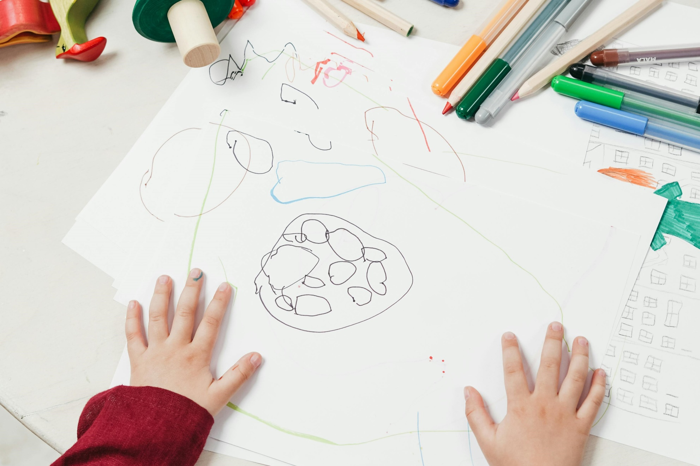

How to create a stop-motion animation
A guide to creating stop-motion animation in class

Age 5-11
CFE Level First and Second

Resource created by Henry Cruickshank

scottishbooktrust.com
Scottish Book Trust is a registered company (SC184248)
and a Scottish charity (SC027669).

Contents
About this resource 2
Research 3
Activity 1: Introduction to the medium 3
Activity 2: The artwork of Lauren Child 3
Activity 3: The ideas and stories within Lauren Child’s work and creating your own story 4
Production 4
Activity 4: Creation of the artwork 4
Animating 6
Activity 5: Bringing your story to life 6
Additional activities 7
Resource sheet 1 8
Resource sheet 2 9
Resource sheet 3 10

About this resource
These activities are aimed to encourage learners to explore the work of Lauren Child, and in particular Charlie and Lola, but the activities could be adapted to work alongside the study of any artist or illustrator. The activities are designed to support children’s understanding of how an animated film/cartoon is created. The activities should be followed in a linear way as the resource is designed to follow the flow of a film production; research and ideas, production (creating the artwork) and filming. However, the activities are adaptable and can be limited or extended to suit the needs of your pupils.

Page 7 and 8 are designed to be printed and distributed to all pupils completing the activity.

Research
Activity 1: Introduction to the medium
EXA 0-05a, EXA 1-05a, EXA 2-05a
Read a Charlie and Lola book, then watch an episode or part of an episode of Charlie and Lola. Briefly discuss what the pupils know about animation either as a group or as part of a class discussion.
Key questions:
- What is animation? Animation is the illusion of movement, a series of images differing slightly from each to give the illusion of movement
- Can they identify different examples of animation? Cartoons, adverts, films that they know.
- Can they work out how Charlie and Lola is created? It is an example of cut out animation, a type of stop motion animation, the name come from the fact that the characters are cut out of card or material. The style of animation fits very well with the original illustrations of Charlie and Lola, as a lot of artwork is created in a very similar manor. This is the style of animation that they will later create.

Activity 2: The artwork of Lauren Child
EXA 0-04a, EXA 1-04a, EXA 0-07a, EXA 1-07a, EXA 2-07a
Identify and describe, either as a class or in small groups, the artwork of the Charlie and Lola. Encourage the pupils to recognise what makes Charlie and Lola characters appear the way they do - e.g. the dark outline, big eyes, the bright colours, the patterned paper, the use of real objects.
Ask pupils to create a drawing of a familiar character (i.e. themselves, friend, sibling, parent or guardian, pet) in the style of Lauren Child.

Activity 3: The ideas and stories within Lauren Child’s work and creating your own story
ENG 1-30a, ENG 2-30a, ENG 1-31a, ENG 2-31a
In her Children’s Laureate blog, Lauren says: “For me, ideas come everywhere, the particles of them are everywhere; on the pavement, in a supermarket queue, out of the window, in the past in, the moment, a sentence overheard…” and “boredom can be the creator’s greatest ally”. Essentially, Lauren believe inspiration can come from anywhere.
Discuss the ideas and stories behind the Charlie and Lola books. Childhood experiences such as choosing a pet, not wanting to go to bed, or not wanting to eat certain foods. With older classes explore the idea of boredom being a great tool for creating ideas.
Create your own story: Encourage pupils, in small groups, to identify everyday events in their lives and create a simple story that begins, but not necessarily ends, with an everyday event. The story should feature their characters they created in activity 2. The stories should be simple enough to be animated within a 30 second to a 1-minute time frame. The story should all take place in one setting. Ask pupils to work in small groups of 3-5 pupils. They will create their films within this grouping. Groups can use the storyboard (resource sheet 1) to help create their story. This is a particularly good approach for visual learners.

Production
Activity 4: Creation of the artwork
EXA 1-02a, EXA 2-02a
Artwork: There are four categories to the artwork: characters, backgrounds, props and the option of a title card.
Materials Required: A4 white Card, A2 paper or card, blue tac, black felt pens, colouring pencils or pens, scissors, old magazines and catalogues, patterned paper.
Characters: Using the drawing they created in activity 2, the pupils will need to redraw their character in parts, as if their character has exploded (see example character resource sheet 2) onto A4 card (if drawn on paper they will be too flimsy to animate with). Draw out the parts with pencil first, then once happy go over the pencil lines with black pen. Ensure pupils’ characters do not become too big or small. The example character is a good size to aim for; too big they won’t fit under the camera and too small they become very difficult to animate. Pupils should be aware that the character limbs will also become shorter as you reassemble them, so if in doubt make them longer and they then can be cut down.
Before cutting the parts out, colour in using coloured pencils or pens. For older groups they could use textured/patterned paper as in Lauren Child’s work, I would suggest that if using this technique, re-draw any lines if obscured.
Cut out all parts and then using very small blobs of blue-tac, reassemble the character.
Backgrounds: Create backgrounds on A2 paper, landscape. The focus of the background should be towards the middle as the camera will not see all the edges. The backgrounds should be of collage construction using coloured and patterned paper and images of real objects such as those cut from catalogues. Use the backgrounds found in Charlie and Lola (or other Lauren Child books) for inspiration. Try to keep the background artwork as flat as possible as this will help with animating and avoid reflective paper as this will result in difficulties with lighting.
Props: Ask pupils to identify and create any additional items they will require to create to tell their story, i.e. a car, shopping trolley etc. These can either be drawn on card and cut out like the characters or cut out of magazines/catalogues then stuck to card.
Title Card: Title cards can be used to start the animation and break up the sequences. Continuing to keep with the style of Charlie and Lola use an oval of white paper or card with the writing within oval and place this against a coloured piece of A2 paper or card. Characters and additional artwork can also be included around the oval.

Animating

Activity 5: Animating: Bringing your story to life
TCH 1-01a, EXA 1-02a, EXA 2-02a, EXA 1-03a, EXA 2-03a
Pupils can use a variety of software to create their animation. See resource sheet 3 for set up of the equipment and outline of how to use the software. An additional member of staff or volunteer will be ideal when it comes to filming.
The group should place their background down under the camera and secure with masking tape or blue-tac to make sure it doesn’t move during filming. If using a title card place this down over the background and capture 30+ pictures this is to allow the viewer the chance to read it. Then remove and return to the background image. Generally, ask pupils to start with the characters off screen and capture 12 frames to start with. Again, this will allow the audience to become familiar with what is happening on the screen.
Remind pupils that every picture of frame captured is just 1-12th of a second and thus they will need 12 frames to make one second of animation. This also means the movements of the characters need to be small, about the width of a finger as a guide; if a character needs to move faster, move it a greater distance, if it needs to move slower move it less than a fingers width. Remind pupils not to move everything all at the same time as it can become hard for the viewer to process what is happening on screen.
Encourage pupils to build in pauses into their animation, taking 12 frames with nothing moving, this again will allow the viewer to process the action.
For older groups ask pupils to think about how they move and try to embody that movement within their character. The cardboard puppet is their actor and thus the pupils acting out movements themselves can help with creating and understanding realistic movements. In addition, they can try out or incorporate different movements (see resource sheet 4).
Finishing off: Once the group has finished their sequence, they can watch it back straight away using the play button. If continuing to film or setting up for another group you may need to click on the capture tap (see screen grab in resource sheet 3). When all filming is complete export the animation using the instructions outlined in resource sheet 3.

Additional activities
TCH 1-01a, EXA 1-02a, EXA 2-02a, EXA 1-03a, EXA 2-03a
If pupils or classes wish to take the process further, here are a few ideas:
- Once the video has been created, record or find sound effects and music and edit the film to incorporate these. You could explore creating your own soundtrack with musical instruments.
- Record your own sound effects and music with a simple diaphone or smart phone. You can turn this into a scavenger hunt by trying to find or create sounds in your class, school or local area.
- Explore editing with software like Microsoft Video Editor or ClipChamp.
- Explore film-making techniques further, try adding in different shots to help tell the story i.e. close up, long shot, establishing shots.
- Use storyboarding to plan how you would film a scene from a book or story.
- Use our resource on creating book reviews and trailers to explore some of your pupil’s favourite books or stories through film-making.
- Try writing a script, or acting out an alternative ending, with our resource which shares 10 expressive arts activities for any book.
- Explore narrator, character development and themes in animation with our resource on the film adaptation of How to Train Your Dragon.

Resource sheet 1
Print this page
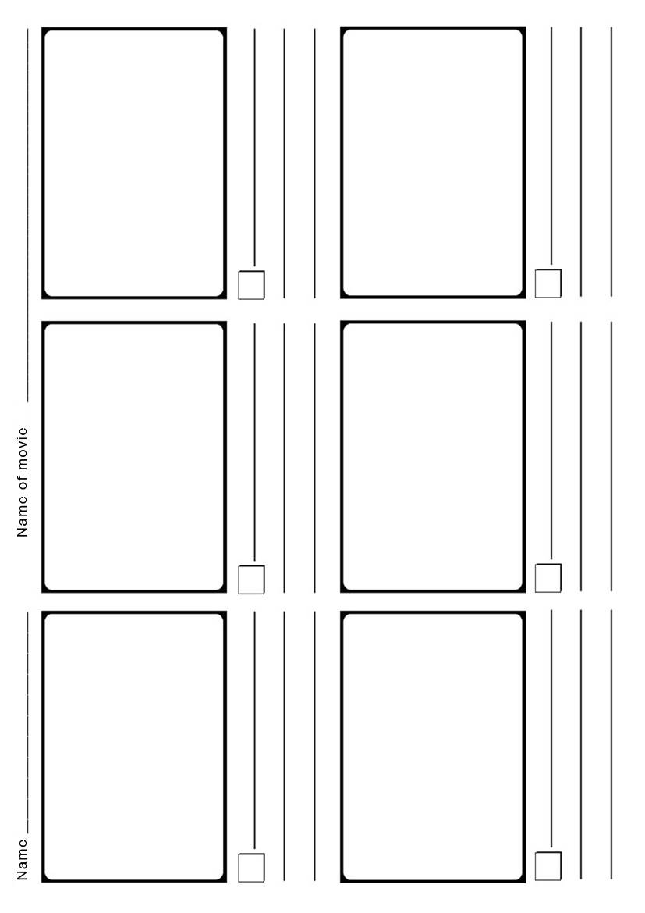

Resource sheet 2
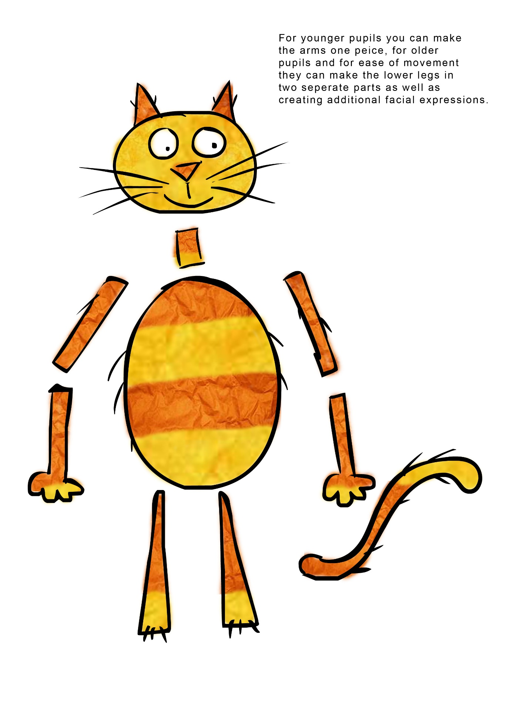
Print this page

Resource sheet 3
Equipment required: Laptop, Webcam (HD is preferable although any webcam work), tripod, Software (Animate it, I Can Animate, Stop Motion Pro, Monkey Jam) masking tape. Optional angle poise lights.
Alternatively, you can use tablet or smartphone (with the software installed) instead of a laptop and webcam, if you go down this route you will require a dedicated tripod for tablet/ smartphone order to enable to hold it steady above the artwork.
The instructions relate to Animate it but other software will be very similar.
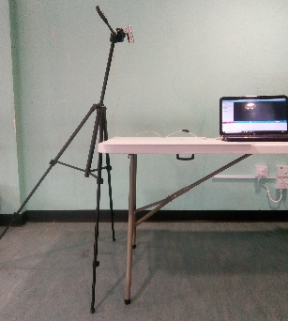
Setting up: Set up in an area that is not affected by natural light or has lighting that will cast shadows. Place tripod, with camera attached, on the floor, next to filming table, as outlined in photo. The front legs should be shorter than the one rear and the camera angled, so it points down at the table, over the artwork as much as possible.
Connect the webcam to the laptop via the USB port. Start up the software click on “Clips” then “My Projects” then “New project”.
Select your webcam (it tends to default to the inbuilt webcam). Click on “Project” then “Project settings”. Check that it is set to 25 per second and Aspect Ratio to widescreen.
Set image to 1280x720, this will be webcam dependant but try to set to a high-quality image. Check that the image/feed from the camera is “live” and not dithering, you may need to drop the quality if the image feed is stalling. Make sure that the camera/image on screen is only seeing the background image and not the table. Once set up tape tripod and camera cable in place. Make sure you are on the Capture tab, select x1 for onion skinning. This will help with animating as you will be able to see how far you have moved your character, it will display the last frame you captured and the current live image. You are now ready to film.
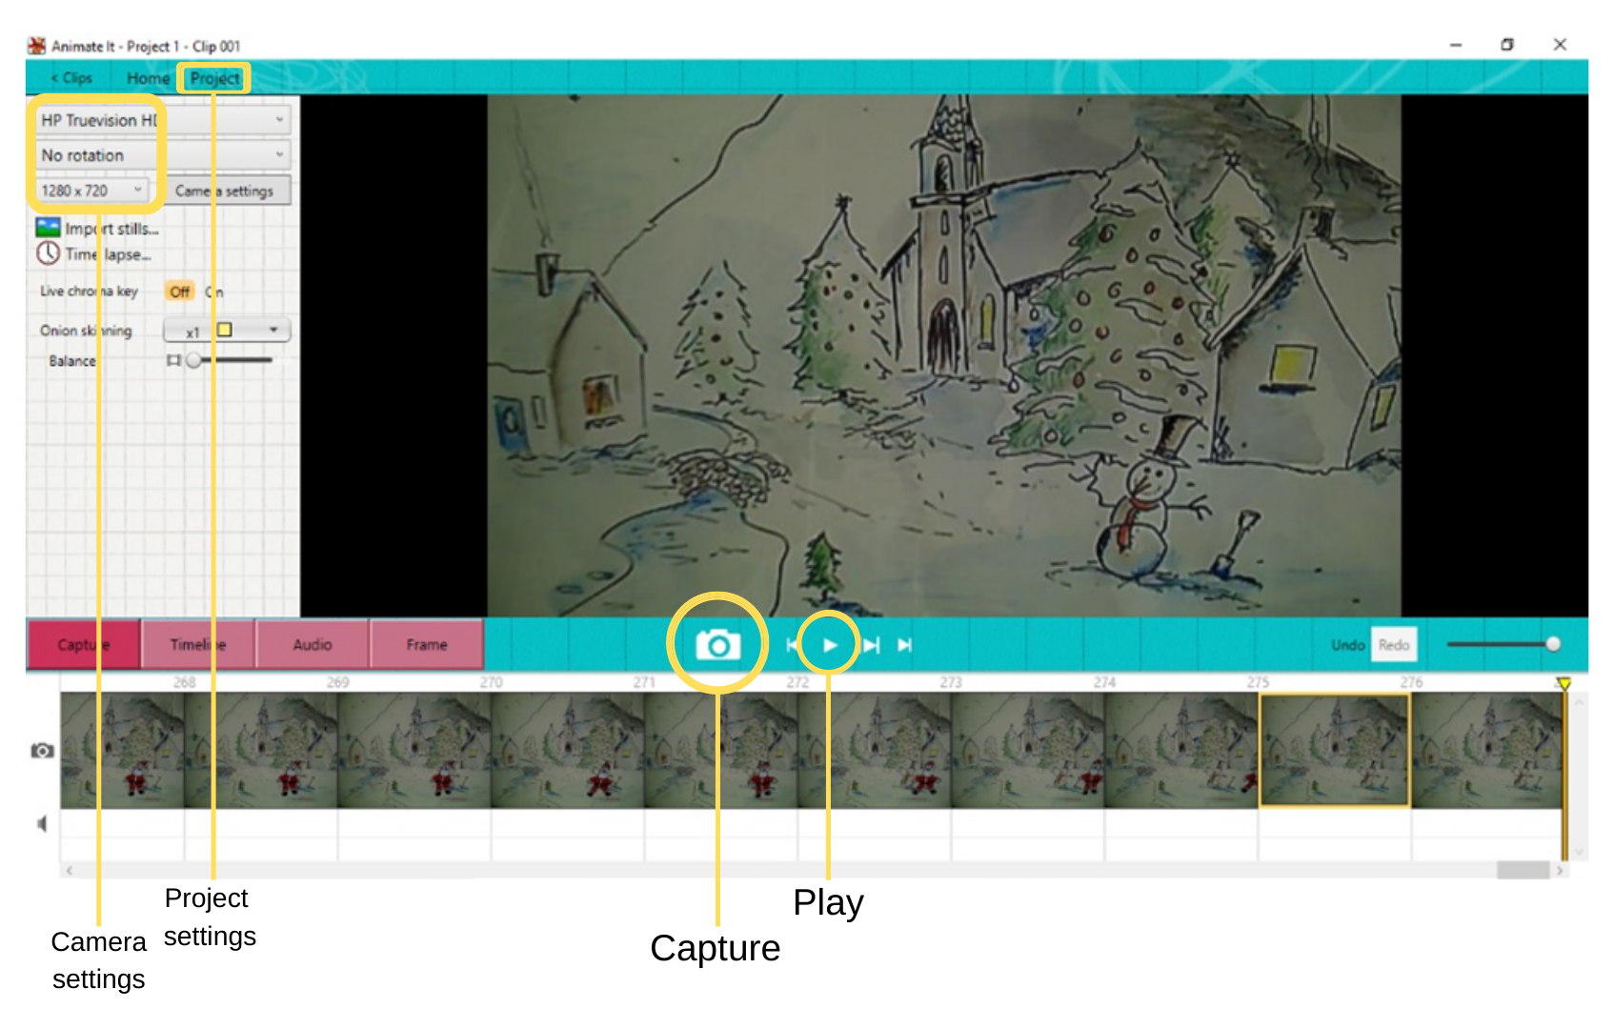
Capturing images: (this is the only section that will need to be passed on to pupils) Use the camera button to capture an image (the camera is just a lens for the computer, and nothing is captured until you click that button).
Make sure the image is “clean” each time, free of hands and pens/pencils etc. If a mistake is made select the frame and use the delete key on the keyboard, you can delete frames at any point in the process. To watch the animation use the play back key (you will need to click on the capture tab to return to filming).
Animate it saves automatically, be aware that other software may not, save regularly.
Export: Once the filming is complete, click on Project>Export. The settings should be automatically correct part from set size to 1280x720 (this again will be webcam dependant choose the size closest to this if not available). Click on the Export button and choose a location and name for you file and then save and the film will start to export.

