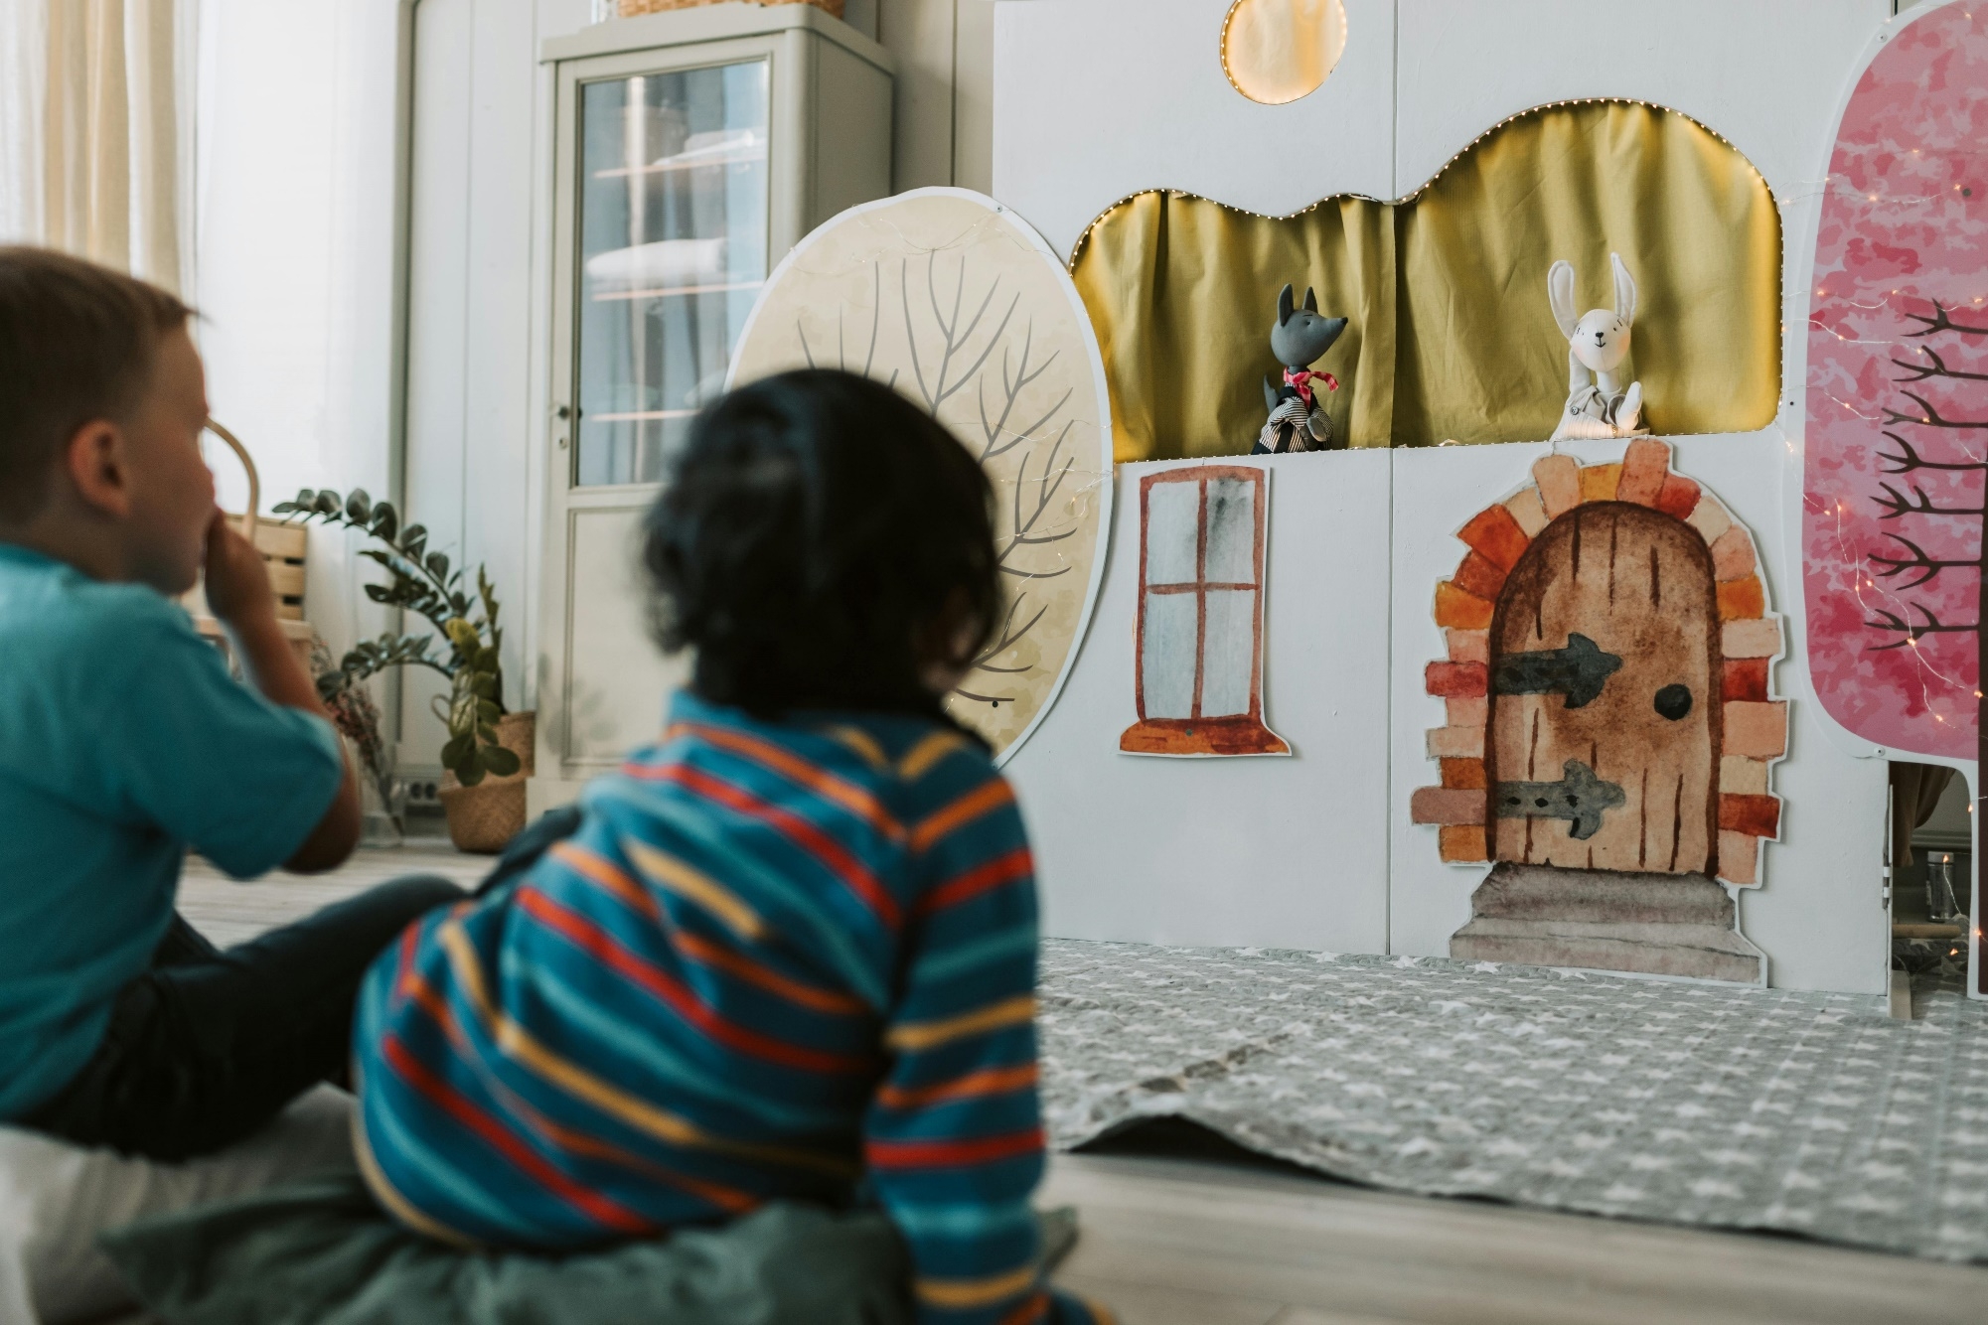

Quick drama activities for performing picture books
Quick activities and ideas to help you bring picture books to life

Age 3–8

CFE Levels Early to First

Resource created by Amy Hall Gibson, freelance theatre practitioner

scottishbooktrust.com
Scottish Book Trust is a registered company (SC184248)
and a Scottish charity (SC027669).

Contents
About this resource 2
Activities 2
Further resources 6

About this resource
The activities in this resource are designed to be an introduction to picture book plays and drama, and can be used to lead to a fully-fledged picture performance. The activities in this resource are designed to be used with the picture books of Ed Vere, but can be used with any book, in any context, to bring picture books to life.

Activities

Activity 1: Whoosh!
HWB 0-22a, Exa 0-12a
This is an excellent game to warm and loosen up for drama activities. Using characters from a book, play the game using character voices. For example, if using Ed’s books you could ask pupils to adopt Mr Big’s voice, Mouse’s voice, the Monster etc.
To send a Whoosh: Recreate a wizard swishing his wand towards something, directing your hands to the person either on your left or right and say the word ‘Whoosh!’ Send the ‘Whoosh’ to the person on your left, this continues in the same direction around the circle until it comes back to the first person.
To block a Whoosh: Make an X symbol with your arms above your head and say ‘Woah’. This then sends the Whoosh back the way it came. This is the only action that can change the direction of the Whoosh.
Zap: A Zap can be done at any point during the game but is very useful if people are blocking your Whoosh. Using both arms create an arrow shape facing across the circle, make eye contact with your chosen person, point at them and say ‘Zap’. This then gives your chosen person the Whoosh which they can send any way round the circle.
For younger pupils keep the rules simple (for instance, don’t introduce the Woah or Zap) and focus more on using the different voices.

Activity 2: Boom chicka boom
EXA 0-12a
This is a call and response game and allows pupils to explore using different voices out loud. Pupils repeat each line after the teacher.
Boom Chicka boom
Boom Chicka boom
Boom Chicka Rocka Chicka Rocka Chicka Boom
Ha Ha
Hee Hee
The aim is to try using different character voices from your chosen picture books. Encourage the pupils to be as experimental as possible.

Activity 3: Go and freeze
EXA 0-12a, HWB 0-22a
Ask the pupils to move around the room listening for the instructions go and freeze. Go = move around, freeze = stop as quickly as possible.
As the group begin responding to the two commands, start to describe how you want them to move around. After this activity, it can be a good opportunity to chat about why the pupils chose to portray the characters’ movement in the way they did. Which character traits inspired them?

Activity 4: 10 second objects
EXA 0-12a
In groups, pupils are given an object from the book to recreate using their bodies. They have a short time to do it in, so that they really have to work together quickly. There is no wrong shape as it is their interpretation of the object. For younger pupils, this can be done individually or in pairs.

Activity 5: 10 second pictures
EXA 0-12a
This is a development from ‘10 second objects’. Using a picture book of your choice, ask the pupils to choose a page/picture they like and then in groups or pairs recreate that picture using their bodies. These should be still pictures.

Activity 6: Voices and emotions
EXA 0-12a, HWB 0-01a
Pick a part of your chosen book where a character is feeling a strong emotion. Ask the pupils how they think this part should be read out. What kind of tone and pitch of voice would convey the emotion best?
Ask pupils to choose a part of the book they enjoyed reading. In pairs they can try out different voices, different styles, and different emotions.
Good examples from Ed’s books might include:
“Wakey, Wakey Mouse!” (Posh voice or as if it was a secret)
“I am Max the brave.” (Pirate voice or as if they were chewing very sticky toffee)
“No one stuck around to find out who he really was.” (Grumpy voice)
“So inside Mr Big felt very very small.” (Sad voice)
This activity can be a good lead into a discussion about feelings. Ask your pupils why they chose to read out their parts in a certain way. Invite your pupils to comment on how the characters are feeling. How do we know how the characters feel just by looking at the illustrations, and why might the characters feel the way they do? Can pupils ever think of times they felt the same way? What would they do in the character’s position?

Activity 7: Change the prop
EXA 1-12a
Show the pupils a piece of fabric and demonstrate how it can be used as a prop to represent different objects in the story. For instance, you could lay the fabric out in front of you on the floor and begin playing it as if it is Mr Big’s piano. Alternatively, the fabric can change from the ribbon at the beginning with Max jumping on it, to the superhero cape, to finally the mouse!
Give each group of pupils a piece of fabric and a copy of Mr. Big or Max the Brave. Ask them to come up with ways to use the piece of fabric to represent items in the story. There are lots of things in these two books which could be represented by a piece of fabric – for instance, in Mr. Big, the fabric could represent the swimming pool, the letter Mr. Big receives, the tablecloth in the restaurant, and so on.
Get each group to act out a scene where the fabric is used as a prop. They can act out their scene silently in front of the rest of the class, who can try to guess which scene is being acted out.

Activity 8: Change the picture
EXA 1-12a
Show your pupils a picture from your chosen book. Tell them that they are going to change the picture so that something different is happening. First, they can draw their changed version of the picture, then they can act it out.

Further resources
- Our 10 expressive arts activities for any book resource contains ideas and activities which can be adapted for any book in your school library
- Our storytelling activities can be used to build confidence in reading and telling stories aloud
- Using the curriculum filter on our Authors Live on Demand library, find broadcasts which are perfect for exploring Expressive arts as a class
- Amy Hall Gibson’s video resources and podcast, created with Starcatchers, share collaborative storytelling tips and inspiration
- Starcatchers also have resources on celebrating Book Week Scotland with pre and non-verbal children and using storytelling to develop emotional literacy and wellbeing

