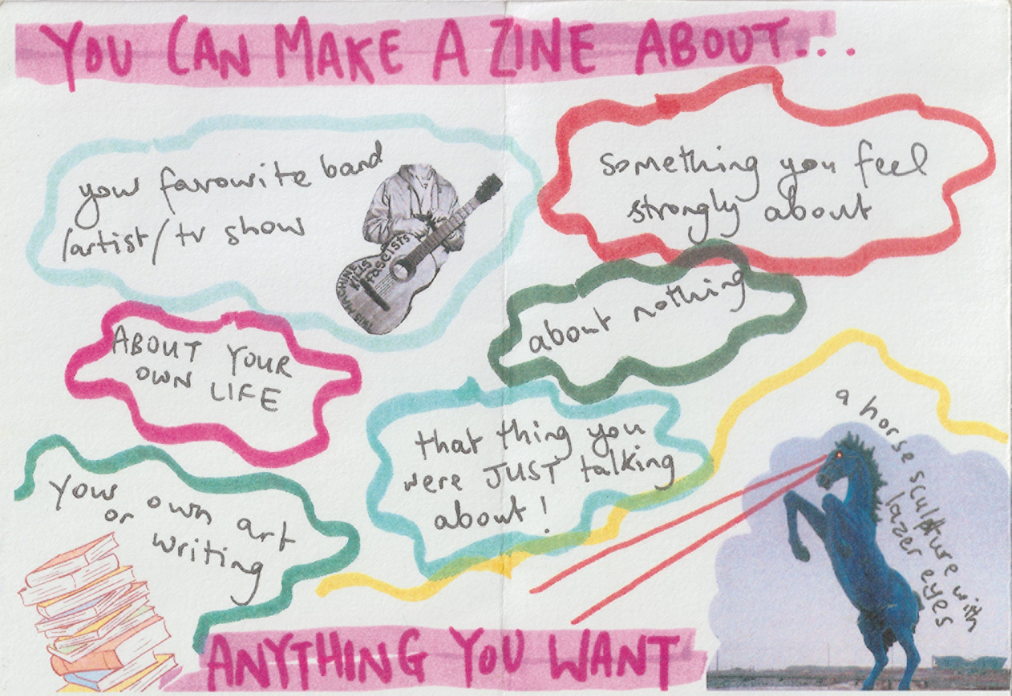

How to make a zine
A template you can use to create your own zine

Suitable for 6+

Resource created by Fi Johnson from the Tiny Zine Swap Shop

scottishbooktrust.com
Scottish Book Trust is a registered company (SC184248)
and a Scottish charity (SC027669).

Contents
About this resource 2
Further resources 2

About this resource
Print the template – you can download this from the ‘How to make a zine’ webpage – and follow its instructions to make your own zine. Once you’ve mastered the folding, you can use plain A4 paper to make your own zine about whatever you like. You can also explore different art materials (pen, pencils, crayons, etc.) or stickers, collaging – whatever you fancy!

Further resources
- Learn more about Fi Johnson’s work on the Tiny Zine Swap Shop website
- Find more tools and tips for young illustrators on the Young Writers section of the Scottish Book Trust website

