

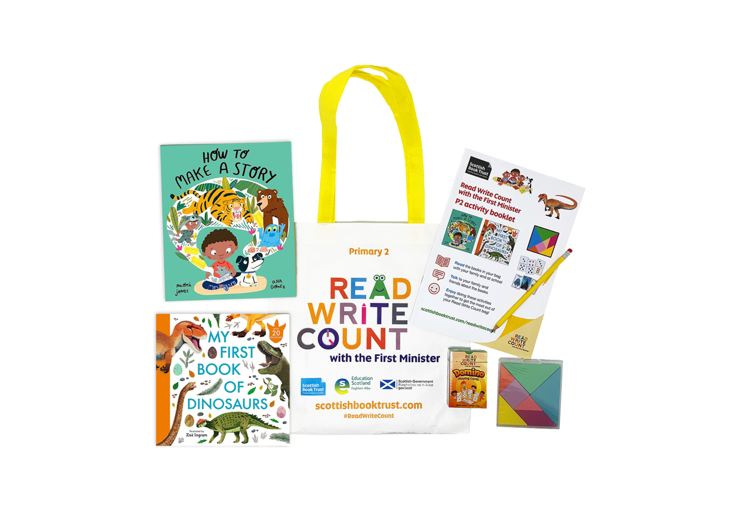

# Read Write Count with the First Minister: P2 worksheets

Printable worksheets you can use to explore your Read Write Count P2 bag

scottishbooktrust.com



Scottish Book Trust is a registered company (SC184248)

and a Scottish charity (SC027669).

## Contents

About this resource 2

Further resources 2

Activity sheet 1: Draw your own comic 3

Activity sheet 2: Monster emotions! 5

Activity sheet 3: Design a book cover 6

Activity sheet 4: *How to Make a Story* story map 7

Activity sheet 5: Design your own dinosaur 8

Activity sheet 6: Create your own dinosaur wordsearch 9

Activity sheet 7: Dinosaur sorting 10

Activity 8: Design your own Story Cards 11

## About this resource

Print these activity sheets at home to explore your Read Write Count P2 bag together! Will you draw your own comic like Milo, design your own dinosaur or make some new story cards for your card deck?

## Further resources

* Find out more about Read Write Count on the Read Write Count [section of the Scottish Book Trust website](https://www.scottishbooktrust.com/reading-and-stories/read-write-count)
* Find more activities, ideas and inspiration for reading and playing together at home on our [Home Activities Hub](https://www.scottishbooktrust.com/home-activities)

## Activity sheet 1: Draw your own comic

Use these comic strip templates to tell a story like Milo in How to Make a Story! If you’re stuck, you could use your Talk it Out cards as inspiration. For example, "if you were an animal what would you be and why?" could lead to you imagining yourself turning into an animal. What would you do with your day if this happened?

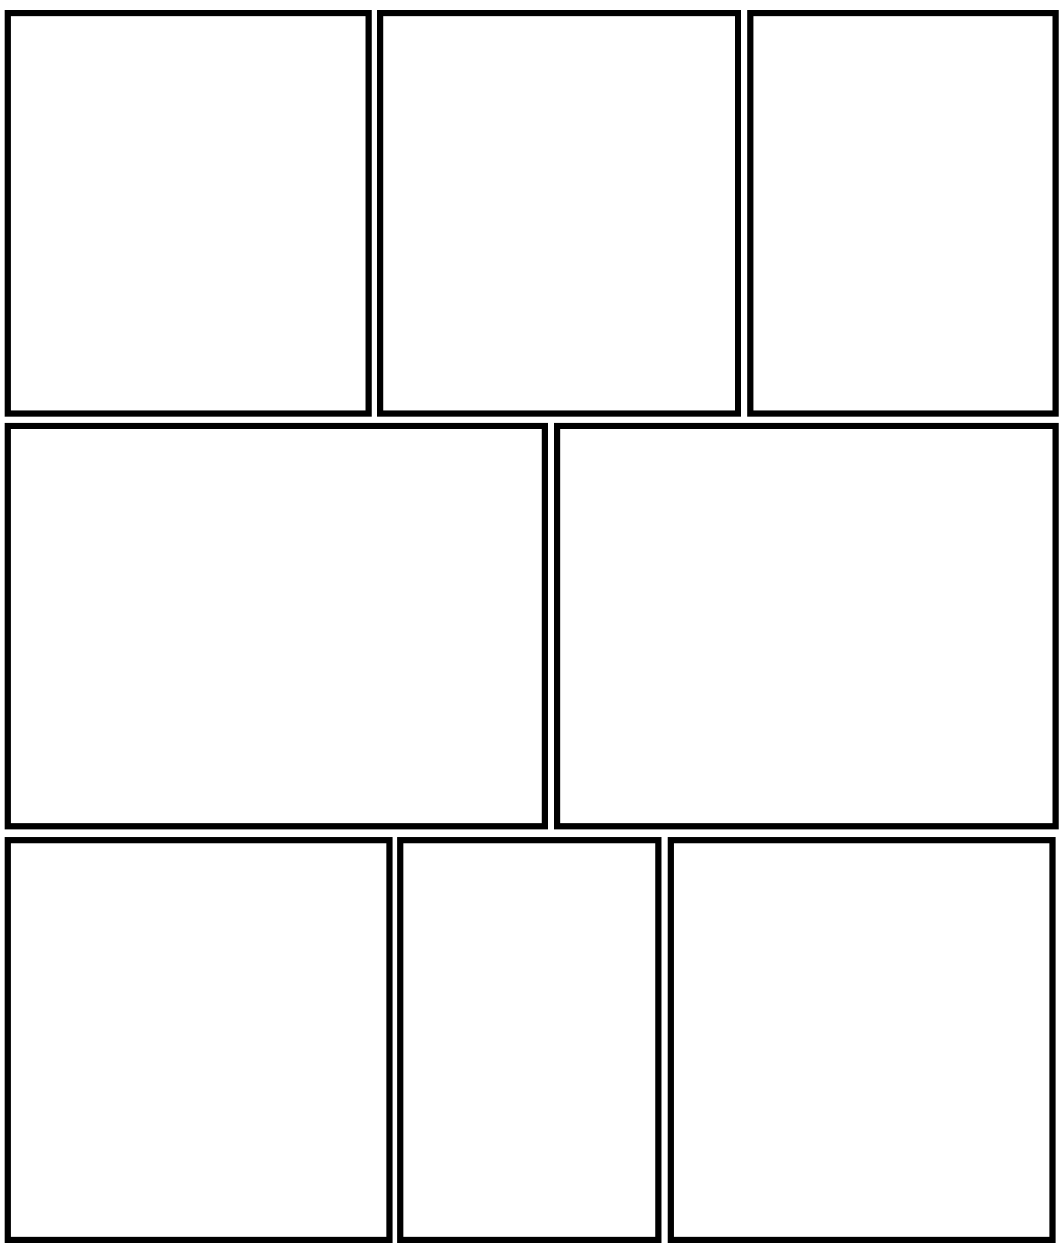

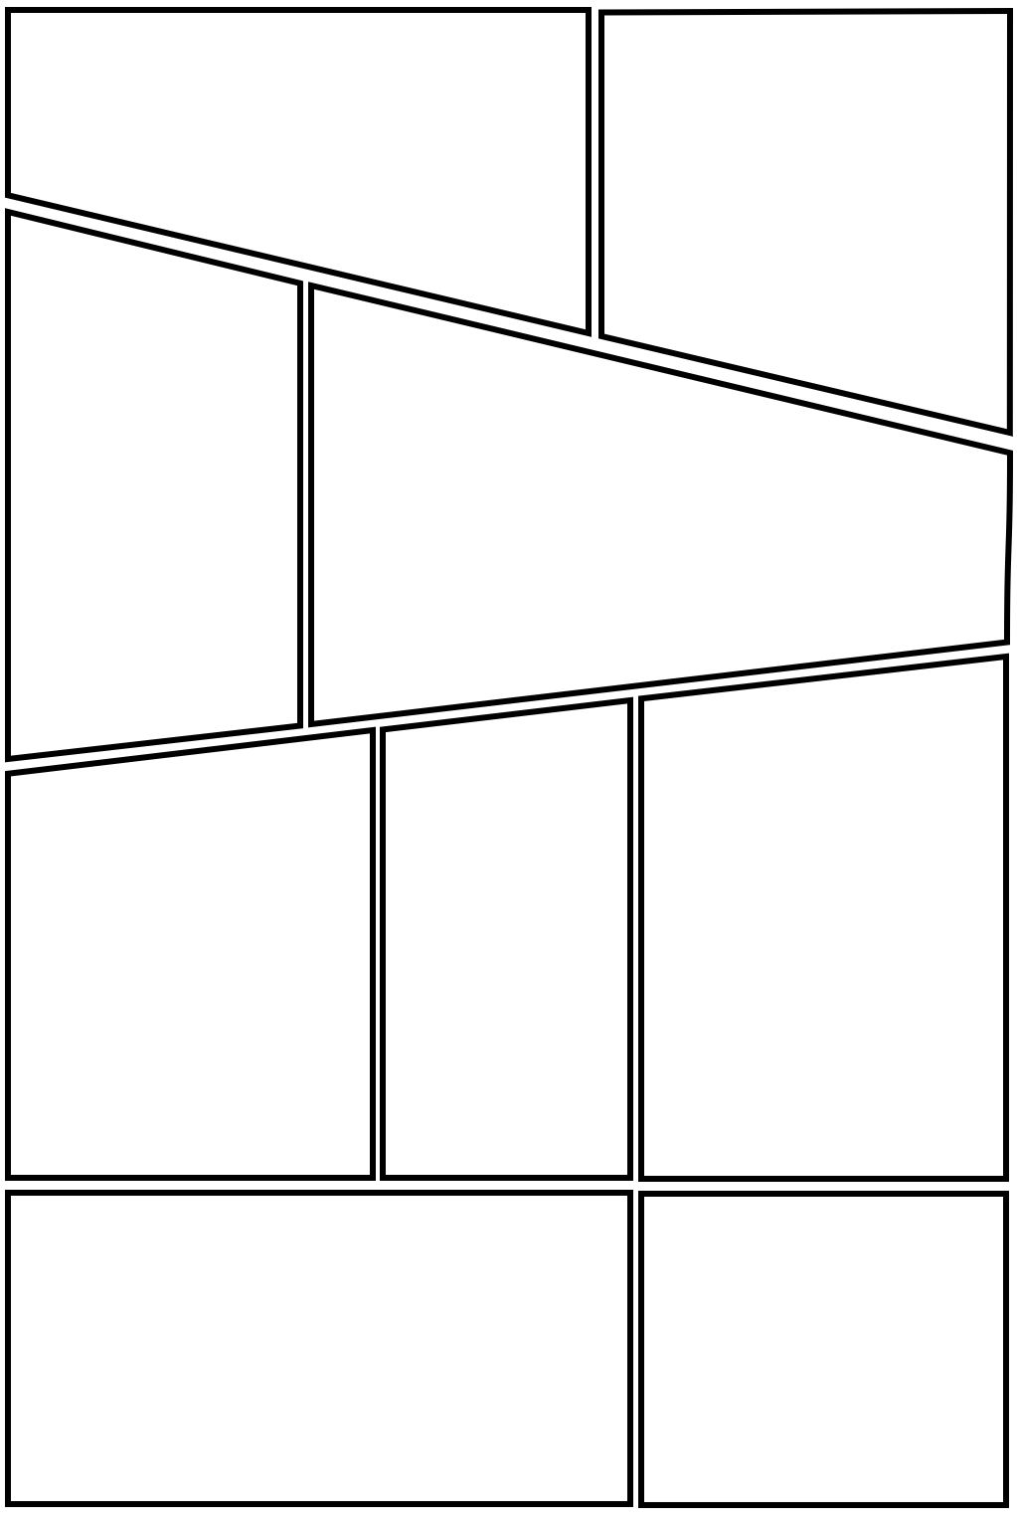

## Activity sheet 2: Monster emotions!

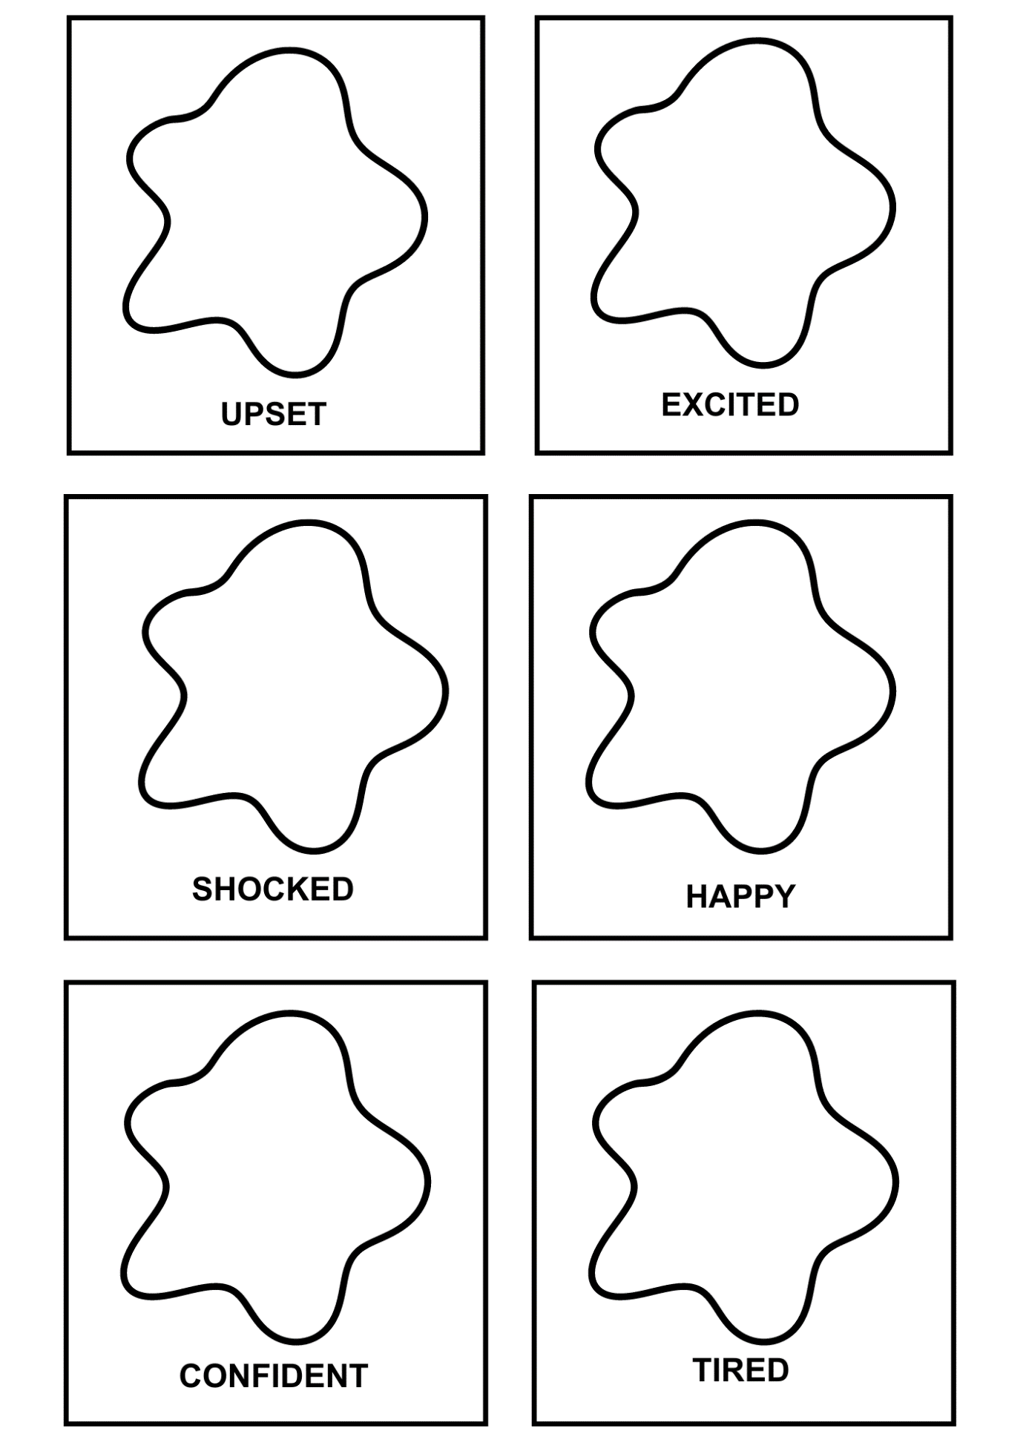Below are some outlines of the monsters from *How to Make a Story*. Draw what some different emotions look like on their faces.

## Activity sheet 3: Design a book cover

Design your own book cover – you could use *How to Make a Story* as inspiration! Make sure your book cover includes the title, your name and some artwork of what happens in the story.

|  |
| --- |
|  |

## Activity sheet 4: *How to Make a Story* story map

Create your own story map to retell the events of the story in sequence.

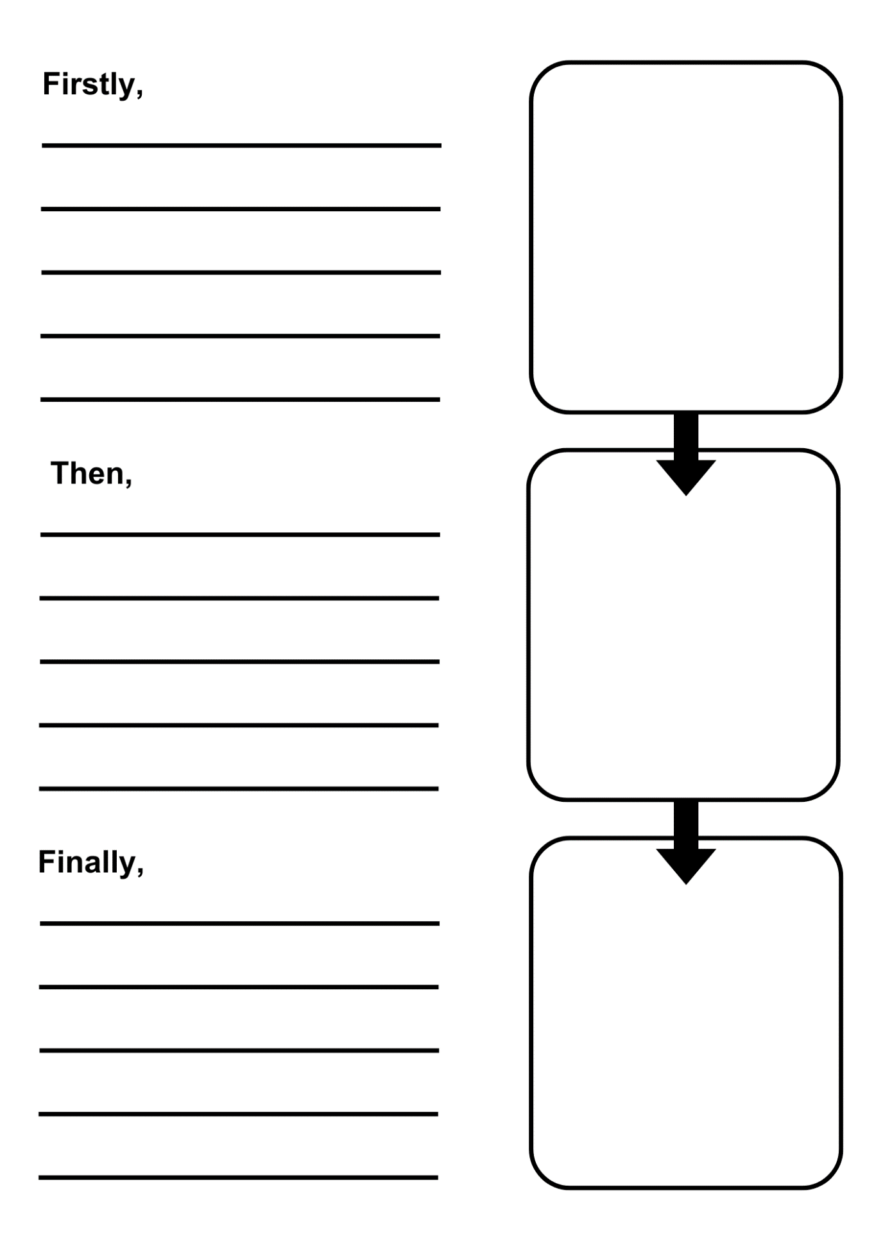

## Activity sheet 5: Design your own dinosaur

Remember animals evolve to fit their environment. Think about this when you design yours. For example: a long neck would help to reach leaves at the top of a tree, sharp teeth would be useful for hunting other creatures, camouflage would help it hide, and webbed feet would be great for swimming. Look at your book for ideas.

**My Dinosaur**

|  |  |
| --- | --- |
|  | |
| What is it called? |  |
| Where does it live? |  |
| What does it eat? |  |
| How big is it? |  |
| A fun fact about my dinosaur is… |  |

## 

## Activity sheet 6: Create your own dinosaur wordsearch

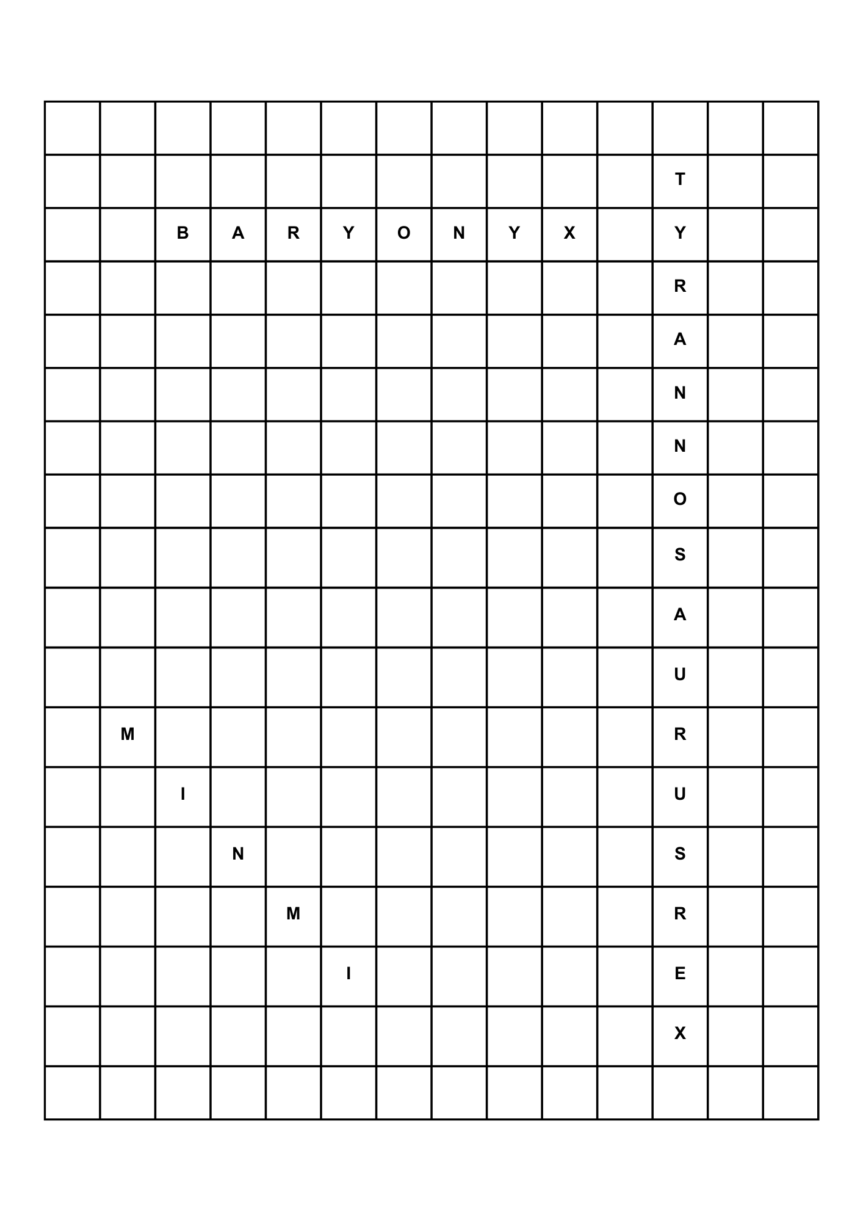Use some of the names of the dinosaurs in *My First Book of Dinosaurs* to create your own wordsearch! If you’re stuck, there’s some words at the bottom of the page you can use for inspiration.

Words you could use for your wordsearch: CLAW, TOOTH, TAIL, FOSSIL, DINOSAUR, PREHISTORIC, EXTINCT, HERBIVORE, CARNIVORE

## Activity sheet 7: Dinosaur sorting

Use this activity sheet to sort the dinosaurs in *My First Book of Dinosaurs*. Use tally marks to count how many there are of each of the headings below. Once you’ve finished, you could turn the numbers into a graph or chart!

|  |  |  |  |  |  |  |  |  |  |
| --- | --- | --- | --- | --- | --- | --- | --- | --- | --- |
| **Herbivores** | | **Carnivores** | | | | | **Omnivores** | | |
|  | |  | | | | |  | | |
| **Smaller than 10 metres** | | | | | **Taller than 5 metres** | | | | |
|  | | | | |  | | | | |
| **Weighs less than 5kgs** | | | **Weighs 5kg – 100kg** | | | | | **Weighs more than 100kg** | |
|  | | |  | | | | |  | |
| **Found in USA, South America or Canada** | **Found in Europe** | | | **Found in Africa** | | **Found in Asia** | | | **Found in Australia** |
|  |  | | |  | |  | | |  |

Create your own category:

|  |  |  |
| --- | --- | --- |
|  |  |  |
|  |  |  |

## Activity 8: Design your own Story Cards

Is there a setting, character or object you want to add to your Story Cards? Cut out the templates below, draw your card and add it to your pack! To make it last longer, you can glue it onto a piece of carboard.

