

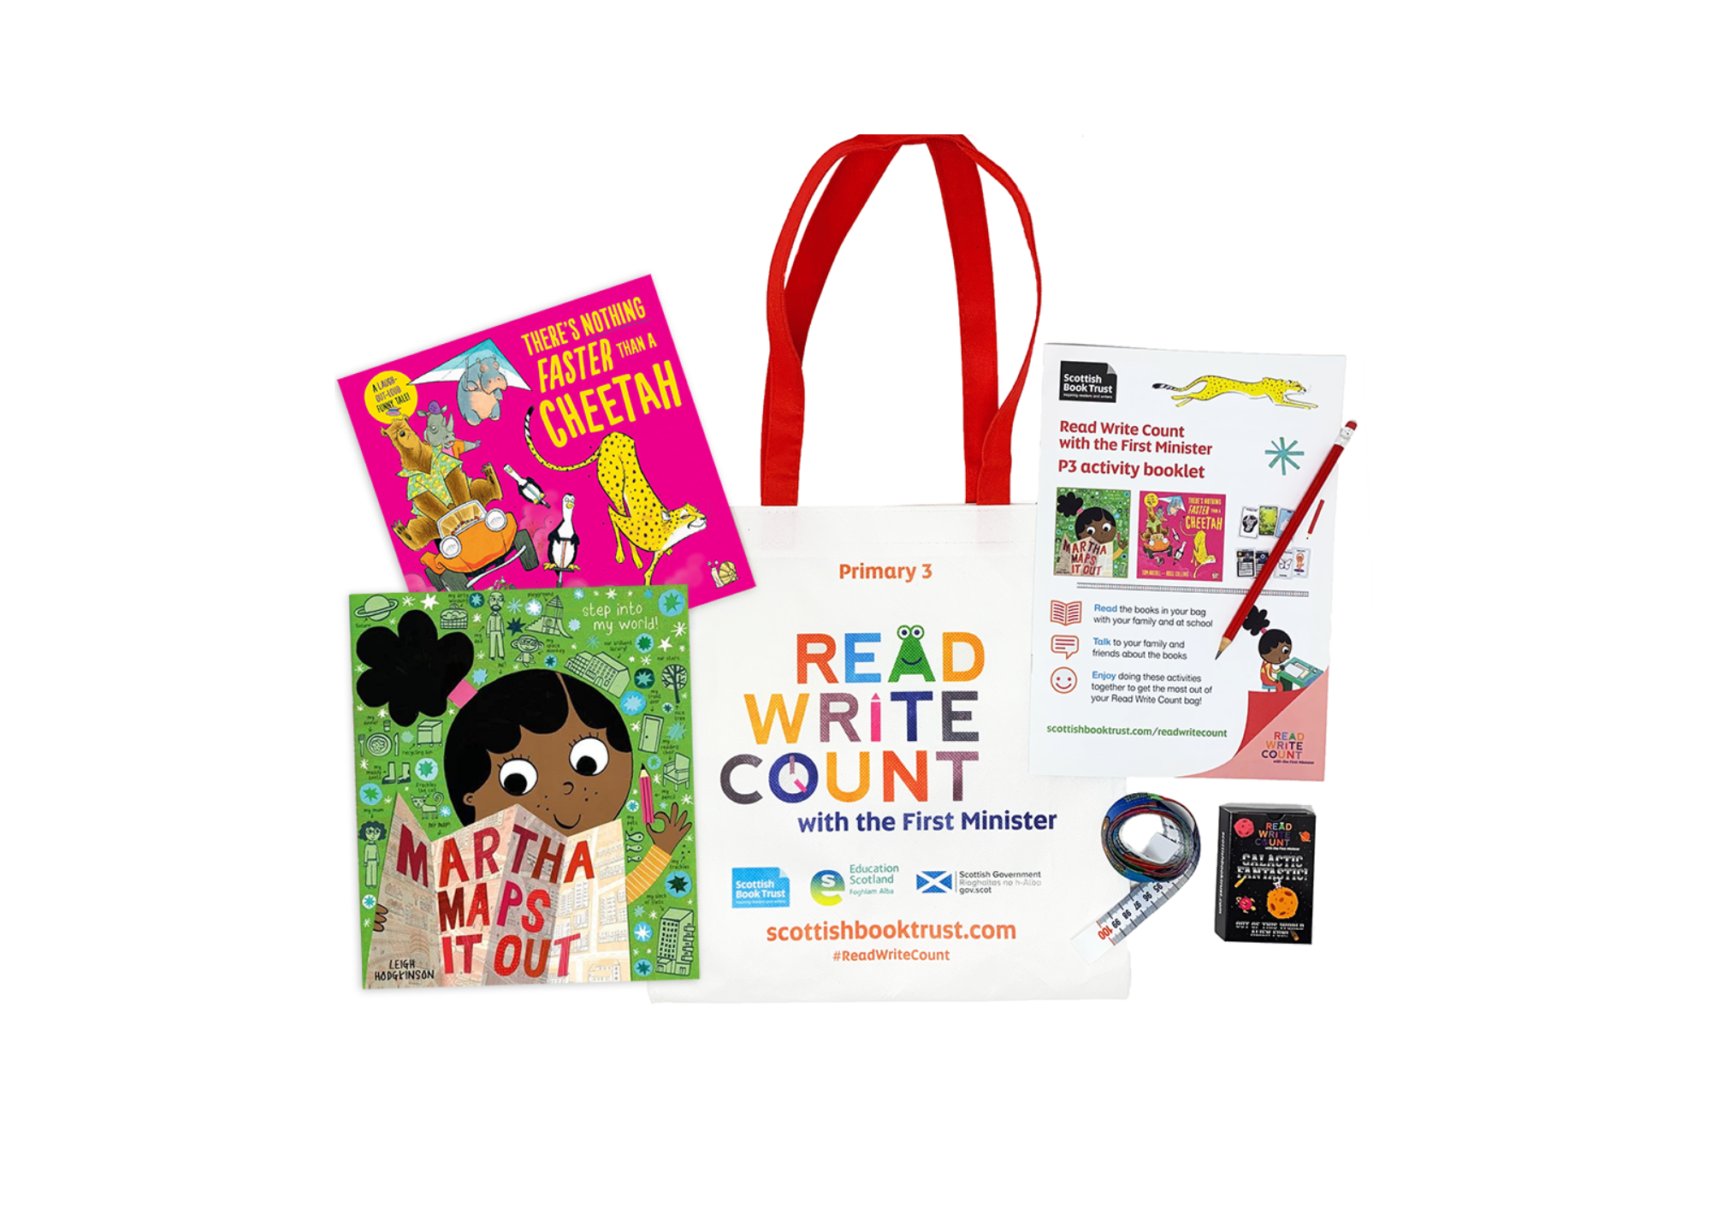

# Read Write Count with the First Minister: P3 worksheets

Printable worksheets you can use to explore your Read Write Count P3 bag

scottishbooktrust.com



Scottish Book Trust is a registered company (SC184248)

and a Scottish charity (SC027669).

## Contents

About this resource 2

Further resources 2

Activity sheet 1: Who will win? 3

Activity sheet 2: Create your own super speedy snail 4

Activity sheet 3: There’s Nothing Faster Than a… 5

Activity sheet 4: Make your own animal board game 6

Activity sheet 5: Design your own dream bedroom 2

Activity sheet 6: Map grid references 3

## About this resource

Print these activity sheets at home to explore your Read Write Count P3 bag together! Will you make your own animal racing board game or design your dream bedroom like Martha’s?

## Further resources

* Find out more about Read Write Count on the Read Write Count [section of the Scottish Book Trust website](https://www.scottishbooktrust.com/reading-and-stories/read-write-count)
* Find more activities, ideas and inspiration for reading and playing together at home on our [Home Activities Hub](https://www.scottishbooktrust.com/home-activities)

## Activity sheet 1: Who will win?

Using the book to help, arrange these creatures in order from slowest to fastest along the race line.

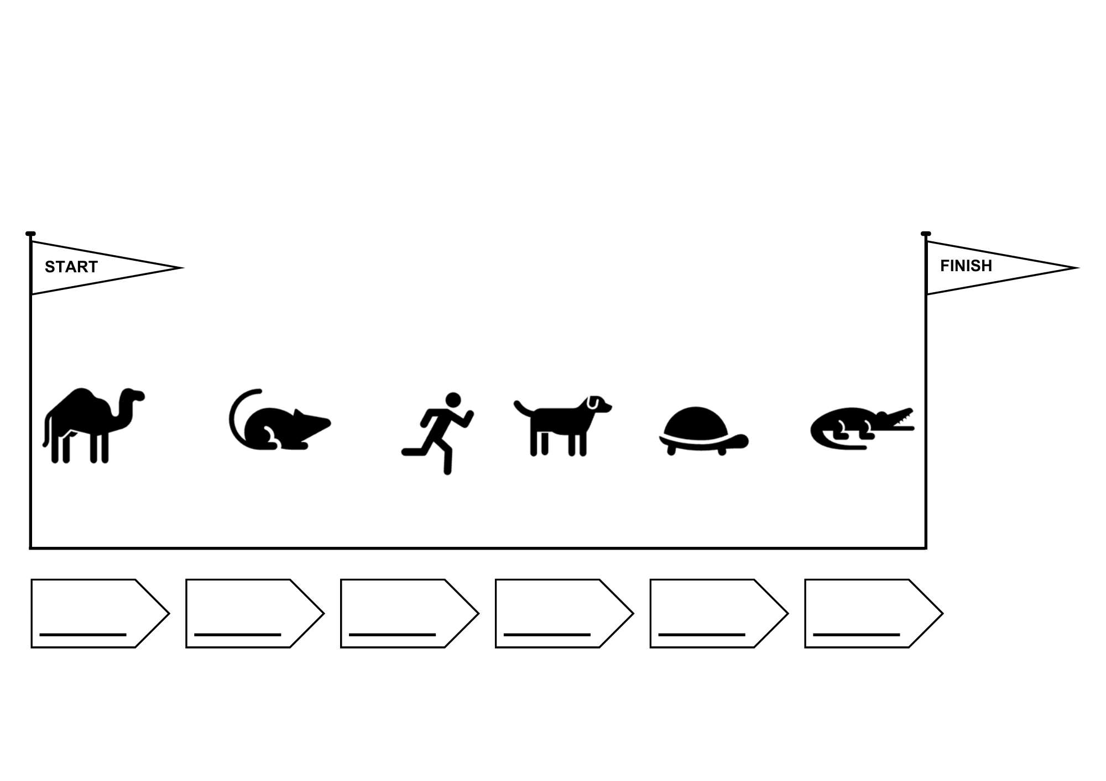

## Activity sheet 2: Create your own super speedy snail

Boost this snails speed by adding things to make it go faster. Jet packs, roller skates, engines, friends, wheels or whatever you can imagine.

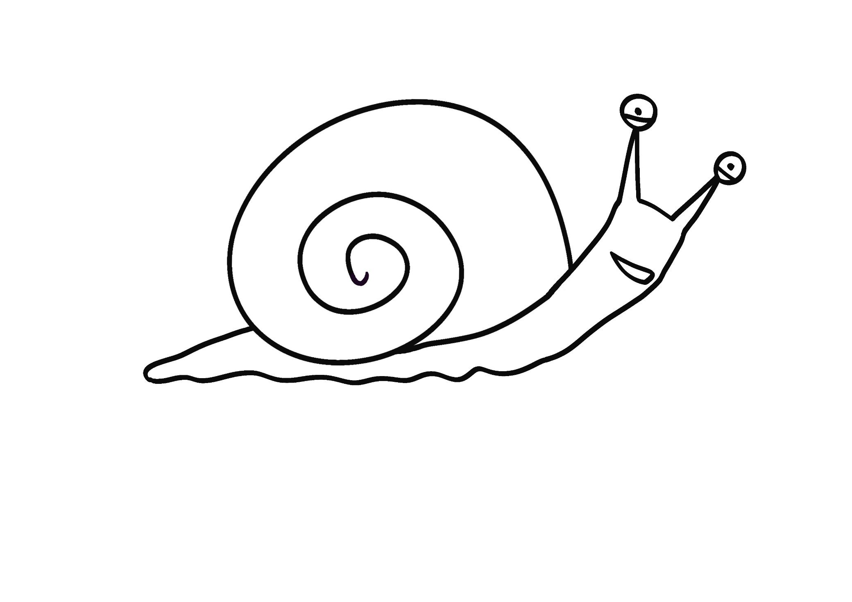

## Activity sheet 3: There’s Nothing Faster Than a…

Each of the animals in the book were able to go faster using an item that begins with the same letter as their animal’s name: lions in lorries, squirrels on snow-mobiles gorillas in go-carts or bees and badgers and beagles on buses.  
  
Choose your own favourite creature, draw and label a picture of them with an item of transport beginning with the same letter as their name.

|  |
| --- |
|  |

## Activity sheet 4: Make your own animal board game

You will need:

* A blank piece of paper
* Pencils or pens
* A number spinner (see the template on the next page) or dice
* Animal tokens (see the template on the next page, or make your own!)



1. Start by drawing a long wiggly racetrack on your piece of paper
2. 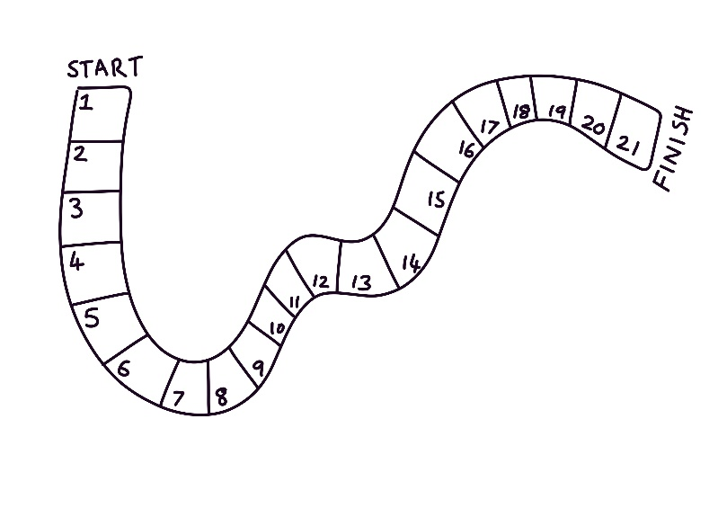Draw lines across the track to create boxes and number them. Write START at the beginning and FINISH at the end.
3. 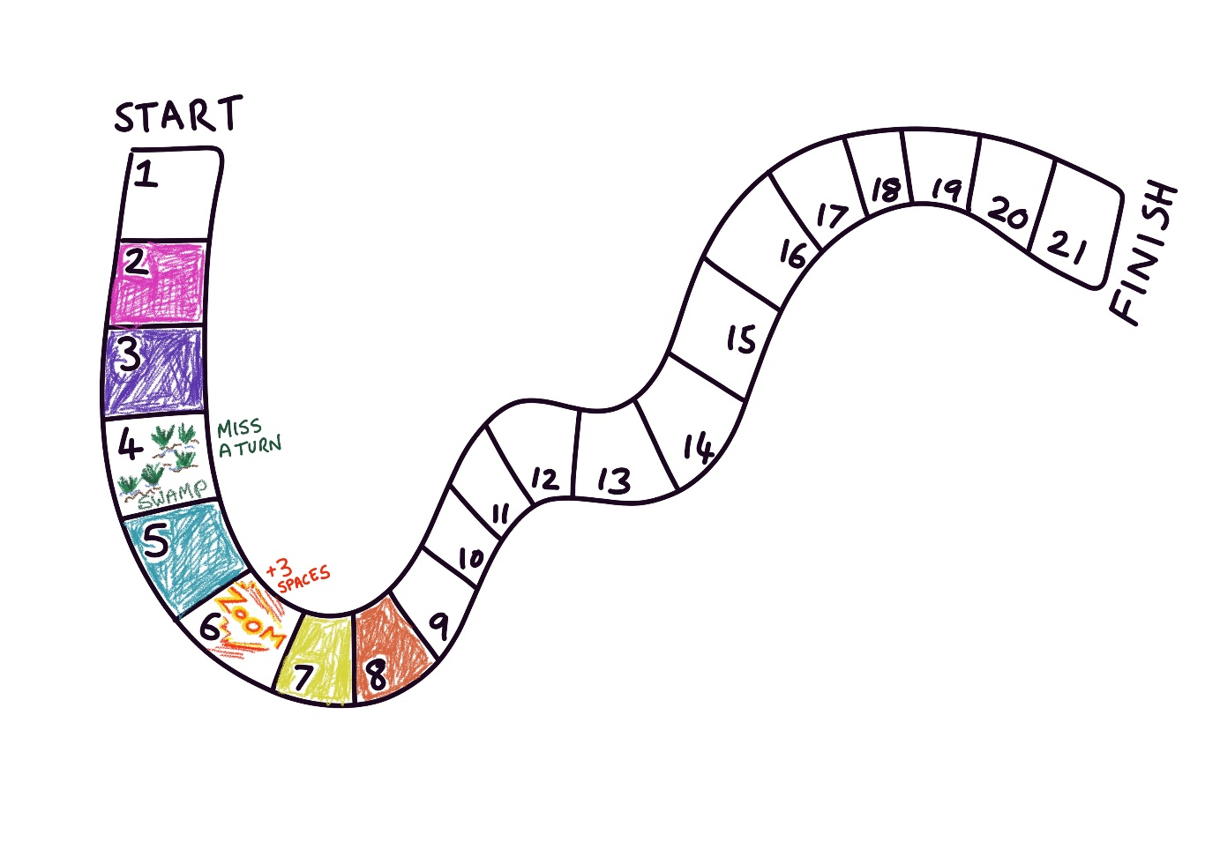Colour in your track. You could choose some boxes to have obstacles – for example you could have a SWAMP box where players who land on it miss a turn, or a ZOOM box where you move forward three places.
4. Create some different looking animal tokens. You can use the template on the next page, draw your own, or use something you already own (e.g. beads) torepresent the animals.
5. Make a number spinner or use dice to play. Take turns to spin or roll a number and move forward. First animal to the FINISH wins!

### Number spinner

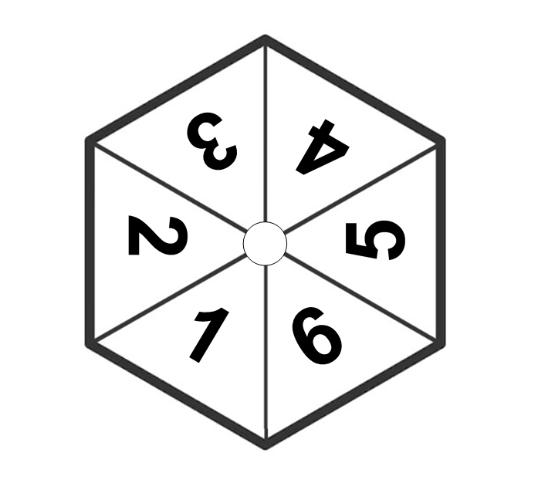Cut out the spinner. Then carefully push a pencil or small stick through the centre circle (put a small ball of Blu Tack or putty underneath to help you do this safely). Spin the pencil and whatever the number spinner lands on is your movement for this turn.

Animal player tokens – cut out and colour in

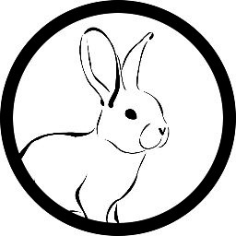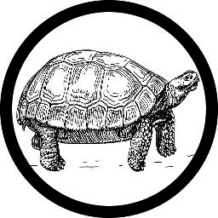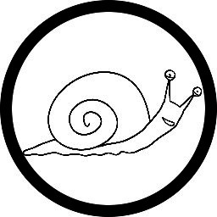

## Activity sheet 5: Design your own dream bedroom

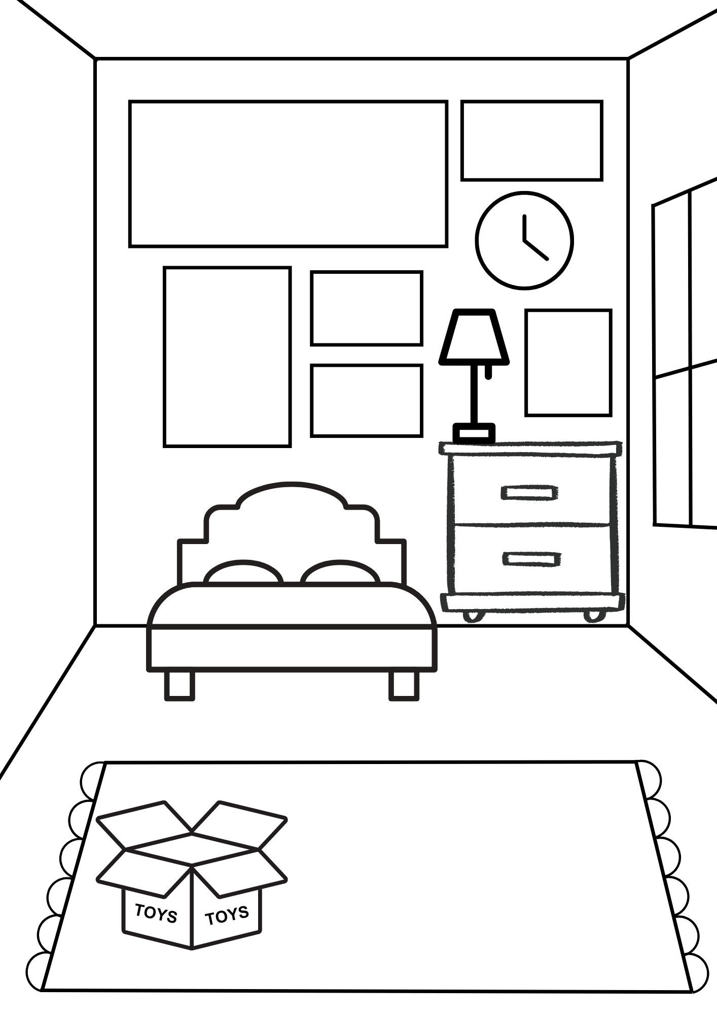Design your own bedroom. You could label everything like Martha does in *Martha Maps it Out*! Why not add some art in the frames on the wall? Or some patterns on the carpet or bedspread!

## Activity sheet 6: Map grid references

Draw your own map like *Martha Maps it Out*.You can then use grid references to describe to a partner the location of different things on your map!

|  |  |  |  |  |  |  |  |  |
| --- | --- | --- | --- | --- | --- | --- | --- | --- |
|  | A | B | C | D | E | F | G | H |
| 1 |  |  |  |  |  |  |  |  |
| 2 |  |  |  |  |  |  |  |  |
| 3 |  |  |  |  |  |  |  |  |
| 4 |  |  |  |  |  |  |  |  |
| 5 |  |  |  |  |  |  |  |  |
| 6 |  |  |  |  |  |  |  |  |
| 7 |  |  |  |  |  |  |  |  |
| 8 |  |  |  |  |  |  |  |  |
| 9 |  |  |  |  |  |  |  |  |
| 10 |  |  |  |  |  |  |  |  |