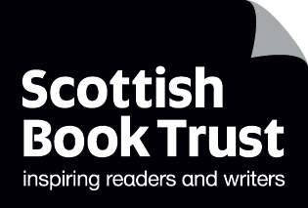

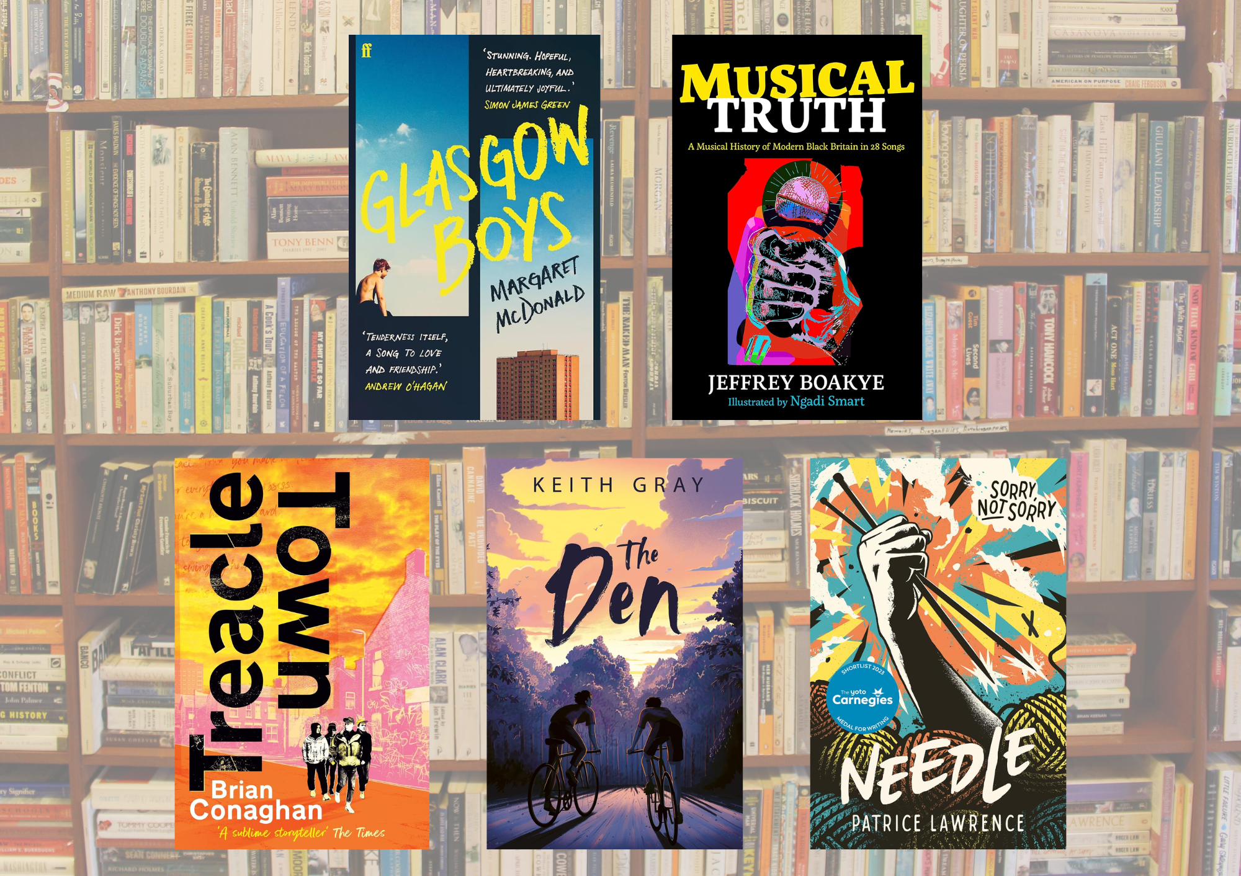

# Teen book discussion guides 2024

Discussion questions and creative writing prompts for running your own book group

## Age: 12+

## For use in classrooms, libraries or book groups

## Resource created by Scottish Book Trust



scottishbooktrust.com



Scottish Book Trust is a registered company (SC184248)

and a Scottish charity (SC027669).

## Contents

About this resource 2

Content notes 3

*Glasgow Boys* by Margaret McDonald 4

*Musical Truth* by Jeffrey Boakye and Ngadi Smart 6

*Treacle Town* by Brian Conaghan 8

*The Den* by Keith Gray 11

*Needle* by Patrice Lawrence 14

Further resources 17

## About this resource

This guide has been created to help you run a book club with pupils or teenagers in your library. We advise looking at the titles with the young people you work with and asking them which ones they’d like to read!  
  
Each discussion guide contains some discussion and creative writing prompts. We have made both printable versions and plain text versions.  
  
For more book recommendations, please see:

* Our [Book Discovery Guides](https://www.scottishbooktrust.com/learning-resources/book-discovery-guide)
* Our [Book Discovery CLPL sessions for teachers and librarians](https://www.scottishbooktrust.com/learning-and-resources/clpl-for-learning-professionals)
* Our [book lists](https://www.scottishbooktrust.com/book-lists)

If you are taking part in Reading Schools, the activities in this resource could support delivery of Key Area:

* 1.2.5: Staff knowledge of contemporary children’s literature
* 1.5.1: Access to high-quality books
* 2.3.2: Staff meaningful conversations around books
* 2.3.3: Creating learner social networks
* 2.3.4: Opportunities for learners to respond to what they’re reading

## Content notes

With all our resources, we highly recommend that you read the book before using it with the teenagers you work with and use your best judgement on whether teaching about this topic is appropriate for the children in your class. Some of the books in this content guide include depictions of:

* Violence
* Drug and alcohol use
* Bullying

## *Glasgow Boys* by Margaret McDonald

**Themes: Friendship, family, care, university, coming of age**

See printable version on page 5

### Discussion questions

1. What did you think of Finlay and Banjo’s relationship? Do you think they’ll stay friends?
2. Whose chapters did you prefer - Finlay or Banjo’s? Why?
3. How did living in care effect Finlay and Banjo even after they’d found their own communities?
4. Have you been to Glasgow? Did the book portray it as you imagined (or have experienced) it?

### Creative writing prompts

1. Banjo and Finlay are completely different but have some key things in common. Draw two overlapping circles - in one circle, write out some characteristics and in the other write the complete opposite. In the overlap, write what traits, hobbies, ideals or flaws they could have in common.
2. Finlay and Banjo spend a lot of time separated from each other. Write a story in the form of a letter. What would you character say to the other person? Remember, as much as possible: *show* but don’t *tell* us how your character feels.

### What to read next

*The Evolving Truth of Ever-Stronger Will* by Maya Macgregor  
Another story of finding yourself, and your family, after care.  
  
*Radio Silence* by Alice Oseman  
Another story of friendship and perseverance.

### ***A screenshot of a computer Description automatically generatedGlasgow Boys* printable discussion guide**

## *Musical Truth* by Jeffrey Boakye and Ngadi Smart

**Themes: music, history and Black history, politics, justice**See printable version on page 7

### Discussion questions

1. What kind of music do you enjoy? Do you have favourite genres or artists, or do you prefer listening to a mixture of different songs?
2. Which songs or artists mentioned in the book had you heard of before? Did you find out anything new about them?
3. Which song or artist were you the most interested in?
4. What connections do you think there are between music and politics? Do you think songs or music are capable of causing change?

### Creative writing prompts

1. Make a playlist of songs with lyrics you really like. Try listening to a couple of songs all the way through without doing anything else. Do you notice anything you haven’t before? Try doing some free writing whilst listening and see what you come up with. **Top tip:** if you like the idea of listening to music when you write more generally - video game soundtracks are great for getting lost in your imagination!
2. Try writing a song! If you’re not sure where to start, you could pick a song you like and re-write it.

### What to read next

Musical World by Jeffrey Boakye and Ngadi Smart  
Another book from the same authors - this time taking readers through history through music.  
  
*Part of the Story that Started Before Me* edited by George the Poet  
A collection of poems exploring Black history from the Romans to today!

### ***Musical Truth* printable discussion guide**

## *Treacle Town* by Brian Conaghan

**Themes: friendship, poetry, social pressure, coming of age**

See printable version on page 10

### Discussion questions

1. How is Con shaped by his friendships? Could you understand why he felt pressure to do certain things that he didn’t want to do?
2. How did Con’s character change over the course of the book? How did the writer help you empathise with Con, even if you didn’t agree with what he was doing?
3. What did you think of Con’s relationship with poetry? How did it help him find another life?
4. Have you ever watched, or been to, somewhere where poetry was read aloud? Do you think it’s more engaging than reading a poem from a book?

### Creative writing prompts

1. Reread Con’s poems, then write your own poem inspired by where you live. Think about the details you want to capture: whether places, people, your home, your school or anything else you think is unique to where you live!
2. Write a story told through text messages. Think about how to capture your character’s voices through how they text. Do they use slang or acronyms, or type everything out in full? What is missing from the dialogue when they can’t see each other, and how can you still capture how they’re feeling?

### What to read next

*A Hurricane In My Head* by Matt Abbott  
Funny, honest and bold poems by a spoken word poet!  
  
*The Poet X* by Elizabeth Acevedo  
Another story about finding your way through writing and poetry.  
  
**Top tip**: you can watch Brian Conaghan share tips for writing on [Authors Live on the Scottish Book Trust website](https://www.scottishbooktrust.com/authors-live-on-demand/brian-conaghan)!

### ***Treacle Town* printable discussion guide**

## *The Den* by Keith Gray

**Themes: friendship, social pressure, coming of age**  
See printable version on page 13

### Discussion questions

1. What did you think about how the author captured friendship in this novel? Could you relate to it with your own friendships?
2. What did the den mean to Marshall and Rory? Why do you think Marshall needed the den more than Rory?
3. How did Marshall and Rorys’ lives at home impact their relationship with each other?
4. How did the author capture the importance of what the characters didn’t say, as much as what they did say? Could you relate to the idea of something you feel you can’t talk about?

### Creative writing prompts

1. Re-read how the author introduces the den. What details does he focus on? Write a paragraph introducing a setting. Think about what you need to describe in terms of how it looks, smells, feels, or what your character might hear.
2. Practice writing a “character fact file”. Interview someone else in your group to create a fact file with headings - e.g. favourite food, favourite film or music, their hobbies, what they’re good at, something they’re scared of, something they don’t like, etc. Once you’ve practiced by interviewing someone, you can use this as a way to create your own characters.

### What to read next

*The Climbers* by Keith Gray  
Another book from same author, exploring friendship and rivalry.

*Mind the Gap* by Phil Earle  
Another story about two teenagers, their friendship and their relationship with fathers.

**Top tip**: you can watch Keith Gray discuss *The Climbers* and share tips for writing [on Authors Live on the Scottish Book Trust website](https://www.scottishbooktrust.com/authors-live-on-demand/keith-gray)!

### ***The Den* printable discussion guide**

## *Needle* by Patrice Lawrence

**Themes: justice, racism, care, family, knitting**See printable version on page 16

### Discussion questions:

1. Why do you think the story was told from Charlene’s point of view? Discuss the impact of reading through Charlene’s perspective and in first person.
2. Discuss Charlene’s love of knitting. What did knitting symbolise throughout the story? Why was Charlene’s knitting so important to her?
3. How did the novel capture the justice system and how it treats young Black people like Charlene? What examples of racism did you notice throughout the novel?
4. The cover says “Sorry, not sorry”. Who in the book do you think owes another character an apology?

### Creative writing prompts

1. One of the way the author keeps tension in the story is by setting the events in a single day. Think about how much can change in just one day. Try and write your own story, or paragraph, where all of the action happens in one day.
2. Do you have a hobby or interest like Charlene’s love of knitting? Next time you spend time with your hobby, take five minutes afterwards to write about it. What do you see, hear or smell? How does it make you feel?

### What to read next

*Run Rebel* by Manjeet Mann  
Like Charlene finds her way through knitting, Amber escapes her abusive father through running.

*Wrecked* by Louisa Reid  
Another novel that looks at the court system: this time, unpicking how something seemingly perfect can be covered with lies.

### ***Needle* printable discussion guide**

## Further resources

See our other teen discussion guides on [the Scottish Book Trust website](https://www.scottishbooktrust.com/learning-resources/read-scottish-teen-books)

For more book recommendations, please see:

* Our [Book Discovery Guides](https://www.scottishbooktrust.com/learning-resources/book-discovery-guide)
* Our [Book Discovery CLPL sessions for teachers and librarians](https://www.scottishbooktrust.com/learning-and-resources/clpl-for-learning-professionals)
* Our [book lists](https://www.scottishbooktrust.com/book-lists)

For more resources to use with secondary pupils see:

* Our [10 things to do with any book secondary resource](https://www.scottishbooktrust.com/learning-resources/great-activities-for-any-book) can be used with any books, and contains activities and ideas that can extend pupil’s engagement with any of these titles
* All our learning resources can be filtered by age, including [12-to-14 year olds](https://www.scottishbooktrust.com/learning-resources) and [15-to-18 year olds](https://www.scottishbooktrust.com/learning-resources)