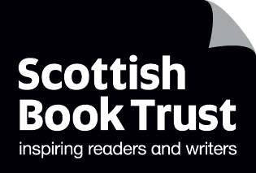

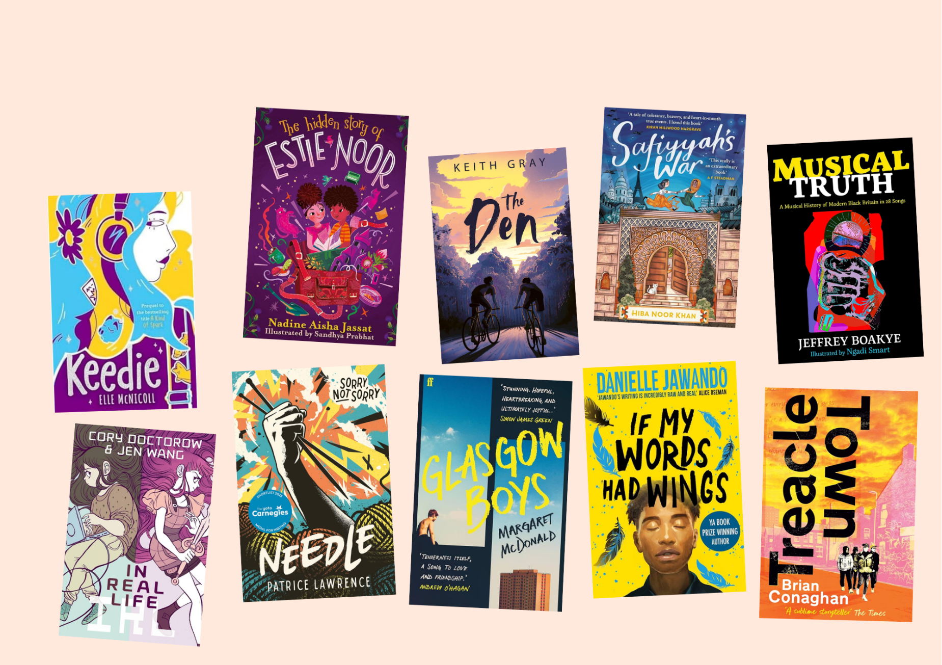

# Teen book discussion guides 2024

Discussion questions and creative writing prompts for running your own book group

## Age: 10+

## For use in classrooms, libraries or book groups

## Resource created by Scottish Book Trust



scottishbooktrust.com



Scottish Book Trust is a registered company (SC184248)

and a Scottish charity (SC027669).

## Contents

About this resource 2

Content notes 3

Book synopses 4

*Keedie* by Elle McNicoll 7

*The Hidden Story of Estie Noor* by Nadine Aisha Jassat 10

*The Den* by Keith Gray 13

*Saffiyah’s War* by Hiba Noor Khan 16

*Musical Truth* by Jeffrey Boakye and Ngadi Smart 19

*In Real Life* by Cory Doctorow and Jen Wang 22

*Needle* by Patrice Lawrence 25

*Glasgow Boys* by Margaret McDonald 27

*If My Words Had Wings* by Daniella Jawando 29

*Treacle Town* by Brian Conaghan 31

Book group ideas 35

Further resources 35

## About this resource

This guide has been created to help you run a book club with pupils or teenagers in your library. We advise looking at the titles with the young people you work with and asking them which ones they’d like to read!  
  
Each discussion guide contains some discussion and creative writing prompts. We have made both printable versions and plain text versions.  
  
For more book recommendations, please see:

* Our [Book Discovery Guides](https://www.scottishbooktrust.com/learning-resources/book-discovery-guide)
* Our [Book Discovery CLPL sessions for teachers and librarians](https://www.scottishbooktrust.com/learning-and-resources/clpl-for-learning-professionals)
* Our [book lists](https://www.scottishbooktrust.com/book-lists)

If you are taking part in [Reading Schools](https://www.readingschools.scot/), the activities in this resource could support delivery of Key Area:

* [1.2.5: Staff knowledge of contemporary children’s literature](https://www.readingschools.scot/resources/1-2-5-staff-knowledge-of-contemporary-children-s-literature)
* [1.5.1: Access to high-quality books](https://www.readingschools.scot/resources/access-to-high-quality-books)
* [2.3.2: Staff meaningful conversations around books](https://www.readingschools.scot/resources/staff-meaningful-conversations-around-books)
* [2.3.3: Creating learner social networks](https://www.readingschools.scot/resources/creating-social-networks)
* [2.3.4: Opportunities for learners to respond to what they’re reading](https://www.readingschools.scot/resources/opportunities-for-learners-to-respond-to-what-they-are-reading)

## Content notes

With all our resources, we highly recommend that you **read the book before using it** and use your best judgement on whether teaching about this topic is appropriate for the pupils you work with.   
  
Some of the books in this content guide include depictions of:

* **Bullying**: *Keedie*
* **Violence (mild)**:*The Den*, *Needle*
* **Violence (explicit)**: *Treacle Town*, *If My Words Had Wings*
* **Drug/alcohol use**: *Treacle Town, If My Words Had Wings*
* **Examinations of racism**: *The Hidden Story of Estie Noor*, *Saffiyah’s War*, *Musical Truth*, *In Real Life*, *Needle*, *If My Words Had Wings*
* **Suicide and self-harm**: *If My Words Had Wings*

Each guide also contains recommended books that readers may enjoy if they liked the book. As with the discussion guide titles, we encourage you to use your best judgement if these are suitable for individual readers.

## Book synopses

### *Keedie* by Elle McNicoll

* **Lower secondary (Age 10+)**
* **Themes: bullying, neurodiversity, family, coming of age**

Keedie and Nina are approaching their fourteenth birthday, but now, more than ever, they feel drawn apart. Keedie is struggling with bullies at school who make fun of her and her other autistic friends, whilst also trying to protect her younger sister Addie. This prequel to *A Kind of Spark* also shines as a standalone novel about navigating friendship, bullying and adversity.

### *The Hidden Story of Estie Noor* by Nadine Aisha Jassat

* **Lower secondary (Age 10+)**
* **Themes: identity, family, friendship, mystery, secrets**

This novel in verse follows Estie, a young girl expelled from school and sent away to stay with her aunt in Scotland. There she finds a secret hidden message and, with the help of her new best friend Idris, is determined to unravel the mystery of an unbelieved story.

### *The Den* by Keith Gray

* **Lower secondary (Age 11+)**
* **Themes: friendship, social pressure, coming of age**

This highly readable book from Barrington Stoke follows Marshall, a 13-year-old who is dreading a summer spend entirely with his dad. Together with his best friend Rory, he discovers an underground den – a haven and a safe space for them both. However, things soon turn when Marshall and Rory disagree about what the den means to them and how they should use it.

### *Safiyyah’s War* by Hiba Noor Khan

* **Lower secondary (Age 11+)**
* **Themes: World War II, religion, friendship, adversity, courage**

Set in Paris during the Second World War, Safiyyah’s father has been arrested by Nazis. Now, it’s up to her to venture into the bombed city to run errands for her family. When Jews seek safety at her mosque, Safiyyah comes up with a plan to use the catacombs to protect them.

### *Musical Truth* by Jeffrey Boakye and Ngadi Smart

* **Mid to upper secondary (Age: 12+)**
* **Themes: music, history and Black history, politics, justice**

This illustrated non-fiction book looks at the history of Black music through 28 songs. From Lord Kitchener to Stormzy, each song dives into the power and importance of music, whilst also examining the history of colonialism and the British Empire.

### *In Real Life* by Cory Doctorow and Jen Wang

* **Mid secondary (Age: 12+)**
* **Themes: video games, consumerism, exploitation, protest**

Andra adores Coarsegold Online: an RPG to which she can escape and play with people from across the world. One day, she meets another user Raymond, a poor Chinese worker whose job is to spend hours mining gold in the game. This graphic novel is a multi-layered look at video gaming its real-life impact.

### *Needle* by Patrice Lawrence

* **Mid to upper secondary (Age 13+)**
* **Themes: justice, racism, care, family, knitting**

This highly readable book is published by Barrington Stoke and follows one day in the life of Charlene, a Black teen growing up in foster care. When her foster brother destroys her latest knitting creation she stabs him with a knitting needle. On the run, Charlene is torn between a racist justice system and her family.

### *Glasgow Boys* by Margaret McDonald

* **Mid to upper secondary (Age 13+)**
* **Themes: Friendship, family, care, university, coming of age**

This split narrative novel follows Finlay and Banjo, two boys who both grew up in the care system. Finlay is studying nursing at Glasgow university, Banjo is finding his way between school, foster parents and a job at a café. Whilst both their futures offer them hope, they still have to process the emotional impact of their past.

### *If My Words Had Wings* by Danielle Jawando

* **Upper secondary (Age 15+)**
* **Themes: Prison, redemption, racism, poetry, protest**

Tyrell is finally leaving prison after 18 months following getting caught up in an armed robbery. In prison, he discovered writing and poetry and was determined to turn his life around for the better. But outside, he’s stereotyped as a young Black offender and finding his way is a lot harder than it seemed.

### *Treacle Town* by Brian Conaghan

* **Upper secondary (Age 15+)**
* **Themes: friendship, poetry, social pressure, coming of age**

Con can’t escape “Treacle Town” where gang violence is rife, and he doesn’t have the money or prospects to get out. When he discovers the world of slam poetry, Con is offered hope of finally leaving his past behind.

## *Keedie* by Elle McNicoll

See printable version on page 9

### Discussion questions:

1. *Keedie* is a prequel to *A Kind of Spark.* Who has read *A Kind of Spark?* If so, was *Keedie* what you expected? If not, did it make you want to read *A Kind of Spark?* What do you anticipate Addie’s story will be like?
2. Do you think Keedie’s Anti-Bullying Agency was a good idea? Discuss your thoughts with someone who thinks differently from you.
3. How does empathy feature as a tool for change in this novel?
4. Why do you think the author has set this story in the small village of Juniper?

### Creative writing prompts

1. Write down some words you would use to describe Keedie. How would you describe her? How did she make you feel? Compare with other people and notice where you overlap, and where you had your own ideas. Now, try this again with some of the other characters in the book. You could use this to inspire creating your own character.
2. For the next few days, carry a notebook with you. Write down any thoughts or observations you have. They might prompt a character or story!

### What to read next

*A Kind of Spark* by Elle McNicoll  
Revisit Juniper from the point of view of Keedie’s sister!

*Speak Up!* by Rebecca Burgess  
Another great story about fighting back against ableist bullying.

**Top tip**: you can watch Elle McNicoll [on Authors Live on the Scottish Book Trust website](https://www.scottishbooktrust.com/authors-live-on-demand/keith-gray)! (Please note: broadcast will be released week of Monday 25 November 2024)

### Printable Keedie guide*Keedie* printable guide

## *The Hidden Story of Estie Noor* by Nadine Aisha Jassat and Sandhya Prabhat

See printable version on page 12

### Discussion questions

1. Did you guess the solution to the mystery? Which clues, if any, did you pick up on?
2. Throughout the book there are images of other texts - including messages, newspapers and more. What did this add to the story?
3. The illustrator has chosen to display the book’s glossary as flags throughout the book. What do you think this could symbolise? How does it connect to other ideas in the story?
4. Have you ever read any novels in verse before? How does it feel different to reading a prose novel? Did you notice any poetic techniques?

### Creative writing prompts

1. Try and find an interesting true story (ideally in a newspaper or magazine, but you can also use one you find online). Now write a story from the perspective from one of the people involved. How do you think they feel? What details from the story are important to include?
2. In the story, a lot of the characters have specific colours (think about Moira’s purple outfit, or Aunt Ru’s orange dressing gown). Create a character by picking a random colour and writing down all the things it reminds you of. How does that colour make you feel? Green might make you think of feeling seasick or it might remind you the smell of cut grass. Would your green person be queasy or fresh and outdoorsy?

### What to read next

*The Stories Grandma Forgot (And How I Found Them)* by Nadine Aisha Jassat  
Another mystery in verse from the same author!  
*Looking for Emily* by Fiona Longmuir  
Another small town with a big mystery to solve…

**Top tip**: you can watch Nadine Aisha Jassat on [Authors Live on the Scottish Book Trust website](https://www.scottishbooktrust.com/authors-live-on-demand)!

### *The Hidden Story of Estie Noor* printable guide

## *The Den* by Keith Gray

See printable version on page 15

### Discussion questions

1. What did you think about how the author captured friendship in this novel? Could you relate to it with your own friendships?
2. What did the den mean to Marshall and Rory? Why do you think Marshall needed the den more than Rory?
3. How did Marshall and Rorys’ lives at home impact their relationship with each other?
4. How did the author capture the importance of what the characters didn’t say, as much as what they did say? Could you relate to the idea of something you feel you can’t talk about?

### Creative writing prompts

1. Re-read how the author introduces the den. What details does he focus on? Write a paragraph introducing a setting. Think about what you need to describe in terms of how it looks, smells, feels, or what your character might hear.
2. Practice writing a “character fact file”. Interview someone else in your group to create a fact file with headings - e.g. favourite food, favourite film or music, their hobbies, what they’re good at, something they’re scared of, something they don’t like, etc. Once you’ve practiced by interviewing someone, you can use this to create your own characters.

### What to read next

*The Climbers* by Keith Gray  
Another book from same author, exploring friendship and rivalry.

*Mind the Gap* by Phil Earle  
Another story about two teenagers, their friendship and their relationship with fathers.

**Top tip**: you can watch Keith Gray discuss *The Climbers* and share tips for writing [on Authors Live on the Scottish Book Trust website](https://www.scottishbooktrust.com/authors-live-on-demand/keith-gray)!

### *The Den* printable discussion guide

## *Saffiyah’s War* by Hiba Noor Khan

See printable version on page 18

### Discussion questions

1. If you had to design a new book cover for this book, what would you change and why? Try and draw, or design, your own.
2. Hiba carried out a lot of research before writing Safiyyah’s War; she visited Paris and accessed historical archives. If you could write a book set anywhere in the world, where would it be? How would you research it?
3. What made the Grand Mosque of Paris perfect for smuggling people out of the city to safety?
4. Safiyyah’s elderly grandmother Setti eats an orange for the first time in a very long time due to food rationing. What do you think it would be like to live on food rations and how would you describe eating your favourite food after a long time without tasting it?

### Creative writing prompts

1. Write an inner monologue of how Hanna might be feeling late one night while she keeps vigil. What does she think about this situation? Is anyone helping her survive while she hides? What are her feelings?
2. Try and write your own code or cipher. Think about why a character might want to use a code - even if they aren’t a spy. What secret might they be hiding?

### What to read next

#### *Letters from the Lighthouse* by Emma Carroll

During World War II, two siblings are sent to a lighthouse.

#### *When the Sky Falls* by Phil Earle

This book follows a boy sent to a rundown zoo during World War II.

### *Safiyyah’s War* printable discussion guide

## *Musical Truth* by Jeffrey Boakye and Ngadi Smart

See printable version on page 21

### Discussion questions

1. What kind of music do you enjoy? Do you have favourite genres or artists, or do you prefer listening to a mixture of different songs?
2. Which songs or artists mentioned in the book had you heard of before? Did you find out anything new about them?
3. Which song or artist were you the most interested in?
4. What connections do you think there are between music and politics? Do you think songs or music can cause change?

### Creative writing prompts

1. Make a playlist of songs with lyrics you really like. Try listening to a couple of songs all the way through without doing anything else. Do you notice anything you haven’t before? Try doing some free writing whilst listening and see what you come up with. **Top tip:** if you like the idea of listening to music when you write more generally - video game soundtracks are great for getting lost in your imagination!
2. Try writing a song! If you’re not sure where to start, you could pick a song you like and re-write the lyrics.

### What to read next

Musical World by Jeffrey Boakye and Ngadi Smart  
Another book from the same authors - this time taking readers through history through music.

*Part of the Story that Started Before Me* edited by George the Poet  
A collection of poems exploring Black history from the Romans to today!

**Top tip:** See our [Books for your music classroom book list](https://www.scottishbooktrust.com/book-lists/books-for-your-music-classroom) for more recommendations for readers who love music!

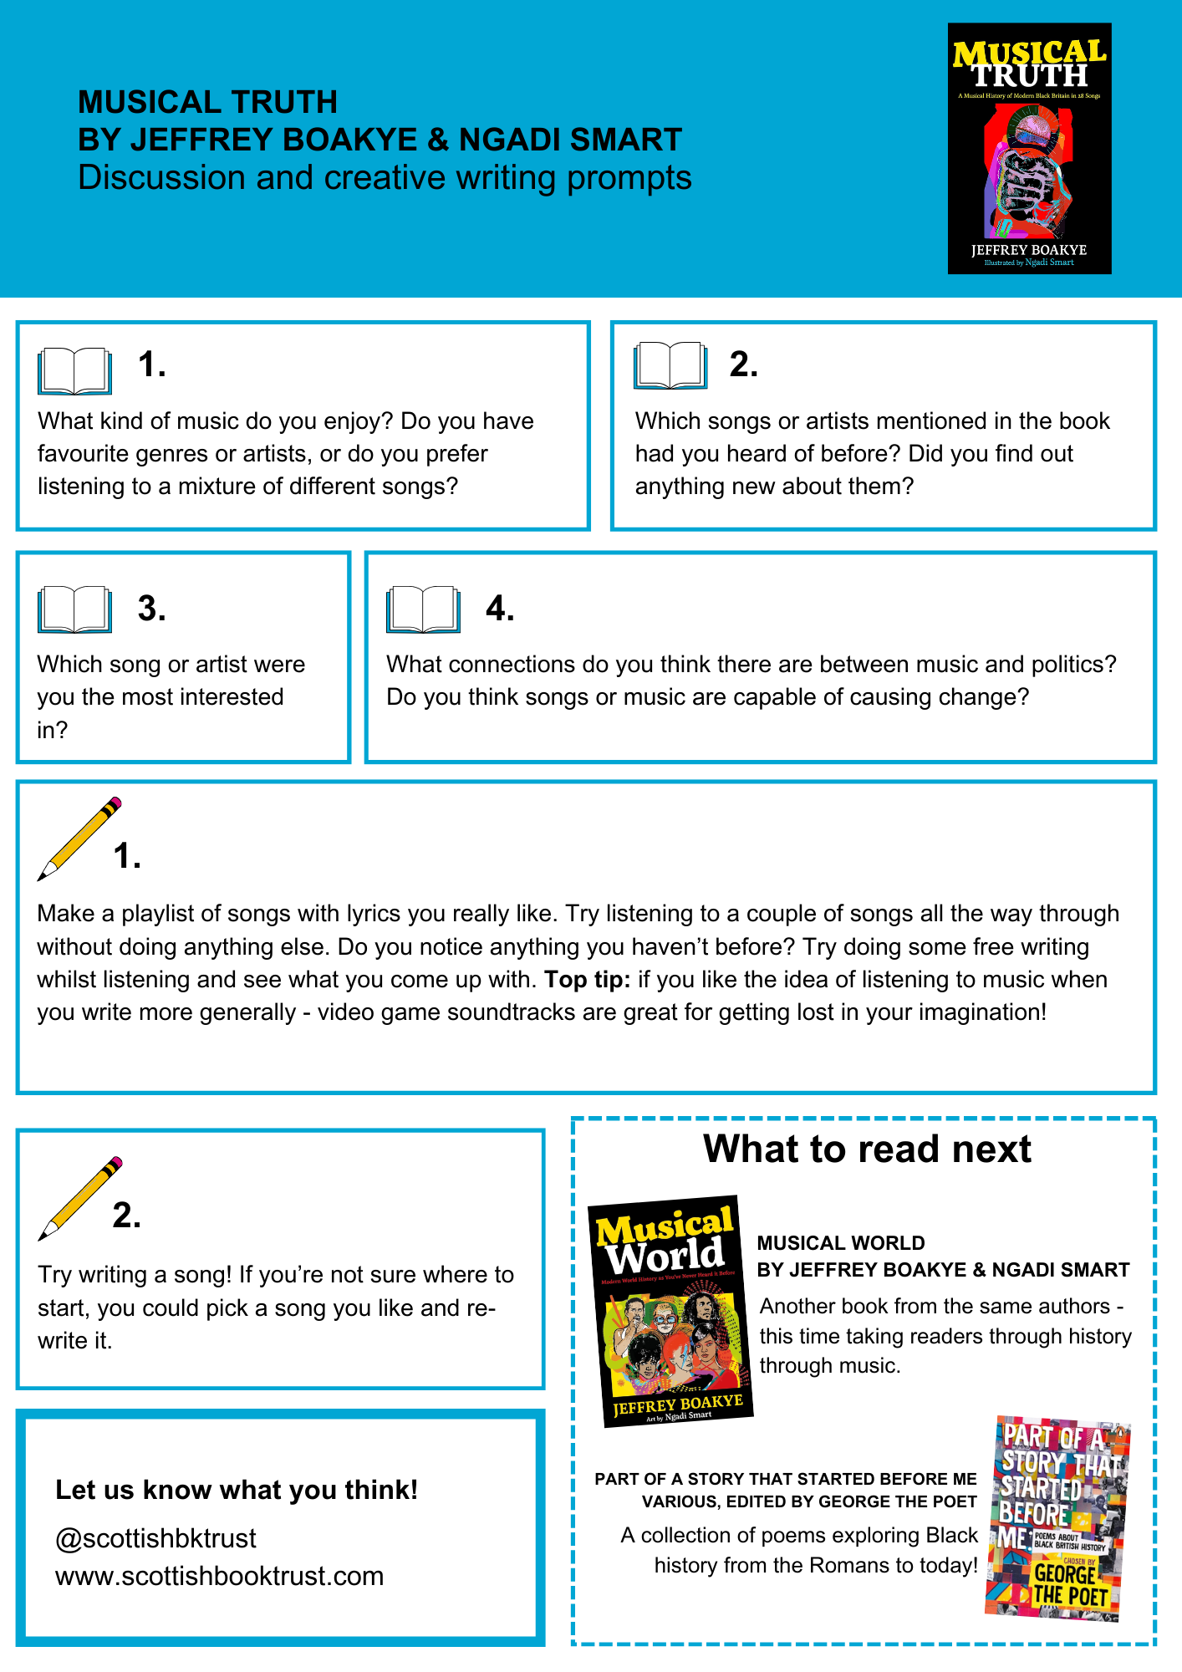

### *Musical Truth* printable discussion guide

## *In Real Life* by Cory Doctorow and Jen Wang

See printable version on page 24

### Discussion questions:

1. Do you play video games? What kind of games do you like playing? Try and swap a recommendation with someone else!
2. What did you think of the artwork in *In Real Life* and how it captured both the video game and Anda’s day-to-day life?
3. Before reading this book, were you aware of the impact video games have on the “real world”? Did anything surprise you?
4. Throughout the book, people are excluded from playing, including non-English speakers as well as women and girls. How do real world prejudices exist within video games? Do you think we can use the same technology to make video games more accessible and welcoming to everyone?

### Creative writing prompts

1. Try writing your own text only game with Twine. You can download the software or use it through your browser. If you’re not sure where to start, they have a reference guide you can use for advice.
2. If you’d like to practice writing fiction, choose a page, or pages, from *In Real Life* and try and write them out in plain text. If you’d like to practice creating your own comics, then pick a scene from another book you’ve enjoyed and try and capture it as a comic!

### What to read next

*Gamish* by Edward Ross  
A graphic novel that journeys through the history of video games.

*Slay* by Brittney Morris  
Another story about a video game with real-life consequences!

**Top tip:** See our [Book Discovery Guide Issue 7](https://www.scottishbooktrust.com/learning-resources/book-discovery-guide) or our [Brilliant books for gamers book list](https://www.scottishbooktrust.com/book-lists/brilliant-books-for-gamers) for more recommendations for readers who love video games.

### *In Real Life* discussion guide

## *Needle* by Patrice Lawrence

See printable version on page 26

### Discussion questions:

1. Why do you think the story was told from Charlene’s point of view? Discuss the impact of reading through Charlene’s perspective and in first person.
2. Discuss Charlene’s love of knitting. What did knitting symbolise throughout the story? Why was Charlene’s knitting so important to her?
3. How did the novel capture the justice system and how it treats young Black people like Charlene? What examples of racism did you notice throughout the novel?
4. The cover says “Sorry, not sorry”. Who in the book do you think owes another character an apology?

### Creative writing prompts

1. One of the way the author keeps tension in the story is by setting the events in a single day. Think about how much can change in just one day. Try and write your own story, or paragraph, where all the action happens in one day.
2. Do you have a hobby or interest like Charlene’s love of knitting? Next time you spend time with your hobby, take five minutes afterwards to write about it. What do you see, hear or smell? How does it make you feel?

### What to read next

*Run Rebel* by Manjeet Mann  
Like Charlene finds her way through knitting, Amber escapes her abusive father through running.  
  
*Wrecked* by Louisa Reid  
Another novel that looks at the court system: this time, unpicking how something seemingly perfect can be covered with lies.

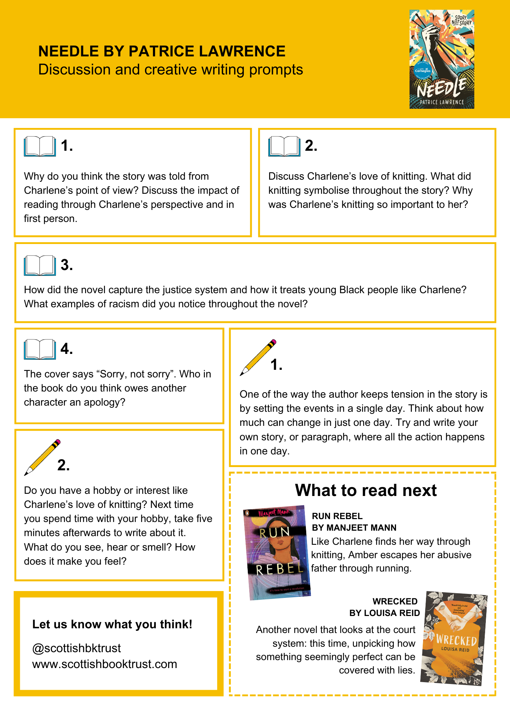

### *Needle* printable discussion guide

## *Glasgow Boys* by Margaret McDonald

See printable version on page 28

### Discussion questions

1. What did you think of Finlay and Banjo’s relationship? Do you think they’ll stay friends?
2. Whose chapters did you prefer - Finlay or Banjo’s? Why?
3. How did living in care effect Finlay and Banjo even after they’d found their own communities?
4. Have you been to Glasgow? Did the book portray it as you imagined (or have experienced) it?

### Creative writing prompts

1. Banjo and Finlay are completely different but have some key things in common. Draw two overlapping circles - in one circle, write out some characteristics and in the other write the complete opposite. In the overlap, write what traits, hobbies, ideals or flaws they could have in common.
2. Finlay and Banjo spend a lot of time separated from each other. Write a story in the form of a letter. What would you character say to the other person? Remember, as much as possible: *show* but don’t *tell* us how your character feels.

### What to read next

*The Evolving Truth of Ever-Stronger Will* by Maya Macgregor  
Another story of finding yourself, and your family, after care.

*Radio Silence* by Alice Oseman  
Another story of friendship and perseverance.

*Glasgow Boys* discussion guide

## *If My Words Had Wings* by Daniella Jawando

See printable version on page 31

### Discussion questions

1. ‘*..the way that this system is designed, it’s so easy to get into, but much harder to get out of.*’ (page 277)   
   Throughout the book, Tyrell constantly faces discrimination based upon assumptions that people make about him. Think about how prison is portrayed in TV/films or in the news. What assumptions did you have about prison and offenders before you read this book? Did anything surprise you?
2. Do you think there are certain ideas or themes that poetry is better at expressing than other forms of writing?
3. Read “Thirteen” by Caleb Femi (one of the poets that Tyrell admires[) on the BBC website](https://www.bbc.co.uk/bitesize/articles/zyy4qyc). What kind of images does Caleb Femi use? How does this compare to the images in Tyrell’s poems in *If My Words Had Wings*?
4. What did you think of the ending? What do you think happens next to Tyrell? What about Dadir or those accused of joint enterprise?

### Creative writing prompts

1. Choose a line from one of Tyrell’s poems (or, if you have a favourite poem, you can use that!) and write it at the top of your page. This is now the title of your poem. Think about how you’re going to respond to that one line and either adapt or extend its meaning.
2. Each of the different characters in the book represent something different to Tyrell. Malik, for example, gives him hope for the future, whereas Clinton makes him nervous. Draw a diagram with Tyrell in the centre and the other characters scattered around. To connect them, write how you think these characters make Tyrell feel. When writing your own story, this is a good way to ensure your character has different relationships with all the other characters in the story, and that your different characters have different functions.

### What to read next

*When Our Worlds Collided* by Danielle Jawando  
Another story of teens brought together by injustice from the same author.  
  
*When Shadows Fall* by Sita Brahmachari  
Another story about escaping violence through friendship and connection.

*If My Words Had Wings* printable discussion guide

## *Treacle Town* by Brian Conaghan

See printable version on page 10

### Discussion questions

1. How is Con shaped by his friendships? Could you understand why he felt pressure to do certain things that he didn’t want to do?
2. How did Con’s character change over the course of the book? How did the writer help you empathise with Con, even if you didn’t agree with what he was doing?
3. What did you think of Con’s relationship with poetry? How did it help him find another life?
4. Have you ever watched, or been to, somewhere where poetry was read aloud? Do you think it’s more engaging than reading a poem from a book?

### Creative writing prompts

1. Reread Con’s poems, then write your own poem inspired by where you live. Think about the details you want to capture; whether places, people, your home, your school or anything else you think is unique to where you live!
2. Write a story told through text messages. Think about how to capture your character’s voices through how they text. Do they use slang or acronyms, or type everything out in full? What is missing from the dialogue when they can’t see each other, and how can you still capture how they’re feeling?

### What to read next

*A Hurricane In My Head* by Matt Abbott  
Funny, honest and bold poems by a spoken word poet!  
  
*The Poet X* by Elizabeth Acevedo  
Another story about finding your way through writing and poetry.  
  
**Top tip**: you can watch Brian Conaghan share tips for writing on [Authors Live on the Scottish Book Trust website](https://www.scottishbooktrust.com/authors-live-on-demand/brian-conaghan)!

### *Treacle Town* printable discussion guide

## Book group ideas

If you’ve used a couple of these discussion guides to run a book group, here are some further ideas:

* Ask pupils to write a bookmark or shelf shouter note to recommend the titles they liked to other readers
* Ask pupils to choose their favourite – you could go round the group or vote
* Create a display of “what to read next” – you could work with your local librarian on this
* Create a book or display of any creative writing you’ve created (make sure you ask pupils what they’d like to include)
* Vote on what to read next!

## Further resources

See our other teen discussion guides on [the Scottish Book Trust website](https://www.scottishbooktrust.com/learning-resources/read-scottish-teen-books)

For more book recommendations, please see:

* Our [Book Discovery Guides](https://www.scottishbooktrust.com/learning-resources/book-discovery-guide)
* Our [Book Discovery CLPL sessions for teachers and librarians](https://www.scottishbooktrust.com/learning-and-resources/clpl-for-learning-professionals)
* Our [book lists](https://www.scottishbooktrust.com/book-lists)

For more resources to use with secondary pupils see:

* Our [10 things to do with any book secondary resource](https://www.scottishbooktrust.com/learning-resources/great-activities-for-any-book) can be used with any books, and contains activities and ideas that can extend pupil’s engagement with any of these titles
* All our learning resources can be filtered by age, including [12-to-14 year olds](https://www.scottishbooktrust.com/learning-resources) and [15-to-18 year olds](https://www.scottishbooktrust.com/learning-resources)