

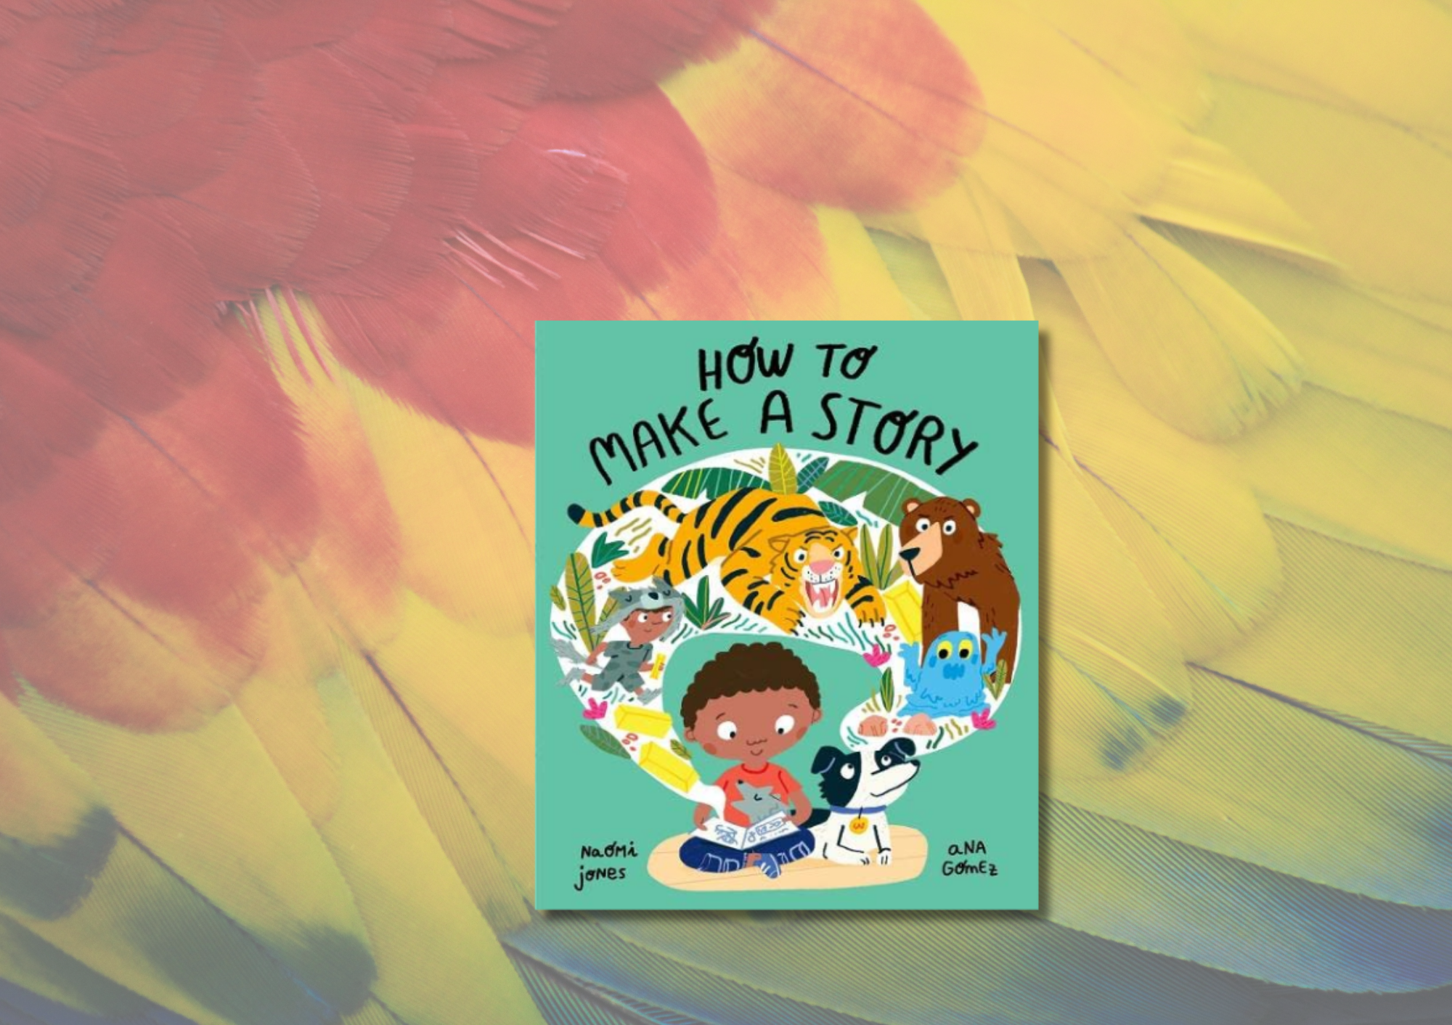

# Read Write Count P2: *How to Make a Story* STEM learning activities

STEM learning activities based on *How to Make a Story* by Naomi Jones and Ana Gomez

## Age 6-8

## CfE First Level

## Decorative imageResource created by Raising Aspirations in Science Education (RAiSE)

scottishbooktrust.com



Scottish Book Trust is a registered company (SC184248)

and a Scottish charity (SC027669).

## Contents

About this resource 2

Learning activities 2

Further resources 6

## About this resource

This resource was developed by [Raising Aspirations in Science Education (RAiSE)](https://education.gov.scot/resources/raise-raising-aspirations-in-science-education/) and provides links to some suggestions for further STEM learning activities to complement and enhance children’s learning from one of the books included in this year’s [Primary 2 Read Write Count bag](https://www.scottishbooktrust.com/learning-resources/read-write-count-for-p2). The key themes explored in these activities are jungle habitats, construction and materials.

## Learning activities

### Activity 1: Cover

LIT 1-04a   
Look at the front cover of the story - discuss the meaning of an author and illustrator. Look at the title and picture and predict what the story is going to be about? What characters do you think we will meet along the way?

### Activity 2: Page 2

LIT 1-11a- ENG 1-03a MNU 1-20b MTH 1-21a  
Discuss what makes a good story and share your favourite story with other learners. Create a graph of everyone's favourite stories. Learners could bring in their favourite book from home and talk about it with their peers, explaining what makes it a good story.

### Activity 3: Page 3

LIT 1-02a, HWB 1-47a  
Discuss different feelings and emotions. What does it mean to be worried? What happens when you feel worried? What makes you feel worried and what can you do to overcome the worry? If you are happy to, share your thoughts with other learners.

### Activity 4: While reading the book or at the end of the story

LIT 1-28a, LIT 1-29a, ENG 1-31a, EXA 1-02a  
Create your own story. What will your character be called? What will they look like? Create a beginning, a middle and an end for your story. Use this book to guide you through.

### Activity 5: Page 6

HWB 1-33a HWB 1-27a HWB 1-22a  
What is Nana doing? Why is Nana doing this? What can you do to keep yourself healthy? See [Cosmic Yoga’s YouTube channel](https://www.youtube.com/user/cosmickidsyoga) for yoga you can follow along with in your classroom.

### Activity 6: Page 6

LIT 1-13a, MNU 1-20b, MTH 1-21a, SCN 1-15a  
‘*Wolf wanted to find lots of shiny treasures!*’ Explore the word “shiny”. Can you find anything shiny in your classroom or outdoor space? Explore different materials and sort items into groups. Did you find any materials Wolf would want? What is your favourite material and why?

### Activity 7: Page 7

LIT 1-04a, LIT 1-06a, LIT 1-14a, LIT 1-18a, SCN 1-01a, SCN 1-03a, SOC 1-12b, SOC 1-13a, TCH 1-02a  
What is a Jungle? Where do you find Jungles? Research jungle temperatures and relate these to the temperature we have in the UK. Use a globe or map to plot where you would find Jungles. Research the animals you might see in the Jungle. Grow you own plants to explore what plants need to thrive.

### Activity 8: Page 8

LIT 1-04a, LIT 1-06a, LIT 1-14a, LIT 1-18a, SCN 1-02a, TCH 1-02a  
Leading on from activity 7, focus on a Jungle in Asia where you would find tigers. Explore their habitat, [food source](https://study.com/academy/lesson/what-do-tigers-eat-lesson-for-kids.html) and travel. Create a food chain with the tiger as the predator. This could be a whole class activity if they haven’t experienced food chains previously.

Activity 9: Page 8EXA 1-03aUsing [Toddler Approved’s guide](https://toddlerapproved.com/sticky-tiger-craft-for-kids/), learn how to use the visual elements of line, shape, form, colour, tone, pattern and texture, create a detailed picture of a tiger.

### Activity 10: Page 10

LIT 1-04a, LIT 1-14a, LIT 1-18a, MNU 1-10c, HWB 1-22a, TCH 1-02a  
Research how fast tigers can run. Set up a running course and time how long it takes you to run from A to B.

### Activity 11: Page 13

MNU 1-11a  
Create your own rockslide using foam bricks or natural materials in your outdoor space. How high can you build a tower before it falls? Measure the height of your tower using standard units. Which tower was the highest? Why do you think this was?

### Activity 12: Page 14

LIT 1-04a, LIT 1-14a, MNU 1-11a, SCN 1-15a  
Make you own slime or gloop!

### Activity 13: Page 17

LIT 1-04a, LIT 1-06a, LIT 1-14a, LIT 1-18a, SCN 1-02a, TCH 1-02a, TCH 1-12a  
Leading on from activity 7 and 8, research bears. Explore their habitat, food source and travel. Create a food chain with the bear as the predator. This should build on previous skills. Learners should now be familiar with food chains from the previous activity. Could they work more independently?

### Activity 14: Page 21

MNU 1-11a, SCN 1-15a, TCH 1-09a, TCH 1-10a  
What is a den? What are dens used for? Heading into your outdoor space, can you create a den? What is the purpose of your den and what material are you going to use?

### Activity 15: Page 24

LIT 1-02a, EXA 1-13a, HWB 1-47a  
Exploring emotions. How can we tell the dribbling monsters are sad? What do you think has made them sad? What makes you sad? Do you use any techniques to help you overcome your sadness? Explore this emotion through discussion and emojis. Draw or write about a time you felt sad. Does this feeling last forever? Play the ‘emotion’ game. Act out an emotion and other learners need to guess what it is.

### Activity 16: Page 26-30

LIT 1-28a, LIT 1-29a, ENG 1-31a, EXA 1-02a  
Revisit activity 4 and create your own story. What will your character be called and what will they look like? Create a beginning, a middle and an end for your story. Use this book to guide you through. Share you story with another learner. Is there anything you can add to improve your story? Redraft your story.

## Further resources

For further Read Write Count resources see our other [STEM learning resources](https://www.scottishbooktrust.com/learning-resources/read-write-count-stem), our [P2 teacher pack](https://www.scottishbooktrust.com/learning-resources/read-write-count-for-p2) or [P3 teacher pack](https://www.scottishbooktrust.com/learning-resources/read-write-count-for-p3) which include cross curricular learning activities on the books and resources from each bag.