

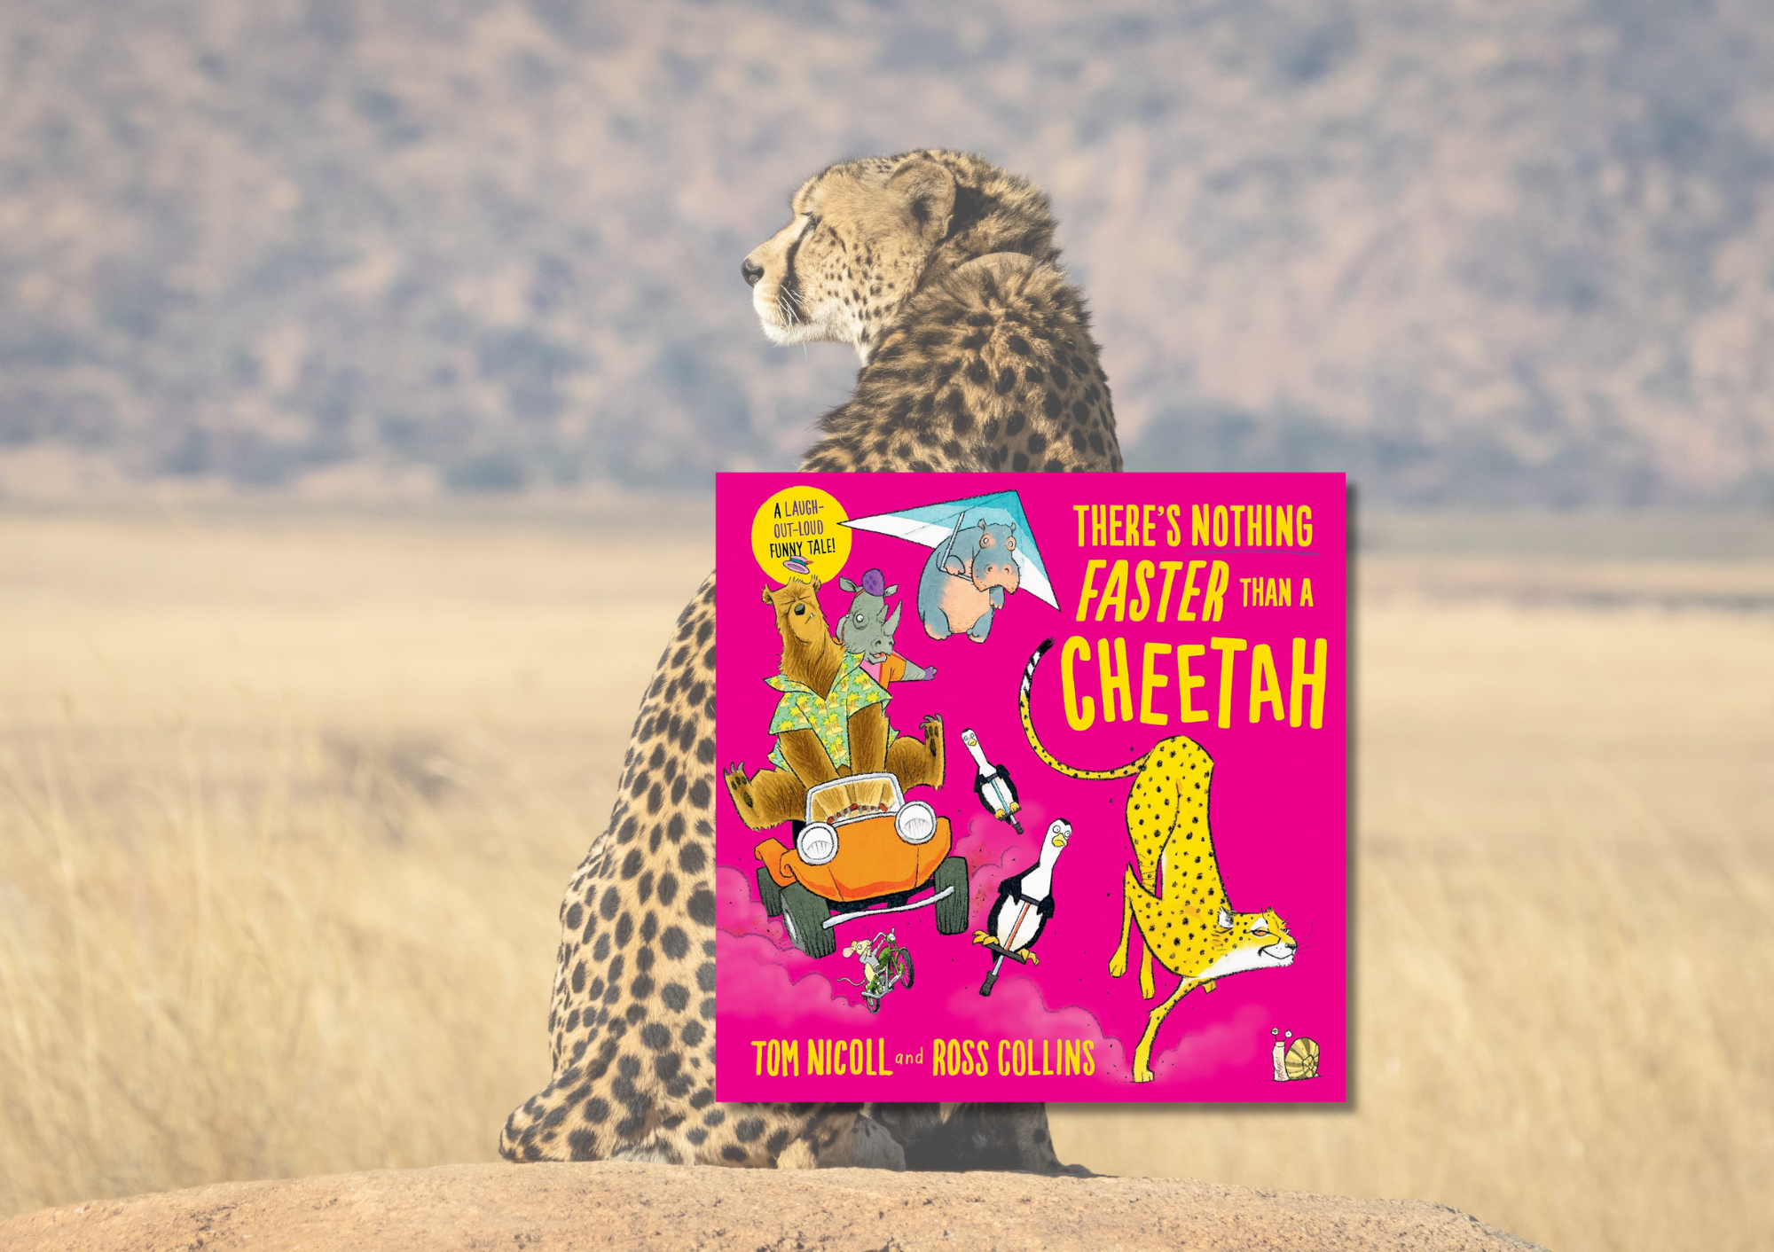

# Read Write Count P3: *There’s Nothing Faster Than a Cheetah* STEM learning activities

STEM learning activities on *There’s Nothing Faster Than a Cheetah* by Tom Nicoll and Ross Collins

## Age 6-8

## CFE First Level

## Decorative imageResource created by Raising Aspirations in Science Education (RAiSE)

scottishbooktrust.com



Scottish Book Trust is a registered company (SC184248)

and a Scottish charity (SC027669).

## Contents

About this resource 2

Learning activities 2

Further resources 6

## About this resource

This resource was developed by [Raising Aspirations in Science Education (RAiSE)](https://education.gov.scot/resources/raise-raising-aspirations-in-science-education/) and provides links to some suggestions for further STEM learning activities to complement and enhance children’s learning from one of the books included in this year’s [Primary 3 Read Write Count bag](https://www.scottishbooktrust.com/learning-resources/read-write-count-for-p3). The key themes explored in these activities are animals, speed and measurement and movement.

## Learning activities

Activity 1: Let’s take a look  
LIT 1-02a, LIT 1-04a  
Using the front cover, discuss the picture and discuss the different animals and their mode of transport. What do we notice? For example, how the different animals are travelling, why do you think they are using different things? Are all the animals using something else to travel? How do animals usually travel? Watch [Explorify’s video “To Flee or Not to Flee”](https://explorify.uk/en/activities/whats-going-on/to-flee-or-not-to-flee) (log in required) and discuss the different habitats of animals and how the animals move.

### Activity 2: What do you wonder?

LIT 1-06a  
Using the information pages, discuss the speed that the animals can move at. Ask the learners “What do you wonder?” Ask learners to group/classify the animals in any way they wish. On completion of the task, ask the learners to explain why they have grouped them in this way, asking “What did you notice?” Explore the different ways in which learners have grouped the animals.

### Activity 3: How many legs?

MNU 1-20b  
Create a pictograph or bar graph of the animals in the book with 0, 1, 2, 3 or 4 legs.

### Activity 4: I think…

LIT 1-09a, EXA 1-16a  
On reading the first two pages, using their knowledge of how animals move, ask the learners to predict the outcome of the race and to explain their response. Throughout the book, draw attention to the snail(s), asking learners to predict what they are doing. Listen to and join in with the [“How Animals Move” song](https://youtu.be/ljlJF77PQfs) from Jack Hartmann Kids Music Channel on YouTube (3 minutes, 55 seconds).

### Activity 5: Animals in action

**LIT 1-09a EXA 1-17a**Using the [“Animals in Action” song](https://youtu.be/CT86Dl442jA) from Jack Hartmann Kids Music Channel on YouTube (3 minutes, 35 seconds), encourage learners to join in with the actions to show how different animals move.In pairs or small groups learners ask learners to think about how other animals move and write lyrics and actions to be added to the song. The groups the, in turn, perform this to create their own class “Animals in Action” song.

### Activity 6: Exploring speed

SCN 1-07a  
Learners select objects from a variety of toy vehicles. Using a stopwatch, record the time the vehicle takes to cover a certain distance when released from a ramp (without pushing). Change a variable, for example, the angle of the ramp, the texture of the surface, ask the learners to predict what will happen before repeating. How does the change in variable affect the time taken? Why?

Activity 7: Making moves  
HWB 1-21a, MNU 1-10c   
Ask learners to think about how they would move using 4, 3, 2, 1 or no limbs. Working in pairs, learners time themselves, using stop watches, in each of their movements (over the same distance). Encourage learners to share their findings by asking, “What did you notice?” This activity could be replicated using outdoor play equipment, e.g., bikes, scooters, cars. The variable change could be the surface that they travel over.

### Activity 8: Show the information

MNU 1-20b  
Conduct a survey on how learners travel to school/how long does it take them to get to school. Create a picto or bar graph with the information.

### Activity 9: Create a fact file book

LIT 1-14a, LIT 1-15a, LIT 1-22a, LIT 1-24a, LIT 1-25a, LIT 1-26a, TCH 1-02a  
Learners choose an animal to research, focusing on its habitat, traits, speed etc and create a fact file on their chosen animal. Using a digital resource, e.g. Book Creator or Canva, collate the fact files into a class book.

### Activity 10: Fast and Slow words

LIT 1-21a  
Learners find as many words as they can which mean fast and slow. They then write the words in a way that depicts e.g. fast, written in the shape of a lightning bolt.  
  
Activity 11: How big?  
MNU 1-11a, TCH 1-02a  
In pairs or small groups, learners estimate the size of a cheetah, a snail and other animals. Learners then research, measure and mark the length and height of the animal on a large piece of paper and draw an outline of the animal around the measurements. Learners can then colour their picture, leaving the measurements visible.

### Activity 12: Look what we know

TCH 1-01a  
Using the research from Activity 9, learners deliver a presentation on their chosen animal, to their peers/adults from home.

### Activity 13: Standing animals

TCH 1-09a, TCH 1-12a  
Using recycled, junk modelling or available materials, recreate one of the animals from the book by building it. Pay close attention to the features of the animal such as the number of legs it has, if it has a tail and the size of its body. You might wish to make a costume of your chosen animals; you could use [Makedo Hub](https://know.make.do/search?q=dino) for inspiration.

### Activity 14: Animal stories

LIT 1-20a, LIT 1-22a, LIT 1-23a   
Using the structure of the story, change the story, replacing the animals and modes of travel with other characters and travel, to create a new story.

### Activity 15: Our world of work

TCH 1-02a, LIT 1-14a, LIT 1-15a, LIT 1-22a, LIT 1-24a, LIT 1-25a, LIT 1-26a  
In pairs, small groups or individually, learners research careers that work with and for animals, e.g. a zoologist. You may like to watch [“What Does a Zoologist Do?” on the Sokanu YouTube channel](https://www.youtube.com/watch?v=5suxAxFm0vE) (1 minute, 46 seconds). You could also learn about PDSA, SSPCA, RSPCA worker, vet, etc. Create a class fact file on the careers the pupils have found.

## Further resources

* For further Read Write Count resources see our other [STEM learning resources](https://www.scottishbooktrust.com/learning-resources/read-write-count-stem), our [P2 teacher pack](https://www.scottishbooktrust.com/learning-resources/read-write-count-for-p2) or [P3 teacher pack](https://www.scottishbooktrust.com/learning-resources/read-write-count-for-p3) which include cross curricular learning activities on the books and resources from each bag.
* You can also watch Tom Nicoll and Ross Collins read from *There’s Nothing Faster Than a Cheetah* and show you how to draw your own cheetah on [our Authors Live on Demand broadcast](https://www.scottishbooktrust.com/authors-live-on-demand/tom-nicoll-and-ross-collins)!